R2 Samples Report for 3 Thresholds

|  |  |  |  |
| --- | --- | --- | --- |
| Strategy | R2 >= 0.5 | R2 >= 0.7 | R2 >= 0.9 |
| RS | 70 (57.57%) | 100 (82.24%) | N/A |
| LL4AL | 40 (32.89%) | 110 (90.46%) | N/A |
| LCMD | 20 (16.45%) | 50 (41.12%) | N/A |
| MCD | 40 (32.89%) | 40 (32.89%) | N/A |
| EGAL | 40 (32.89%) | 70 (57.57%) | N/A |
| BayesianAL | 40 (32.89%) | 70 (57.57%) | N/A |
| GSx | 20 (16.45%) | 30 (24.67%) | N/A |
| GSy | 50 (41.12%) | 60 (49.34%) | N/A |
| GSi | 40 (32.89%) | 50 (41.12%) | N/A |
| GSBAG | 30 (24.67%) | 50 (41.12%) | N/A |

All_Strategies_on_uhpc_mss.png

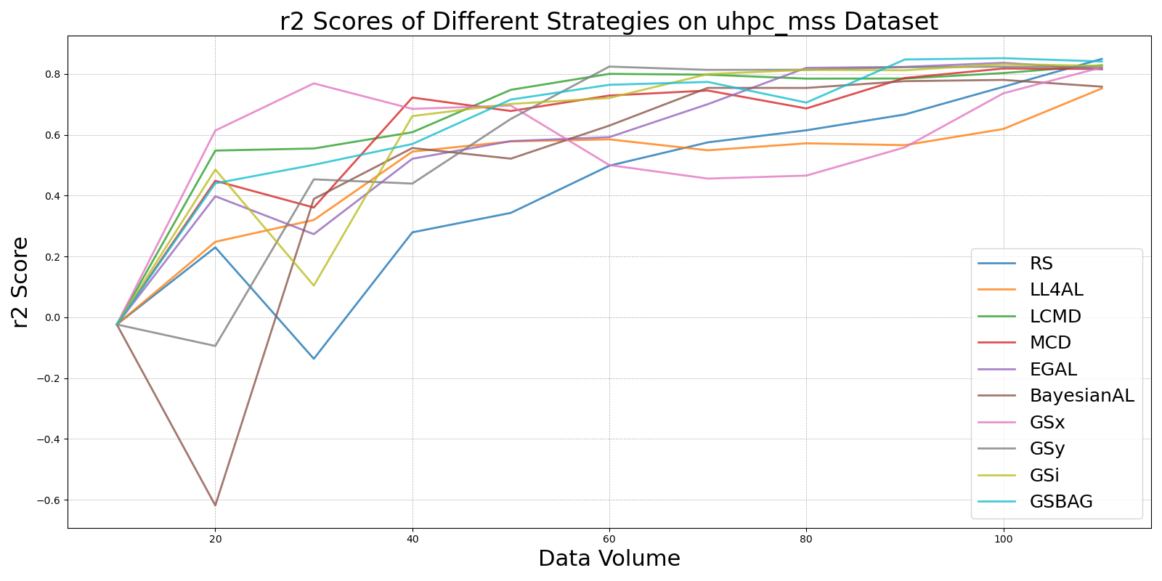

BayesianALvs_RS_on_uhpc_mss.png

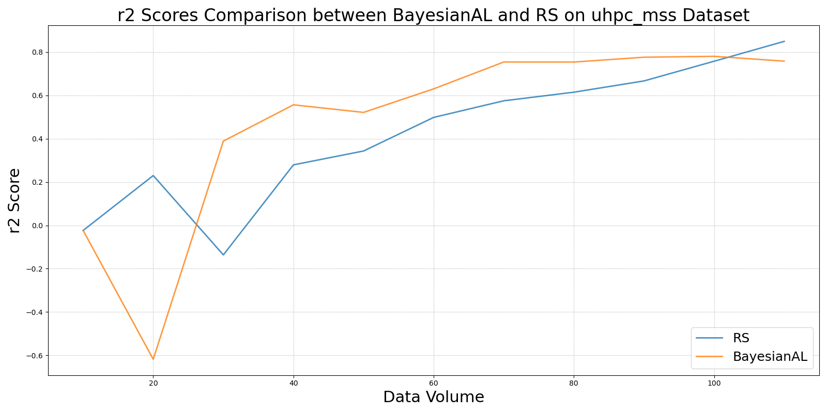

EGALvs_RS_on_uhpc_mss.png

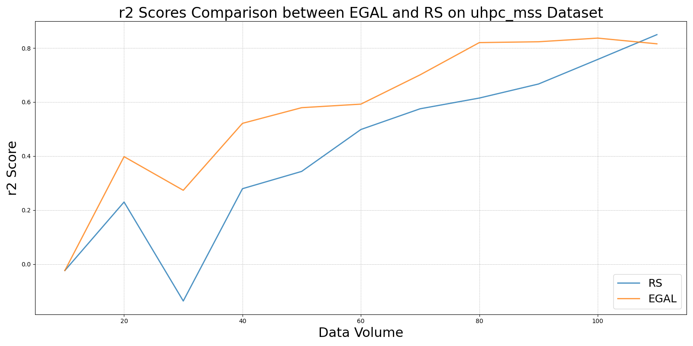

GSBAGvs_RS_on_uhpc_mss.png

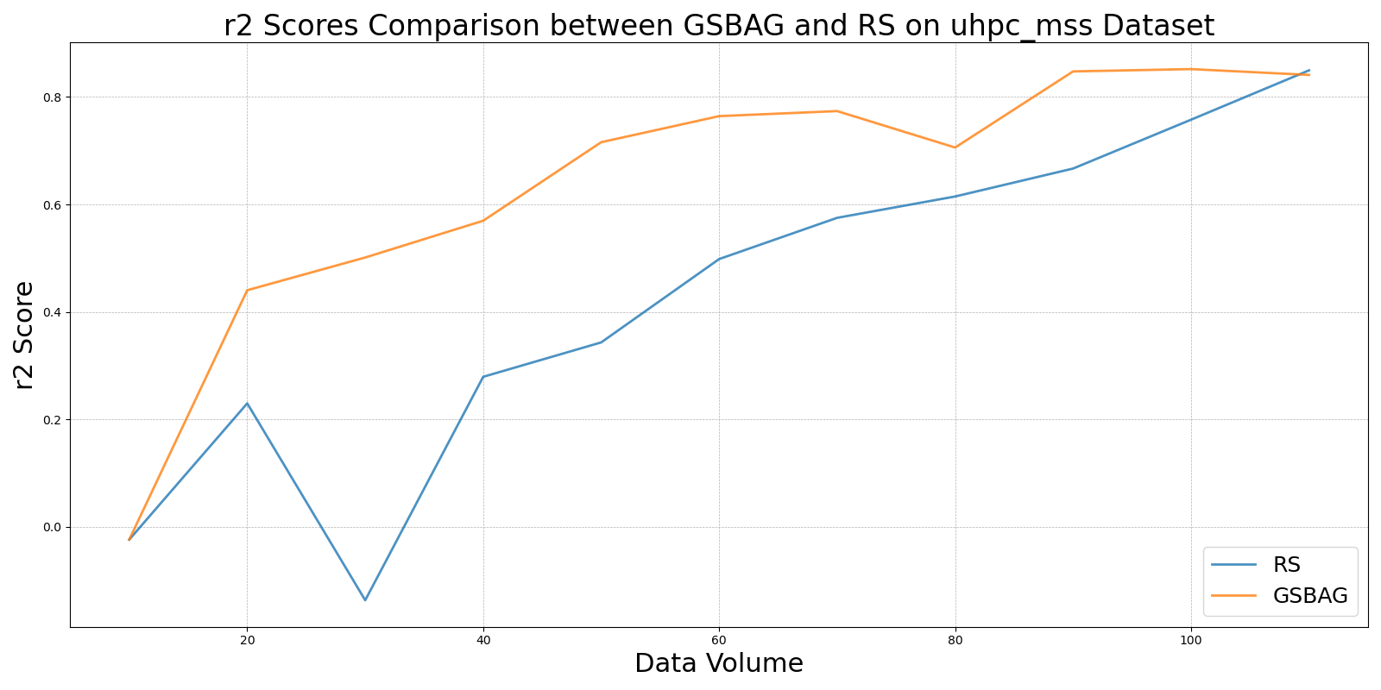

GSivs_RS_on_uhpc_mss.png

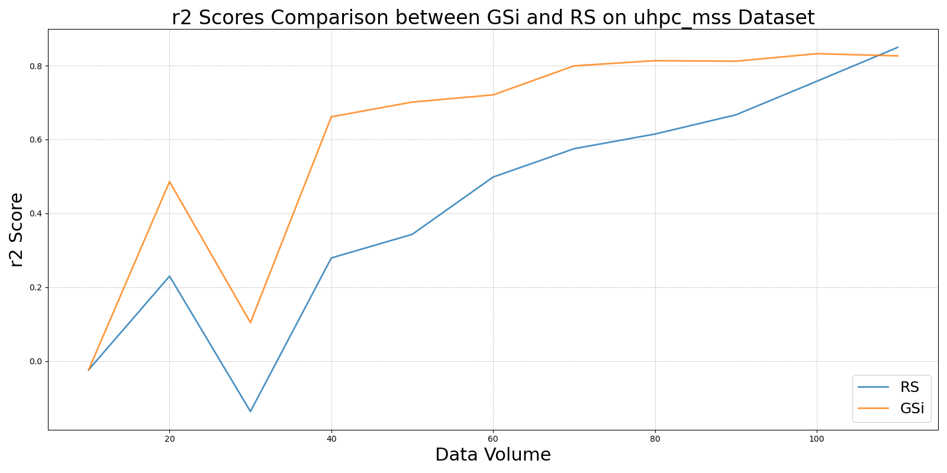

GSxvs_RS_on_uhpc_mss.png

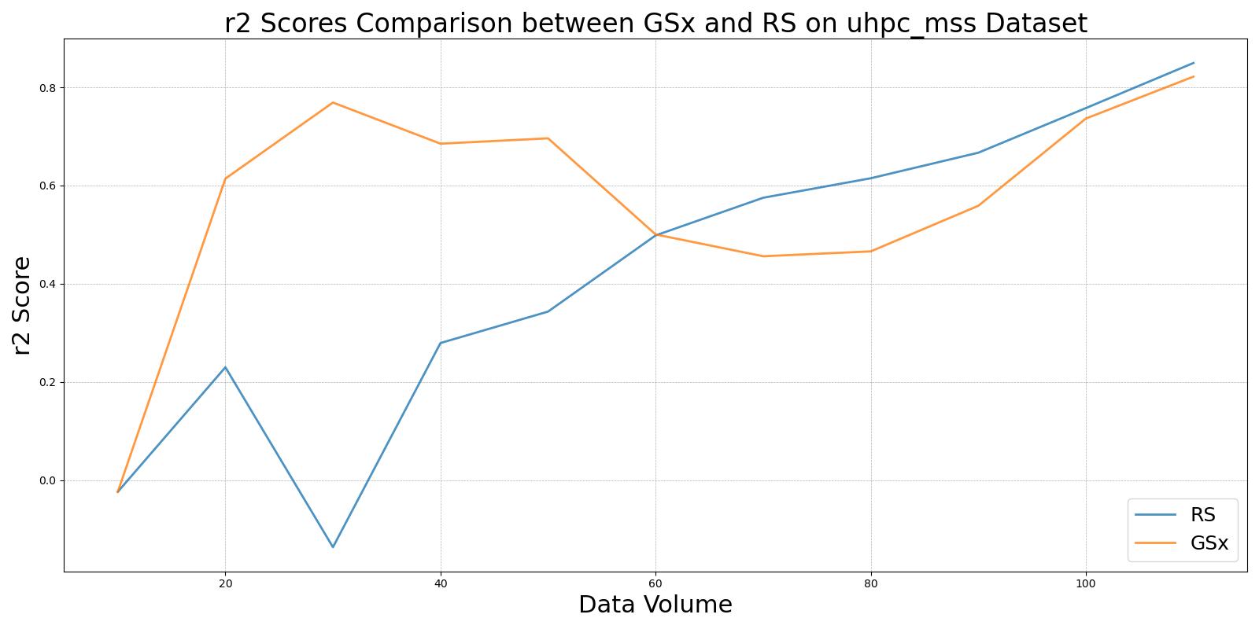

GSyvs_RS_on_uhpc_mss.png

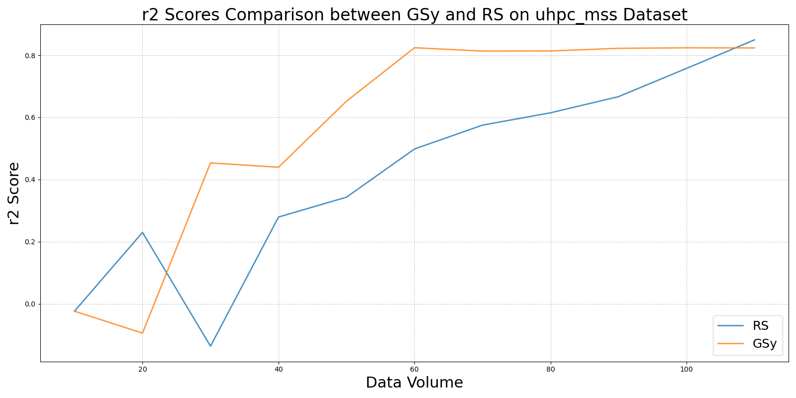

LCMDvs_RS_on_uhpc_mss.png

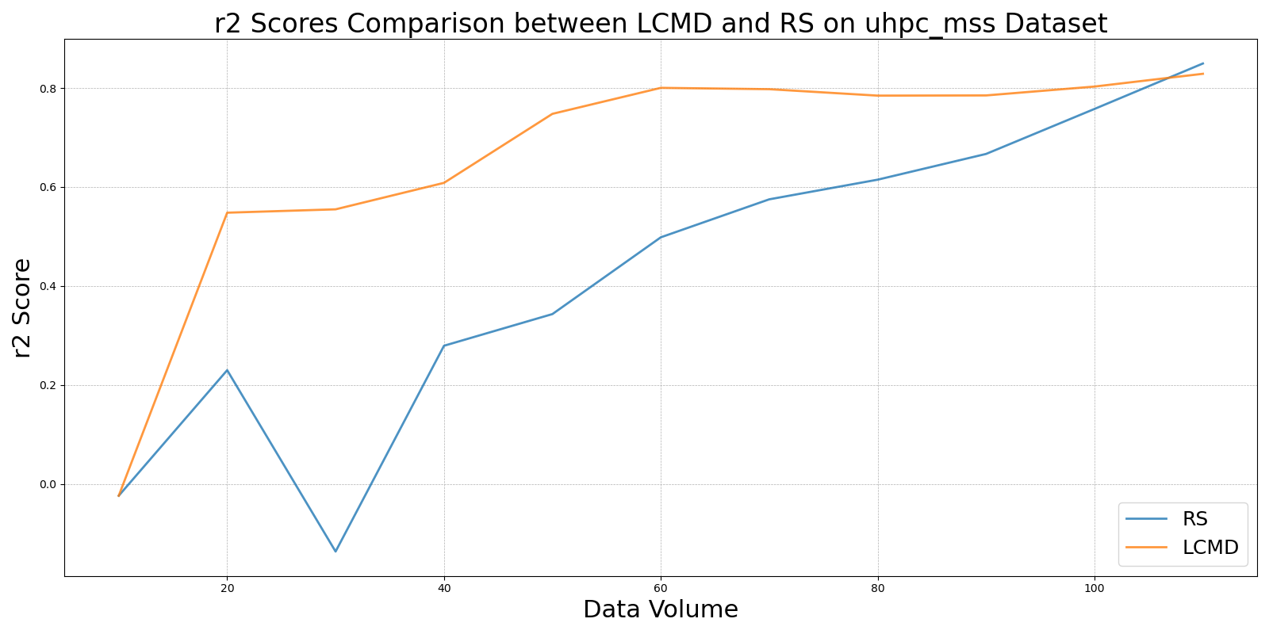

LL4ALvs_RS_on_uhpc_mss.png

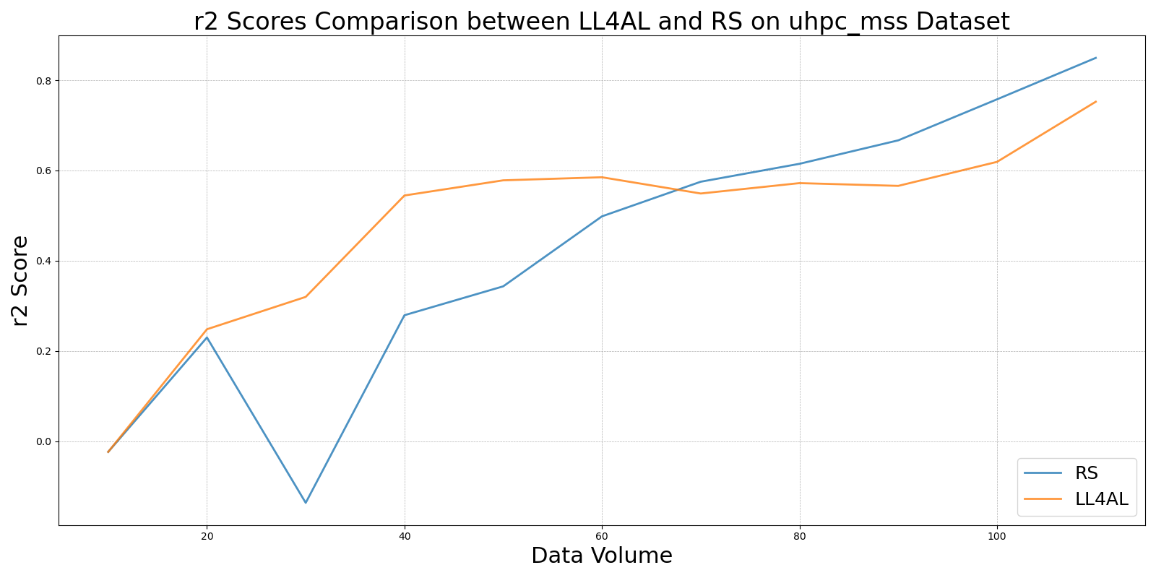

MCDvs_RS_on_uhpc_mss.png

