R2 Samples Report for 3 Thresholds

|  |  |  |  |
| --- | --- | --- | --- |
| Strategy | R2 >= 0.5 | R2 >= 0.7 | R2 >= 0.9 |
| RS | 20 (23.15%) | 20 (23.15%) | N/A |
| LL4AL | 20 (23.15%) | 30 (34.72%) | N/A |
| LCMD | 20 (23.15%) | 20 (23.15%) | 50 (57.87%) |
| MCD | 30 (34.72%) | 30 (34.72%) | 60 (69.44%) |
| EGAL | 20 (23.15%) | 20 (23.15%) | 50 (57.87%) |
| BayesianAL | 30 (34.72%) | 30 (34.72%) | 50 (57.87%) |
| GSx | 20 (23.15%) | 20 (23.15%) | N/A |
| GSy | 20 (23.15%) | 20 (23.15%) | 20 (23.15%) |
| GSi | 20 (23.15%) | 20 (23.15%) | 40 (46.30%) |
| GSBAG | 20 (23.15%) | 20 (23.15%) | 40 (46.30%) |

All_Strategies_on_uhpc_porpsoty.png

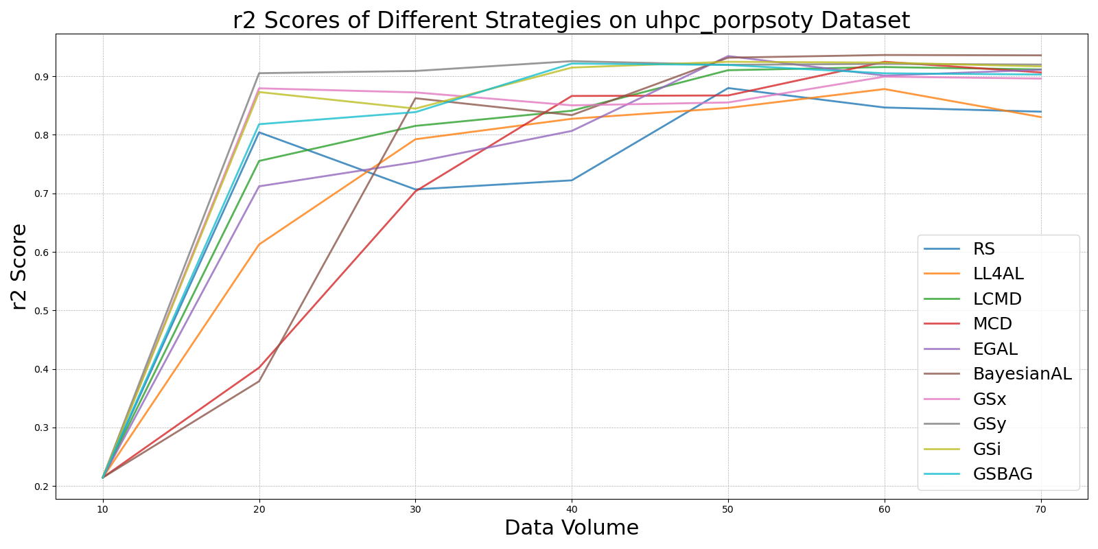

BayesianALvs_RS_on_uhpc_porpsoty.png

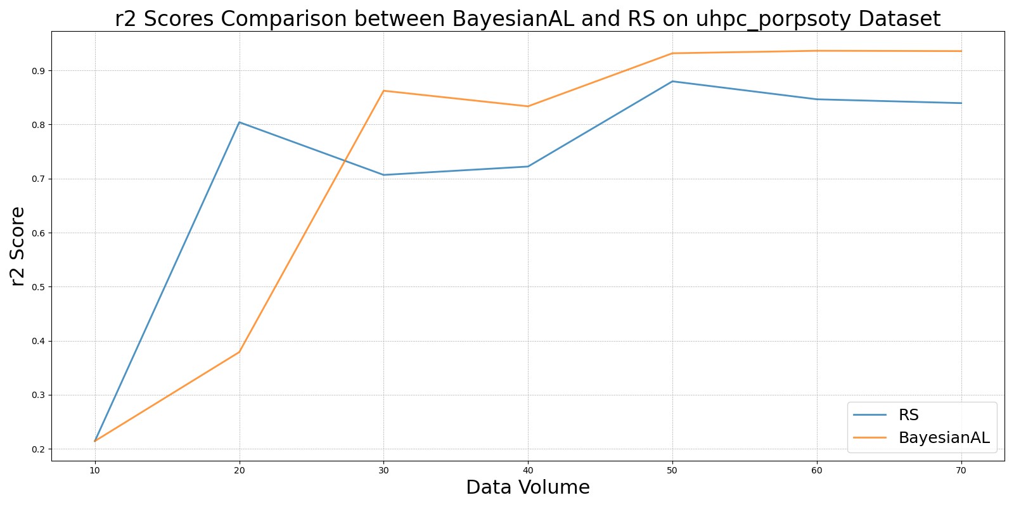

EGALvs_RS_on_uhpc_porpsoty.png

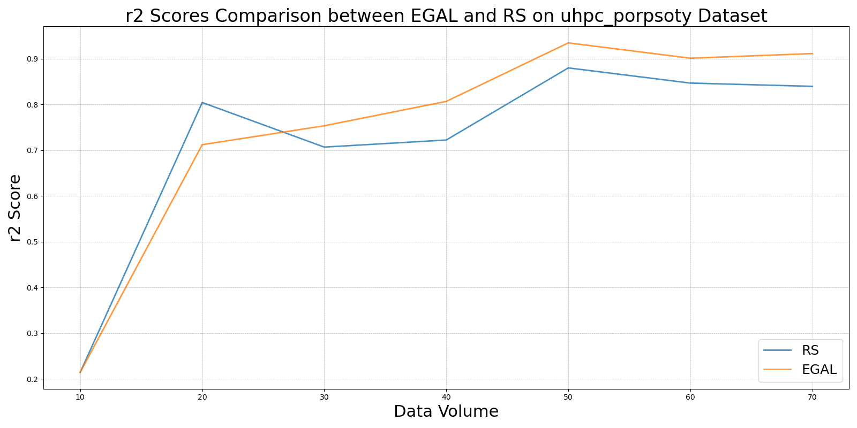

GSBAGvs_RS_on_uhpc_porpsoty.png

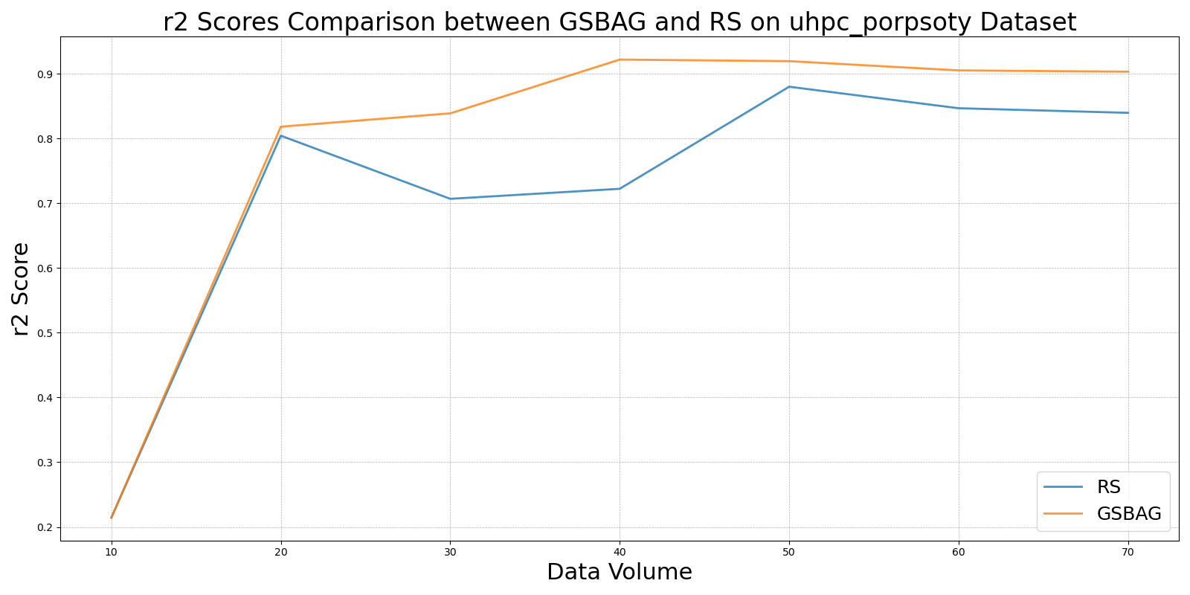

GSivs_RS_on_uhpc_porpsoty.png

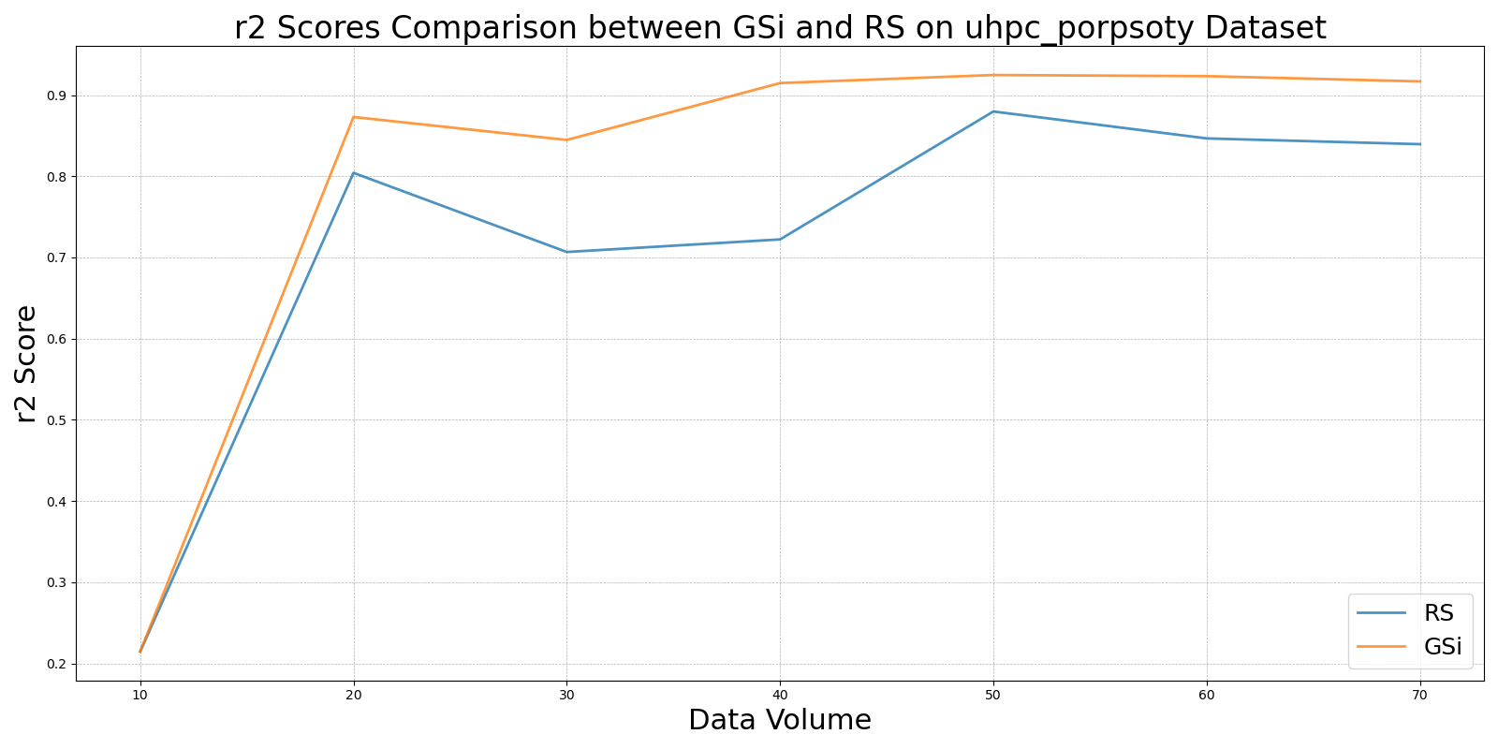

GSxvs_RS_on_uhpc_porpsoty.png

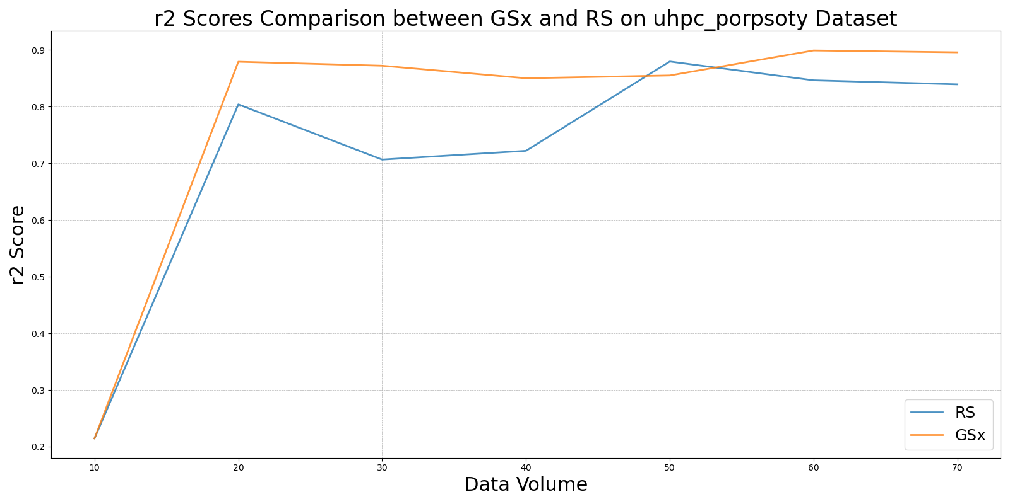

GSyvs_RS_on_uhpc_porpsoty.png

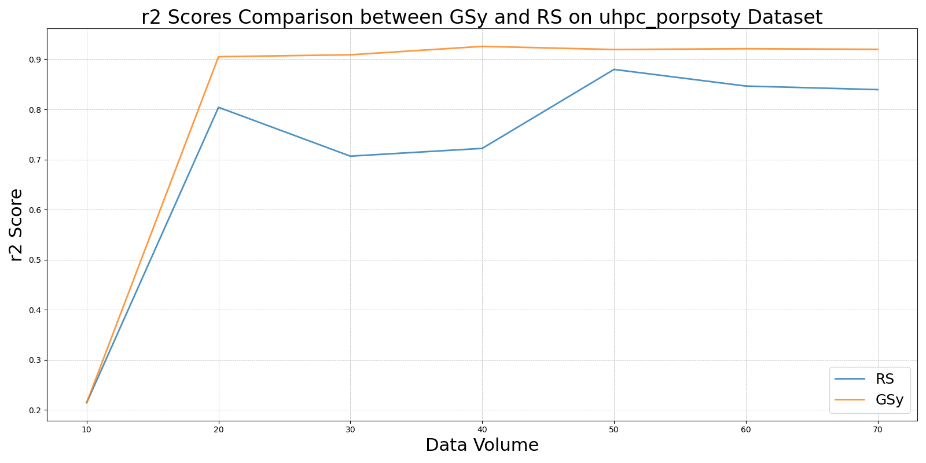

LCMDvs_RS_on_uhpc_porpsoty.png

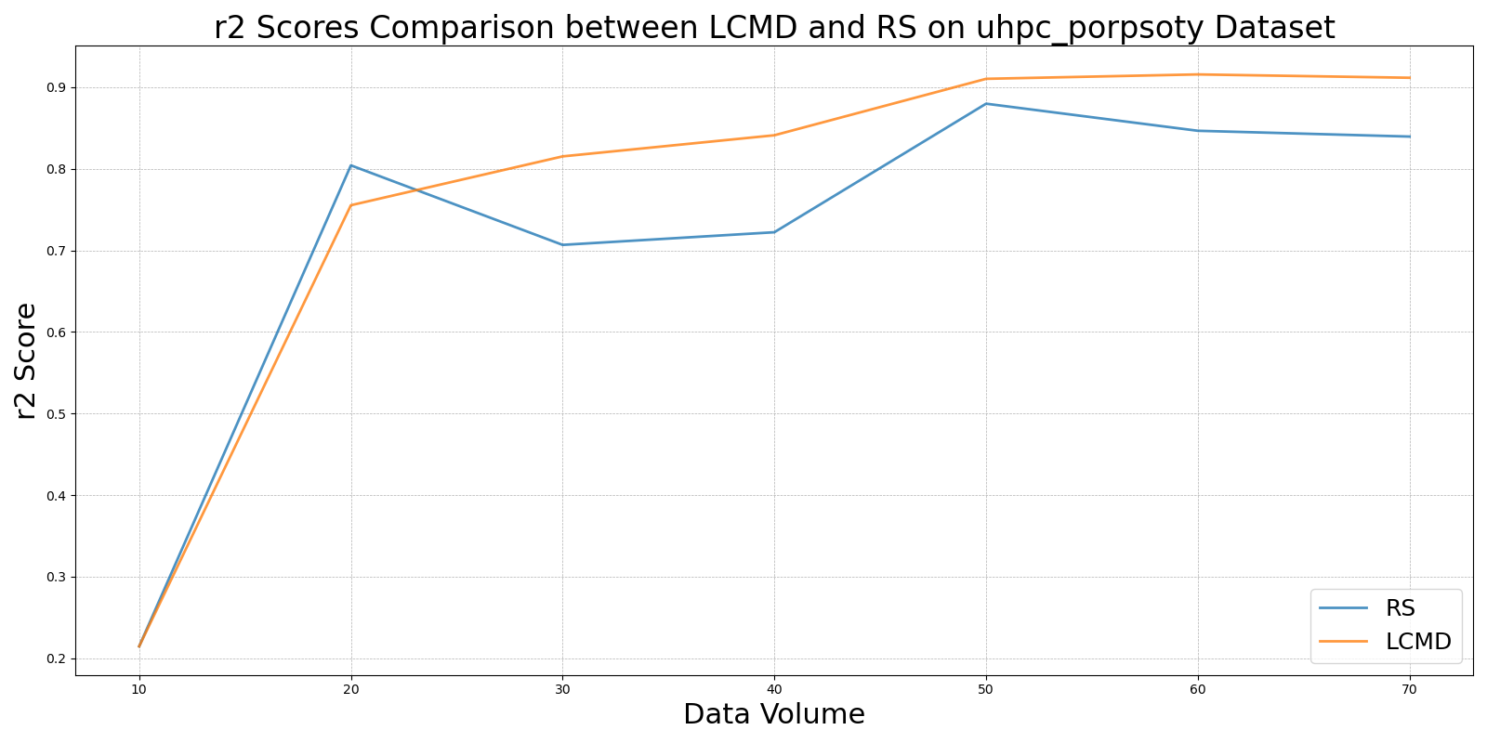

LL4ALvs_RS_on_uhpc_porpsoty.png

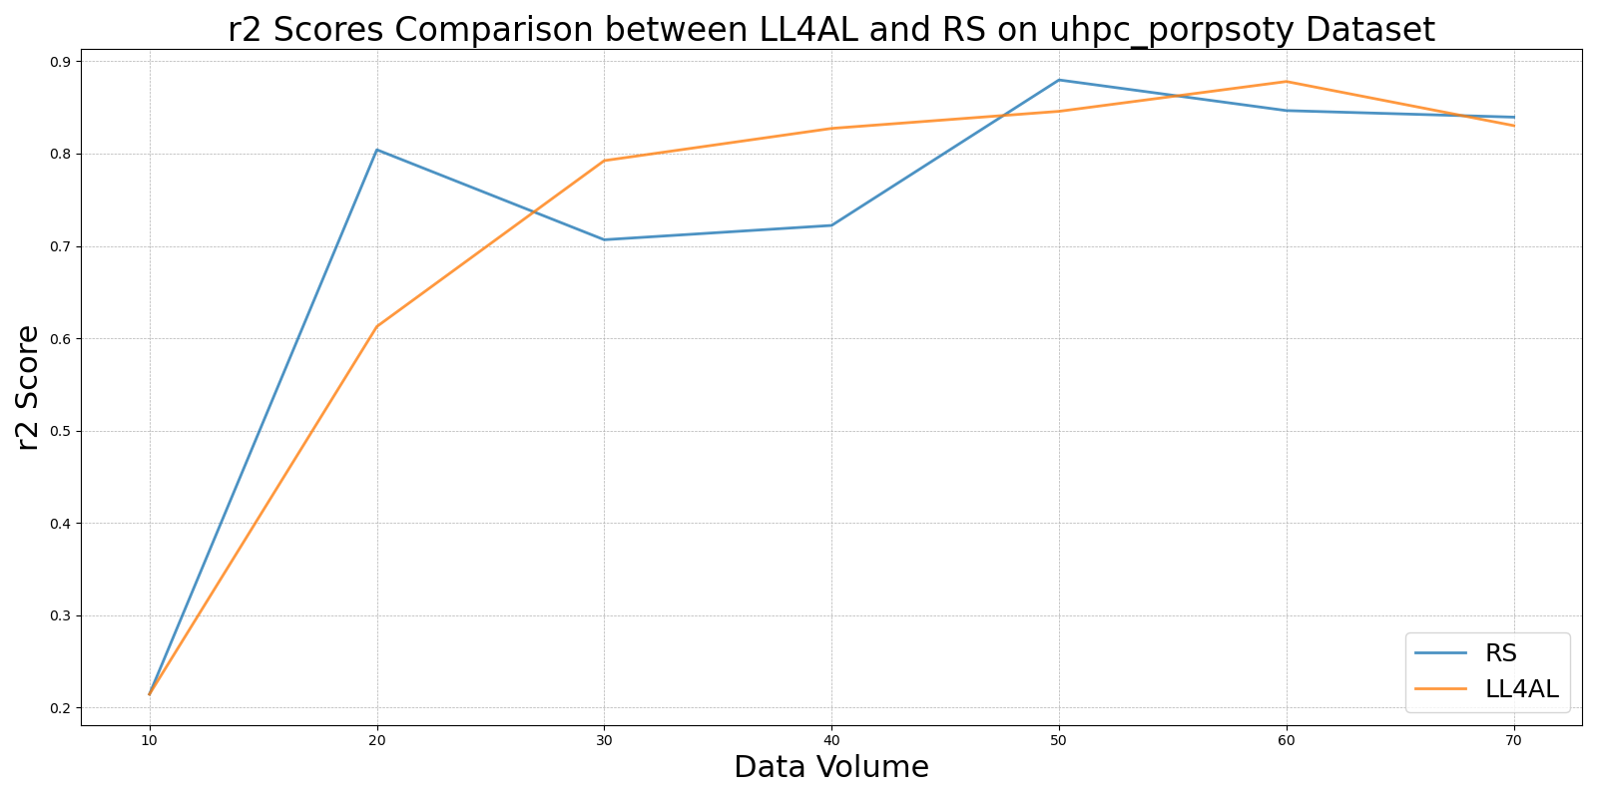

MCDvs_RS_on_uhpc_porpsoty.png

