R2 Samples Report for 3 Thresholds

|  |  |  |  |
| --- | --- | --- | --- |
| Strategy | R2 >= 0.6 | R2 >= 0.7 | R2 >= 0.8 |
| RS | 10 (1.36%) | 50 (6.81%) | 50 (6.81%) |
| LL4AL | 10 (1.36%) | 30 (4.08%) | 30 (4.08%) |
| LCMD | 10 (1.36%) | 20 (2.72%) | 20 (2.72%) |
| MCD | 10 (1.36%) | 90 (12.25%) | 100 (13.62%) |
| EGAL | 10 (1.36%) | 50 (6.81%) | 70 (9.53%) |
| BayesianAL | 10 (1.36%) | 260 (35.40%) | 400 (54.47%) |
| GSx | 10 (1.36%) | 20 (2.72%) | 20 (2.72%) |
| GSy | 10 (1.36%) | 30 (4.08%) | 30 (4.08%) |
| iGS | 10 (1.36%) | 20 (2.72%) | 20 (2.72%) |
| GSBAG | 10 (1.36%) | 20 (2.72%) | 20 (2.72%) |

All_Strategies_on_Pullout_ifss.png

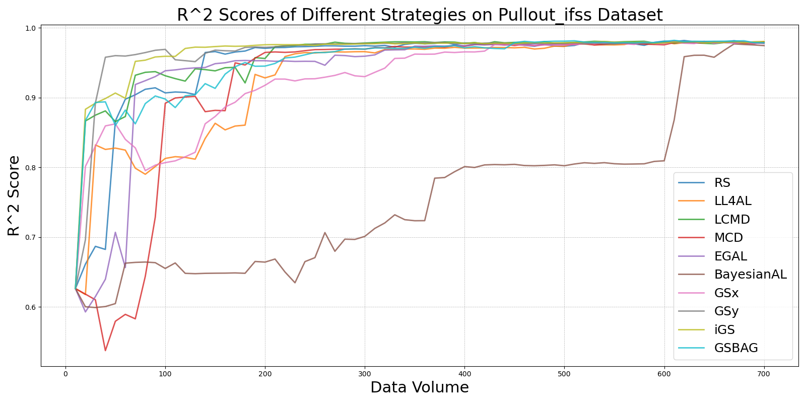

BayesianAL_vs_RS_on_Pullout_ifss.png

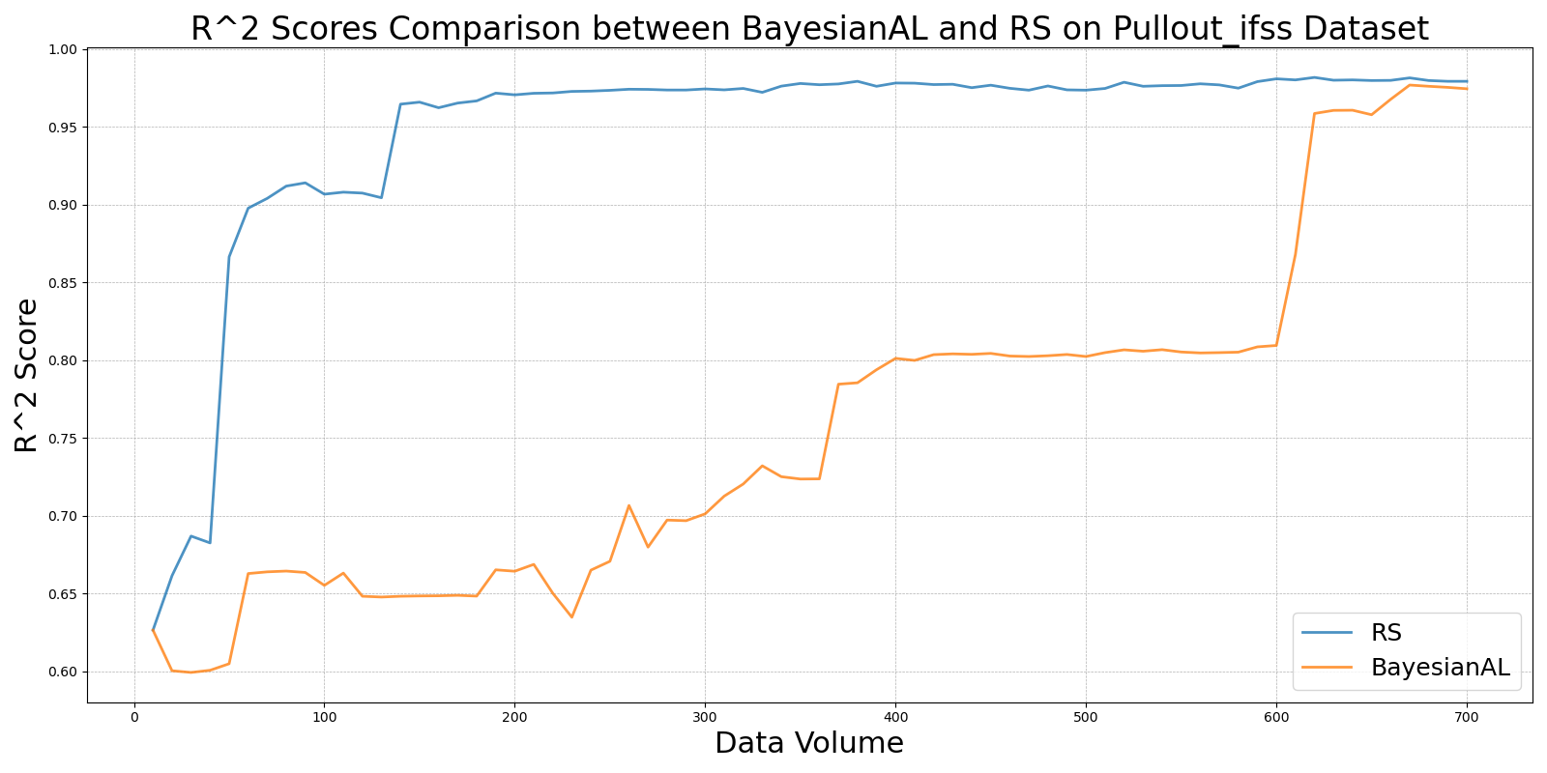

EGAL_vs_RS_on_Pullout_ifss.png

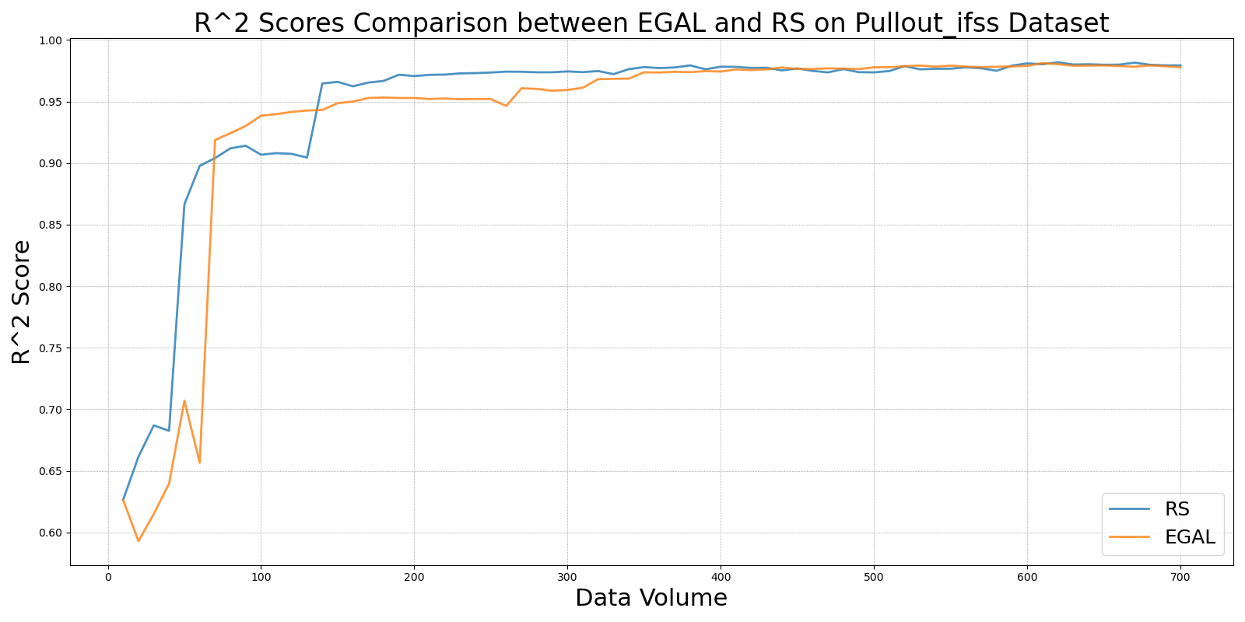

GSBAG_vs_RS_on_Pullout_ifss.png

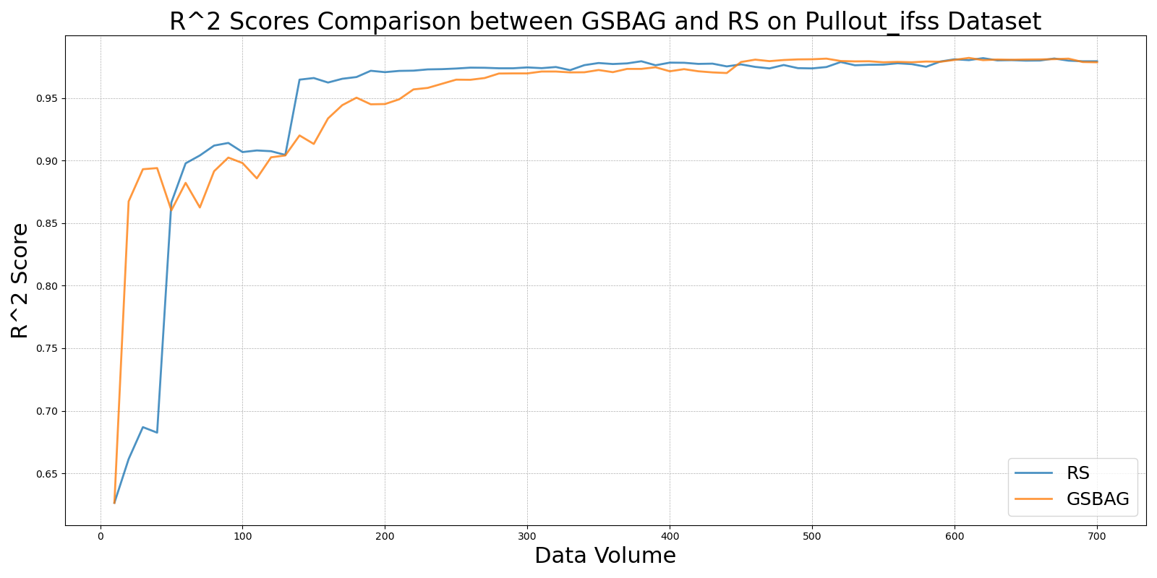

GSx_vs_RS_on_Pullout_ifss.png

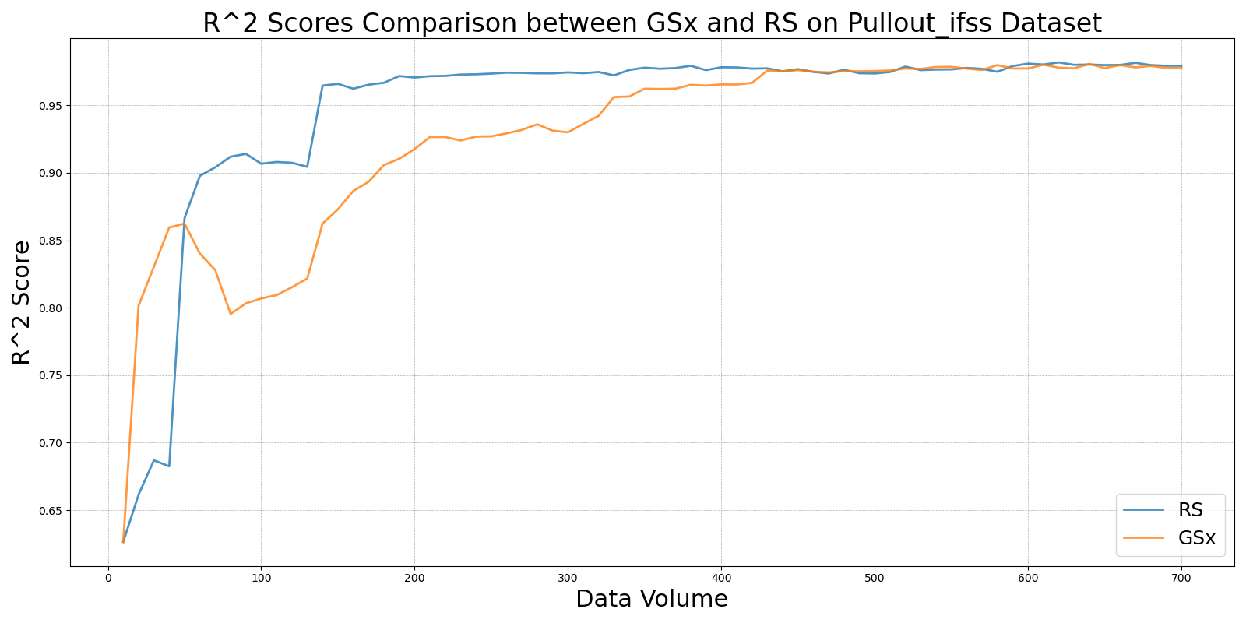

GSy_vs_RS_on_Pullout_ifss.png

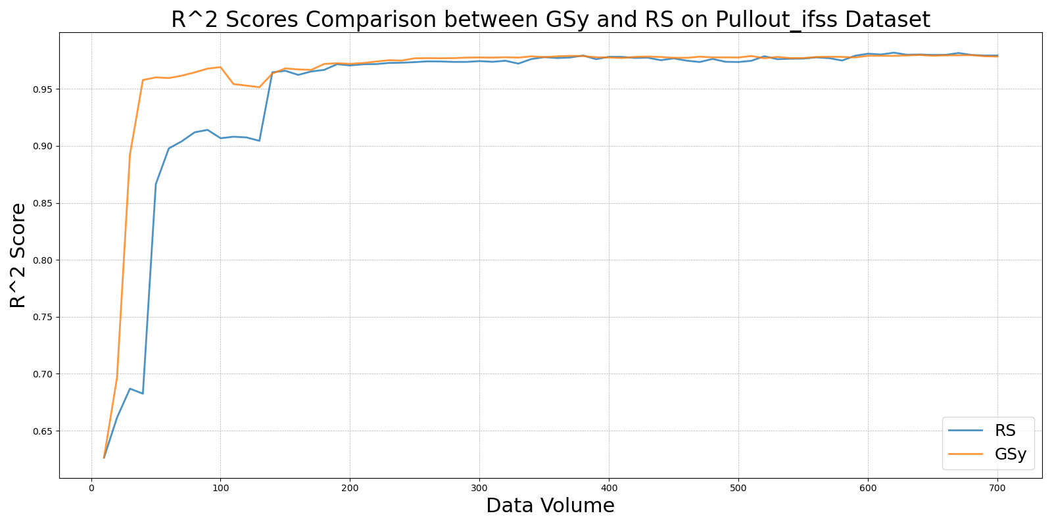

iGS_vs_RS_on_Pullout_ifss.png

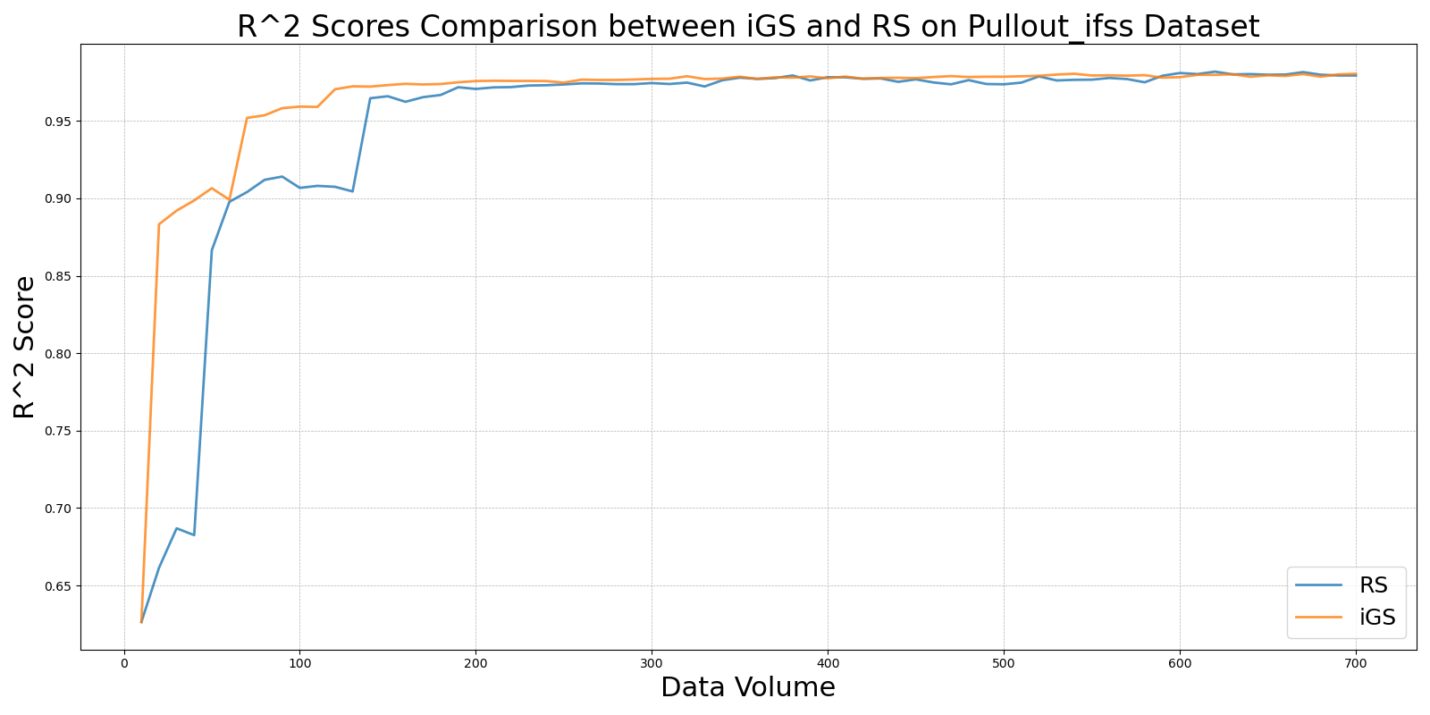

LCMD_vs_RS_on_Pullout_ifss.png

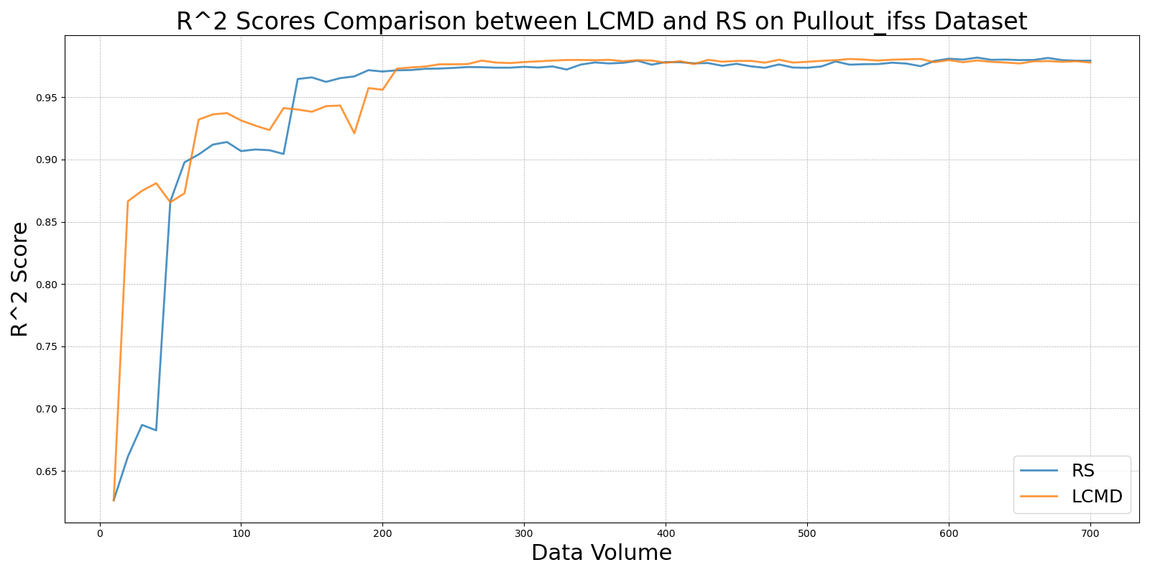

LL4AL_vs_RS_on_Pullout_ifss.png

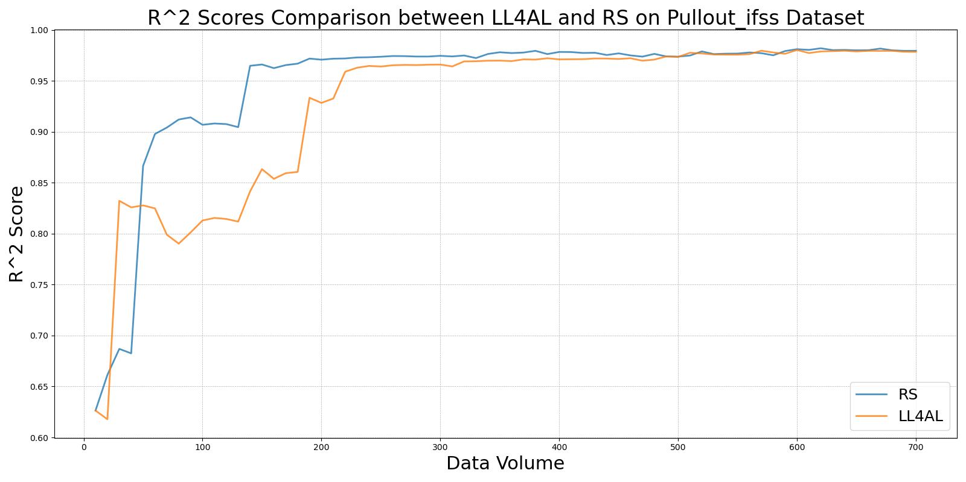

MCD_vs_RS_on_Pullout_ifss.png

