R2 Samples Report for 3 Thresholds

|  |  |  |  |
| --- | --- | --- | --- |
| Strategy | R2 >= 0.6 | R2 >= 0.7 | R2 >= 0.8 |
| RS | 50 (6.07%) | 70 (8.50%) | 170 (20.63%) |
| LL4AL | 80 (9.71%) | 130 (15.78%) | 330 (40.05%) |
| LCMD | 50 (6.07%) | 60 (7.28%) | 180 (21.84%) |
| MCD | 70 (8.50%) | 80 (9.71%) | 210 (25.49%) |
| EGAL | 40 (4.85%) | 60 (7.28%) | 130 (15.78%) |
| BayesianAL | 60 (7.28%) | 80 (9.71%) | 140 (16.99%) |
| GSx | 50 (6.07%) | 100 (12.14%) | 190 (23.06%) |
| GSy | 70 (8.50%) | 120 (14.56%) | 150 (18.20%) |
| iGS | 50 (6.07%) | 100 (12.14%) | 170 (20.63%) |
| GSBAG | 40 (4.85%) | 40 (4.85%) | 160 (19.42%) |

All_Strategies_on_UCI_concrete.png

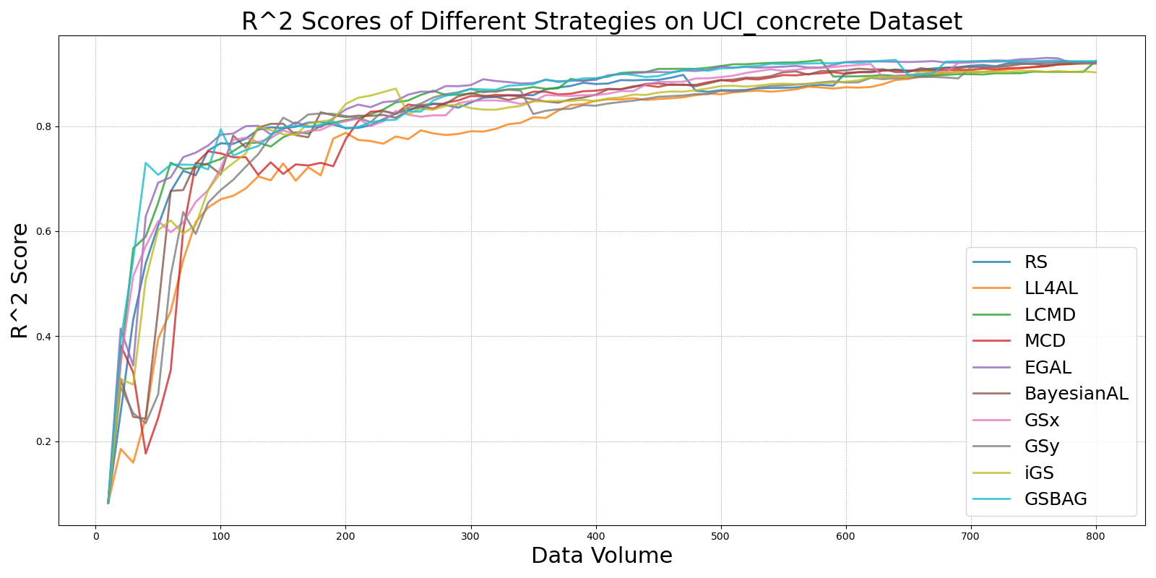

BayesianAL_vs_RS_on_UCI_concrete.png

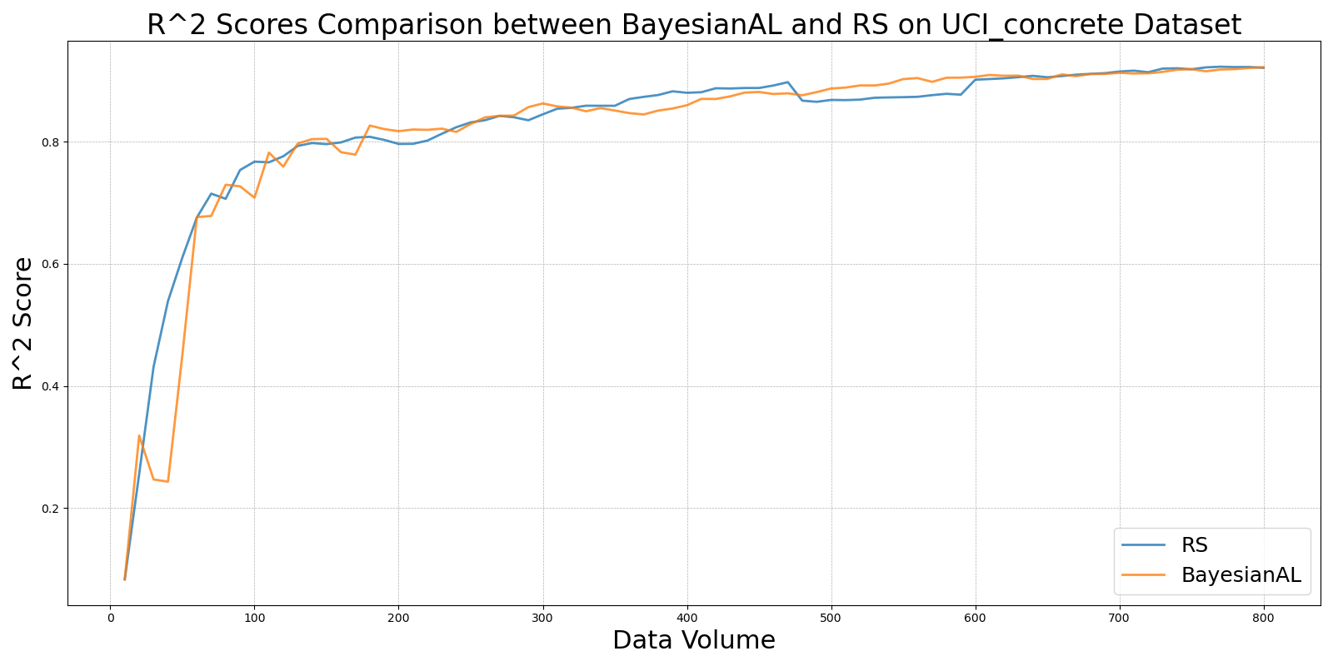

EGAL_vs_RS_on_UCI_concrete.png

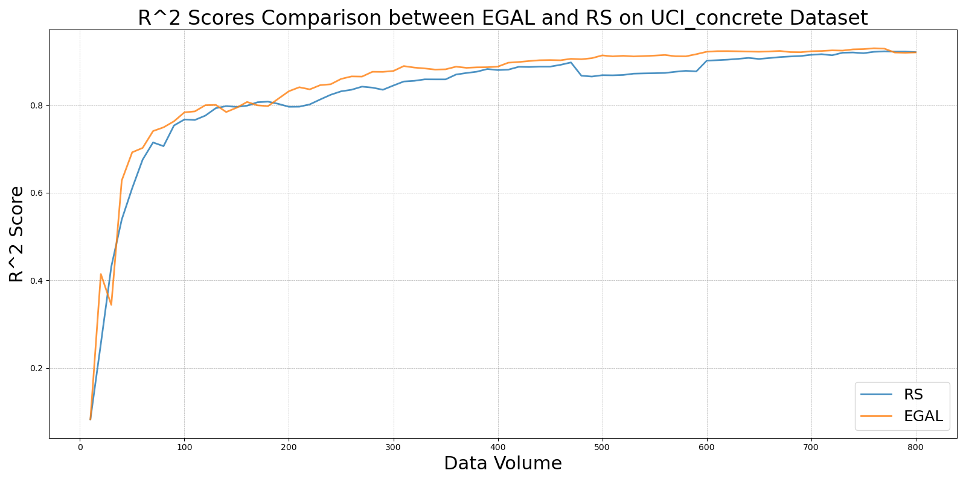

GSBAG_vs_RS_on_UCI_concrete.png

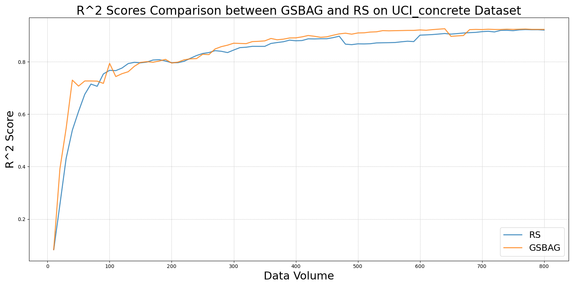

GSx_vs_RS_on_UCI_concrete.png

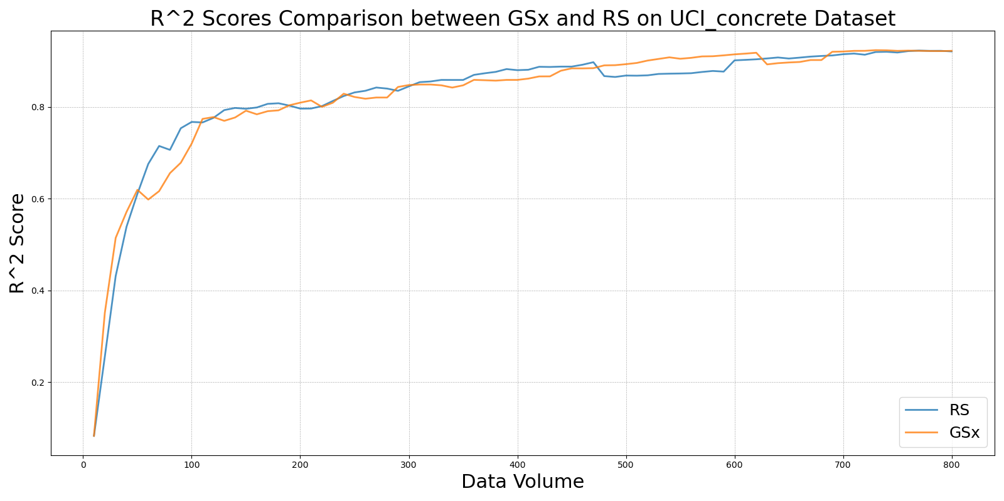

GSy_vs_RS_on_UCI_concrete.png

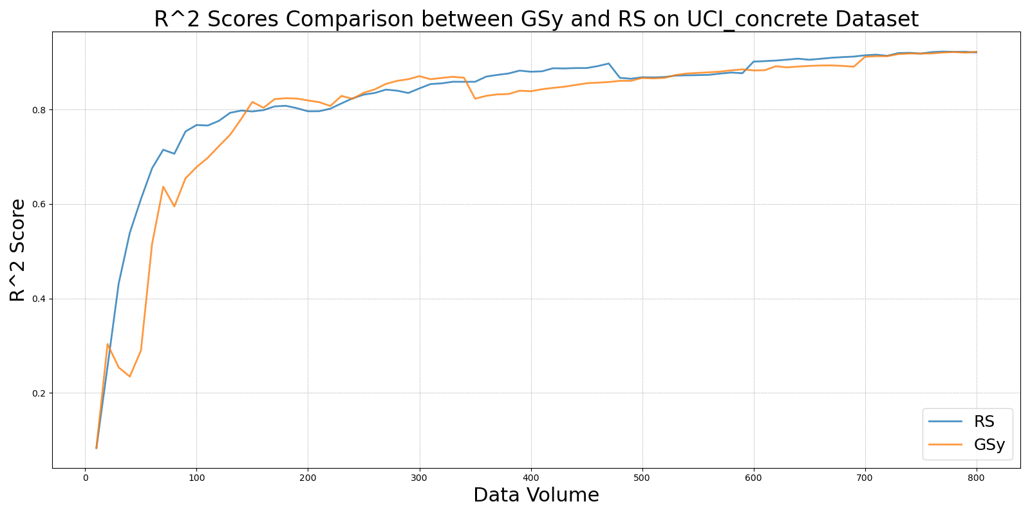

iGS_vs_RS_on_UCI_concrete.png

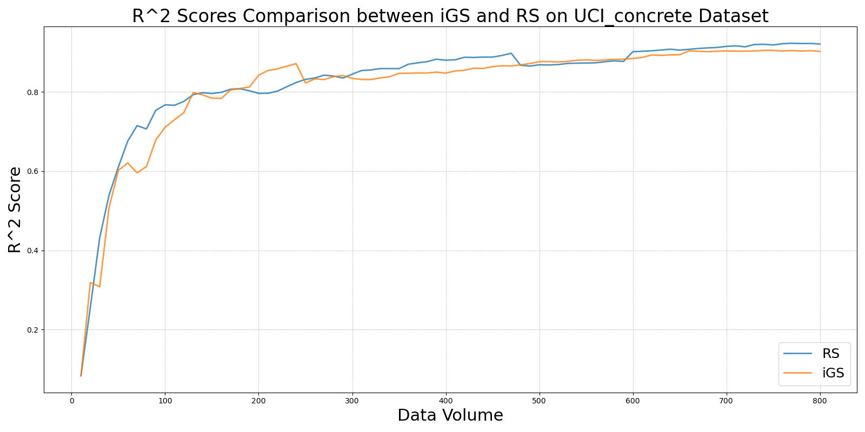

LCMD_vs_RS_on_UCI_concrete.png

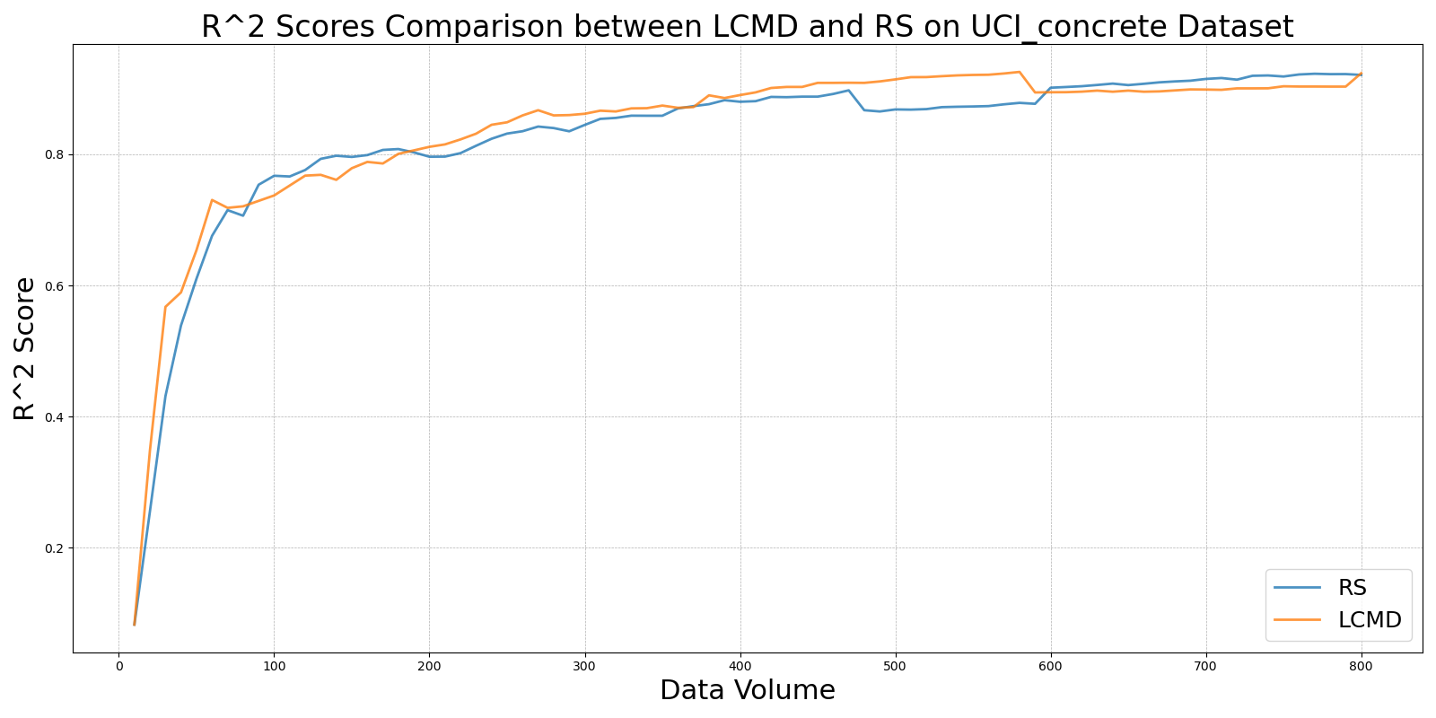

LL4AL_vs_RS_on_UCI_concrete.png

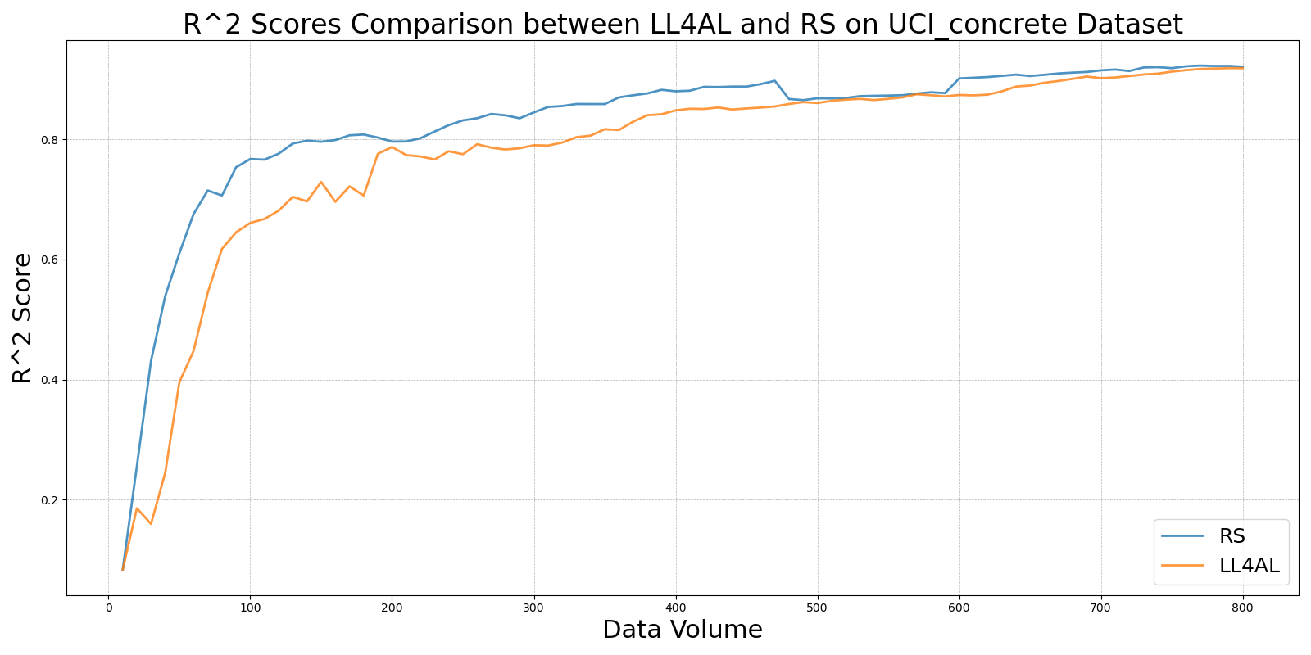

MCD_vs_RS_on_UCI_concrete.png

