R2 Samples Report for 3 Thresholds

|  |  |  |  |
| --- | --- | --- | --- |
| Strategy | R2 >= 0.6 | R2 >= 0.7 | R2 >= 0.8 |
| RS | 80 (26.39%) | 140 (46.17%) | 240 (79.16%) |
| LL4AL | 260 (85.75%) | 290 (95.65%) | N/A |
| LCMD | 100 (32.98%) | 130 (42.88%) | N/A |
| MCD | 110 (36.28%) | 200 (65.96%) | N/A |
| EGAL | 160 (52.77%) | 170 (56.07%) | 250 (82.45%) |
| BayesianAL | 210 (69.26%) | 230 (75.86%) | N/A |
| GSx | 140 (46.17%) | 170 (56.07%) | N/A |
| GSy | 70 (23.09%) | 120 (39.58%) | N/A |
| iGS | 110 (36.28%) | 130 (42.88%) | 220 (72.56%) |
| GSBAG | 190 (62.66%) | 230 (75.86%) | N/A |

All_Strategies_on_UHPC_cs.png

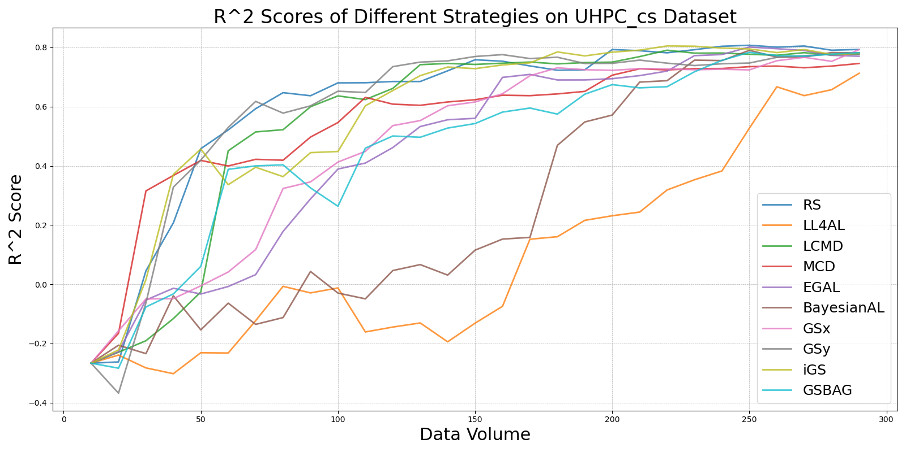

BayesianAL_vs_RS_on_UHPC_cs.png

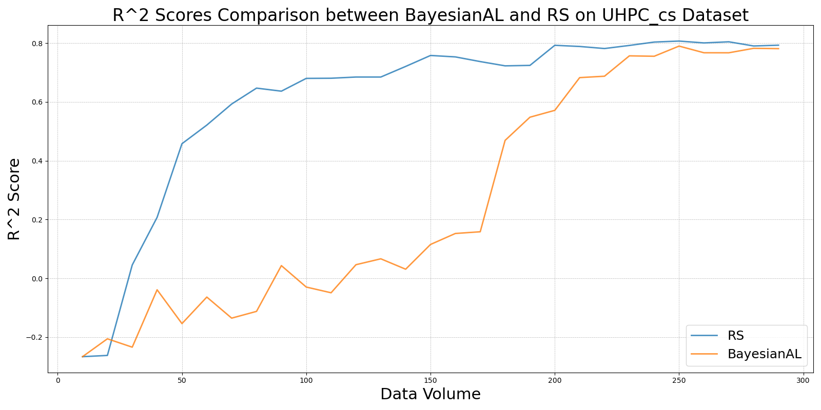

EGAL_vs_RS_on_UHPC_cs.png

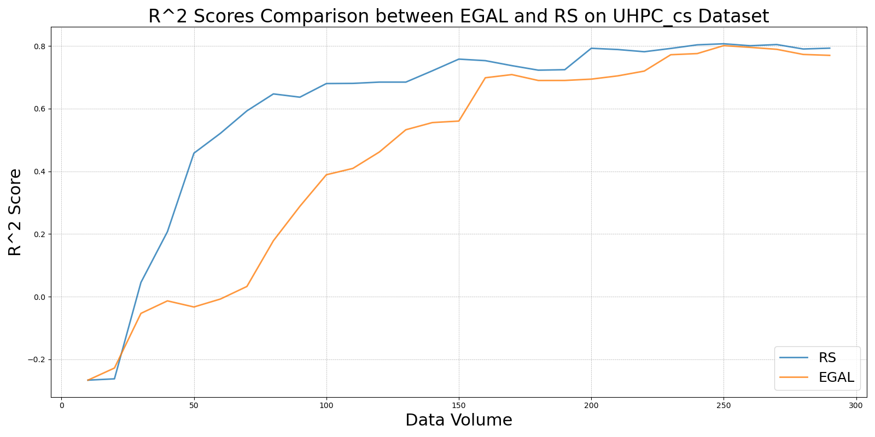

GSBAG_vs_RS_on_UHPC_cs.png

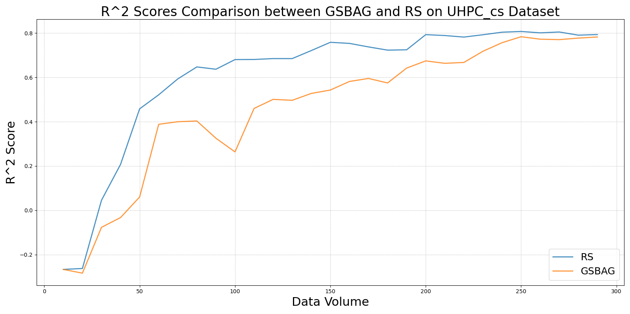

GSx_vs_RS_on_UHPC_cs.png

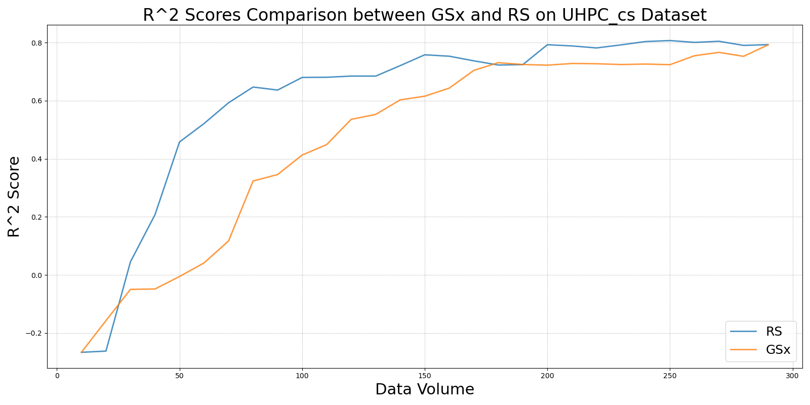

GSy_vs_RS_on_UHPC_cs.png

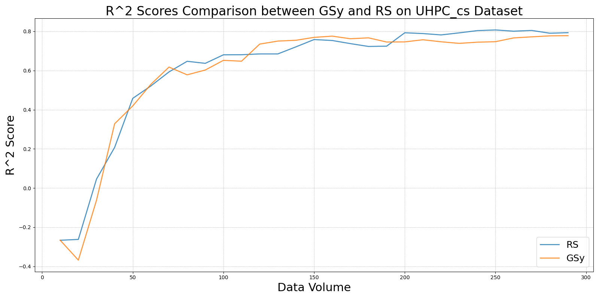

iGS_vs_RS_on_UHPC_cs.png

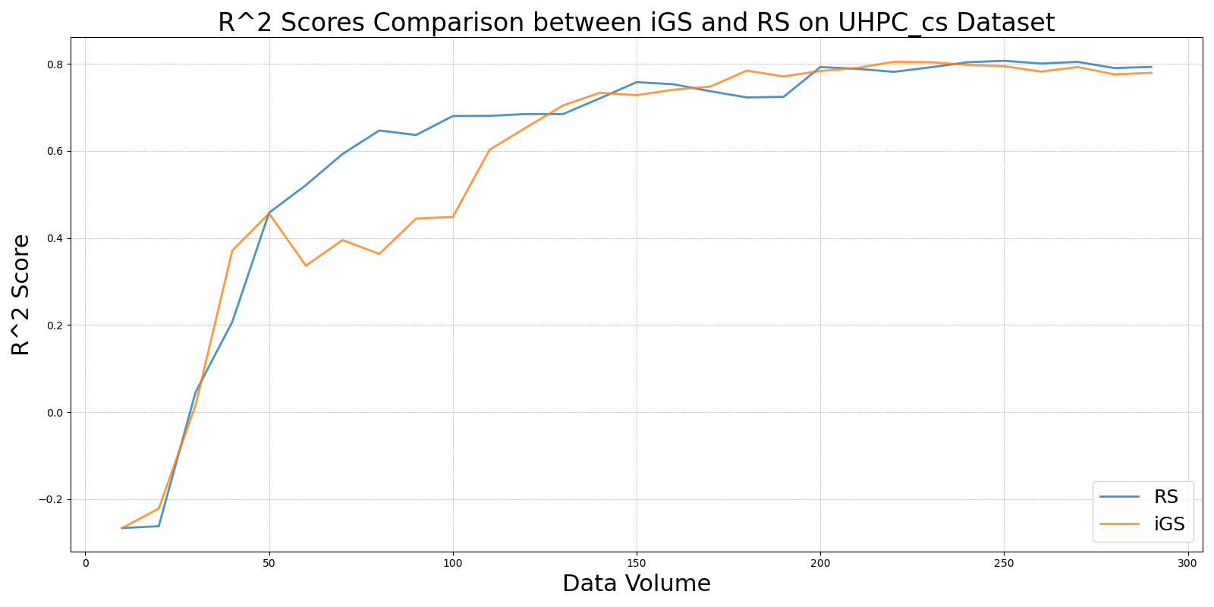

LCMD_vs_RS_on_UHPC_cs.png

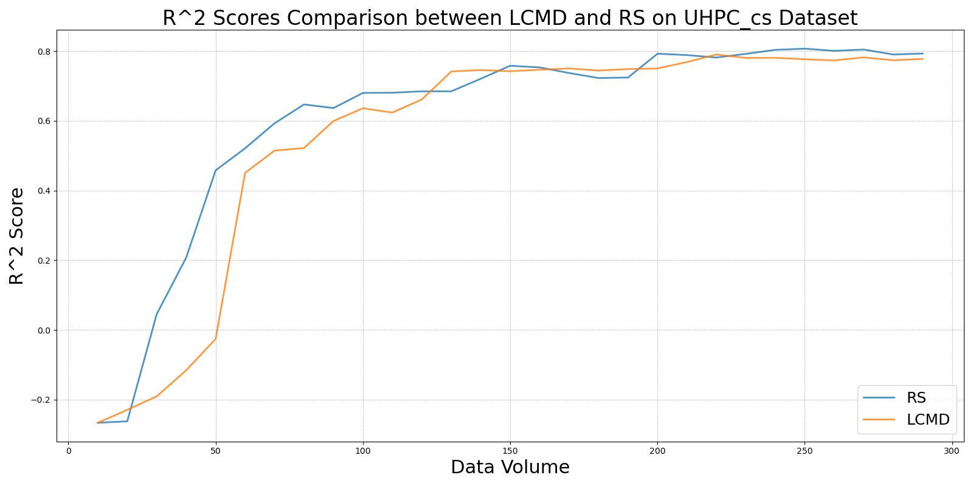

LL4AL_vs_RS_on_UHPC_cs.png

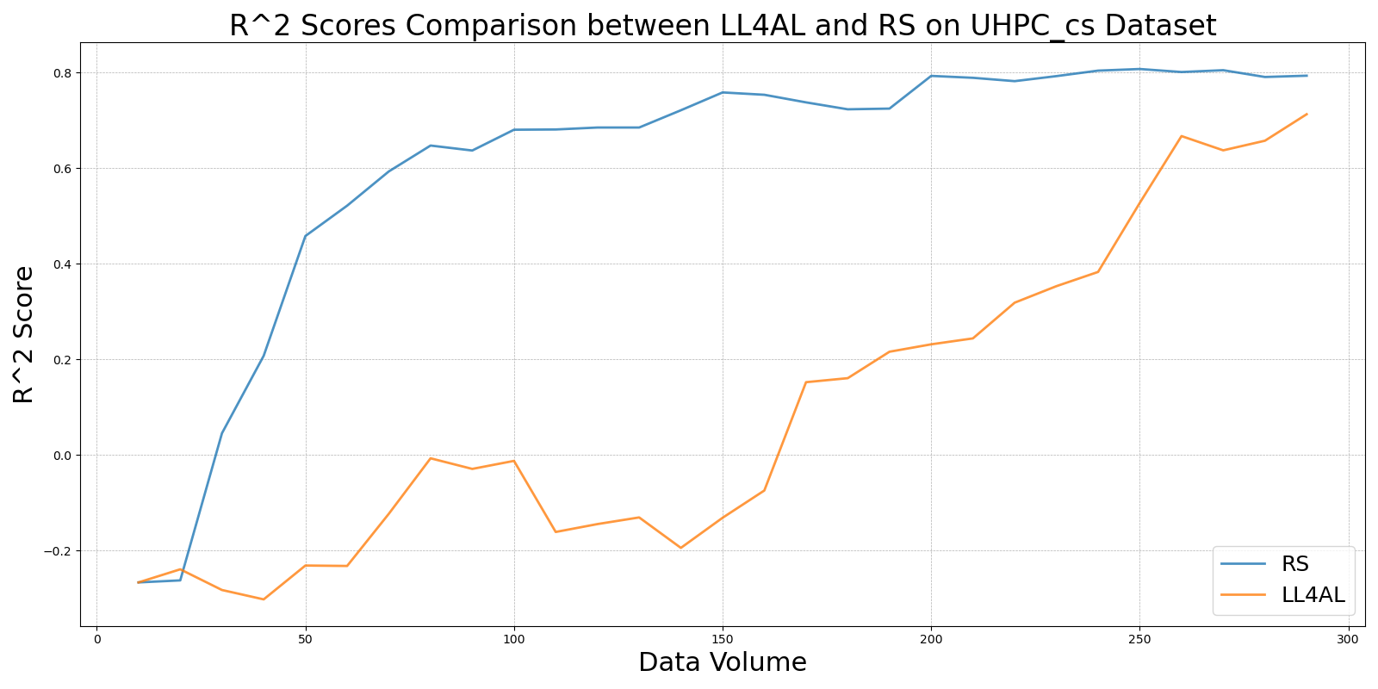

MCD_vs_RS_on_UHPC_cs.png

