**Crypto portfolio**

**literal review + a look at the paper**

**Hence, in this paper we examine questions associated with previous research:**

1) 加密货币投资组合能否盈利

Are cryptocurrency portfolios profitable compared to traditional financial asset classes? We evaluate the performance of portfolios of cryptocurrencies factors relative to conventional financial asset classes such as stocks, bonds, treasury bills, and a cryptocurrency index.

2) 有无指标分析表现 （高度非正态分布）

Is there a proper metric to compare the performances of different underlying assets? Because the empirical distributions of cryptocurrency returns are highly non-normal, this has limited the number of researchers who have examined the risk factors and analysed cryptocurrencies' performances. → 使用ASD

3) 若能超额收益，长短腿哪一个有助于

If outperformance of cryptocurrency exists, do long leg or short leg of cryptocurrency factor portfolios contribute to outperformance? →长腿（long-short strategies）

4) 超额收益是否源于风险溢价或错误定价

Does any outperformance of cryptocurrency factor portfolios come from risk premium or mispricing? → 错误定价，因为α significant但R2很小

5) 是否能用错误定价引子+基本引子+三因素模型来解释outperforming

Can outperforming cryptocurrency factor portfolios be accurately explained by adding mispriced factors and cryptocurrency fundamental factors to a coin market three-factor model? → 加入四个错误定价引子+electricity and computing power，α significant但R2很小，仍然为错误定价

**To fill this gap,**

we examine the performance of cryptocurrency portfolios based on different risk factors by conducting almost stochastic dominance (ASD) proposed by Leshno and Levy (2002) on the 400 largest cryptocurrencies, which account for over 80% of total market capitalization.

对占总市值 80% 以上的 400 种最大的加密货币进行了**近似随机优势（ASD）**分析，从而考察了基于不同风险因素的加密货币投资组合的表现

因为 1）传统均值方差法不适用 2）消除投资者极端偏好的影响

→ ASD is a non-parametric method

which **compares two uncertain prospects** by maximizing expected utility, and **does not require any assumption** about the return distribution.

Inspired by Fama and French (1993), Carhart (1997), Liu et al. (2019) and Feng et al. (2020), we divide the available factors information into four categories: size, momentum, volume and volatility. We sub-divide the four large categories into 27 factor portfolios (see Table 3) to study whether cryptocurrencies share similarities with stocks regarding anomalies and examine each factor's relative performance against selected benchmarks.

通过多个模型启发，将四大类衡量加密货币的因素规模、动量、交易量和波动率细分为27个因子组合，研究在anomalies是否与股票相似

**2. Related Literature**

**2.2 Almost Stochastic Dominance**

[1] Bali, T.G., Demirtas, K.O., Levy, H. and Wolf, A., 2009. Bonds versus stocks: Investors’ age

and risk taking. *Journal of Monetary Economics,* 56(6), pp. 817-830.

Almost stochastic dominance (ASD) and almost mean–variance (AMV) approaches are used to examine the dominance of stock and bond portfolios. ASD and AMV rules unambiguously support the popular practice of **advising higher stock to bond ratio for long investment horizons. *using ASD find when people ages, they should buy more stocks**

[2] Levy, H. and Levy, M., 2019. Stocks versus Bonds and the Investment Horizon. *Available at*

*SSRN 3458828*.

We employ the distribution-free First-degree Stochastic Dominance with a Riskless asset (FSDR) criterion to compare stocks to bonds for various investment horizons. We find that for any horizon greater than 3 years, stocks dominate bonds by FSDR. This implies that for any combination of bonds with the risk-free asset (TIPS), there exists a combination of stocks with TIPS that dominates it for any investor with non-decreasing preferences. Hence, the dominance of stocks over bonds for the long-run holds not only for all expected

utility maximizers, but for all Prospect Theory investors as well.

**\*The same result as Bali (2009)**

[3] Post, T., 2003. Empirical tests for stochastic dominance efficiency. *Journal of Finance,* 58(5),

pp. 1905-1931.

Using our tests, the Fama and French market portfolio is significantly inefficient relative to benchmark portfolios formed on market capitalization and book-to-market equity ratio.

**\* SSD (Second-Order Stochastic Dominance) is better than Fama-French**

[4] Board, J.L. and Sutcliffe, C.M., 1994. Estimation methods in portfolio selection and the

effectiveness of short sales restrictions: UK evidence. *Management Science,* 40(4), pp. 516-

534.

[5] Bali, T.G., Brown, S.J. and Demirtas, K.O., 2013. Do hedge funds outperform stocks and bonds? *Management Science,* 59(8), pp. 1887-1903.

Hedge funds employ a wide variety of dynamic trading strategies, and make extensive use of derivatives, short selling, and leverage.

The article uses both classic and ASD rules to find dominance and because the return distribution of hedge fund portfolios as well as the distribution of equity and bond returns exhibit significant departures from normality, the classical selection rules do not provide an appropriate framework to explain investors’ preferences. But ASD works and it does not require a parametric specification of investors’ preferences and does not make any assumptions about asset returns.

The results indicate that popular hedge fund strategies (long/short equity hedge and emerging markets) outperform the U.S. equity market. However, the remaining nine hedge fund strategies considered in this paper do not generate superior performance over the S&P 500 index. **\*in the hedge funds to SP500, ASD works better than classic**

**Conclusion: ASD is good when modeling not normal, but no strategies**

**2.3 Long/Short Legs of Zero-Investment Portfolios**

[1] Israel, R. and Moskowitz, T.J., 2013. The role of shorting, firm size, and time on market

anomalies. *Journal of Financial Economics,* 108(2), pp. 275-301.

Long positions make up almost all of size, 60% of value, and half of momentum profits. Shorting becomes less important for momentum and more important for value as firm size decreases. The value premium decreases with firm size and is weak among the largest stocks. Momentum profits, however, exhibit no reliable relation with size.

Find no evidence that shorting profits are more important for momentum.

Overall, the premium for momentum, whether long-short or long-only, appears to be consistently higher than that of value, especially among large cap stocks in which the value premium is weakest. **\* Long is better**

[2] Blitz, D., Baltussen, G. and van Vliet, P., 2019. When Equity Factors Drop Their Shorts.

*Available at SSRN 3493305*.

Standard academic factor portfolios take hypothetical long positions in stocks with attractive characteristics and combine them with short positions in stocks with unattractive characteristics. Therefore, factor premiums can be disentangled into a long-leg premium and a short-leg premium. We found that factor premiums originate in both legs but are typically stronger on the long side. **\* Long is better**

[3] Frazzini, A. and Pedersen, L.H., 2014. Betting against beta. *Journal of Financial Economics,*

111(1), pp. 1-25.

Portfolios of high-beta assets have lower alphas and Sharpe ratios than portfolios of low-beta assets.

[4] Barroso, P. and Santa-Clara, P., 2015. Momentum has its moments. *Journal of Financial*

*Economics,* 116(1), pp. 111-120.

**Momentum** has offered investors the highest Sharpe ratio while it has also had the worst crashes. However, it can be predicted and managing the risk of momentum leads to substantial economic gains.

Scaling the portfolio to have constant volatility over time is a more natural way of implementing the strategy than having a constant amount in the long and short leg with varying volatility. **\* Use and study about long-short legs**

[5] Daniel, K. and Moskowitz, T.J., 2016. Momentum crashes. *Journal of Financial Economics,*

122(2), pp. 221-247.

Also the **momentum** predicting.

A momentum strategy is a bet on past returns predicting the cross section of future returns, typically implemented by buying past winners and selling past losers.

**Conclusion: Factor premiums originate stronger on the long side.**

**4. Methodology**

mean-variance and normal stochastic dominance没有办法解决dominance问题因为必须得𝜇 > 𝜇 and 𝜎 < 𝜎 同时满足，然而微小的𝜎劣势和巨大的𝜇优势的情况下并无法得出dominate的结论，因此使用Stochastic Dominance

**1. First-Order Stochastic Dominance.**

累积分布CDF ( 即F(X) )

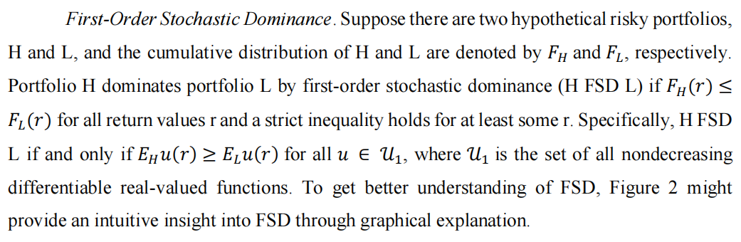其中，r为return， F(r)为cumulative probability，当H一直在L下边时，Portfolio H dominates portfolio L by first-order stochastic dominance (H FSD L)

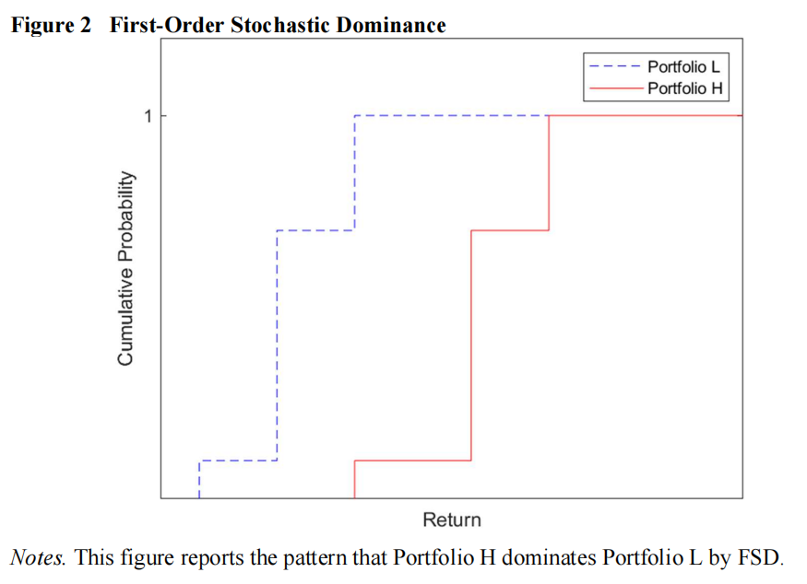不过这种FSD的情况很少见所以我们会出现SSD.

2. Second-Order Stochastic Dominance.

This violation area that break the FSD rule that portfolio H dominates portfolio L if portfolio H plots below the portfolio L for every given return r.

However, there might exist SSD according to the SSD proposition, because SSD examines the dominance regard to the area that enclosed by cumulative distributions of two portfolios, which is more tolerant than that of FSD that only compares the value of cumulative distributions. 因为SSD考察了两个投资组合的**累积分布包围的区域的主导地位**，这比只比较累积分布值的FSD更宽容。

If portfolio H SSD L, such condition 𝒂 ≥ 𝒃 must be held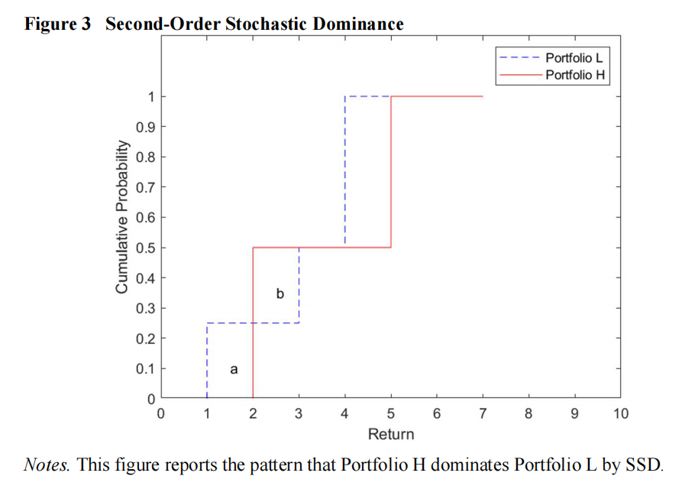.

若a≥b，虽然在[2,3]的时候H在L之上，仍然在[0,2]的时候在L之下且面积小于在之上的。

Additionally, if the first point of portfolio H prior to that of portfolio L (the minimum value of portfolio H is smaller than that of portfolio L) that

produces negative area by the SSD formula, then no matter how big the positive area after their first intersection, there would not be SSD because it violates the condition that ∫ିஶ ௥ [𝐹௅ (𝑠) − 𝐹ு (𝑠)]𝑑𝑠 ≥ 0 in the interval.

然而要注意，一开始的H必须要在L之下，而后面不管有多少变化都是如此

Nevertheless, portfolio H might fail to dominate L if area of b is slightly bigger than a no matter how big the positive area in the following part, and this is the reason why this paper conducts almost stochastic dominance, to avoid such an economically irrational selection.

简单来说就是第一个interval中，H必须在L之下，第二个interval中允许H在L之上，但次面积必须小于第一个interval中H在L之下的面积，否则之后再多H在L之下的面积都不顶用。

3. Almost Stochastic Dominance

尽管现实世界中大多数投资者会偏好一种资产而不是另一种资产，但由于一些极端的效用函数只违反了这些规则的一小部分，随机规则无法解释这种偏好。几乎随机支配（ASD）为解决这类问题提供了一种更为现实的情形。

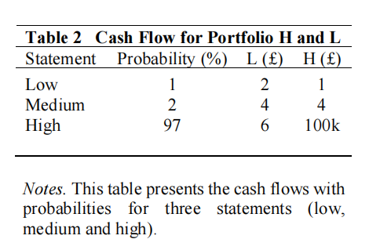在很小的probability的情况下L比H的return多，然而在更多情况下H比L多

1）Almost First-Order Stochastic Dominance (AFSD)

Almost First-Order Stochastic Dominance (AFSD) might solve the problem of a pathological utility function by excluding a few extreme utility functions and examining whether the small violation of FSD can be ‘ignored’. 和FSD类似，但是允许一些小冲突

显然在这张图中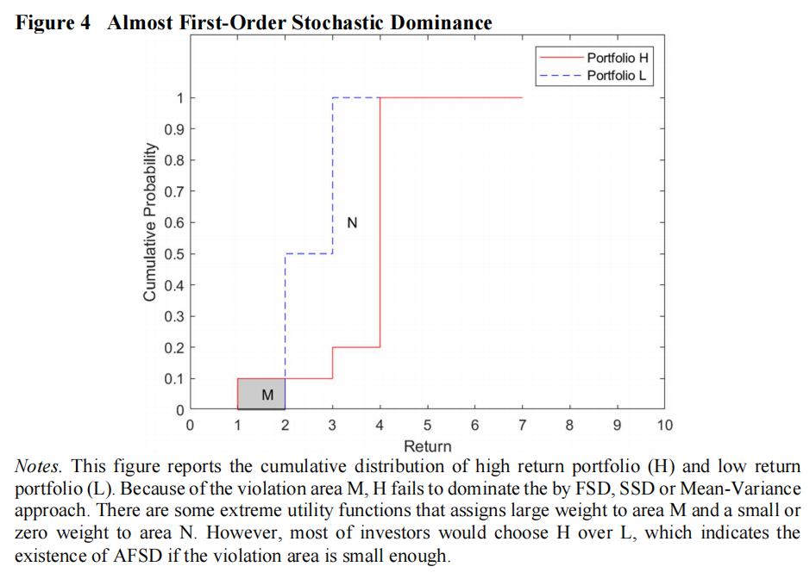 1）对于FSD，H并不一直在L下，不成立 2）对于SSD，第一个区间[1,2]中，H在L上，也不成立

其中M的范围表现为：

而𝜀1则为M/(M+N)的范围

虽然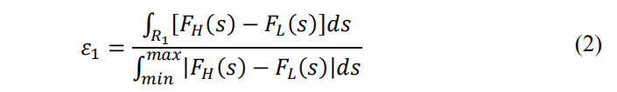M的出现导致了FSD的不成立，但若M部分足够小，仍然可以忽视

the violation area could be ‘ignored’ if 𝜀1 is smaller or equal than 5.9%

**对crypto进行检验：**

首先要先忽视M部分，看看剩下的是否符合FSD，才能去test CDF是否符合AFSD

The precondition to test AFSD is the cumulative distribution should be in traditional sense of FSD. In other words, firstly, ignoring the violation area and evaluating whether the rest part of CDF has a traditional sense of FSD; secondly, continue the test if the CDF meets the precondition.

H为红色-portfolio L为蓝色-stock/bond/rf

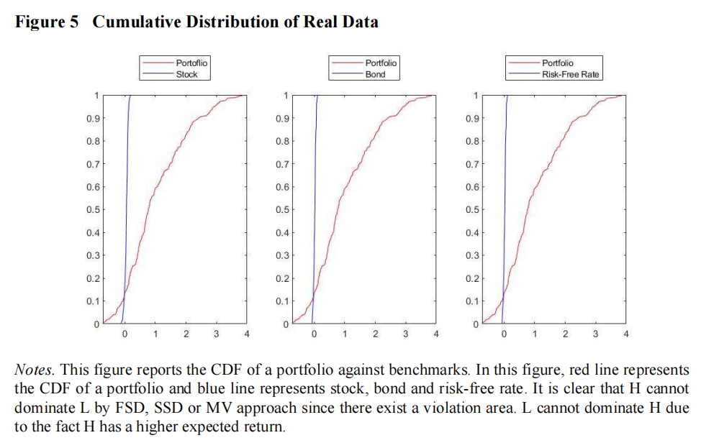

1.不符合FSD

2.不符合ASD，第一个区间H在L上

3.不符合传统MV

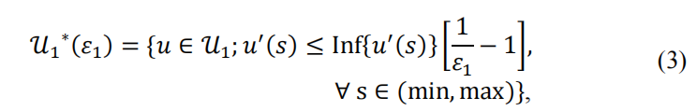4.有可能符合AFSD，若第一个区间the violation area足够小

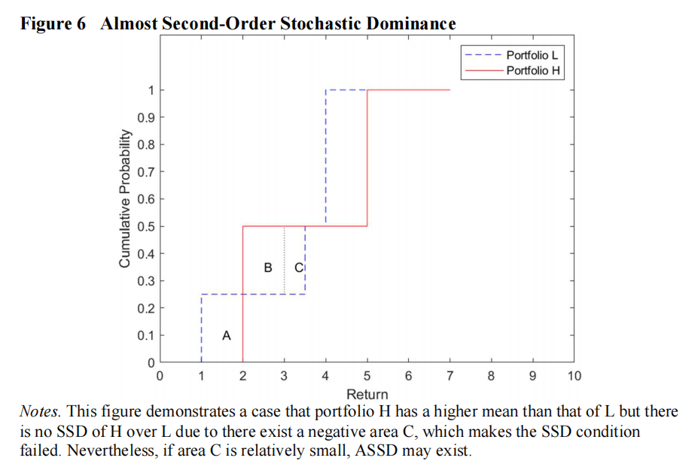2）**Almost Second-Order Stochastic Dominance (ASSD)**

首先，第一个区间中，H必须在L下，即A>0

其次，在第二个区间中，A<B+C，因此不符合SSD

The range of SSD violation area (C in this paper) could be defined as

Also, the empirical ASSD violation area 𝜀ଶ may be defined by

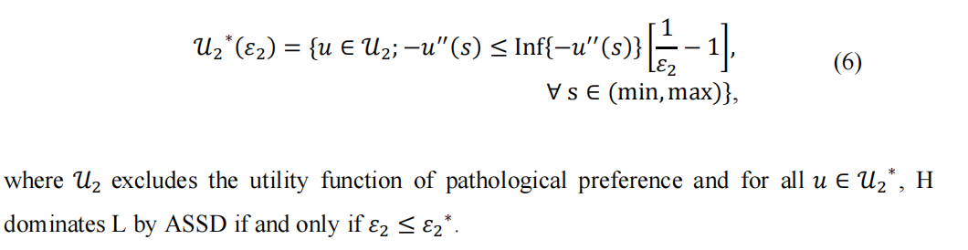the threshold value 𝜀2 ∗ of ASSD is 3.2%

Hence, in this paper, **the violation area for ASSD** would be same as that of AFSD but

needs to **be compared with a lower critical value of 3.2%** because **ASSD/SSD focuses on risk averters**, which is developed by Levy et al

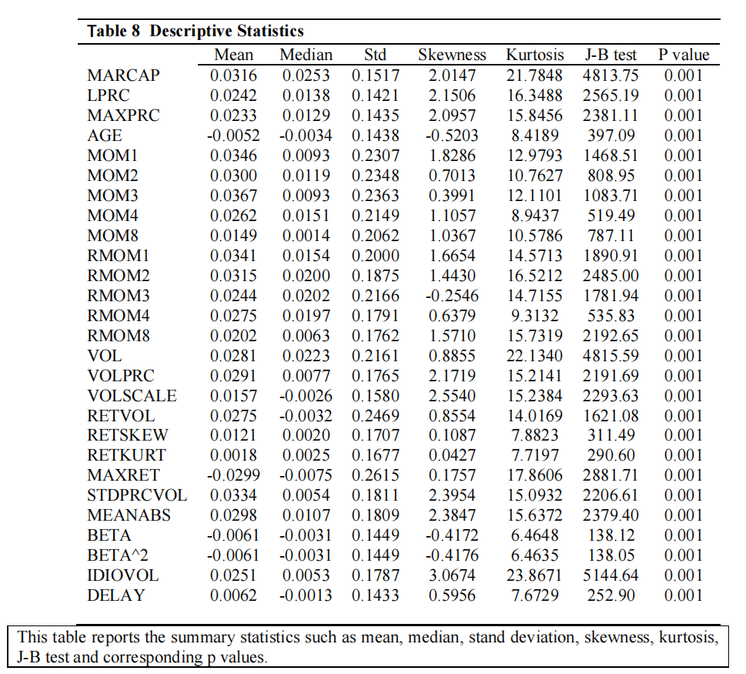**5. Factor portfolio**

**Size-Related Portfolios+ Momentum-Related Portfolios+ Volume-Related Portfolios+ Volatility-Related Portfolios**

**6. Empirical Analysis**

In this section, we analyze the empirical result of AFSD, ASSD and decomposition of

zero-investment for 4-week, 13-week, 26-week, 52-week and 78-week horizon portfolios

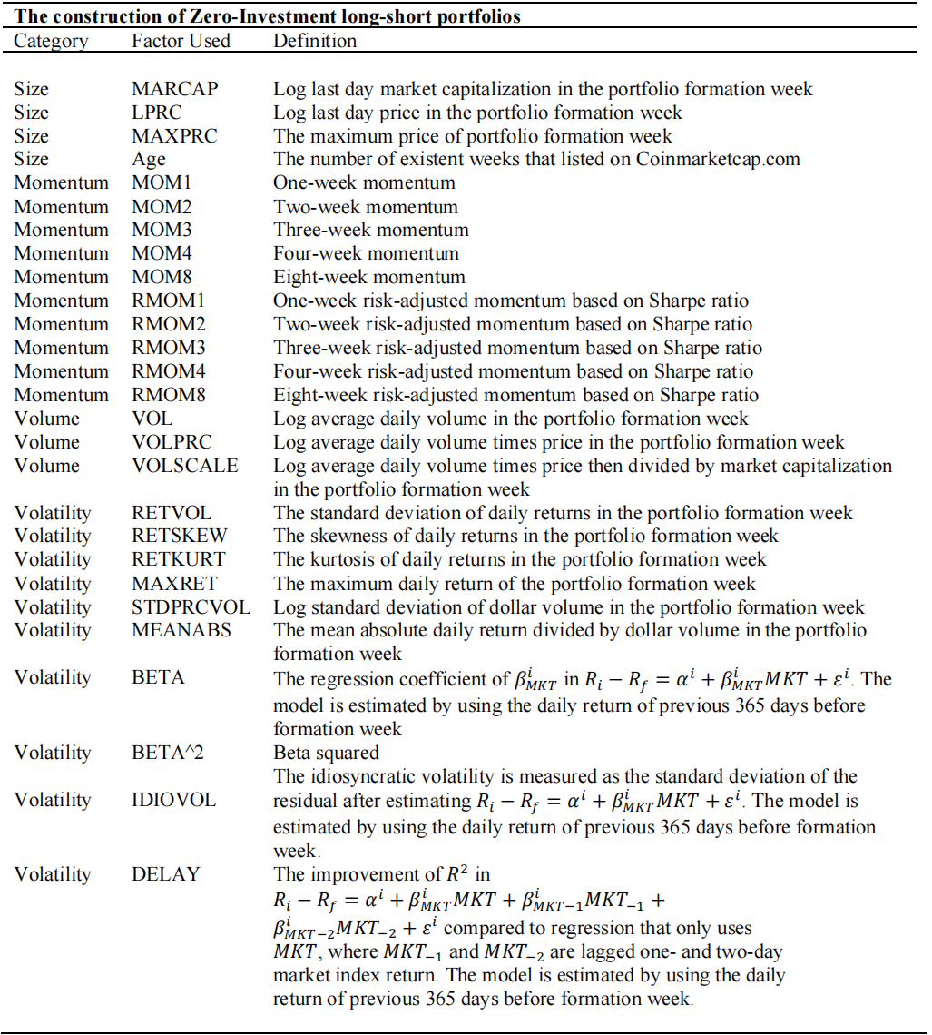based on factors listed in Table 3.

分别计算对这27个计算了4-week, 13-week, 26-week, 52-week and 78-week AFSD和ASSD的violence area

For AFSD, 𝜀1≤5.9%， For ASSD, 𝜀2≤3.2%

随后对Long-leg and short-leg再次分别计算，得到各自的𝜀1 𝜀2

**6.4 Regression Analysis**

We have discovered **nine outperforming portfolios** by conducting almost stochastic dominance. In this section, we decide to investigate whether cross-sectional return of nine dominant portfolios **can be explained by applying the coin market three factor model** of Liu et al. (2019).

We start with construction of three factors. The three-factor model is inspired by the

Fama-French three factor model, and the three factors are cryptocurrency market, size and momentum. The formation of cryptocurrency market excess is discussed in Section 2. For size factor, we sort the coins into three size groups by market capitalization: bottom 30 percent (small group, S), middle 40 percent (middle group, M) and top 30 percent (big group, B). We then form value-weighted portfolios for each of three groups, and the cryptocurrency size factor (CSMB) is the return on small group minus that on big group.

