README file for the second task of COMP3421 Assignment 1

Content:

1. Instruction:

Student Name: Yuanjing Shi

Student ID: 13104584d

My Break Out game for elders got two special considerations for its corresponding focus group. They are 1. Multi-language support and 2. Real Dual-player mode.

Manual:

* Single Mode/单人模式 – One player mode with one paddle
* Dual Mode/双人模式- Dual-player mode with one paddle, sharing lives and scores
* English – English interface
* 中文-Chinese interface
* Start/开始游戏 – Start or resume the game after you choose the difficulty level, default level is one.
* Pause/暂停游戏- Pause the game. All movements would be paused and so would the timer.
* Restart/重新启动- Restart the whole game.
* Level1/第一难度- Difficulty level-one
* Level2/第二难度- Difficulty level-two
* Level3/第三难度- Difficulty level-three
* Level4/第四难度- Difficulty level-four
* Level5/第五难度- Difficulty level-five
* Level6/第六难度- Difficulty level-six
* Paddle One-controlled by both mouse and key “left arrow” (code:37) and key “right arrow” (code:39).
* Paddle Two-controlled by key “a” (code:65) and key “d” (code:68)

2. First method & implementation

Since the focus group of this breakout game is elders, Our game provides

both English and Chinese user interface support.

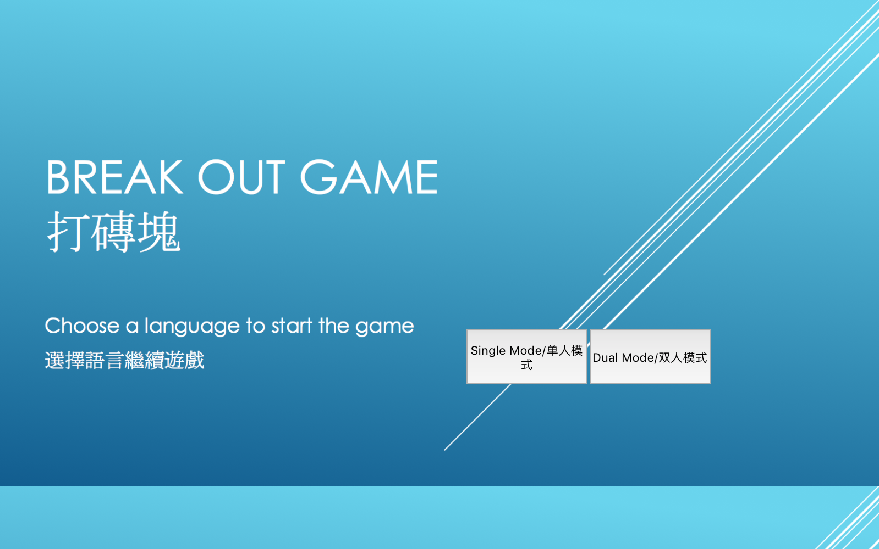

When user(s) start the game, there would be two buttons for user, in both Chinese and English, for them to choose the preferable play mode. After that user could be able to choose their preferable language via two new buttons showed on the start screen.

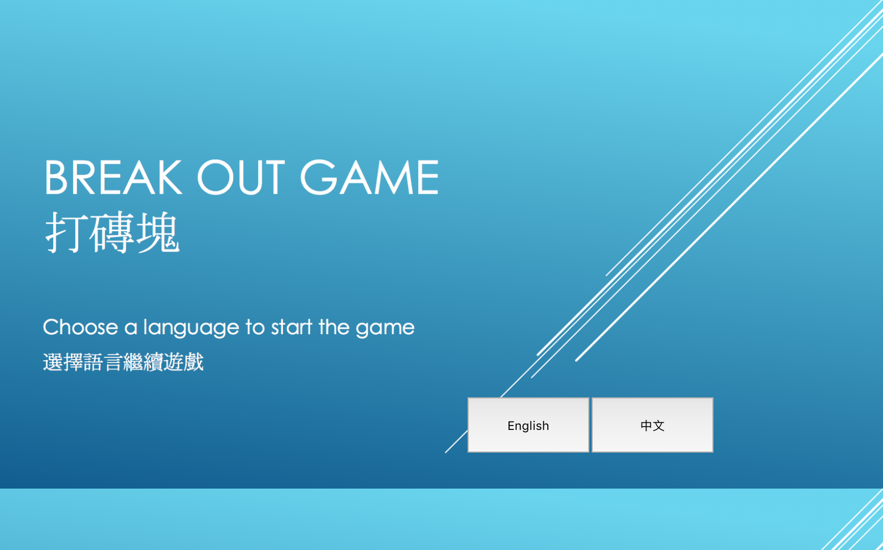

After user(s) set up the game mode and language, it is time to get the real game started. Here we use English interface as an example:

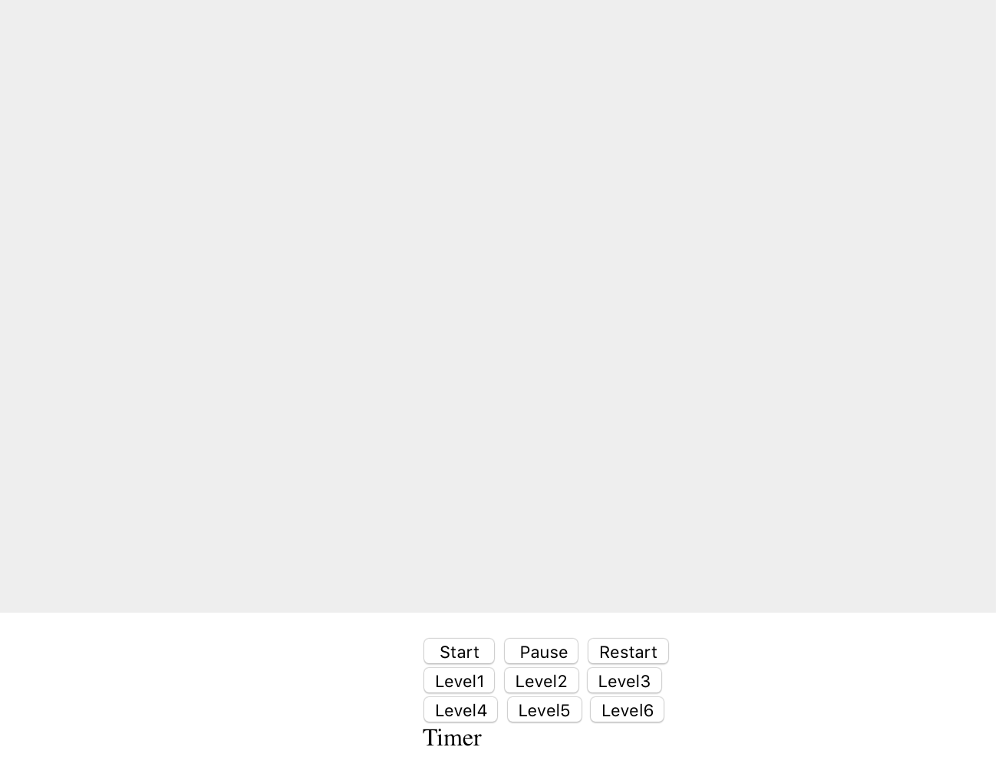

Once user(s) click the “start” button, the game would be triggered in its default settings-level 1. And timer would start to count down one second a time until it is out. All

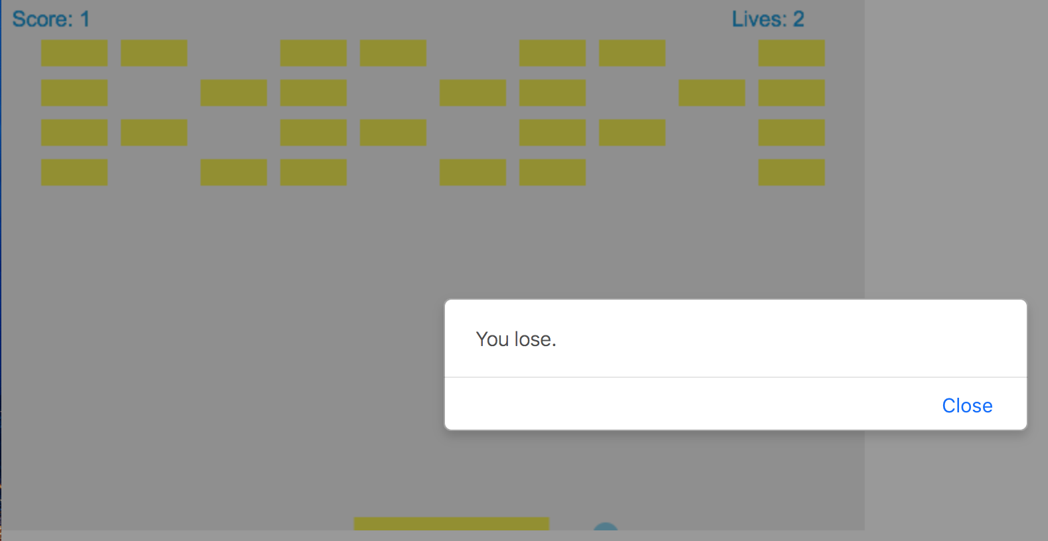

As one can see, all the notifications, score board & life board is in English. Also, I would attach all Chinese interfaces in the index.

About the implementation, since we are using setInterval() function to update the whole game board. All we need is to create a function to be triggered via onclick event from language buttons. Code of this function is shown as below:

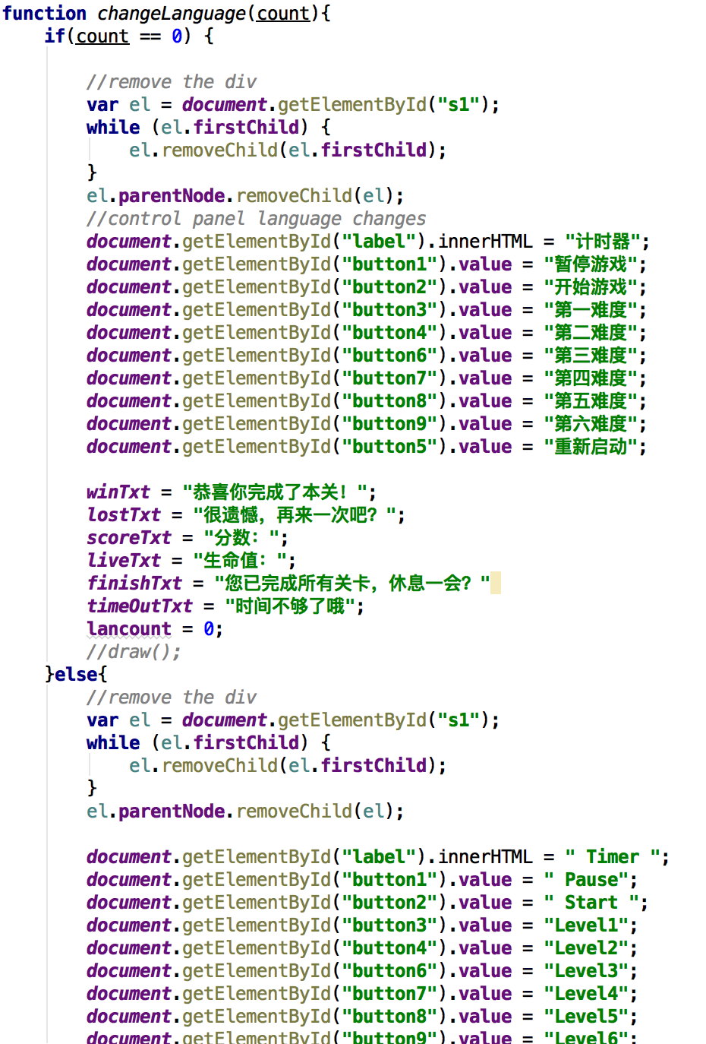

Since the exclusive parameter in this function is count, program would set all language vars to its value depending on user’s choice(count returns 1 or 2).

That is the end of first special consideration.

3. Second method & implementation

As we mentioned before, this break out provides real dual-player mode, which means two players could individually move their paddle to hit the bouncing ball. Below is a screenshot of program demonstration:

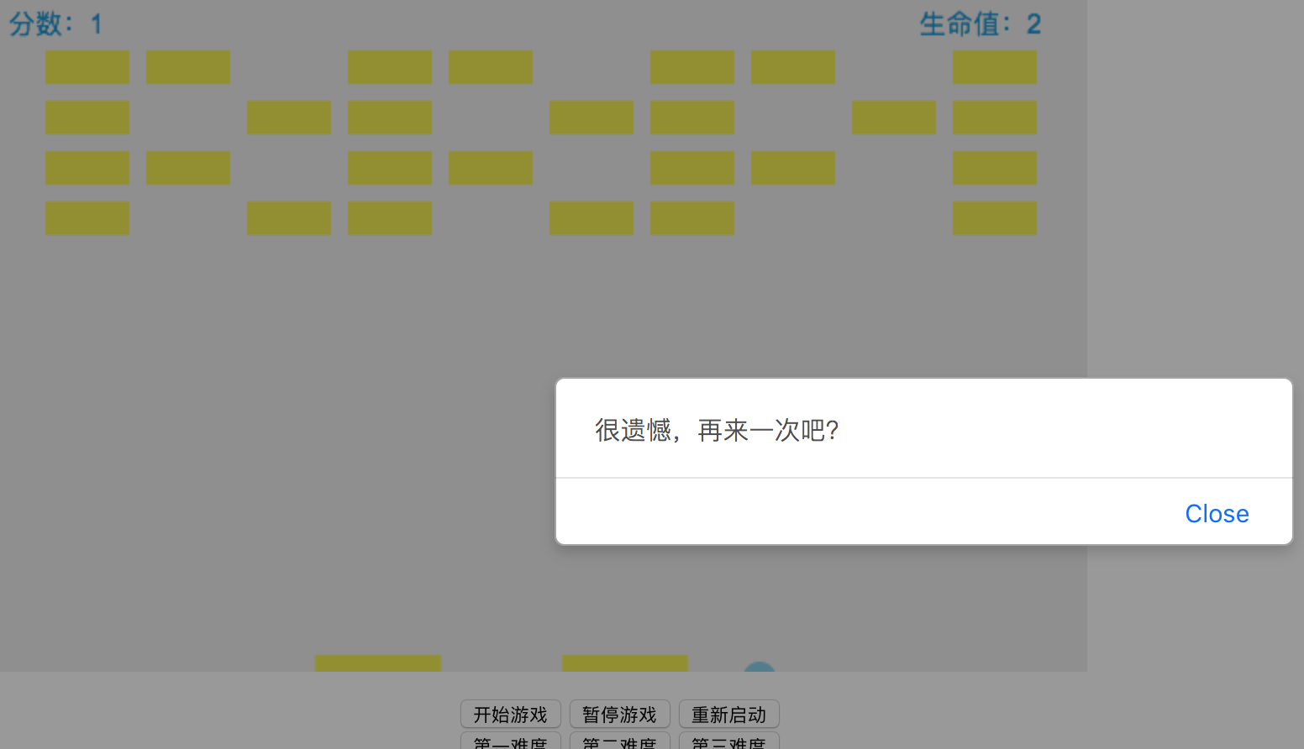

This time we choose Chinese interface & dual-player mode to start the game. You can see playing the second level would be not that challenge since there are two paddles, both able to catch the ball and throw it back to field.

As for the implementation, it is important to keep a paddleCount variable to return the necessary Boolean value, which is the key value for the following function to determine if they need to create the second paddle. The code demo is as follow:

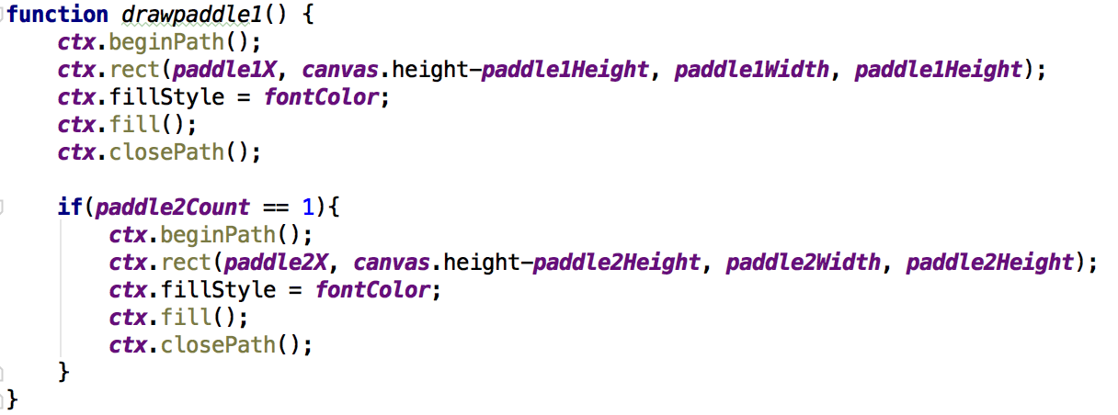

Also it is kind of tricky to change the draw() function from one-paddle mode to two paddle. The changes are also shown as follow:

Originally you just need to tell if the ball bounces out the the frame instead on the only one paddle:

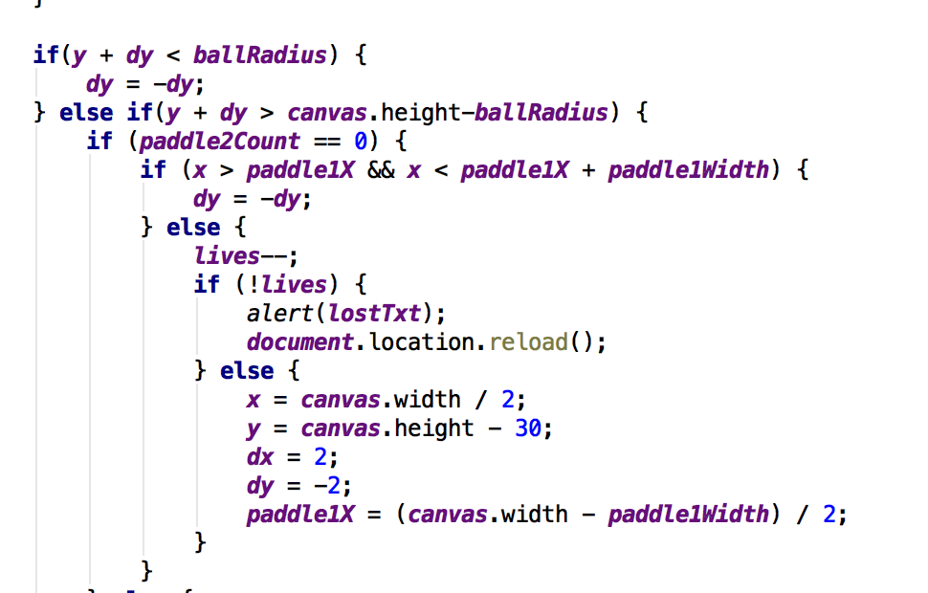

But now both of the paddles need to be considered:

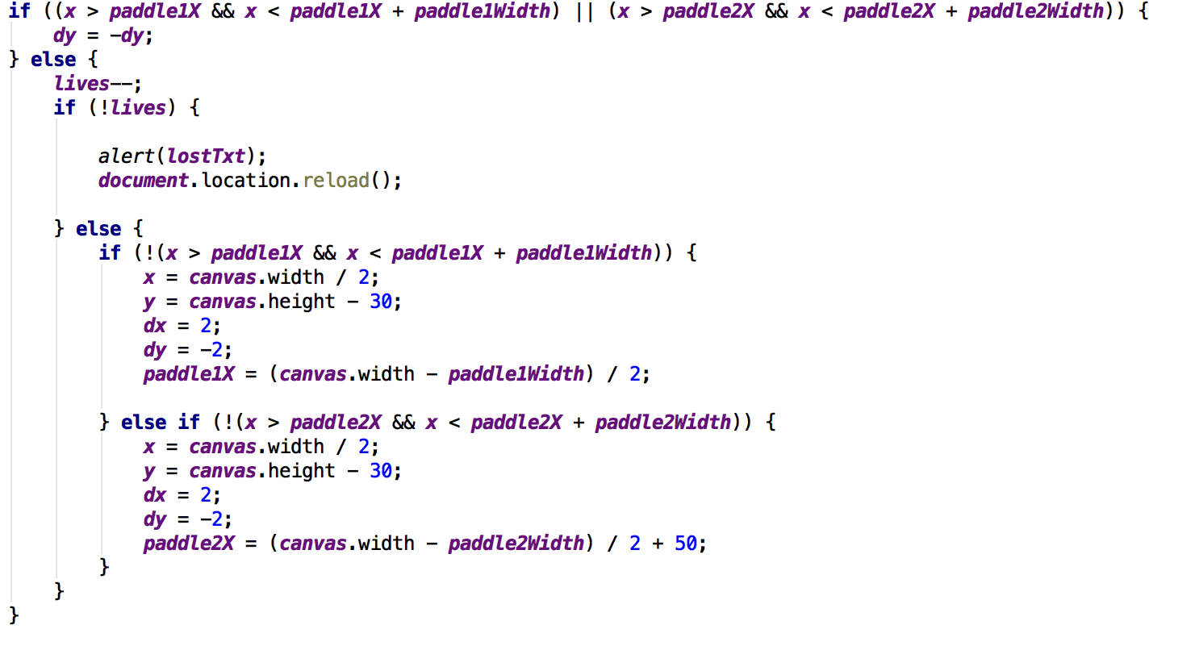

So here our two players could play the break out game together!

Also it is important to notice that the second paddle could only be controlled by key “a”-left movement and key “b”-right movement, since commonly there is only one mouse on one personal computer.

