COMP3421 Class Exercise 8

Name :

Student ID :

<!DOCTYPE html>
<html> <head>
<script src="http://maps.googleapis.com/maps/api/js">
</script>

<script>
var myCenter=new google.maps.LatLng(51.508742,-0.120850);

function initialize() {
var mapProp = {
center: myCenter,
zoom:5,
mapTypeId: google.maps.MapTypeId.XXXX
};

var map = new google.maps.Map(document.getElementById("googleMap"),mapProp);
var marker = ZZZZ;
marker.setMap(map);
google.maps.event.addListener(marker,'click',function() {
map.setZoom(YYYY);
map.setCenter(marker.getPosition());
});
}
google.maps.event.addDomListener(window, 'load', initialize);
</script>
</head>
<body>
<div id="googleMap" style="width:500px;height:380px;"></div></body></html>

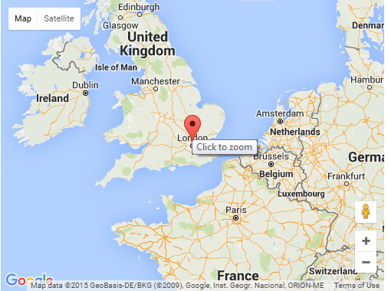

Complete the missing code with the following requirements.

- Set the map type as a road map.
- Add a marker in the center of the map.
- When the mouse cursor is on top of the marker, the message ‘Click to zoom’ appears.
- When the marker is clicked, the map will zoom in the London region.

