Lab 4 – JavaScript/Objects/Events

Objective
After this lab session, you will learn how to
- Change the content of a webpage
- Do drag and drop of an image
- Modify a breakout program
- Try the code below to display time (hour, minutes, seconds) and update it continuously. Modify it to display with a larger font size and add a millisecond field.
<?xml version = "1.0" encoding = "utf-8"?>
<!DOCTYPE html PUBLIC "-//W3C//DTD XHTML 1.0 Strict//EN"
"http://www.w3.org/TR/xhtml1/DTD/xhtml1-strict.dtd">
<html xmlns = "http://www.w3.org/1999/xhtml">
<head> <title>Clock</title>
<script type="text/javascript">
function addzero(i) { if (i < 10) { i = "0" + i; } return i; }
function runClock() {
var today = new Date();
var h = today.getHours();
var m = today.getMinutes();
var s = today.getSeconds();
h = addzero(h); m = addzero(m); s = addzero(s);
document.getElementById('clock').innerHTML = h +":"+ m +":"+ s;
t = setTimeout('runClock()', 1000);
}
</script>
</head>
<body onload="runClock()">
<div id="clock"></div>
</body> </html>

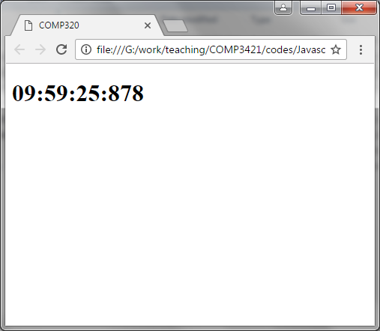

- Modify the code below such that there are 2 boxes on the page and the image can be dropped into any of the 2 boxes as shown in the figure. Also, the image can be dragged and dropped between each other.
<!DOCTYPE HTML>
<html>
<head>
<style>
#div1 {
width: 350px;
height: 70px;
padding: 10px;
border: 1px solid #aaaaaa;
}
</style>
<script>
function allowDrop(ev) {
ev.preventDefault();
}

function drag(ev) {
ev.dataTransfer.setData("text", ev.target.id);
}

function drop(ev) {
ev.preventDefault();
var data = ev.dataTransfer.getData("text");
ev.target.appendChild(document.getElementById(data));
}
</script>
</head>
<body>

<p>Drag the image into the rectangle:</p>

<div id="div1" ondrop="drop(event)" ondragover="allowDrop(event)"></div>
<br>
<img id="drag1" src="chicken.gif" draggable="true" ondragstart="drag(event)" width="336" height="69">

</body>
</html>

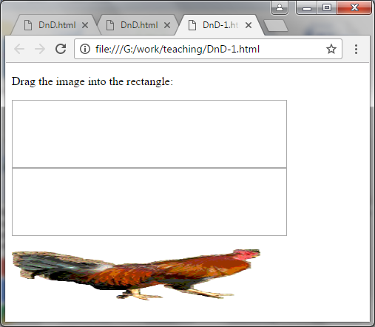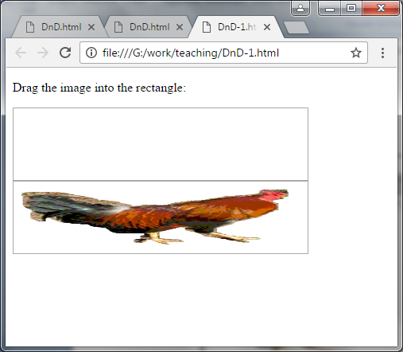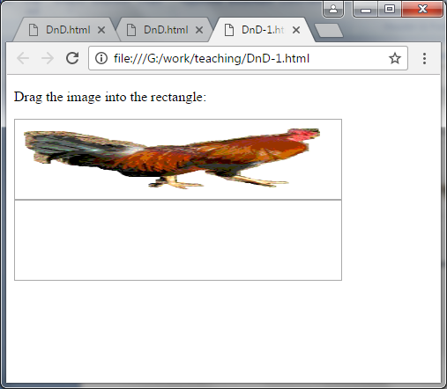
- Modify the code below to allow 2 keys to control the paddle in horizontal movements.
<!DOCTYPE html>
<html>
<head>
<meta charset="utf-8" />
<title>Let us Play</title>
<style>* { padding: 0; margin: 0; } canvas { background: #eee; display: block; margin: 0 auto; }</style>
</head>
<body>

<canvas id="myCanvas" width="480" height="320"></canvas>

<script>
var canvas = document.getElementById("myCanvas");
var ctx = canvas.getContext("2d");
var ballRadius = 10;
var x = canvas.width/2;
var y = canvas.height-30;
var dx = 2;
var dy = -2;
var paddleHeight = 10;
var paddleWidth = 75;
var paddleX = (canvas.width-paddleWidth)/2;
var rightPressed = false;
var leftPressed = false;
var brickRowCount = 5;
var brickColumnCount = 3;
var brickWidth = 75;
var brickHeight = 20;
var brickPadding = 10;
var brickOffsetTop = 30;
var brickOffsetLeft = 30;
var score = 0;
var lives = 3;
var bricks = [];
for(c=0; c<brickColumnCount; c++) {
bricks[c] = [];
for(r=0; r<brickRowCount; r++) {
bricks[c][r] = { x: 0, y: 0, status: 1 };
}
}

document.addEventListener("mousemove", mouseMoveHandler, false);
// missing code here for keyevents

function keyDownHandler(e) {
// missing code here
}
function keyUpHandler(e) {
// missing code here
}
function mouseMoveHandler(e) {
var relativeX = e.clientX - canvas.offsetLeft;
if(relativeX > 0 && relativeX < canvas.width) {
paddleX = relativeX - paddleWidth/2;
}
}
function collisionDetection() {
for(c=0; c<brickColumnCount; c++) {
for(r=0; r<brickRowCount; r++) {
var b = bricks[c][r];
if(b.status == 1) {
if(x > b.x && x < b.x+brickWidth && y > b.y && y < b.y+brickHeight) {
dy = -dy;
b.status = 0;
score++;
if(score == brickRowCount*brickColumnCount) {
alert("YOU WIN, CONGRATS!");
document.location.reload();
} } } } }
}
function drawBall() {
ctx.beginPath();
ctx.arc(x, y, ballRadius, 0, Math.PI*2);
ctx.fillStyle = "#0095DD";
ctx.fill();
ctx.closePath();
}
function drawPaddle() {
ctx.beginPath();
ctx.rect(paddleX, canvas.height-paddleHeight, paddleWidth, paddleHeight);
ctx.fillStyle = "#0095DD";
ctx.fill();
ctx.closePath();
}
function drawBricks() {
for(c=0; c<brickColumnCount; c++) {
for(r=0; r<brickRowCount; r++) {
if(bricks[c][r].status == 1) {
var brickX = (r*(brickWidth+brickPadding))+brickOffsetLeft;
var brickY = (c*(brickHeight+brickPadding))+brickOffsetTop;
bricks[c][r].x = brickX;
bricks[c][r].y = brickY;
ctx.beginPath();
ctx.rect(brickX, brickY, brickWidth, brickHeight);
ctx.fillStyle = "#0095DD";
ctx.fill();
ctx.closePath();
} } }
}
function drawScore() {
ctx.font = "16px Arial";
ctx.fillStyle = "#0095DD";
ctx.fillText("Score: "+score, 8, 20);
}
function drawLives() {
ctx.font = "16px Arial";
ctx.fillStyle = "#0095DD";
ctx.fillText("Lives: "+lives, canvas.width-65, 20);
}
function draw() {
ctx.clearRect(0, 0, canvas.width, canvas.height);
drawBricks();
drawBall();
drawPaddle();
drawScore();
drawLives();
collisionDetection();
if(x + dx > canvas.width-ballRadius || x + dx < ballRadius) {
dx = -dx;
}
if(y + dy < ballRadius) {
dy = -dy;
}
else if(y + dy > canvas.height-ballRadius) {
if(x > paddleX && x < paddleX + paddleWidth) {
dy = -dy;
}
else {
lives--;
if(!lives) {
alert("GAME OVER");
document.location.reload();
}
else {
x = canvas.width/2;
y = canvas.height-30;
dx = 3;
dy = -3;
paddleX = (canvas.width-paddleWidth)/2;
}
}
}
// missing code here to update paddle position
x += dx;
y += dy;
requestAnimationFrame(draw);
}
draw();
</script>
</body>
</html>
