Lab 7 – Ajax
1. Try the code below and retrieve the information after selecting a customer. (note. For all the files (HTML, XML, JS), place them in your personal website for proper functions)
<html>
<style>
table,th,td { border : 1px solid black; border-collapse: collapse; }
th,td { padding: 5px;}
</style>
<head>
<script>
function showCustomer(str) {
var xhttp;
if (str == "") { document.getElementById("txtHint").innerHTML = ""; return; }
xhttp = new XMLHttpRequest();
xhttp.onreadystatechange = function() {
if (this.readyState == 4 && this.status == 200) {
document.getElementById("txtHint").innerHTML = this.responseText;
} };
xhttp.open("GET", "http://www4.comp.polyu.edu.hk/~cstyng/getusername.php?str="+str, true);
xhttp.send();
}
</script>
</head>
<body>

<h1>Lab 7 Question 1</h1>
<form action="">
<select name="customers" onchange="showCustomer(this.value)">
<option value="">Select a customer:</option>
<option value="one">John</option>
<option value="two">Peter</option>
<option value="three">Mary</option>
</select>
</form>
<br>
<div id="txtHint">Customer info will be listed here...</div>
</body>
</html>
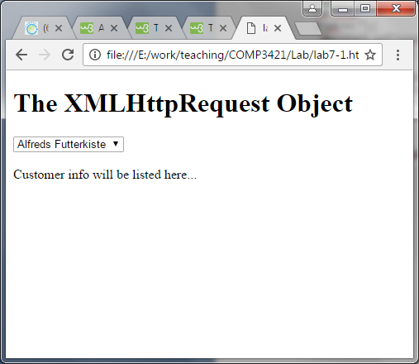
2. Design a XML and an ajax program similar to the one at
http://www.w3schools.com/xml/tryit.asp?filename=tryxml_display_table with some additional requirements.
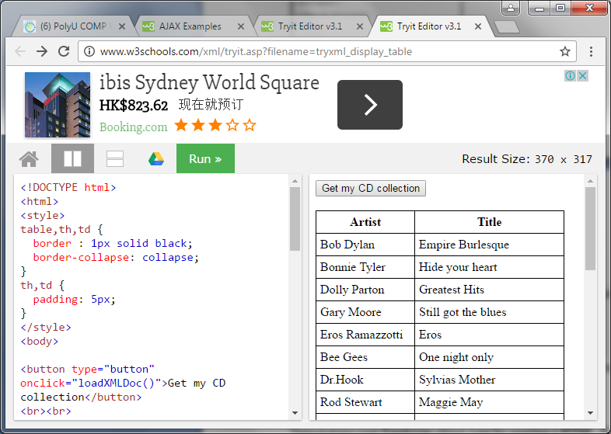

- Display the prices of the CDs in the third column.
- If the price is higher than 10 then highlight the table cell in yellow.

A XML data fragment is below.
<CD>
<TITLE>Empire Burlesque</TITLE>
<ARTIST>Bob Dylan</ARTIST>
<COUNTRY>USA</COUNTRY>
<COMPANY>Columbia</COMPANY>
<PRICE>10.90</PRICE>
<YEAR>1985</YEAR>
</CD>

The XML data file is available at www.comp.polyu.edu.hk/~cstyng/cd_catalog.xml.
3. A PHP program named “test1.php” is saved at http://www4.comp.polyu.edu.hk/~cstyng/test1.php. The source code is provided below.

<?php switch($_REQUEST['str']) {
case 'one':
echo "chocolate.jpg";
break;
case 'two':
echo "strawberry.jpg";
break;
default:
echo "peach.jpg";
break;
}
?>

Provide an html file with an ajax program, which will prompt a user to enter ‘one’, ‘two’ or other character strings with a textbox. According to the input string, a fruit photo will be shown without refreshing the webpage. The HTML file below will help you to solve the question. The image files are all at www.comp.polyu.edu.hk/~cstyng.

<!DOCTYPE html>
<html>
<head>
<title>Simple Image change</title>
</head>
<body>
<h1>Changing the Image</h1>
<img src="" id="myImage" width="100" height="150">
<form action="">
<select onchange="changeImage(this.value)">
<option value="">Select an image:</option>
<option value="1">chocolate</option>
<option value="2">strawberry</option>
<option value="3">peach</option>
</select>
</form>

<script>
function changeImage(s) {
var image = document.getElementById('myImage');
if (s==1) { image.src = "chocolate.jpg";}
if (s==2) { image.src = "strawberry.jpg";}
if (s==3) { image.src = "peach.jpg";}
}
</script>
<p><strong>Note:</strong> Select to Change the dissert</p>
</body>
</html>

