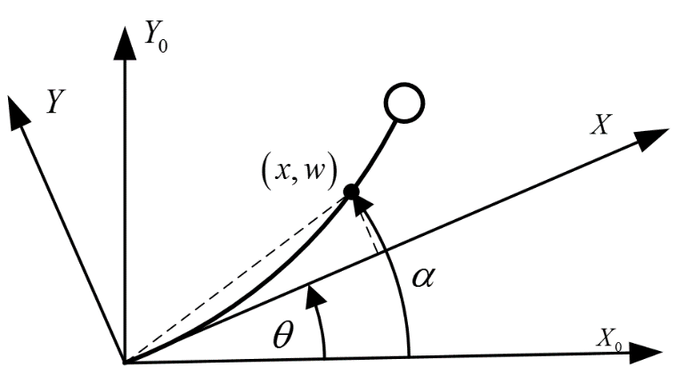

Motion analysis:

A position vector R to every point of the system can be constructed:



Where  and  are unit vectors in the x, y directions. The velocity of the position vector:



The kinetic energy of the beam, can then be computed by integrating this expression over entire mass of the flexible system,



Then the kinetic energy of the flexible manipulator is given by



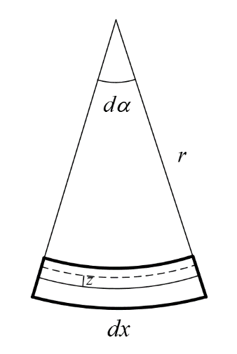

The length of the neural axis in figure, bending of an Euler Bernoulli beam, is . Then the strain of a fiber with a radial distance, z, is given by



Therefore, the fore resulting from this stress is expressed as



Where  is the differential element of area at the location of the fiber. Then bending moment of it could be given by



After integrating bending moment along whole section, we have



Where 

The elastic potential energy of it is given by



Assumed mode method

Assuming it moves on a horizontal plane and does not undergo a torsional deformation, the flexible manipulator can be modeled as an Euler-Bernoulli beam, having equation,



Where  is the normalized position along manipulator. Now assuming separability in time and space of deflection, that is



Plug into and separate variable gives,



Left side of depends on  only, and right side depends on  only, and  and  are independent variables, which means that both side equals a constant. Considering the manipulator is a stable system, that  will go to 0 when  goes to infinity, the constant is chosen to be positive as . Thus, the general solution of differential equation above is given by





Where . The clamped-mass boundary condition below is applied to determine mode shape.





Which can be simplified as



Such boundary condition lead to



Where so-called frequency equation is given by setting to zero the determinant of matrix Q. It can be shown that the positive values of  are given by the solution of transcendental equation



Where  and 

Lagrangian approach

Lagrange function of flexible manipulator can be given as



According to Lagrange equation



Considering 2 of modal terms, the dynamic equations for the manipulator can be derived as



Where  is the joint variable,  is the vector of modal amplitudes, and  is the control torque at the joint location, every element of inertia matrix  is given by





Desired displacement



Desired velocity



Desired acceleration



The first two flexible mode



F1=1.9261Hz;

F2=7.6642Hz;

Calculated desired flexible mode

