Yuanping Song

UID:

AI-powered Analysis of Animal Behavior – An Application of Computer Science toward Biology and Beyond

The tremendous breakthrough in the field of machine learning during recent years leaves few in doubt of what artificial intelligence could one day achieve. Just as tech giants are busy commercializing seemingly futuristic technologies, a more exciting aspect of the current machine learning revolution is perhaps its potential to help us acquire more knowledge faster and better by becoming an indispensable tool in scientific research.

A team of biologists from Colombia University demonstrated in their latest study of animal behavior the extraordinary potential at the intersection of artificial intelligence and scientific research. The group’s effort centered on finding the exact connection between an organism’s neural signals and its motor responses. In a previous publication by the same group, researchers were able to image the real-time neural activity of a small Aquarian model organism name hydra. They determined that a hydra’s nervous system is composed of four non-overlapping neural nets, each responsible for certain types of motor function. As a natural follow-up question, they wish to associate the firing of individual neurons, which they can already track with high precision, to what exactly the animal is doing at the moment. In order to accomplish this, the researchers needed a reliable way of identifying the mode of behavior of a hydra in a video footage. On this seemingly straightforward task, the old school method did not work out as one would expect: when two human observers try to tell what a hydra is doing in a given frame of video, there is not very much agreement, as the following diagram illustrates:

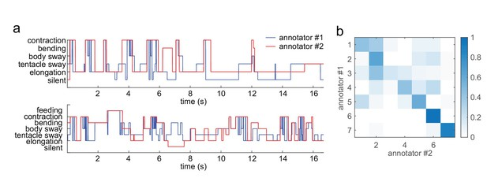

Figure a) is a representation of how two human annotators classified a hydra’s behavior in a footage. And figure b) is the corresponding confusion matrix. Ideally, all of the colored squares should lie on the main diagonal, indicating total agreement between the two annotators, however we see significant off-diagonal spread in the data which signifies that the data is marred by a high degree of subjectivity.

In order to reduce the influence of human error, the researchers turned toward machine learning methods. They mapped the problem of capturing hydra movement to that of identifying deformable human body in computer vision, which is solved by extracting features from the video, and treating it as a collection of those features. This is known as the bag of worlds model, also seen in document processing and spam detection algorithms. The entire process is summarized in the following illustration:

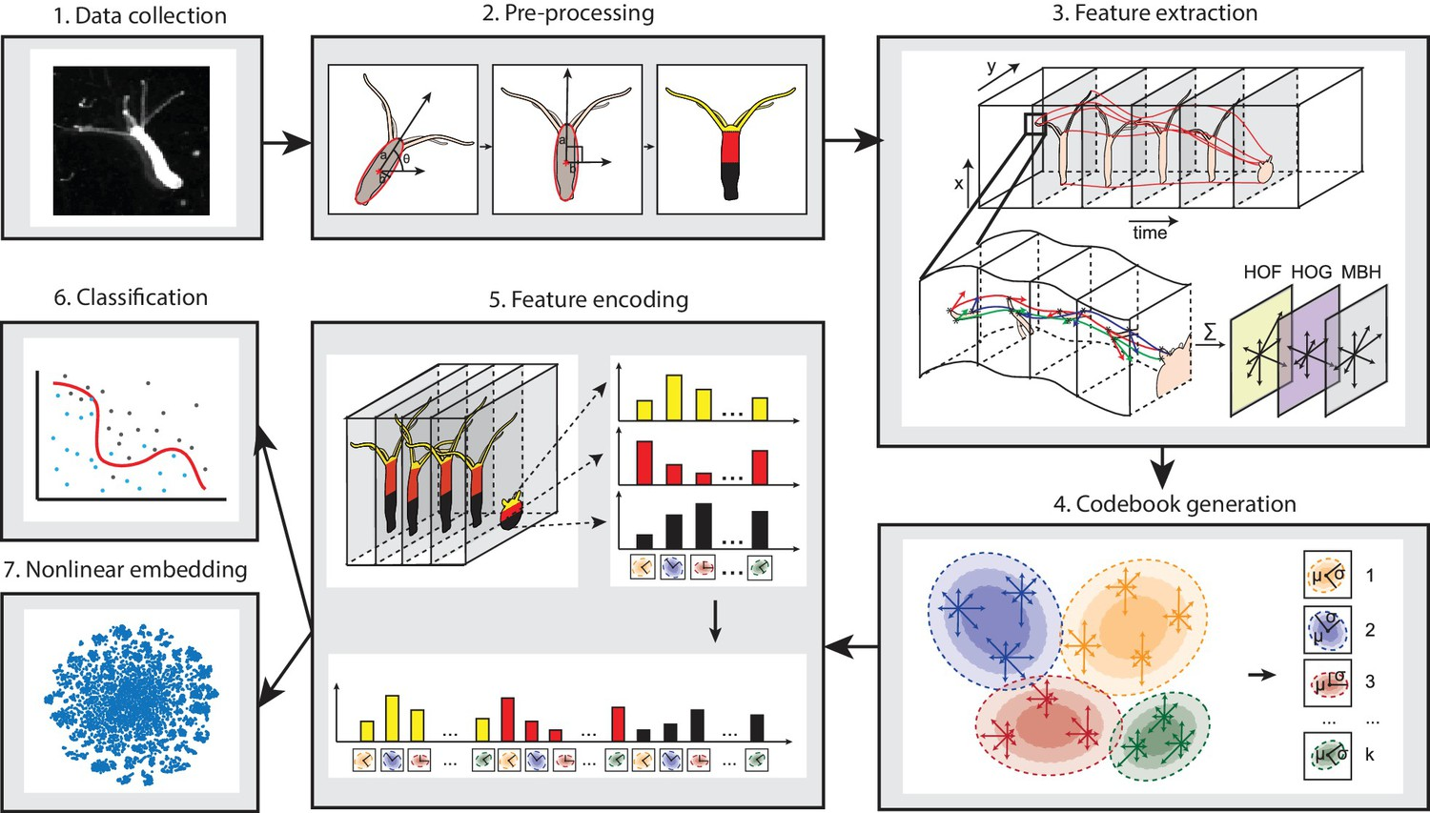

We see that video footage is transformed into more easily manipulated forms through successive stages. The hydra first need be centered in its frame, then its body is rotated to an upright position and replaced with abstract geometric shapes. Then features can be extracted, and the data can be piped to the last stage: either supervised learning with SVM or unsupervised learning with t-SNE. Interestingly, the experimenters first trained their model using the first approach on a dataset produced by human annotators. They compared the consistency of the prediction of this model to that of the training set and found them to be comparable. They therefore concluded that this treatment has been successful in that the algorithm developed at least matched human performance. Moreover, in order to fully utilize currently available technology, the researcher unleashed unsupervised learning algorithm on hydra footage, giving it limited guidance in the hope that the algorithm will be able to discover structure in the data by itself. The outcome is unexpectedly positive; the clustering algorithm not only rediscovered behaviors that the researchers had previously known but also identified three a new somersaulting behavior and three subphases of feeding behavior.

Using the trained models to process even larger amounts of data, including that collected over several days and under a variety of settings, researchers were surprised to find that hydra’s behavioral modes remains fundamentally unchanged regardless of environmental factors such as light, temperature, or the availability of food. It seems that hydra’s simple neural system affords only one plan for every possible situation.

This research is remarkable in several ways. First, its findings are in itself very impressive; machine learning algorithms were used before to analyzing animal behavior, but none were carried out to such a degree that an animal’s motion can be completely understood for every instant in time. Hydra is a sufficiently simple organism with easily imaged neurons and a small enough set of behaviors that this is actually accomplished. Second, the process showed how greatly computer science can benefit research in other areas of science. It does not merely accelerate discovery, but in many cases makes it possible. For instance, it would not be reasonable to expect human annotators to pore over days of video and still be able to maintain a high level of objectivity, or for them to reliably discern events that occurs on a time scale of several seconds, as is in the case of hydra egestion. Third, researchers were highly impressed by the constancy of hydra’s behavioral modes. They are hopeful that a lesson can be gleaned from those little animals on how to best develop an efficient algorithm for coordinating robots. And lastly, understanding hydra is a step toward understanding animals with more complex neural systems and how those systems work in general. Computers have already shown surprising strength in making such models, which leaves one wondering if better hardware combined with more advanced software will eventually lead to true Artificial Intelligence.

Works Consulted

“An AI for Deciphering What Animals Do All Day.” *Columbia News*, 30 Apr. 2018, <http://news.columbia.edu/content/1923>.

Dupre, Christophe, and Rafael Yuste. “Non-Overlapping Neural Networks in Hydra Vulgaris.” *Current Biology*, vol. 27, no. 8, Apr. 2017, pp. 1085–97. *www.cell.com*, doi:[10.1016/j.cub.2017.02.049](https://doi.org/10.1016/j.cub.2017.02.049).

Han, Shuting, et al. “Comprehensive Machine Learning Analysis of Hydra Behavior Reveals a Stable Basal Behavioral Repertoire.” *ELife*, vol. 7, Mar. 2018, p. e32605. *elifesciences.org*, doi:[10.7554/eLife.32605](https://doi.org/10.7554/eLife.32605).