Data exploration:

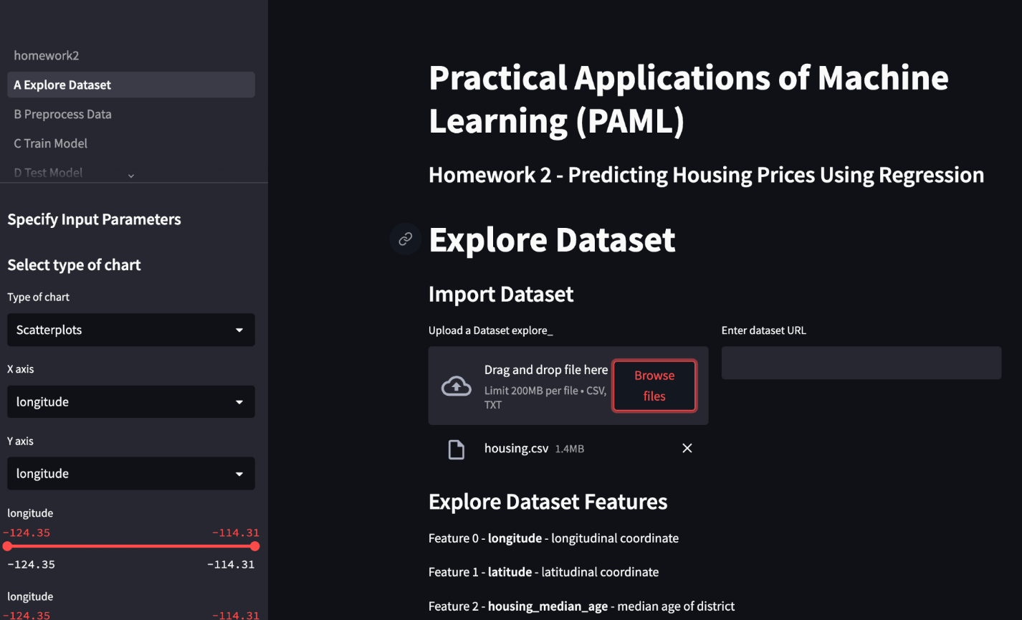

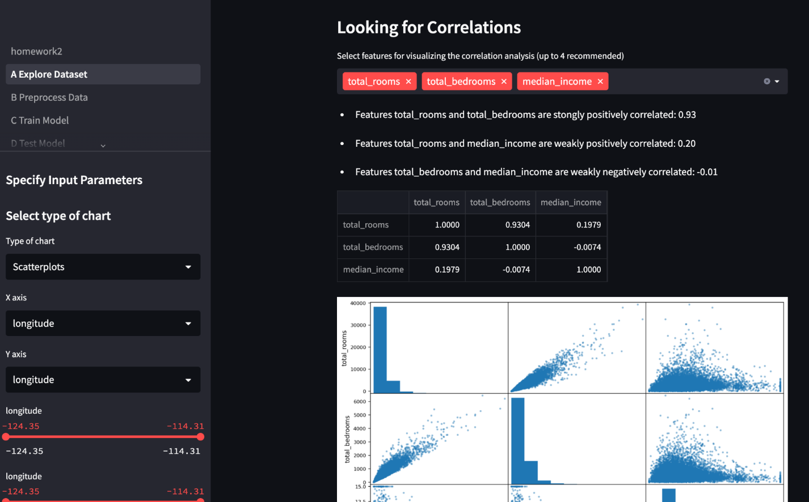

Preprocessing: The dataset is transformed into features that can be used by the regression model. This includes encoding categorical variables, scaling numerical variables, and creating new features.

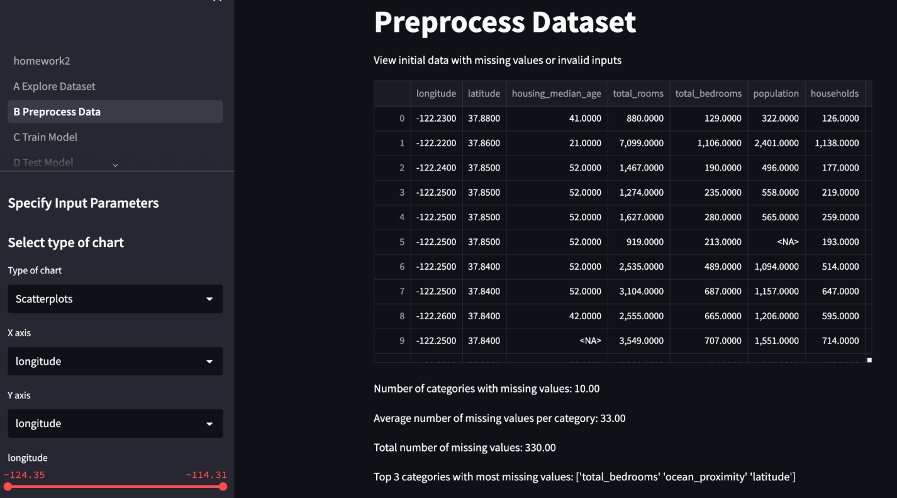

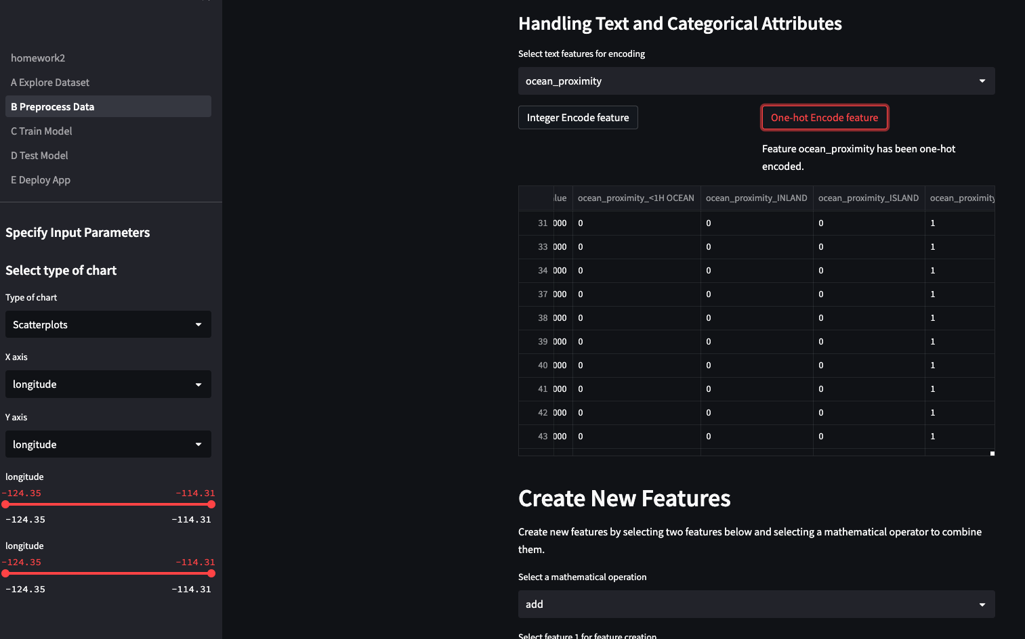

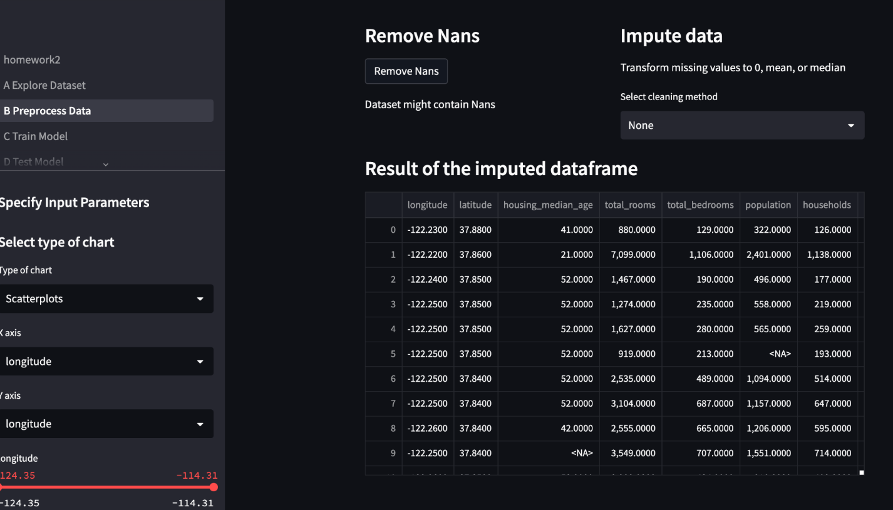

Model training: The regression model is trained using a training dataset. We evaluate multiple regression algorithms and select the best performing one.

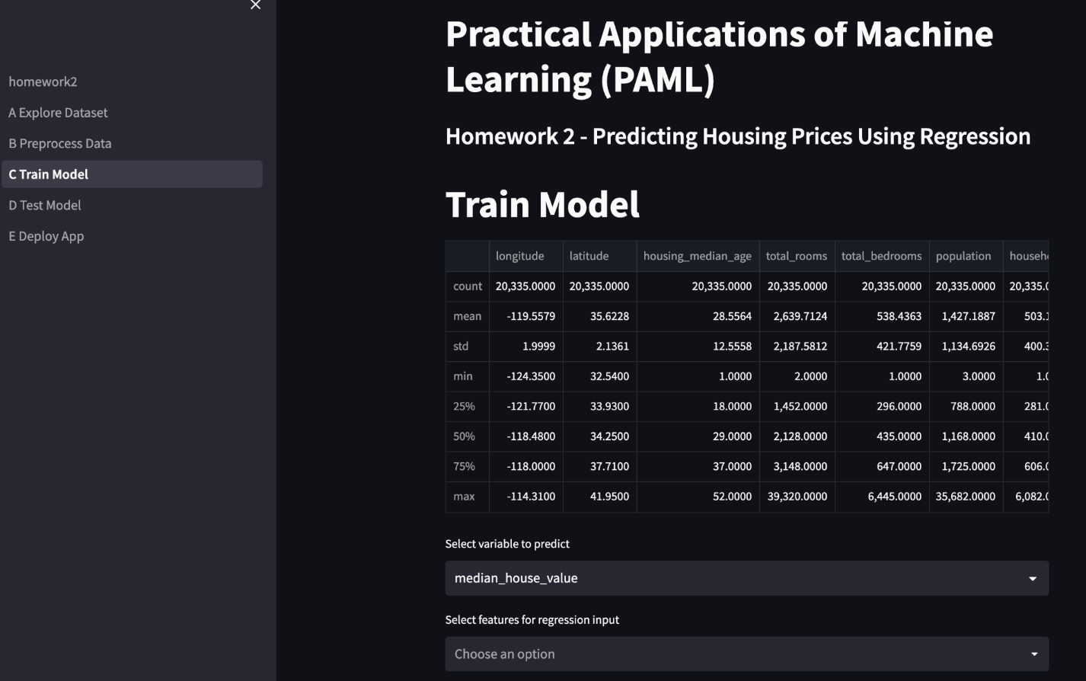

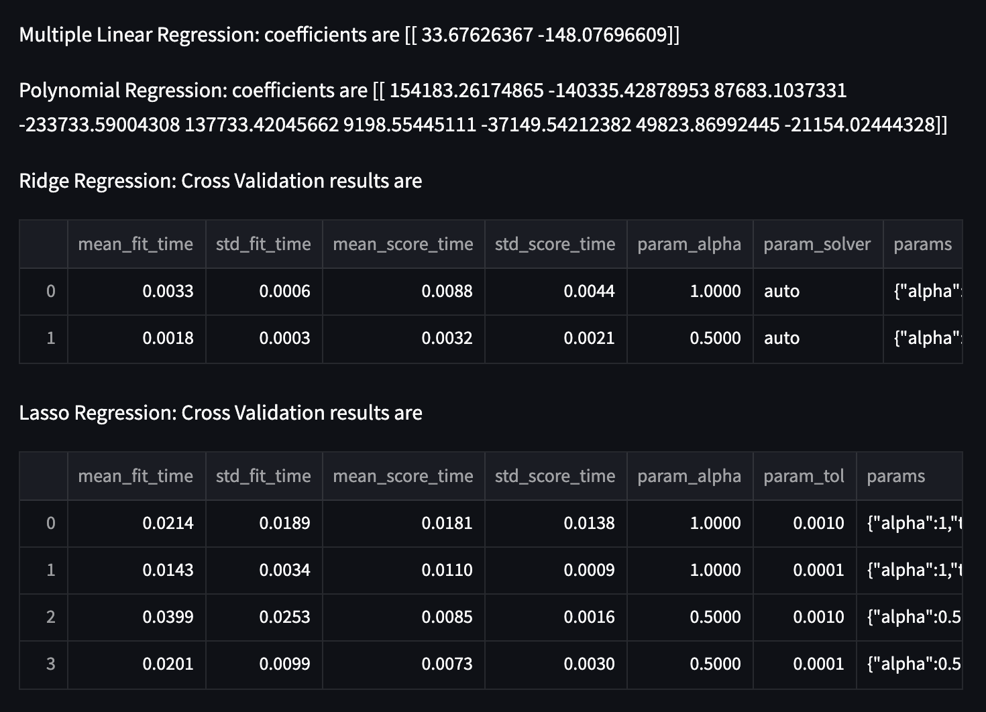

Model testing: The trained model is tested using a testing dataset to evaluate its performance. We use metrics such as mean absolute error and mean squared error to assess the model's accuracy.

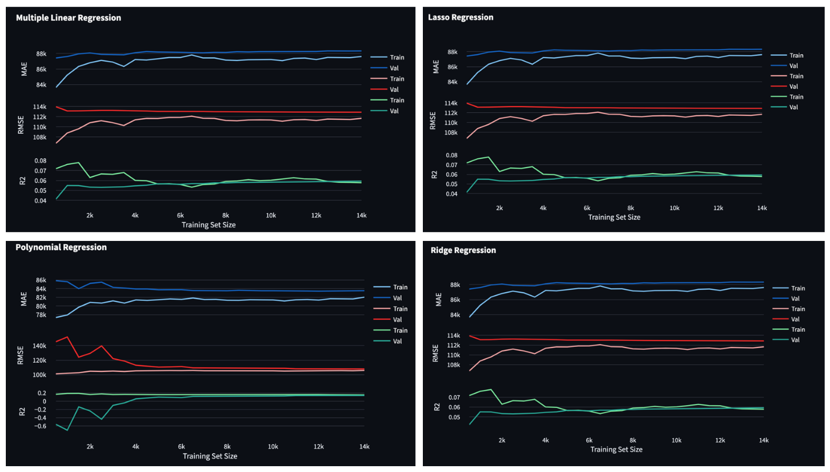

Web deployment: The model is deployed using Streamlit, a Python library for building web applications. The user can input the features of a house and the model will output a predicted housing price. The user can also visualize the data used for training and testing the model.

