Historical Asymmetric Theory
Directional thresholds: +11.5% for XST->XQQ and -7.0% for XQQ->XST, using symmetric delta ((XST - XQQ) / avg) * 100.

Performance Summary
Window | Thresholds | Real switches | Asymmetric strategy % | Always XST % | Always XQQ % | 50/50 % | Edge vs 50/50 (pp)
Last 2 years | +11.5% / -7.0% | 4 | 71.60% | 14.43% | 43.84% | 29.14% | +42.46
Last 5 years | +11.5% / -7.0% | 6 | 203.31% | 65.52% | 82.62% | 74.07% | +129.24

Charts
Asymmetric switch signals - last 5 years
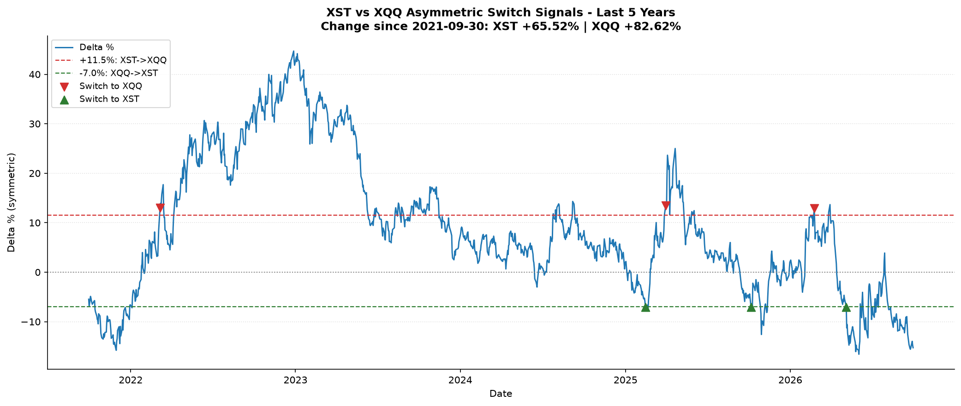
Asymmetric switch signals - last 2 years
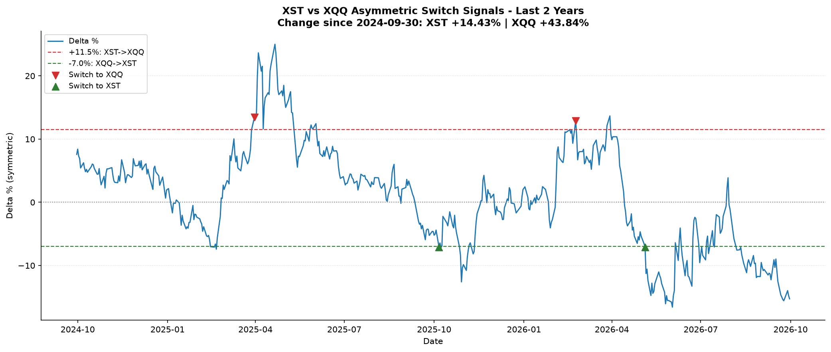
Asymmetric real switches - last 5 years
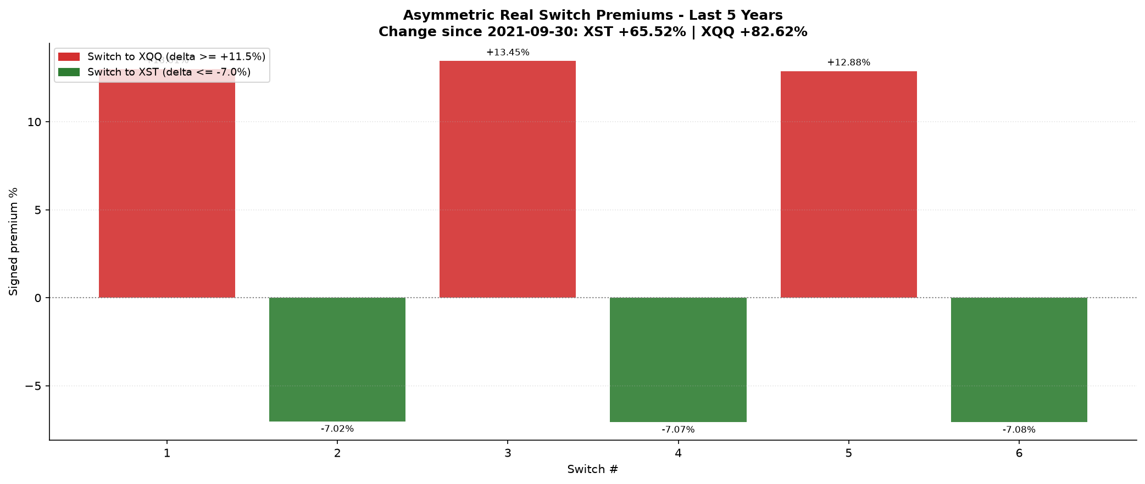
Asymmetric real switches - last 2 years
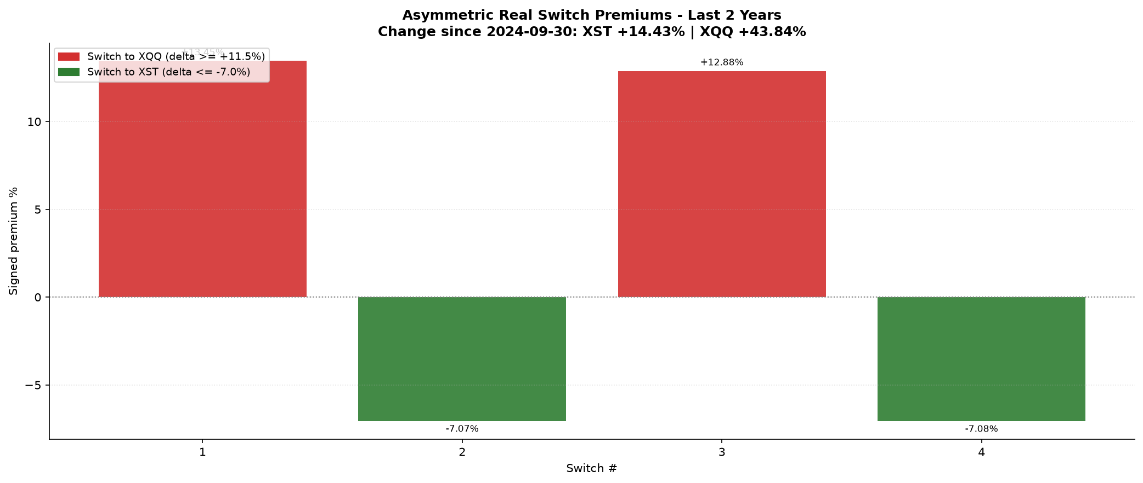
Asymmetric switch duration - last 5 years
