Historical Asymmetric Theory
Directional thresholds: +11.5% for XST->XQQ and -7.0% for XQQ->XST, using symmetric delta ((XST - XQQ) / avg) * 100.

Performance Summary
Window | Thresholds | Real switches | Strategy return % | 50/50 return % | Diff vs 50/50 (pp)
Last 2 years | +11.5% / -7.0% | 6 | 130.10% | 32.84% | +97.26
Last 5 years | +11.5% / -7.0% | 6 | 226.15% | 77.59% | +148.55

Charts
Asymmetric switch signals - last 5 years
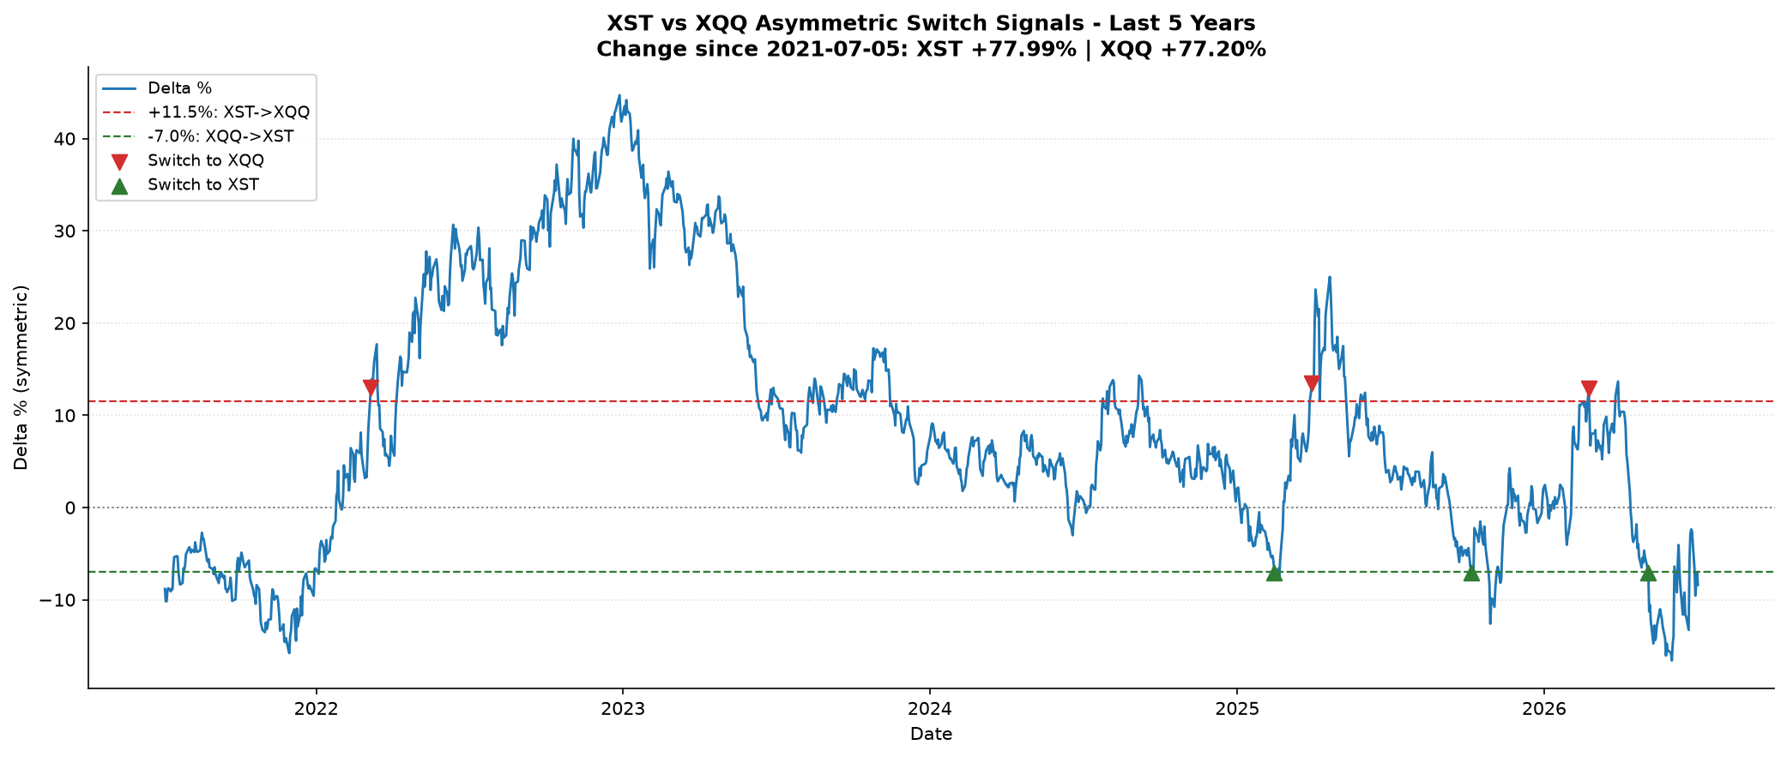
Asymmetric switch signals - last 2 years
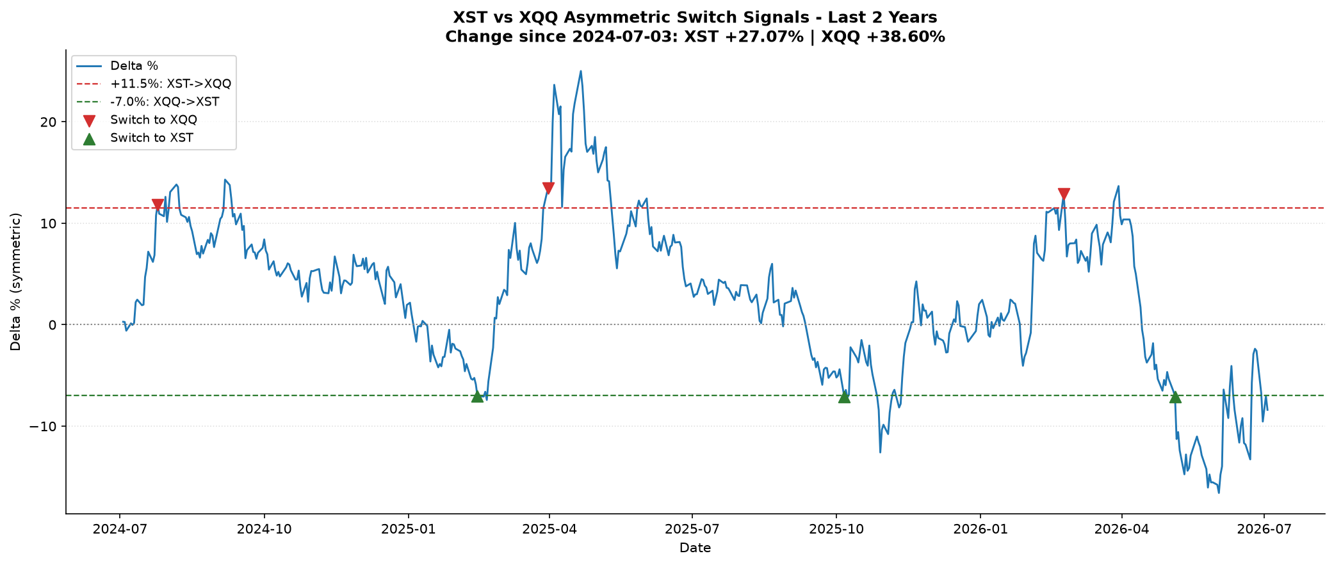
Asymmetric real switches - last 5 years
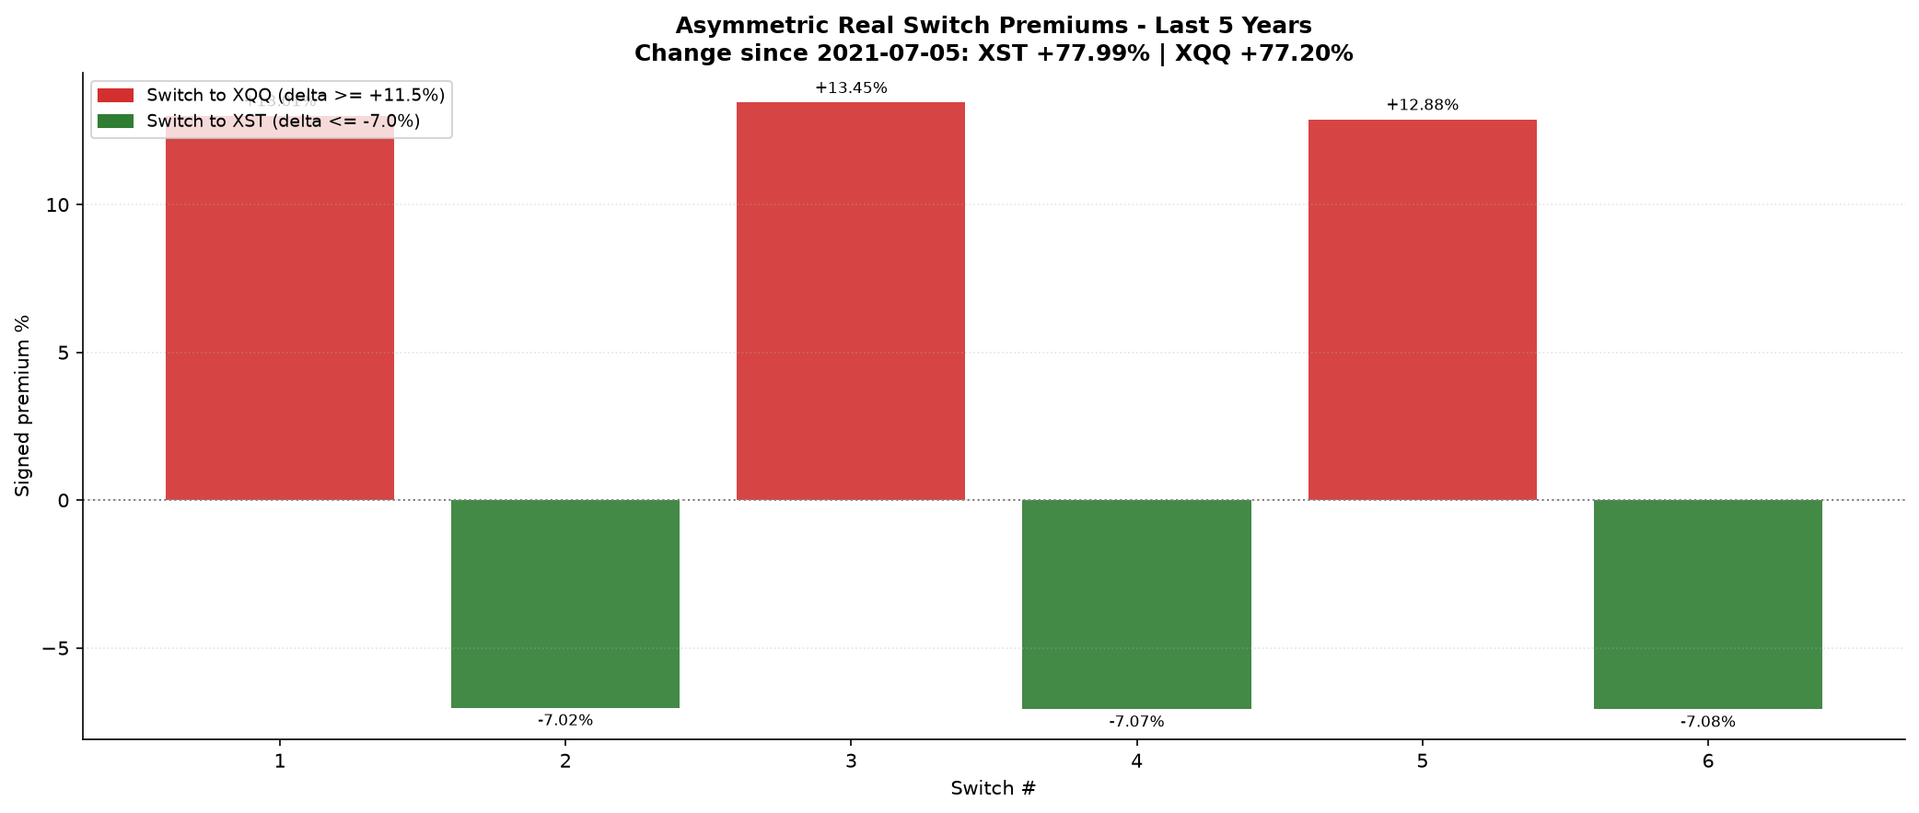
Asymmetric real switches - last 2 years
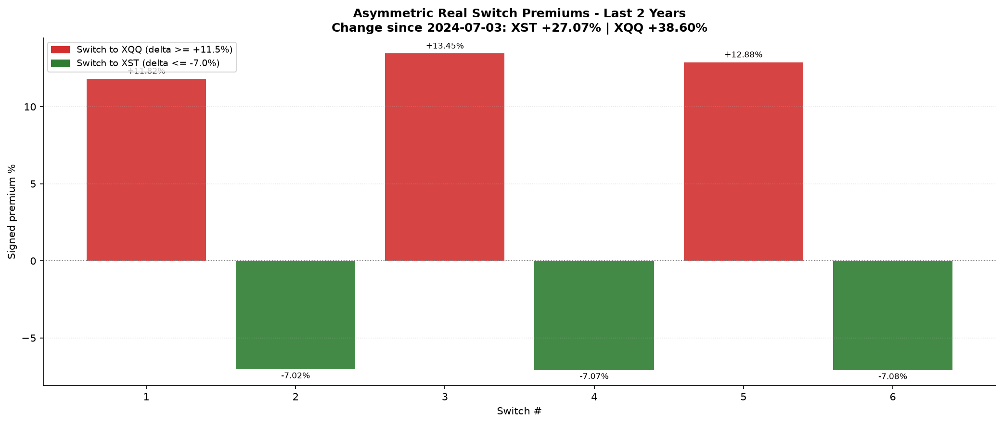
Asymmetric switch duration - last 5 years
