**CAD Programming Assignment 3**

**Mixed-Signal Electronic Design**

**312510224 林煜睿**

1. **Mixed-signal simulation**

* **Schematic**

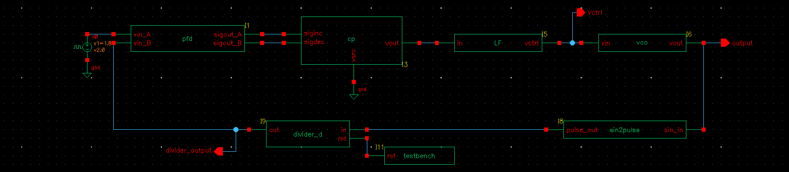

* **Waveform**

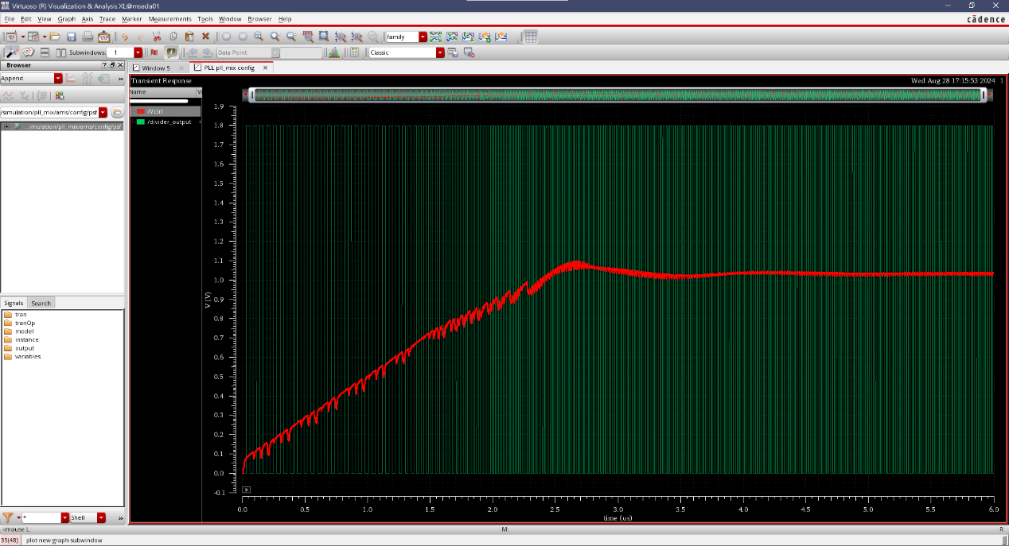

1. **ADC**

* **Schematic**

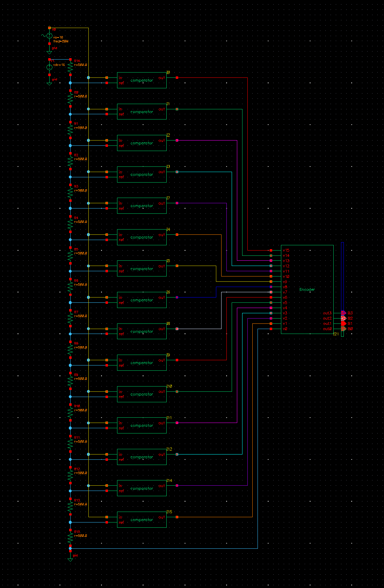

* **Waveform**

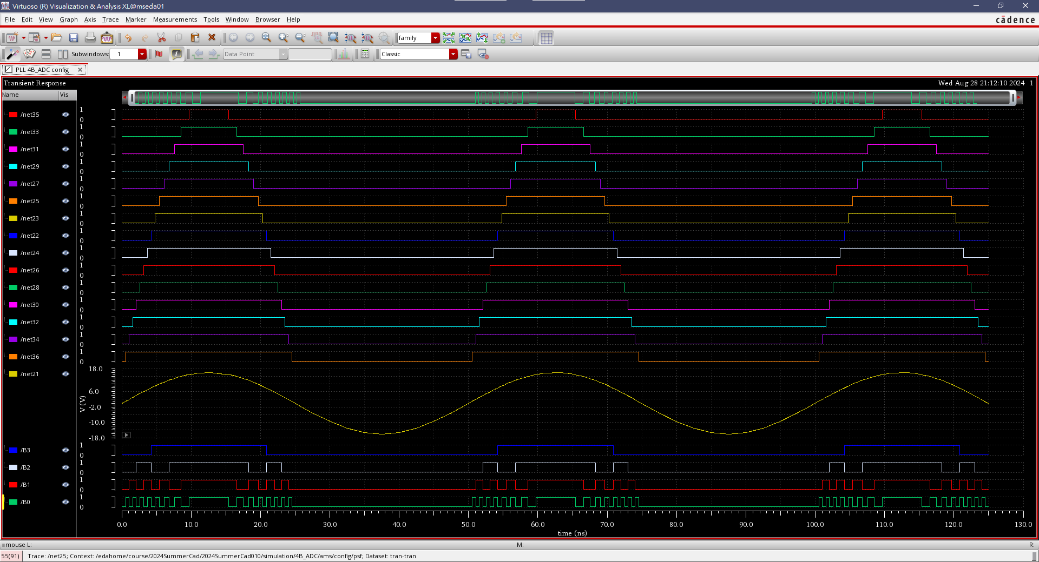

1. **What you have learned from this course**

In the first half of the semester, I learned important EDA concepts such as simplifying K-maps using the Quine-McCluskey method, ROBDD algorithms, Static Timing Analysis, Clock Gating/Power Gating, and more, which gave me a deeper understanding of frontend processing. After the midterm exam, we started delving into the analog domain. Although I wasn't familiar with it, teacher's clear explanations were highly beneficial to me. Coupled with the hands-on experience from lab sessions, not only did I gain a deeper understanding of the algorithms, but I also improved my coding skills through optimization.

Overall, this course has greatly enriched me both in terms of knowledge and C++ practical skills. I am very grateful to the teacher and the teaching assistants for their patient guidance.

1. **Suggestion for this course**

I suggest that the TA provide a breakdown of the performance for each lab, including the scores for each case. I believe this would help me better understand the areas where I still need improvement.