Data Structures and Algorithms

INFO 6205

Homework 10

Due: December 3, 2020

1. Solve the Minimum Spanning Tree for the following Graph 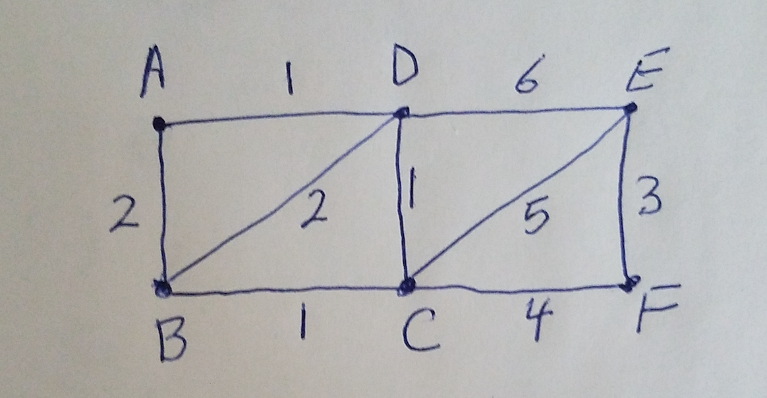

a) Kruskal’s algorithm step-by step show all data structures

b) Prim’s Algorithm step-by-step, show all data structures

c) Write Java code for kruskal’s algorithm , compile and run

algorithm Kruskal(G) is

F:= ∅

for each v ∈ G.V do

MAKE-SET(v)

for each (u, v) in G.E ordered by weight(u, v), increasing do

if FIND-SET(u) ≠ FIND-SET(v) then

F:= F ∪ {(u, v)}

UNION(FIND-SET(u), FIND-SET(v))

return F

d) Write Java code for Prim’s algorithm, compile and run

1. Make a queue (Q) with all the vertices of G (V);

2. For each member of Q set the priority to INFINITY;

3. Only for the starting vertex (s) set the priority to 0;

4. The parent of (s) should be NULL;

5. While Q isn’t empty

6. Get the minimum from Q – let’s say (u); (priority queue);

7. For each adjacent vertex to (v) to (u)

8. If (v) is in Q and weight of (u, v) < priority of (v) then

9. The parent of (v) is set to be (u)

10. The priority of (v) is the weight of (u, v)

e) Compare Space and Time complexity between the two algorithms

2. Explain:

Cell, Gene, Chromosomes, DNA

Human Genome Project?

Cell Nucleus

Genomic Language

DNA Mutations, name three explain

3. Read this article:

<https://www.cancer.gov/about-cancer/treatment/types/precision-medicine/tumor-dna-sequencing>

a) What is Tumor DNA sequencing?

b) Which gene does the article identify as an example? And mutations in the identified gene

causes what kind of problem?

c) In this article what is the name of Gene and what is the root cause of cancer and how it is created?

<https://www.cancer.gov/about-cancer/treatment/types/precision-medicine/tumor-dna-sequencing>

4. Read this article on Genetic Algorithm (GA)

<https://www.analyticsvidhya.com/blog/2017/07/introduction-to-genetic-algorithm/>

A) The following model describes the biology in human. Describe the Model,

How does it work?



B) What is the goal of Genetic Algorithm? Explain with Example

C) Genetic Algorithm mimics its model from science of biology (True/False)?

Explain exact details

5. Genetic Algorithm:

<https://towardsdatascience.com/introduction-to-genetic-algorithms-including-example-code-e396e98d8bf3>

` A) What are the steps of GA described in the article?

B) Read the example Java code as how it relates to steps in (A)

C) Compile and run the code, explain the results.

D) What are possible termination points?

E) Change the code to consider for 8 genes. Compile and Run.

F) Compare (C) and (E), explain results

6. Consider the following Text and Pattern

Text: ABCADBABCBABABCDABCDABDE

Pattern: BAB

a) Apply Brute-Force substring search algorithm to scan Pattern in

Text string. Show step-by-step of the algorithm. Write Java code

for the algorithm for input data. What is time complexity?

b) Apply Robin-Karp substring search algorithm to scan pattern in the

text string. Show step-by-step of algorithm. Write Java code

for the algorithm for input data. What is time complexity?

c) What is the difference between the two time complexity?

7. Consider this Graph

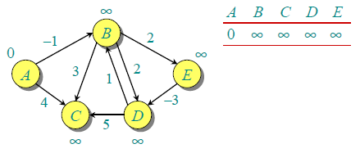

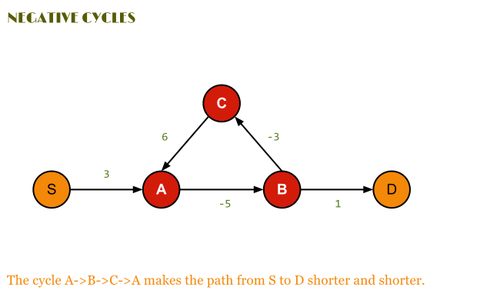

a) Solve the Shortest path of this graph using Bellman-Ford algorithm, step-by-step

b) Consider the following bellman-ford graph, A negative “cycle” makes the path

shorter and shorter: i) What does that mean? ii) How to test for negative cycle?

c) Write Java code for the graph considering the following Algorithms:

<https://algorithm.programmingpedia.net/en/tutorial/4791/bellman-ford-algorithm>

Procedure Bellman-Ford(Graph, source):

n := number of vertices in Graph

for i from 1 to n

d[i] := infinity

parent[i] := NULL

end for

d[source] := 0

for i from 1 to n-1

flag := false

for all edges from (u,v) in Graph

if d[u] + cost[u][v] < d[v]

d[v] := d[u] + cost[u][v]

parent[v] := u

flag := true

end if

end for

if flag == false

break

end for

Return d

Procedure Bellman-Ford-With-Negative-Cycle-Detection(Graph, source):

n := number of vertices in Graph

for i from 1 to n

d[i] := infinity

parent[i] := NULL

end for

d[source] := 0

for i from 1 to n-1

flag := false

for all edges from (u,v) in Graph

if d[u] + cost[u][v] < d[v]

d[v] := d[u] + cost[u][v]

parent[v] := u

flag := true

end if

end for

if flag == false

break

end for

for all edges from (u,v) in Graph

if d[u] + cost[u][v] < d[v]

Return "Negative Cycle Detected"

end if

end for

Return d

8. Read the following reference:

<https://www.hackerearth.com/practice/algorithms/greedy/basics-of-greedy-algorithms/tutorial/>

a) Solve the greedy problem for A={8,7,6,5,4,3,2,1}, T=15

b) Write Java code for greedy algorithm with input data in (a)

c) Consider the Scheduling program, how does that work?

d) How (c) is different in (a)?

9. Consider paper “Genetic Algorithms for Balanced Minimum Spanning Tree Problem”.

A) Read and understand only the first 5 pages.

<https://annals-csis.org/Volume_5/pliks/249.pdf>

B) What elements in Algorithm-1 relates to Genetic algorithm, explain

C) How do you initialize population

D) Read the Abstract and explain what the paper intends to accomplish

E) Write Java code for Algorithm-1 described in paper

F) Compile and Run the code

D) Discuss your Input Data, Data Structures, and Outputs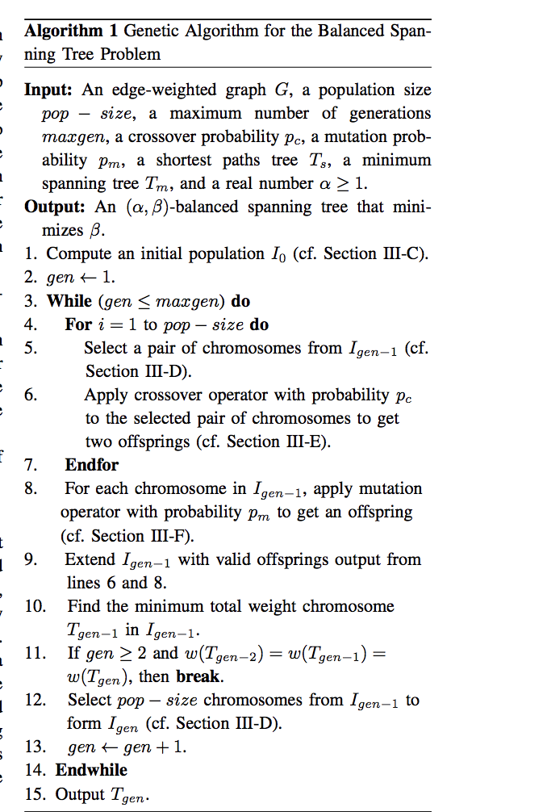

Reference: Balanced Spanning Tree

<https://stackoverflow.com/questions/4795983/balanced-spanning-tree-t-from-undirected-graph>