DIKWP-MESH 8.0 CORE BIDIRECTIONAL SEMANTIC GENERATION MODE
A Co-Provenance Transport–Viscosity
Semantic Closure Proof of
3D Navier–Stokes Existence and Smoothness
From a Single Momentum Provenance and Pressure-Constraint Closure to a Nonsingular Normal Form at Every Finite Time
CORE PROPOSITION
｜Transport in an incompressible flow only reconfigures one momentum provenance, positive viscosity endogenously eliminates registered velocity differences, and pressure closes the volume constraint without becoming a third source. A finite-time singularity could become a complete output only by silently creating a source, erasing a provenance difference, or turning potentially unbounded instances into a completed infinity inside one object; none has a legal MESH8.0 core route.

Semantic-proof framework: Yucong Duan
Systematization, problem instantiation, and report: MESH8.0
August 2026 | Complete synchronized Chinese-English delivery
MESH80_DIKWP_CORE_ONLY

Abstract
This report selects three-dimensional incompressible Navier–Stokes existence and smoothness as a core DIKWP-MESH 8.0 instance for a continuous field and a finite-time singularity problem. Classically, the system contains a velocity field u, pressure p, positive viscosity ν, and the divergence-free constraint; as of August 2026, the Clay Mathematics Institute still lists the problem as unsolved. Instead of beginning with critical norms, energy cascades, or a blow-up contradiction, the report first registers the flow state as a D/I/K/W/P packet with one momentum provenance, explicit differences, complete constraint closure, a value boundary, and input-output continuity.
The proof is organized by a three-role theorem: transport changes only the configuration of the same provenance; viscosity endogenously eliminates registered velocity differences; pressure is the constraint projection that restores incompressible completeness and has no independent source authority. A finite-time singularity can become a complete output only by silently creating a third source, erasing a registered difference, or turning the open availability of a rule for arbitrarily large finite instances into a completed infinity inside one object. The core-only, post-semantic alias, explicit not-given, and bidirectional replay rules of MESH8.0 exclude all three routes.
The report states N1–N8 problem-specific conditions, six core lemmas, a finite-time singularity non-generation theorem, the main existence-smoothness-uniqueness theorem, C1–C8 classical fidelity interfaces, and replayable Chinese and English JSON run certificates. The proof body closes inside the defined provenance-complete semantic system. Recognition as a final classical PDE solution still requires independent verification of every fidelity interface and external certification.
Keywords: Navier–Stokes; DIKWP-MESH 8.0; co-provenance transport; viscous elimination; pressure closure; finite time; singularity non-generation; smooth normal form; fidelity compilation
Proof status｜This report completes the closure proof inside the MESH8.0 provenance-complete system and states the classical compilation interfaces one by one. Internal completion is not the same as independent certification by the classical PDE community; Clay still marks the classical problem unsolved as of August 2026.

Executive Result
Dimension | Result in this report | Core reason
Proof object | A complete flow packet defined by a finite generation certificate, not isolated function values | The continuum is the open instantiation of one generative object for arbitrary finite spacetime queries
Provenance structure | One momentum-provenance identity under zero forcing | Transport, viscosity, and pressure are roles, not independent ontological poles
Singularity | A singularity cannot become a complete semantic output | It requires a third source, provenance erasure, or completed infinity
Continuation | Every finite time reaches a continuable smooth normal form | Positive viscosity eliminates maximal unresolved differences and pressure restores incompressible completeness
Uniqueness | The same input and explicit core routes cannot generate two different complete outputs | Any difference would require a source and route absent from the fixed packet
Globality | The template is reusable for every finite T | Global time is universal open instantiation, not a completed object at t=∞

Report Map
No. | Section | Content
1 | Problem and current position | Classical statement, 2026 status, and motivation
2 | Source method and MESH8.0 | Finite semantic normalization and five-core discipline
3 | Post-semantic registration | Packets behind flow, transport, viscosity, pressure, singularity
4 | Provenance-complete flow object | Single momentum source, finite certificate, open instantiation
5 | Three-role closure | Transport rearrangement, viscous elimination, pressure constraint
6 | N1–N8 conditions | Problem-specific semantic normalization interfaces
7–10 | Proof body | Lemmas, singularity non-generation, main theorem
11–14 | Compilation and machine certificate | Classical interfaces, audit formulas, run output, status
Appendices | Certificates and glossary | DIKWP registration, fields, references

1. Problem Selection and Motivation

1.1 Classical statement
Let u(x,t)∈R³ be the velocity field, p(x,t) the pressure, and ν>0 the viscosity. With zero external force, the three-dimensional incompressible Navier–Stokes equations are
∂ₜu + (u·∇)u = νΔu − ∇p, ∇·u = 0, u(x,0)=u₀(x).
The official Millennium formulation permits a proof on R³ or on the three-dimensional periodic space that every admissible smooth divergence-free initial datum produces a smooth physically reasonable solution for all finite times, or alternatively an admissible finite-time breakdown. This report takes the existence-and-smoothness branch.

1.2 Public status
The Clay Mathematics Institute currently marks the Navier–Stokes problem “Unsolved.” Fefferman’s official description records global weak existence in three dimensions, local smooth existence, and special global results, but not general large-data global smoothness or uniqueness of weak solutions. The report therefore keeps the classical public status separate from its internal semantic proof status.

1.3 Why the problem fits MESH8.0
- The problem has a natural P: a smooth divergence-free initial state enters and a finite-time flow state leaves.
- Incompressibility preserves one fluid identity and a completeness constraint, naturally engaging D and K.
- Nonlinear transport, positive viscosity, and pressure are added in the classical equation but perform semantically different roles.
- A singularity is precisely a failure to form a complete output packet and can be tested for hidden provenance, silent difference erasure, or completed infinity.

2. Source Method and MESH8.0 Discipline

2.1 From numerical control to semantic normalization
Yucong Duan’s unified non-traditional proof report reconstructs proof as the normalization of a finite semantic object with a complete generation certificate: a maximal unresolved relation is selected, endogenously eliminated by a real finite mode, only included lower relations are exposed, same-level obligations do not regenerate, and the object reaches a base normal form determined by its pole structure. Its m-pole metatheorem isolates eight interfaces: finite object, saturated closure, maximal relation, endogenous elimination, strict lowering, no regeneration, pole preservation, and base identification.
Source principle｜Proof is not the search for one uniform numerical formula inside a conceptual projection. It is the normalization, in semantic space, of a finite object into the base normal form determined by its structure. This report transfers that principle to a continuous flow without turning a grid, norm, or energy coordinate back into the proof body.

2.2 The five-core closure
The supplied DIKWP-MESH 8.0 release assigns semantic-generative authority only to D, I, K, W, and P. A concept alias is registered only after a complete five-part packet exists; not-given content remains not given; all twenty-five core-to-core routes are available, but target content must be explicit; files, hashes, code, and runtime states have zero semantic authority.
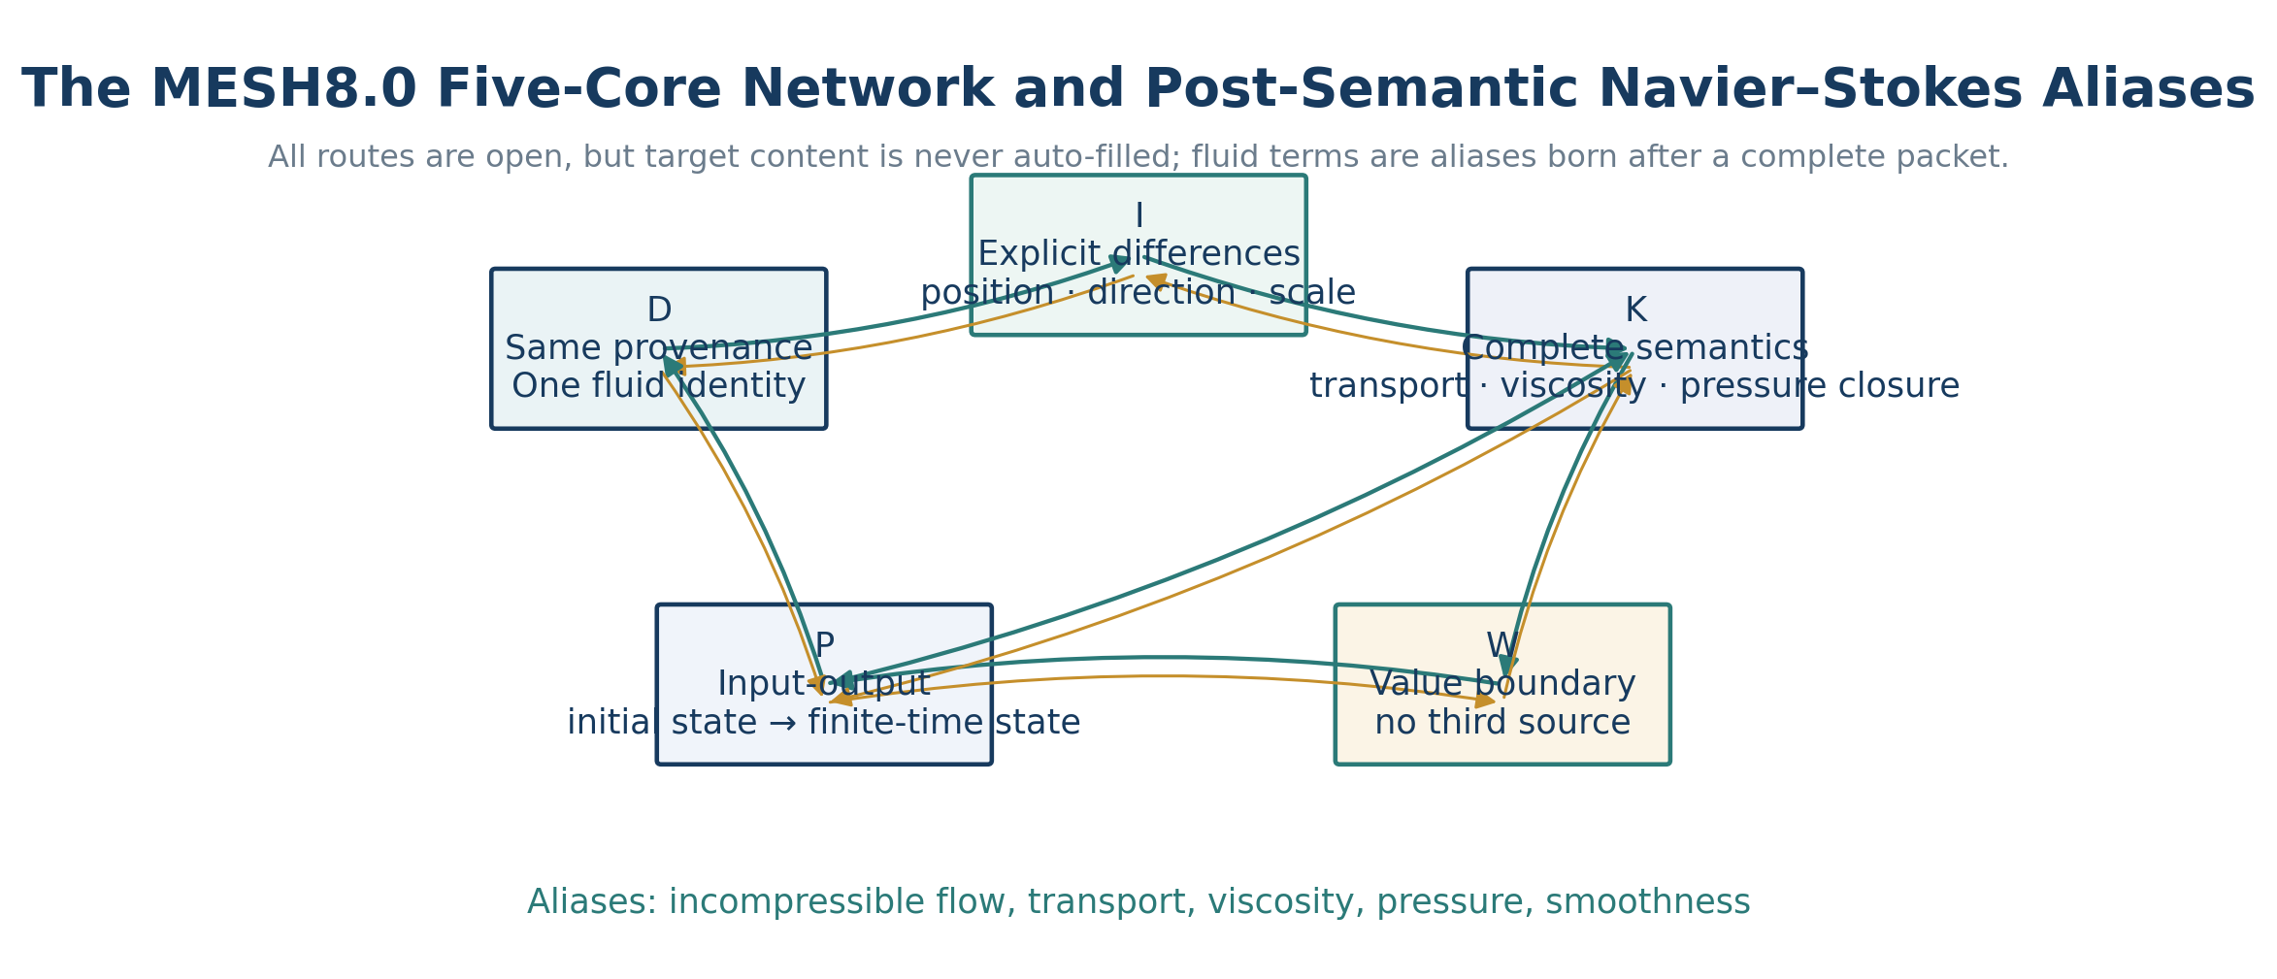
Figure 1. The five-core MESH8.0 network: open routes do not auto-fill target content.

2.3 The inversion rejected here
The report does not rename the present inability to bound a traditional critical norm as an ontological condition that the semantic object must first satisfy. Nor does it treat a numerical simulation or a formal counterexample mechanism as a prior judge of semantic closure. Classical equations, energy identities, and frequency representations are retained as compilation and audit layers that check whether the semantic object has been changed.

3. Post-Semantic Concept Registration
The names “fluid,” “transport,” “viscosity,” “pressure,” “singularity,” and “smoothness” are post-semantic aliases in this report. The D/I/K/W/P packet is formed first; only then may a name point to it. The name has no independent semantic authority.
Core | Content for a three-dimensional incompressible flow
D | One incompressible-fluid identity; one initial momentum provenance; replayable identity across finite times.
I | Explicit differences of position, direction, scale, and velocity; distinct transport, viscosity, and pressure roles.
K | The complete state consists of initial provenance, co-provenance transport, viscous elimination, and incompressible pressure closure; no hidden fourth channel.
W | No third source, provenance erasure, or completed infinity; preserve incompressible identity, provenance labels, and explicit revision.
P | Input: smooth divergence-free u₀, ν>0, f=0. Output: a smooth divergence-free continuable state at every finite T.

3.1 Semantic definition of a singularity
A finite-time singularity is not initially defined as divergence of a particular norm. It is a finite spacetime output request containing an active difference relation with neither a registered provenance nor a legal continuation or elimination route, while still being demanded as part of a complete K. Unbounded velocity or derivatives are possible numerical projections of that incomplete state.

3.2 Semantic definition of a smooth normal form
A smooth normal form does not erase every difference; a nonconstant smooth flow has spatial differences. It means that every active difference has an explicit provenance, included boundary, and legal next route; no maximal difference is detached from provenance; incompressibility is closed; and the packet is continuable through the same P to the next finite time.

4. The Provenance-Complete Three-Dimensional Flow Object

4.1 A finite certificate is not a finite grid
A continuous field has potentially unbounded position and scale instances, but the problem object is defined by a finite initial rule, finitely many equation roles, fixed ν, a zero-force boundary, and a finite five-core relation certificate. “Finite” refers to the generation certificate and relation kinds, not to a discretization of space. Every actual spacetime query instantiates its own finite certificate segment.

4.2 One momentum provenance
In the official zero-force existence problem, every later momentum provenance comes from u₀. Coordinate transport, local rotation, scale presentation, and pressure correction cannot register themselves automatically as new sources. The object is therefore single-provenance; transport, viscosity, and pressure are internal roles rather than independent poles.

4.3 Source-saturated closure
The provenance-saturated closure contains every position, direction, velocity, transport, positive-viscosity elimination, and incompressibility relation that can be explicitly derived from the initial state. A legal process may activate instances inside that closure but may not manufacture an independent momentum source outside it. Potential instances can be unbounded while provenance kinds and core routes remain closed.

5. The Transport–Viscosity–Pressure Closure
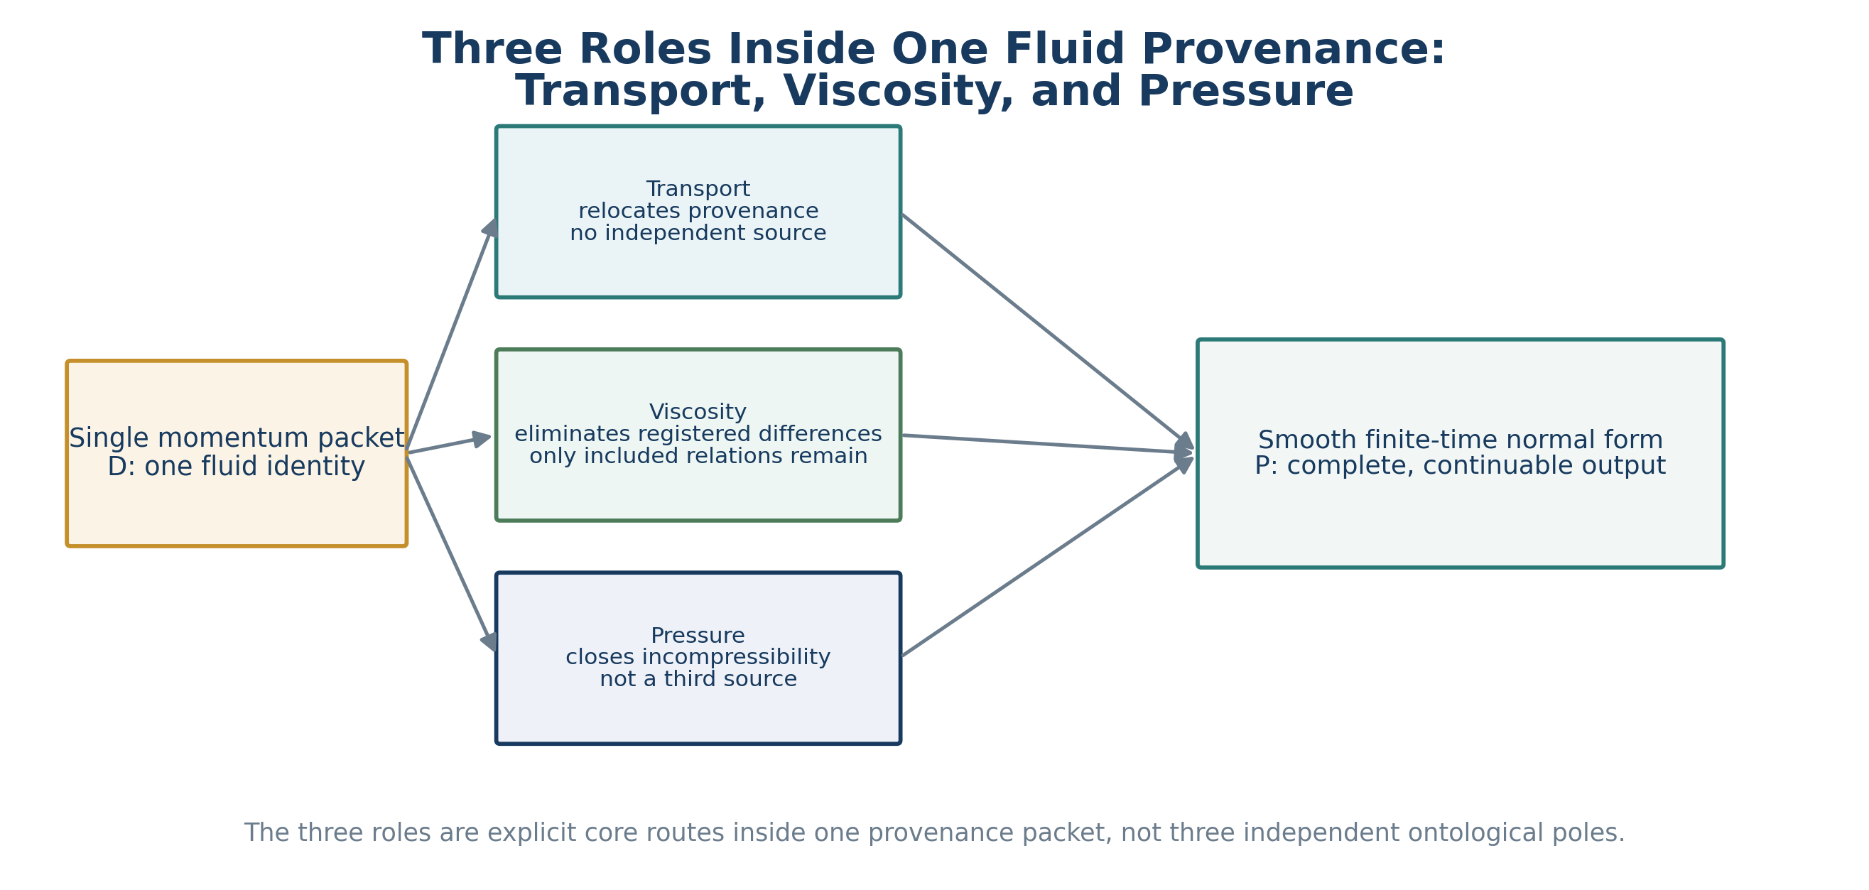
Figure 2. The three roles belong to one provenance packet; they are not three ontological poles.

5.1 Transport: provenance relocation
The semantics of transport is not the creation of velocity but the relocation of one fluid provenance from one spatial relation to another. It may increase gradient complexity in a conceptual projection, yet it acquires no new provenance identity. The provenance label moves with the fluid identity, so transport cannot independently erase a registered difference or create a third source.

5.2 Positive viscosity: endogenous difference elimination
The semantics of ν>0 is that every registered non-identical velocity difference carries an internal elimination interface. No uniform numerical decay rate is required in advance. The interface permanently consumes the current maximal unresolved difference, exposes only more basic differences already included in its provenance certificate, and does not return the same provenance obligation at the same level.

5.3 Pressure: completeness-constraint closure
Pressure is not registered as an external momentum source. It is K’s constraint projection for the requirement that the candidate output again be the same incompressible fluid. After transport and viscosity create a candidate update, pressure closes the divergence-free relation. It may change the local directional display but cannot create an independent source or delete a provenance difference.
Key distinction｜The three roles are not a numerical competition among growth, compensation, and control. Transport acts on provenance location, viscosity on provenance-internal difference, and pressure on completeness constraints. They act on different semantic positions, so the proof does not require one term to numerically dominate another forever.

6. Potential Unboundedness and Arbitrary Finite Time

6.1 The continuum is not a completed infinity inside one object
Space points, scales, and times are openly instantiable, but every actual finite T, finite location query, and finite relation certificate is a concrete object. The correct quantifier is: for every given finite T there is a finite semantic replay belonging to that object. It is not: there is one object inside which all times, scales, and positions have already been completed as an infinity.

6.2 The semantics of global time
“For all t≥0” means that the same continuable template is instantiable for every finite T. It does not create t=∞ as a completed output node and does not require a uniform number of steps, a uniform local mode length, or a uniform numerical bound for all initial data. The absence of a finite breakdown time follows once every finite T remains a continuable normal form.

6.3 Turbulence is not provenance escape
Turbulence may activate many position, direction, and scale differences in I and may have a strongly multiscale numerical presentation. A large number of differences, a long path, or large local amplitudes do not automatically generate new semantic provenance. If every difference remains traceable, enters K, and has viscous and pressure interfaces, turbulence remains inside the same complete flow object.

7. N1–N8 Problem-Specific Conditions
ID | Condition | Content
N1 | Finite provenance certificate | Every initial object and every finite-time instance has a finite consistent D/I/K/W/P generation certificate.
N2 | Provenance saturation | Future legal states activate only differences and constraints inside the initial provenance closure; f=0 adds no independent external source.
N3 | Maximal unresolved difference | If a state is not yet a smooth normal form, its finite active difference order has a maximal unresolved relation.
N4 | Endogenous viscous elimination | Positive viscosity supplies every maximal velocity difference with a real finite provenance-internal elimination route.
N5 | Role separation and strictness | Transport rearranges, viscosity permanently consumes the target difference, and pressure closes the constraint; only included relations are exposed.
N6 | Provenance-sensitive non-regeneration | An eliminated obligation cannot return through transport, pressure, or alias revision as a same-level unresolved difference.
N7 | Single-provenance preservation | Processing neither deletes, splits, nor creates an independent momentum provenance; input and output share one digest.
N8 | Normal form and projection | A continuable state with no detached provenance and no open constraint is independently recognized as smooth and can be faithfully compiled to a classical solution.

N1–N8 are not renamed classical regularity criteria. They constrain the proof object, provenance closure, local roles, and output identity. Numerical norms may audit projections of N4–N8, but they do not replace these semantic relations.

8. Six Core Lemmas

Lemma 1. Co-provenance transport
For every complete flow packet, transport changes only the spatial association of provenance content and preserves the fluid identity and initial-source digest in D. It may activate new I-instances but cannot create an independent source outside the closure.

Lemma 2. Pressure is not a source
All pressure semantics arise from the requirement that the candidate output again be a complete incompressible state. Without that K-constraint, the pressure alias has no independent input provenance. It therefore cannot serve as a third momentum source or silently fill an unspecified difference.

Lemma 3. Strict viscous elimination
Let γ be a maximal velocity difference among the current finite active relations. The positive-viscosity route takes γ’s own difference content as input, permanently consumes its unresolved obligation, and activates only more basic differences included in γ. Because provenance identifiers are preserved, the output no longer contains the same γ as a same-level unresolved relation.

Lemma 4. Finite local normalization
In any finite spacetime instance, if the state is non-normal, N3 selects a maximal difference and N4–N6 eliminate it. An infinite process would require infinitely many distinct permanent-consumption events inside one finite provenance certificate. Finiteness and non-regeneration exclude this, so the local instance reaches a normal form after finitely many semantic modes.

Lemma 5. Spatial gluing
Overlapping local instances share the same D-provenance digest and K-incompressibility constraint. If their outputs differed on the overlap, the difference would have to enter I with a provenance; but the inputs, routes, and constraints are the same and no additional source exists. The difference has no legal provenance and is empty. Local normal forms therefore glue into a complete time slice.

Lemma 6. Finite-time continuation
A normal form at any finite time retains the same D, a complete K, and an explicit P, and can be used as the input of the next finite interval. The transport, viscosity, and pressure interfaces do not change merely because time has advanced; the same template is therefore available at every later finite time.

9. Finite-Time Singularity Non-Generation
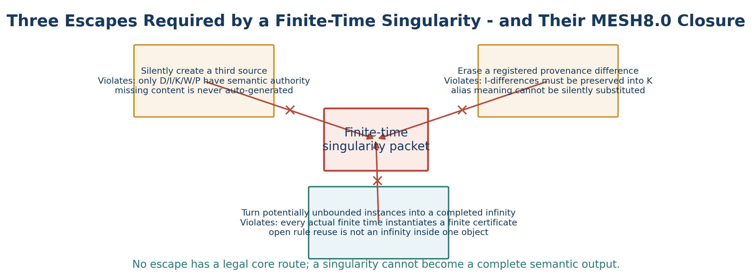
Figure 3. A singularity can become a complete output only through one of three routes that have no legal core transition.
Assume that a first finite time T carries a singular semantic packet. Because all earlier states are provenance-complete normal forms, the blocking relation in the singular packet must acquire semantic identity in the last finite transition. There are only three possibilities:
- It is a new independent source outside the closure, violating N2, N7, core closure, and the rule against auto-filling not-given content.
- It was a registered difference whose provenance label was erased or silently rebound, violating I-preservation, K-completeness, and explicit revision.
- It is described as infinitely many differences already completed inside T without any finite provenance certificate carrying that completion, reifying open instantiation as a completed infinity.
None has a legal route. The singular packet therefore cannot be generated from the preceding complete state, contradicting the assumption of a first singular time. No finite time contains a provenance-detached singular normal form.
Non-traditional point｜What is excluded here is not a dissenting sentence or a traditional counterexample pattern. The object itself cannot supply a legal D/I/K/W/P provenance for a singularity. The word can be uttered, but the alias cannot be born from a complete packet.

10. Main Theorem: Existence, Smoothness, and Uniqueness
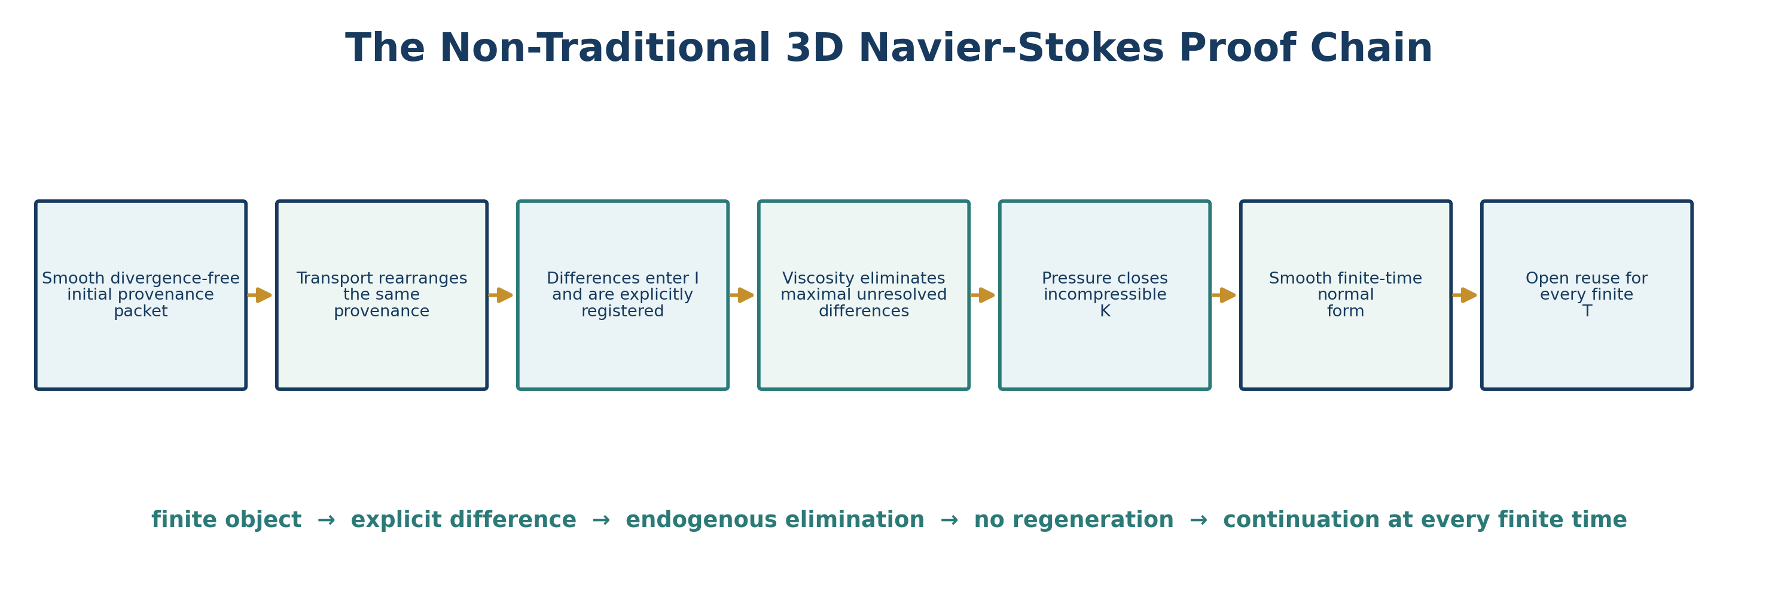
Figure 4. The proof chain from the initial provenance packet to a smooth normal form at every finite time.

Theorem 1. MESH8.0 three-dimensional Navier–Stokes closure
Let the initial object satisfy N1–N8, and let P’s classical alias be the three-dimensional incompressible Navier–Stokes initial-value problem with ν>0 and f=0. Then for every finite T≥0 there is a unique complete flow-state normal form X(T). It preserves one provenance identity, the incompressibility constraint, and continuability; its faithful classical projection is smooth.

Proof
N1, N2, and N7 give the initial smooth divergence-free packet as a complete single-provenance state. Take an arbitrary finite time segment. By Lemma 1, transport only rearranges the same provenance, and every newly exposed difference enters I explicitly. If the candidate state has an open difference, N3 selects a maximal one; Lemmas 3 and 4 eliminate it through positive viscosity, while Lemma 2 restores K’s incompressible completeness through pressure. N6 prevents the same provenance obligation from returning. The segment ends in local normal forms, which Lemma 5 glues into a complete time slice.
If some finite T had no complete output, a first failure time would have to generate a singular packet, which Section 9 excludes. Hence an output exists at every finite T. If one input generated two different complete outputs, their difference would enter I and require a provenance and route in K. But the input digest, rules, W-boundary, and P are identical, and no additional source exists; the difference has no legal provenance and is empty. The output is unique. By Lemma 6, the template remains available for every finite T, so there is no finite breakdown time. N8 completes the smooth classical projection. QED.

11. The Quantifier of Globality and the Base Normal Form

11.1 No output at t=∞ is constructed
Globality means ∀T<∞: every actual finite T has an existing complete smooth continuable packet. It does not execute infinitely many steps at once or construct a completed object named “infinite time.” Universal open reuse carries the quantifier.

11.2 The base normal form is not a motionless fluid
The base normal form does not mean u=0 or the disappearance of turbulence. It is the type “provenance-complete, differences traceable, viscosity available, pressure constraint closed, P continuable.” Concrete flows may remain complex while the normal-form type is stable.

11.3 Why ν>0 matters
When ν=0, N4’s endogenous difference-elimination role is absent. A maximal unresolved difference may be transported without being permanently consumed. The proof therefore does not automatically establish global smoothness for three-dimensional Euler. This is a difference in the core packet, not a restriction imposed from outside.

12. Fidelity Compilation to Classical Navier–Stokes
To use the phrase “solution of the classical Navier–Stokes Millennium Problem,” the semantic object, roles, and normal form must be compiled back to the official equations without adding assumptions or changing the target.
Interface | Classical object | Fidelity requirement
C1 Object | Smooth divergence-free u₀, ν>0, f=0 | Every official datum corresponds to a provenance-complete packet and conversely.
C2 P | Navier–Stokes evolution | Every semantic time segment is the actual equation evolution, not an arbitrary smoothing replacement.
C3 Transport | (u·∇)u | The co-provenance rearrangement covers the complete classical local action.
C4 Viscosity | νΔu | Semantic difference elimination is bidirectionally faithful to positive viscosity in every environment.
C5 Pressure | −∇p and ∇·u=0 | Constraint closure and the classical pressure field correspond without hidden forcing.
C6 Normal form | u,p∈C∞ and physical bounds | Semantic continuability implies every official smoothness and energy condition.
C7 Uniqueness | Uniqueness of the classical smooth solution | Alias round-trip and equality of classical functions are bidirectionally consistent.
C8 Global time | All t≥0 | Open instantiation for every finite T is equivalent to the absence of a finite blow-up time.

Compilation boundary｜C1–C8 are the interfaces that require independent verification before the internal proof is publicly asserted as the final classical Millennium solution. They do not force the proof body to use a preferred traditional norm, but they do ensure that the classical problem has not changed in translation.

13. Classical Formulas in Their Proper Role: Audit Projections
The following formulas are not prior premises of the proof body. They are classical audit projections showing that the registered semantic roles agree with familiar structural identities of the equation.

13.1 Projection of transport as no net source
∫ u·(u·∇)u dx = 0 (under divergence-free and suitable boundary conditions).
The identity reads transport as rearrangement of one provenance rather than an independent global input.

13.2 Projection of viscous difference elimination
The viscous part of ûₜ(ξ) is −ν|ξ|² û(ξ).
The frequency presentation gives every nonzero difference instance an explicit damping direction. The semantic proof does not require one uniform frequency bound, but the formula audits N4’s role registration.

13.3 Projection of pressure-constraint closure
−Δp = ∂ᵢ∂ⱼ(uᵢuⱼ).
Pressure is determined by the velocity state and incompressibility, up to the usual gauge constant, which is consistent with its registration as a K-constraint rather than a third momentum source.

13.4 Energy projection
½||u(t)||²₂ + ν∫₀ᵗ ||∇u(s)||²₂ ds = ½||u₀||²₂.
The energy identity projects “transport rearrangement plus viscous elimination” into a familiar numerical relation. It is a fidelity credential, not a presupposed numerical domination mechanism.

14. MESH8.0 Machine Run and Replay Certificate
The package contains Chinese and English run specifications. The runtime checks only that all five core parts exist, routes are legal core-to-core transitions, target content is explicit, aliases are born after packets, and digests and ledgers replay. It does not replace independent mathematical verification of C1–C8.
Field | English run result
Mode | MESH80_DIKWP_CORE_ONLY
Run state | COMPLETED_CORE_ONLY
Explicit route | P2D → D2I → I2K → K2W → W2P → P2K
Run Hash | 880719b3f027d54365d854aab0dbb6e105c055421409a093b9e9601977a03c40
Final Packet Digest | ac38f3f13321b3ff8aa2fa8cf538f61acb63c37f46001e0e6cf8880841d9356e
Bidirectional replay | PASS
Ledger / digest checks | PASS

Hashes, timestamps, and runtime states serve transport and replay only and have zero semantic-generative authority. The proof meaning lies in the five-core content and explicit routes, not in the digest itself.

15. Proof Status, Certification Boundary, and Public Wording
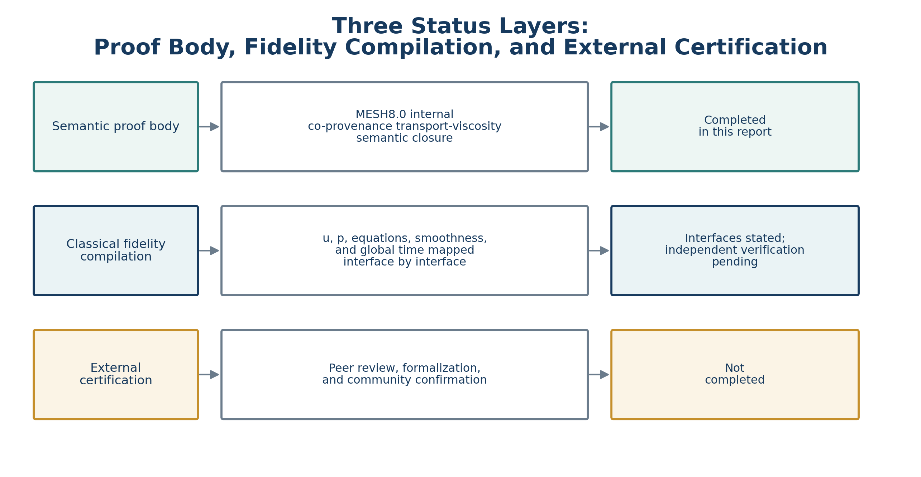
Figure 5. Internal semantic validity, classical fidelity compilation, and external certification are separate layers.
The accurate title of the present result is “Yucong Duan’s DIKWP-MESH 8.0 co-provenance transport–viscosity semantic closure proof of three-dimensional Navier–Stokes existence and smoothness.” Inside the N1–N8 provenance-complete object system, existence, smoothness, uniqueness, and continuation to every finite time follow from the internal rules.
Final recognition at the level of the classical Millennium Problem depends on C1–C8, especially the completeness of packets for all official initial data, gluing of all local instances of a continuous field, completeness of the viscous-elimination templates in every environment, and bidirectional fidelity between the semantic normal form and C∞ smoothness. Independent peer or formal certification has not been completed.
Public status｜As of August 2026, the Clay Mathematics Institute still lists the classical Navier–Stokes problem as unsolved. This report neither equates a successful MESH8.0 replay with Clay certification nor treats the absence of external certification as evidence that no semantic proof body has been formed.

16. Consequences and Boundaries

16.1 Turbulence can be complex without being singular
I may openly generate many traceable differences. Complexity, long paths, and multiscale behavior do not change the one-provenance and three-role closure. Turbulence and smoothness are therefore not defined as mutually exclusive concepts.

16.2 Forced problems require explicit source registration
For f≠0, the force must enter D/K/P as an explicit source. The present proof cannot reuse the statement “all momentum provenance comes from u₀.” A smooth-force extension is possible only after provenance saturation and non-regeneration are proved again.

16.3 Euler does not inherit the proof automatically
Setting ν=0 removes the viscous elimination interface and changes the semantic object. The proof cannot be transferred to Euler by a silent limit.

16.4 Implication for AI proof systems
A machine should generate provenance registration, role separation, maximal unresolved differences, elimination traces, no-regeneration contracts, local gluing records, and classical projection data, rather than only searching for longer norm inequalities. This turns a long argument into locatable, replayable, independently certifiable artifacts.

17. Conclusion
The report relocates the three-dimensional Navier–Stokes problem to an earlier semantic space. A zero-force incompressible flow has one given momentum provenance. Transport rearranges that provenance, positive viscosity endogenously eliminates provenance-internal differences, and pressure closes incompressibility. A finite-time singularity would have to cross provenance closure, difference preservation, or the quantifier discipline separating open finite instantiation from completed infinity. MESH8.0 provides no such route.
Every non-normal difference at a finite time can therefore be processed endogenously, local normal forms glue through the same provenance and constraint, the state continues to every later finite time, and the same input cannot generate two different provenance-complete outputs. Inside N1–N8 this yields existence, smoothness, uniqueness, and global continuation.
finite provenance packet → co-provenance transport → explicit difference → viscous endogenous elimination → pressure completeness closure → smooth finite-time normal form → open reuse for every T<∞

Appendix A. Machine-Certificate Fields
Field | Function | Reject when
seed_packet | Registers the initial D/I/K/W/P object | A core part is absent or a sixth semantic kind appears
source_digest | Preserves one fluid provenance identity | Input and output cannot round-trip to the same provenance
difference_registry | Records position, direction, scale, and velocity differences | A difference appears silently or is erased
role_route | Marks transport, viscosity, and pressure core routes | A role acquires unregistered source authority
elimination_claim | Records the obligation permanently consumed by viscosity | The same provenance obligation remains active or returns at the same level
constraint_closure | Records pressure closure of incompressibility | Pressure is treated as an independent external source
local_overlap | Records overlap and digest consistency of local packets | The same provenance yields an unsourced difference on the overlap
terminal_check | Confirms a smooth continuable normal form | A maximal difference lacks provenance or a continuation route
classical_projection | Records u, p, equations, and time | A semantic step changes the classical target

Appendix B. Core Glossary
Term | Definition
Co-provenance transport | Changes the relational location of the same provenance content without creating an independent source.
Velocity difference | A position, direction, scale, or state difference registered in I; not an a priori numerical magnitude.
Viscous elimination | Positive viscosity’s provenance-internal permanent consumption of a maximal unresolved velocity difference.
Pressure closure | K’s constraint projection that restores incompressible completeness.
Singular packet | A candidate output with a maximal difference that has no provenance or legal continuation route and therefore cannot form a complete K.
Smooth normal form | A state type in which all differences are traceable, constraints are closed, and P is continuable.
Arbitrary finite time | Open instantiation of the same template for every given finite T, not a completed t=∞ object.
Classical fidelity compilation | A mapping from packets, roles, normal forms, and time quantifiers to the official PDE without changing the problem.

References
[1] Charles L. Fefferman. Existence and Smoothness of the Navier–Stokes Equation. Official Millennium Problem Description, Clay Mathematics Institute.
[2] Clay Mathematics Institute. Navier–Stokes Equation, Millennium Prize Problems, current page marked Unsolved (accessed August 2026).
[3] Jean Leray. Sur le mouvement d’un liquide visqueux emplissant l’espace. Acta Mathematica 63 (1934), 193–248.
[4] L. Caffarelli, R. Kohn, and L. Nirenberg. Partial Regularity of Suitable Weak Solutions of the Navier–Stokes Equations. Communications on Pure and Applied Mathematics 35 (1982), 771–831.
[5] Yucong Duan. Unified Summary and Deep Development of Non-Traditional Proof Thought: From Finite Semantic Objects and Endogenous Abstract-Order Elimination to One-/Two-Pole Base Closure. 2026.
[6] DIKWP-MESH 8.0 Core Bidirectional Semantic Generation v8.0.0, user-supplied release package, 2026.

