The Transparent Opportunity Economy
Routes, Saturation, and DIKWP Contribution after Model-Native Software
DIKWP Research Programme
2026-09-07
TOEP-1000:2026-DRAFT
Open-source research reference implementation
Contents
Routes, Saturation, and DIKWP Contribution after Model-Native Software
Executive summary
1. Discriminating the two source arguments
2. From information gaps to opportunity-denominator gaps
3. DIKWP as an economic capability language
4. What must be transparent
5. ClearPath decision model
6. A route-finding workflow for ordinary people
7. Synthetic examples
8. Training-opportunity integrity
9. Transparent contribution without total surveillance
10. Architecture and deployment
11. Open-core commercialization
12. TOEP-1000
13. Reality boundary
Conclusion
References

Routes, Saturation, and DIKWP Contribution after Model-Native Software
DIKWP ClearPath Transparent Opportunity Economy OS v1.0.0
Status: open-source research reference implementation
Draft protocol: TOEP-1000:2026-DRAFT

Executive summary
Advanced models are moving from content generation toward choosing among code, APIs, browsers, graphical interfaces, files, and other tools. AI-assisted programming also lowers the cost of producing scripts, prototypes, and applications. Together, these changes commoditize a growing share of generic execution.
They do not automatically create customers, funded demand, trust, distribution, authority, local context, or responsibility. A new gap therefore appears after information and production barriers fall: the opportunity-denominator gap. Thousands of people may acquire similar capabilities while the number of funded positions, projects, or customers remains small. Early entrants may capture reputation, data, distribution, and switching costs before later entrants arrive.
This report defines a Transparent Opportunity Economy. Before a course, career route, or entrepreneurial path is marketed, the economic denominator should be disclosed: funded demand, remaining paid capacity, current and expected qualified supply, automation exposure, price, cost, first-revenue delay, first-mover concentration, access requirements, DIKWP transformations, acceptance evidence, expiry, and correction.
ClearPath evaluates a specific route under a specific person's declared constraints. It can return GO_​NOW, TEST_​CHEAPLY, PIVOT_​TO_​COMPLEMENT, or NO_​CURRENT_​VIABLE_​PATH. The last result closes a route until named evidence changes; it never declares that a person has no value or no future.

1. Discriminating the two source arguments

1.1 Interface walls are weakening; permission walls remain
The first source argues that an agent can increasingly choose among APIs, browser actions, code, shells, and graphical interfaces rather than follow a workflow fully predetermined by a developer. Its most defensible structural claim is that graphical interfaces are becoming machine-usable interfaces and that the software vendor may lose some control over navigation and sequencing.
The same source explicitly distinguishes interface access from authorization. Better computer use does not grant credentials, data rights, administrative privileges, or legal authority. It also states that the author had not independently tested the reported frontier model at the time. The analytical implication is therefore not “apps disappear,” but:
Scarcity(interface entry)↓
while:
Scarcity(authority, trusted data, customers, responsibility, acceptance) remains

1.2 “AI coding is a dead end” is a rhetorical title, not the article's final proposition
The accessible written version accompanying the second video attacks the belief that learning AI coding, building a product, and waiting for customers is a complete livelihood strategy. Later, it explicitly qualifies the title: AI coding is useful as a tool, but generic software production alone is neither a moat nor a customer-acquisition system. It redirects attention toward industry knowledge, repeated customer problems, trust, and translating workflows into executable agent skills.
Its strongest internal chain is:
Production cost↓ → Homogeneous supply↑ → Distribution and customers become bottlenecks → Context and accountability gain relative scarcity
Some numerical and market claims in that source were not independently established for this report and are treated as author assertions rather than baseline facts.

1.3 Software work has not literally disappeared
Independent evidence does not support a categorical claim that all software work is ending. The U.S. Bureau of Labor Statistics projects 10% employment growth for software developers, quality assurance analysts, and testers from 2025 to 2035. The World Economic Forum also lists software developers among occupations expected to see substantial net growth, while reporting broad task and skill disruption. ILO and OECD analysis is likewise better described as coexistence among automation, augmentation, new tasks, productivity effects, and displacement risk.
The precise proposition adopted by ClearPath is:
Generic execution without customer access, domain context, responsibility, differentiation, or verifiable outcomes is rapidly losing value as a standalone economic moat.

2. From information gaps to opportunity-denominator gaps
Let funded paid capacity over a declared period be Q, current qualified supply be S_​0, and expected new qualified supply be S_​1. Saturation is:
σ=(S_0+S_1) / (max(Q,1))
When σ is high, acquiring more generic capability may not improve economic outcomes. The bottleneck may instead be:
- a named buyer with a budget;
- access to the buyer;
- local trust;
- distribution;
- regulated authority;
- physical execution;
- acceptance and warranty;
- responsibility for errors and repair.
A first-mover pattern is strongest where supply is cheaply replicated, demand grows slowly, distribution is concentrated, switching costs are high, and outputs are interchangeable. It is weaker where opportunities regenerate through locality, relationships, regulation, physical work, continuing care, or responsibility-bearing service.
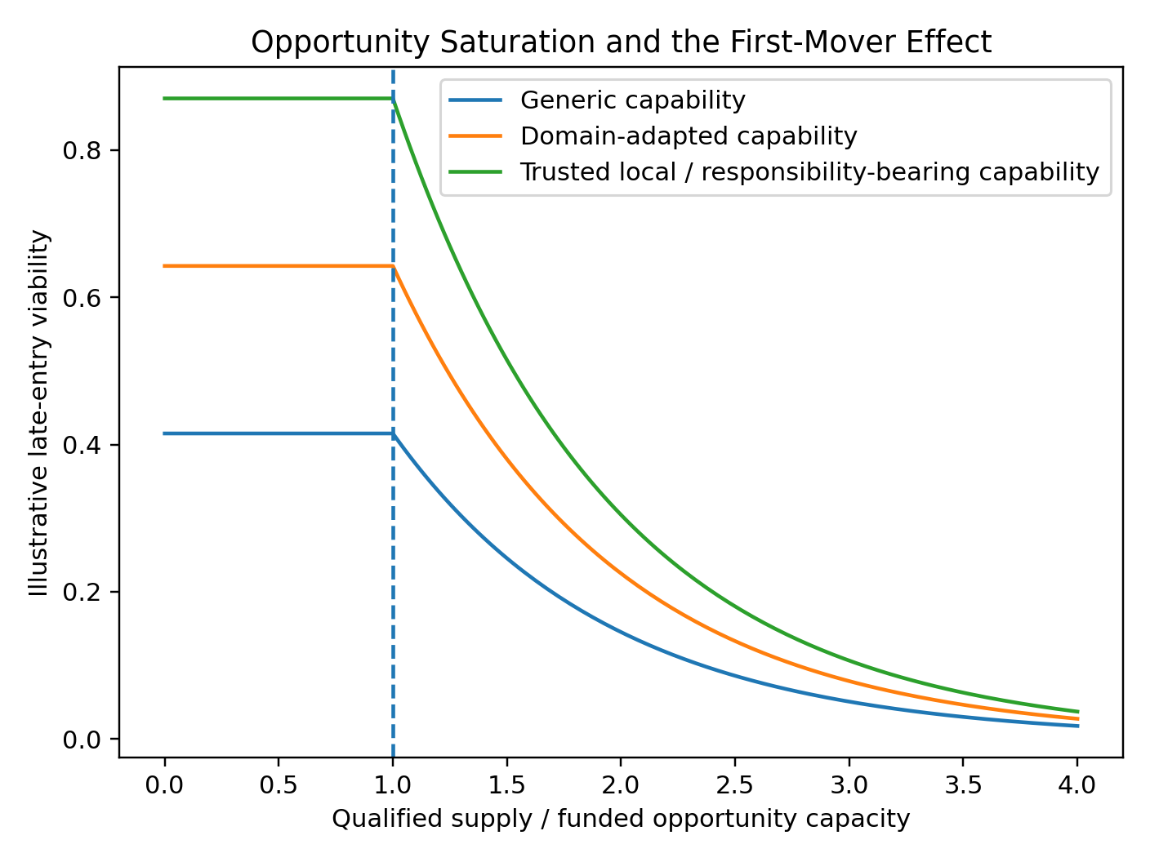
Opportunity saturation

3. DIKWP as an economic capability language
ClearPath separates five storage positions:
- D - Data: records, observations, events, and states;
- I - Information: differences, changes, relations, and anomalies;
- K - Knowledge: structures that can be explained, reproduced, and transferred;
- W - Wisdom: trade-offs under conflicting purposes, uncertainty, and consequences;
- P - Purpose: whose objective is being served, why action is justified, when it stops, and who carries responsibility.
Economic value is produced not only by storage but by 25 directed transformations:
T={D,I,K,W,P} × {D,I,K,W,P}
Examples include D-to-I observation, I-to-K validation, K-to-W contextual judgment, W-to-P bounded action, and P-to-D generation of reality receipts.
As model capability rises, many D/I and generic code transformations become cheaper. Some K work also commoditizes. Relative value migrates toward context, Purpose legitimacy, real-world access, trust, verification, acceptance, and responsibility. This does not claim that models can never support W or P; it means that authority and consequence do not automatically transfer to the model.
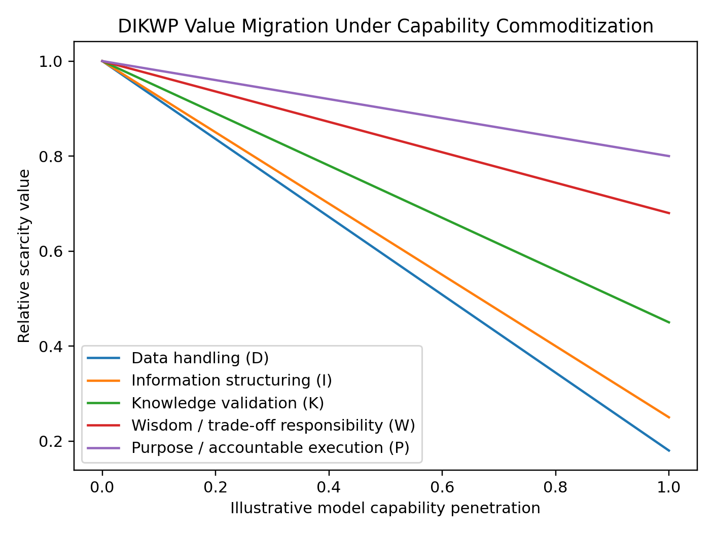
DIKWP value migration

4. What must be transparent
A Transparent Opportunity Economy does not publish every private fact about every person. It publishes the denominator needed to evaluate an opportunity.
A minimally useful opportunity record includes:
1. the paying buyer or funder category;
2. funded paid capacity over a declared period;
3. current qualified supply and counting method;
4. expected new supply;
5. demand and supply growth assumptions;
6. the share of work directly commoditized by models;
7. price and variable cost per accepted outcome;
8. entry cost and time to first revenue;
9. expected opportunity lifetime;
10. customer, trust, distribution, regulatory, and local-execution requirements;
11. supplier concentration;
12. training seats and training revenue marketed against the same route;
13. required DIKWP transformations;
14. evidence, falsifiers, update time, and expiry.
The decisive transparency ratios are not merely successful cases. They include:
PaidOutcomeRate=(people obtaining paid outcomes) / (people entering the route)
and:
RemainingSlotCoverage=(remaining paid capacity) / (current+expected qualified supply)
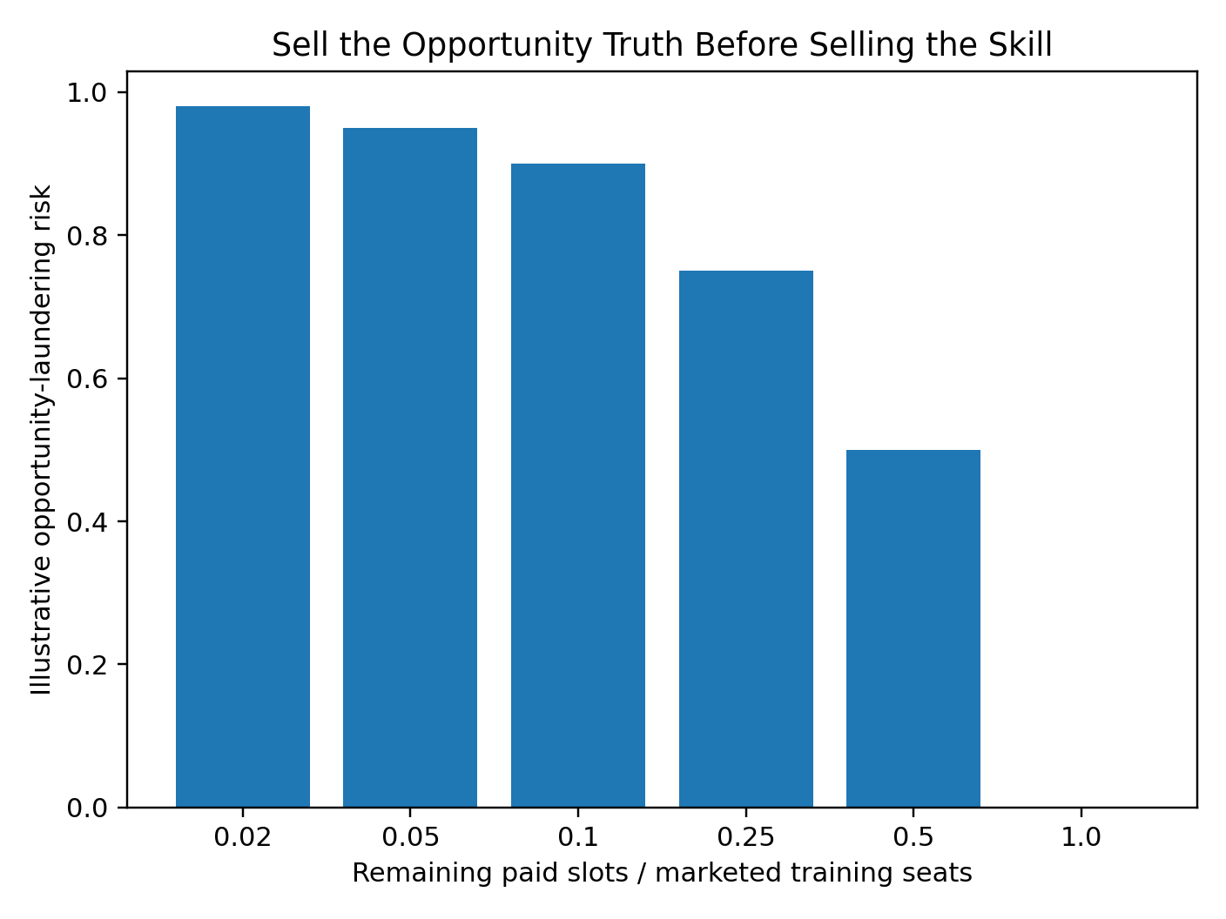
Training integrity
Personal public records should disclose only purpose-bounded, evidenced transformations and expiry. Cash runway, debt, family obligations, health, location, political or religious views, and vulnerability stay private by default.

5. ClearPath decision model
For world w:
Q_w = Q · d_w
S_w = (S_0+S_1) · s_w
σ_w = (S_w) / (max(Q_w,1))
The engine also estimates paid-slot coverage, opportunity half-life, gross margin, residual non-commoditized need, first-mover capture, and opportunity-laundering risk.
For each DIKWP transformation t, available capability combines demonstrated evidence and source-node storage:
A_t=0.78E_t+0.22S_src(t)
The analysis separately preserves capability, customer access, trust, distribution, regulatory access, local execution, time, budget, runway, remaining capacity, margin, concentration, and risk fit. It uses a geometric mean so that one severe bottleneck cannot be washed away by unrelated strengths.
Five incompatible worlds are retained:
1. governed augmentation;
2. rapid capability commoditization;
3. winner-take-most platform concentration;
4. local trust and responsibility reopening niches;
5. AGI-scale labour-value compression.
The engine reports both a weighted mean and a robust floor:
V_floor=min_wV_w
Scenario weights are importance weights, not objective probabilities.
The four route decisions are:
- GO_​NOW - enter a narrow funded experiment;
- TEST_​CHEAPLY - conduct only a small reversible test;
- PIVOT_​TO_​COMPLEMENT - move toward context, trust, local execution, regulation, validation, or responsibility;
- NO_​CURRENT_​VIABLE_​PATH - stop spending until evidence changes a closure condition.
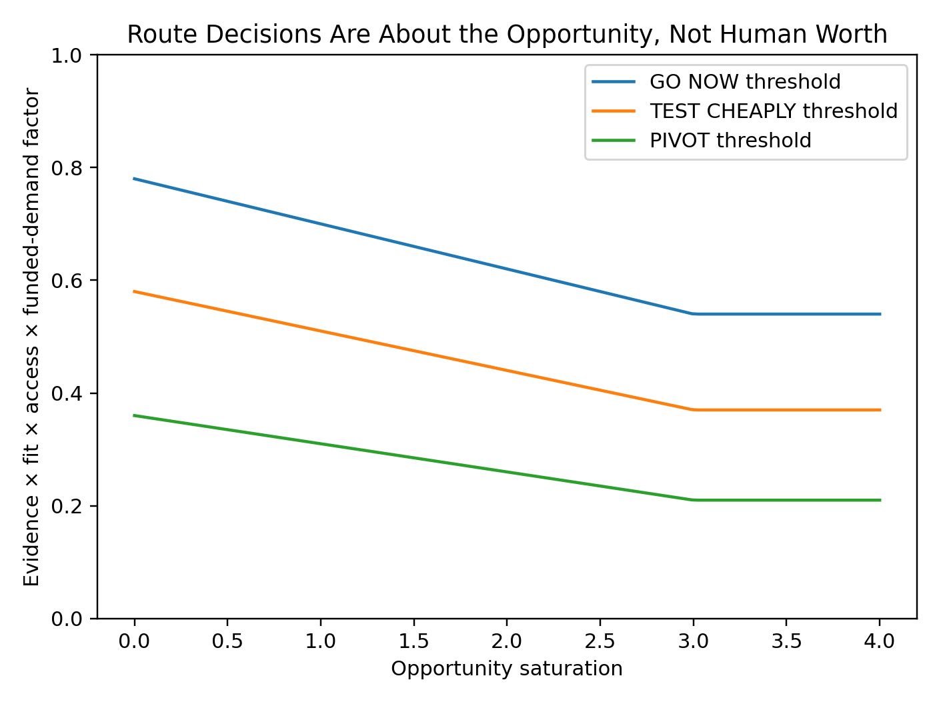
Decision zones

6. A route-finding workflow for ordinary people
A useful question is not “Am I valuable?” It is:
In the next twelve months, who has a funded problem, what outcome will be accepted, how many paid positions exist, how many qualified suppliers will compete, and which bottleneck is mine?
A defensible first experiment requires:
- a named problem holder;
- evidence of cost or unmet need;
- a narrow deliverable;
- written acceptance conditions;
- a price, prepayment, procurement signal, or other value commitment;
- a maximum time and money loss;
- a stop condition;
- a receipt that can falsify the route.
A NO_​CURRENT_​VIABLE_​PATH decision instructs the person to preserve time and cash, stop buying generic training for that route, test only reopening conditions, and search adjacent funded problems. It does not infer low intelligence, poor character, or permanent exclusion.
The portfolio engine compares several routes. It distinguishes:
FUNDED_ROUTE_FOUND
LOW_COST_TEST_ROUTE_FOUND
ONLY_COMPLEMENTARY_PIVOTS_FOUND
NO_CURRENT_VIABLE_PATH_IN_TESTED_SET
The last result applies only to the tested set.

7. Synthetic examples
In the generic AI micro-SaaS fixture, 180 funded slots face 6,500 projected qualified suppliers, producing a saturation ratio of 36.11. Twelve thousand training seats are marketed against the route. Even though the synthetic person has strong generic DIKWP execution evidence, the route is closed because distribution, entry cost, residual demand, and remaining paid capacity fail.
The local SME workflow-and-agent integration fixture has named local buyers, lower distribution requirements, a shorter route to first revenue, and greater context and accountability. It receives GO_​NOW, but only for a narrow paid pilot, not for a large platform build.
The local care and public-service navigation fixture also receives GO_​NOW in the synthetic data because local context, trust, physical coordination, and responsibility remain significant. It still requires professional boundaries and named human authority.
These fixtures test mechanisms; they are not market forecasts.

8. Training-opportunity integrity
A training provider should establish more than educational efficacy. It should disclose the opportunity denominator against which the course is marketed.
ClearPath calculates:
Coverage_training=(Q) / (Seats_marketed)
DownstreamValue=Q · max(Price-Cost,0)
TrainingRevenue=Seats_marketed · TrainingPrice
Risk reasons include:
- fewer than one remaining paid slot per ten marketed seats;
- training revenue exceeding declared downstream opportunity value;
- high-certainty marketing in a saturated route;
- success stories without a complete entrant denominator;
- skill obsolescence faster than course updating;
- training economics that depend mainly on recruiting the next cohort.
The principle is:
Sell the opportunity truth before selling the skill.

9. Transparent contribution without total surveillance
A result may include D collection, D-to-I structuring, I-to-K validation, K-to-W judgment, W-to-P action, and P-to-D reality verification. ClearPath can create a transparent allocation proposal using evidence quality, scarcity, responsibility, verified outcome share, and risk burden.
The reference score is:
Score_i=0.30O_i+0.24E_i+0.20R_i+0.16S_i+0.10B_i
Platform fees are capped at 12%, while commons and correction reserves are separated. The reference engine never transfers money.
Transparent contribution must not become a totalizing worker-surveillance system. It must preserve collective labour standards, unquantified care, privacy, appeals, team outcomes, and protection against permanent individualized ranking. OECD analysis of skills-first systems warns that better skill signalling can coexist with new bias, obsolescence, weakened protections, and over-individualized wage setting. ClearPath treats these as design constraints.

10. Architecture and deployment
The release includes:
- a bilingual standalone HTML application;
- Python CLI and zero-dependency core;
- single-route and multi-route portfolio analysis;
- training integrity and contribution modules;
- privacy-minimized capability cards;
- append-only responsibility ledger;
- loopback JSON API;
- stateless MCP tools;
- A2A and OpenAPI reference records;
- JSON Schemas;
- TOEP-1000 draft specification;
- bounded state exploration and static audit;
- source, Wheel, PYZ, source ZIP, and Git bundle distributions.
Hard boundaries:
automatic_external_action_authority = 0
automatic_employment_decision_authority = 0
automatic_payment_authority = 0
person_level_worth_score = null
Deployment modes include individual guidance, training-integrity review, local economic-development registries, enterprise task markets, and aggregate public opportunity observatories. No deployment should create a permanent population capability registry.

11. Open-core commercialization
The Apache-2.0 core retains all essential decision logic, export, schemas, and correction semantics. Commercial value can be built around trusted operation:
- independent funded-demand verification;
- employer, school, association, and public-service connectors;
- signed and expiring opportunity records;
- sector-specific DIKWP task libraries;
- multilingual and low-connectivity deployment;
- independent appeals and correction propagation;
- outcome evaluation and audit;
- organizational opportunity portfolio management.
A credible first paid pilot is not “predict the perfect career.” It is:
Verify the denominators behind 50-200 transition or training routes, close unsupported paths, identify 3-10 funded experiments, and establish a quarterly update and correction process.
The commercial proposition should be falsified if institutions will not pay for denominator verification, if decisions do not change, or if ordinary participants do not avoid waste or obtain paid experiments.

12. TOEP-1000
The Transparent Opportunity Economy Protocol standardizes:
funded demand
supply denominator
DIKWP transformations
evidence stage
entry cost
first-mover capture
plural-world risk
experiment conditions
reality receipts
closure and reopening
contribution allocation
appeal and correction
Conformance levels:
- L0 - route identity, buyer, purpose, timestamp;
- L1 - capacity, supply, price, cost, and evidence;
- L2 - DIKWP requirements, personal evidence, and privacy minimization;
- L3 - plural worlds, decisions, closure, and reopening;
- L4 - training integrity, contribution, and reality receipts;
- L5 - signatures, revocation, cross-institution correction, and independent audit.

13. Reality boundary
ClearPath is a research alpha. It cannot establish that an input market estimate is true, that all routes have been found, that GO_​NOW will make money, that a closed route will stay closed, or that DIKWP fully captures a human being. It is not an employment decision system, labour-market forecast, legal opinion, financial recommendation, or certification.
The most dangerous misuse would be turning route analysis into a secret hiring score, social credit, automated wage setting, or a justification for excluding disadvantaged people from a route using incomplete data.
Every consequential deployment requires sources, timestamps, scope, a named human authority, appeal, correction, expiry, and model retirement.

Conclusion
The combined source argument is not “everyone should stop programming” or “everyone who learns agents will succeed.” It is:
Generic execution becomes abundant → Funded opportunity, context, trust, responsibility, and distribution become scarce
The old economy often publishes the numerator: successful cases, salaries, tool capability, and early-entrant returns. A Transparent Opportunity Economy publishes the denominator: all entrants, remaining paid capacity, qualified supply, budgets, failures, opportunity lifetime, and automation speed.
A responsible system must be able to say both:
A small, paid, reversible route exists here.
and:
This route currently lacks enough evidence; stop spending and search elsewhere.
DIKWP's deeper contribution is not reducing people to measurable capability. It is creating an accountable exchange language for whose Purpose is served, which transformations are required, what funded demand exists, who carries consequences, how outcomes are verified, and how errors are corrected.

References
1. User-provided source, GPT-6, “Demolishing” the App Wall, 2026. Structural source only; reported model details require independent verification.
2. Fan Kai, Stop Learning AI Coding: It Is a Dead End, 25 May 2026. Accessible written companion to the linked video; several quantitative claims are treated as author assertions.
3. GitHub, Octoverse 2025, updated 28 February 2026.
4. U.S. Bureau of Labor Statistics, Software Developers, Quality Assurance Analysts, and Testers, 2025-2035 outlook.
5. World Economic Forum, Future of Jobs Report 2025.
6. International Labour Organization, Generative AI and Jobs: A Refined Global Index of Occupational Exposure, 2025.
7. OECD, A Skills-First Labour Market, 2026.
8. OECD, Skills in the AI Age, 2026.

