DIKWP-MINEX-FABRIC-OS
Minimum-Energy Capability Fabric
Model-Native, Generated-Code, API, Browser, GUI, Federated Borrowing and Metered Exchange
Architecture, Mathematical Specification, Implementation, Verification and Deployment Report
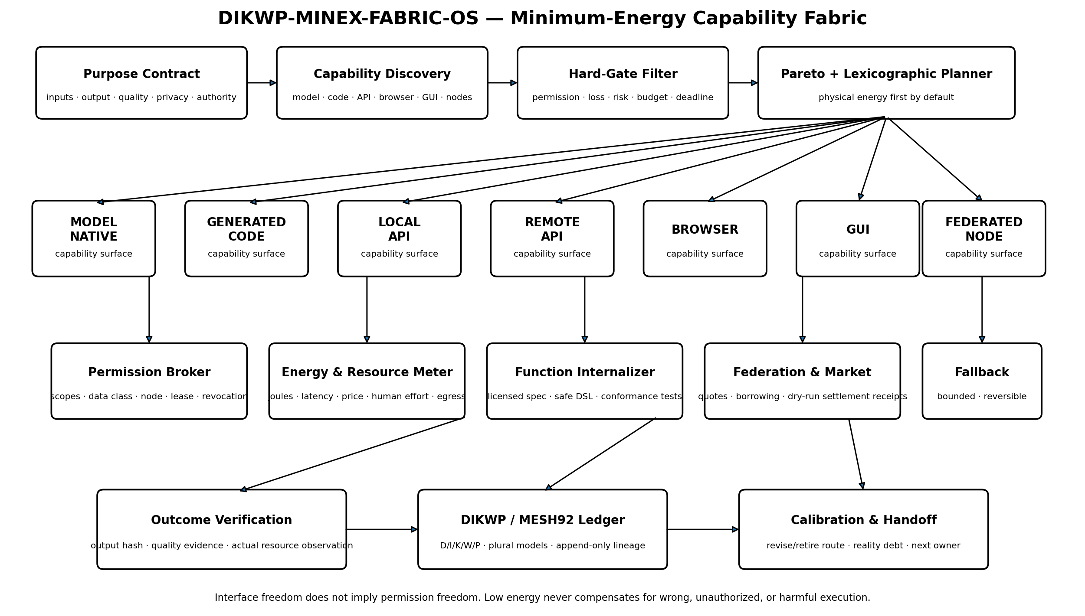
Yucong Duan · 2026 · v1.0.0
Open-source reference implementation · Apache-2.0 code · CC BY 4.0 documentation

Executive Summary
DIKWP-MINEX-FABRIC-OS is a capability operating layer positioned above individual applications. It starts from a user purpose and asks which authorized carrier can produce the required result with the least physical energy and least effective expenditure while preserving quality, provenance, privacy, reversibility and accountability. The candidate carrier may be a frontier model acting directly, a generated local function, a local or remote API, a browser, a graphical application operated through computer use, a capability hosted on another machine, or a human specialist.
The central design decision is to separate function from application. A spreadsheet is not the task “profile this table”; it is one possible implementation. A word processor is not the task “compose this report”; it is one possible carrier. When a model or small generated function can produce a more accurate or sufficiently accurate result at lower energy and lower latency, the system may choose that route. When a formal API is more reliable, it remains preferred. When no formal interface exists, an authorized GUI route may remain available. When the local computer lacks a capability, the system may obtain a quote and borrow a function from another authorized node.
Low energy is not allowed to become a universal excuse. Authorization, data class, minimum quality, minimum reliability, maximum semantic loss, privacy risk and irreversibility are hard gates. Only routes that satisfy those gates enter a Pareto frontier. The default selector then minimizes physical energy, followed by monetary cost, latency, human effort and data egress. Money, privacy, correctness and human burden are not silently converted into joules.
Release result
The reference release contains 19 capability manifests, 12 deterministic scenarios, 66 automated tests, a localhost capability-node protocol, a licensed function-internalization example, a dry-run capability market, append-only evidence ledgers, a bilingual offline dashboard, a single-file ZipApp and complete source code. All reference ledgers validate. No real payment, permission escalation or external automatic action is performed.

Source and claim boundary
The immediate scenario source is the user-supplied article “GPT-6, Breaking Down the App Wall”. It describes a possible shift from developer-predefined workflows to agent-selected use of APIs, browsers, shells and GUIs; it also emphasizes that a richer interface does not remove login, data, identity or administrative permissions. This report uses those ideas as design premises. It does not independently certify the article’s named future products, benchmark values or vendor announcements.
The methodological source is DIKWP-MESH 9.2: evidence, plural world models, prospective prediction, named and reversible intervention, reality outcome, calibration, revision or retirement, memory reconsolidation and causal handoff. The report therefore separates declared resource profiles from measured hardware energy and separates a working reference protocol from production certification.

1. Why an application is no longer the right unit of computation
Classical desktop computing binds a human purpose to a named application and a fixed interaction sequence. The user opens the application, locates the right document, navigates menus, performs transformations and exports a result. APIs partially loosen this binding by exposing machine-oriented operations, but the software vendor still determines which operations are callable, how they are priced and which interfaces are available.
Stronger models change the optimization problem. A model may directly perform a linguistic, analytical, coding or design function. It may write a small, task-specific program instead of launching a large application. It may call a formal API, operate a browser, or use a GUI. These routes differ in energy, latency, reliability, data movement, price and observability. The user’s real objective is not to maximize application usage; it is to obtain the desired outcome under declared constraints.
The transition should therefore be understood as a move from application-centric computing to purpose-centric capability routing. Applications remain valuable as systems of record, identity, policy, specialized algorithms and stable data models. What changes is the locus of workflow control. The capability fabric, rather than the application menu, can select and compose the route.
This shift creates both an efficiency opportunity and a governance problem. A model that can reach a screen has a broader interface, but not broader legal or administrative rights. A remote capability may be more efficient, but may create data egress and jurisdictional exposure. A locally generated function may save energy, but may be wrong outside its tests or may improperly reproduce proprietary behavior. A capability market may reduce idle duplication, but it can also centralize power or obscure accountability. MINEX-FABRIC addresses these tensions explicitly.

2. System objective and non-negotiable principles
Principle | Operational consequence
Purpose before application | The task contract names the intended result, not the software that has traditionally produced it.
Permission before operability | A route is rejected unless the principal, node, data class and required scopes are authorized.
Correctness before economy | A route below the quality or reliability threshold cannot win because it is cheap or energy efficient.
Semantic preservation | Format conversion, summarization and surrogate functions must stay within a declared semantic-loss budget.
Physical energy as a first-class quantity | Joules are represented explicitly and never conflated with price, time or privacy.
Non-aggregated governance | Critical rights and risks remain separate coordinates rather than one compensatory score.
Plural execution routes | Model-native, code, API, browser, GUI, federated and human paths can coexist and compete.
Measured outcomes revise models | Declared profiles create reality debt until measured on actual hardware and workloads.
Internalization requires permission | Only open or explicitly authorized specifications may be locally reimplemented.
Exchange is capability-limited | Borrowing a function does not transfer ownership of the provider’s software, data or model.
Revision is append-only | New measurements create successor manifests; they do not erase prior claims or failures.
External action remains human-authorized | The release fixes automatic external action authority at zero.

3. Architecture

Figure 1. End-to-end architecture. A purpose contract is compiled into capability requirements. Candidate routes are discovered, filtered by hard constraints, retained on a Pareto frontier and selected through a published lexicographic order. Execution outcomes, quotes, resource observations and unresolved obligations return to the evidence and calibration layer.
Component | Responsibility
Purpose Contract Compiler | Free-form intent is converted into operation, input/output contracts, quality requirements, data class, resource ceilings, allowed modes and selection order.
Capability Registry | Stores versioned manifests for model-native functions, generated code, APIs, browser and GUI routes, federated nodes and human services.
Authorization Broker | Checks principal, scope, node, data class, expiry, payment permission and call limit. It does not infer rights from interface availability.
Resource Estimator and Meter | Maintains physical energy, latency, price, human effort, data egress, semantic loss, privacy, irreversibility, quality, reliability and evidence class.
Constraint-First Planner | Rejects infeasible routes, computes a Pareto frontier and selects using a published lexicographic policy.
Execution Adapters | Runs only allowlisted reference operations or produces a dry-run plan for external adapters.
Function Internalizer | Compiles a permitted declarative function and admits it only after conformance tests.
Federation Broker | Discovers remote manifests and obtains quotes. Execution requires bearer authentication and a signed lease.
Metered Exchange Layer | Binds quote terms to an output hash. The reference release moves no real funds.
Outcome and Calibration Layer | Updates energy, latency, quality and reliability through successor manifests and retains failure lineage.
DIKWP/MESH92 Ledger | Separates observations, differences, bounded closure, value/permission constraints and executable purpose; records reality debts and handoff.

4. Formal task and capability model
A task is represented as:
T = (P, op, X, Y, Q_min, R_min, L_sem_max, R_priv_max, R_irrev_max, E_max, C_max, tau_max, A)
P is the purpose; op is the required operation; X and Y are the input and output contracts; Q_min and R_min are minimum quality and reliability; L_sem_max is the permitted semantic loss; R_priv_max and R_irrev_max are privacy and irreversibility ceilings; E_max, C_max and tau_max are physical-energy, money and latency limits; A is the authorization context.
A capability manifest records:
c = (op_c, mode, provider, node, scopes, data_classes, q, r, e, latency, price, human, egress, loss, privacy, irreversibility, license, lineage)
A capability is not merely a function signature. It is a governed promise: who provides it, where it runs, which data it may receive, what scopes it requires, what quality and reliability are expected, how much energy and time it consumes, what it costs, and what evidence supports those claims.
The feasible set is defined by conjunction rather than compensation:
F(T,A) = { c | op_c = op(T) AND Authorized(c,T,A) AND q(c) >= Q_min AND r(c) >= R_min
AND loss(c) <= L_sem_max AND privacy(c) <= R_priv_max
AND irreversibility(c) <= R_irrev_max AND energy(c) <= E_max
AND price(c) <= C_max AND latency(c) <= tau_max }
If F is empty, the correct result is NO_FEASIBLE_ROUTE. The planner does not secretly reduce quality, expand data access, accept an expired lease or exceed a payment ceiling merely to return an answer.

5. Minimum-energy selection without value laundering
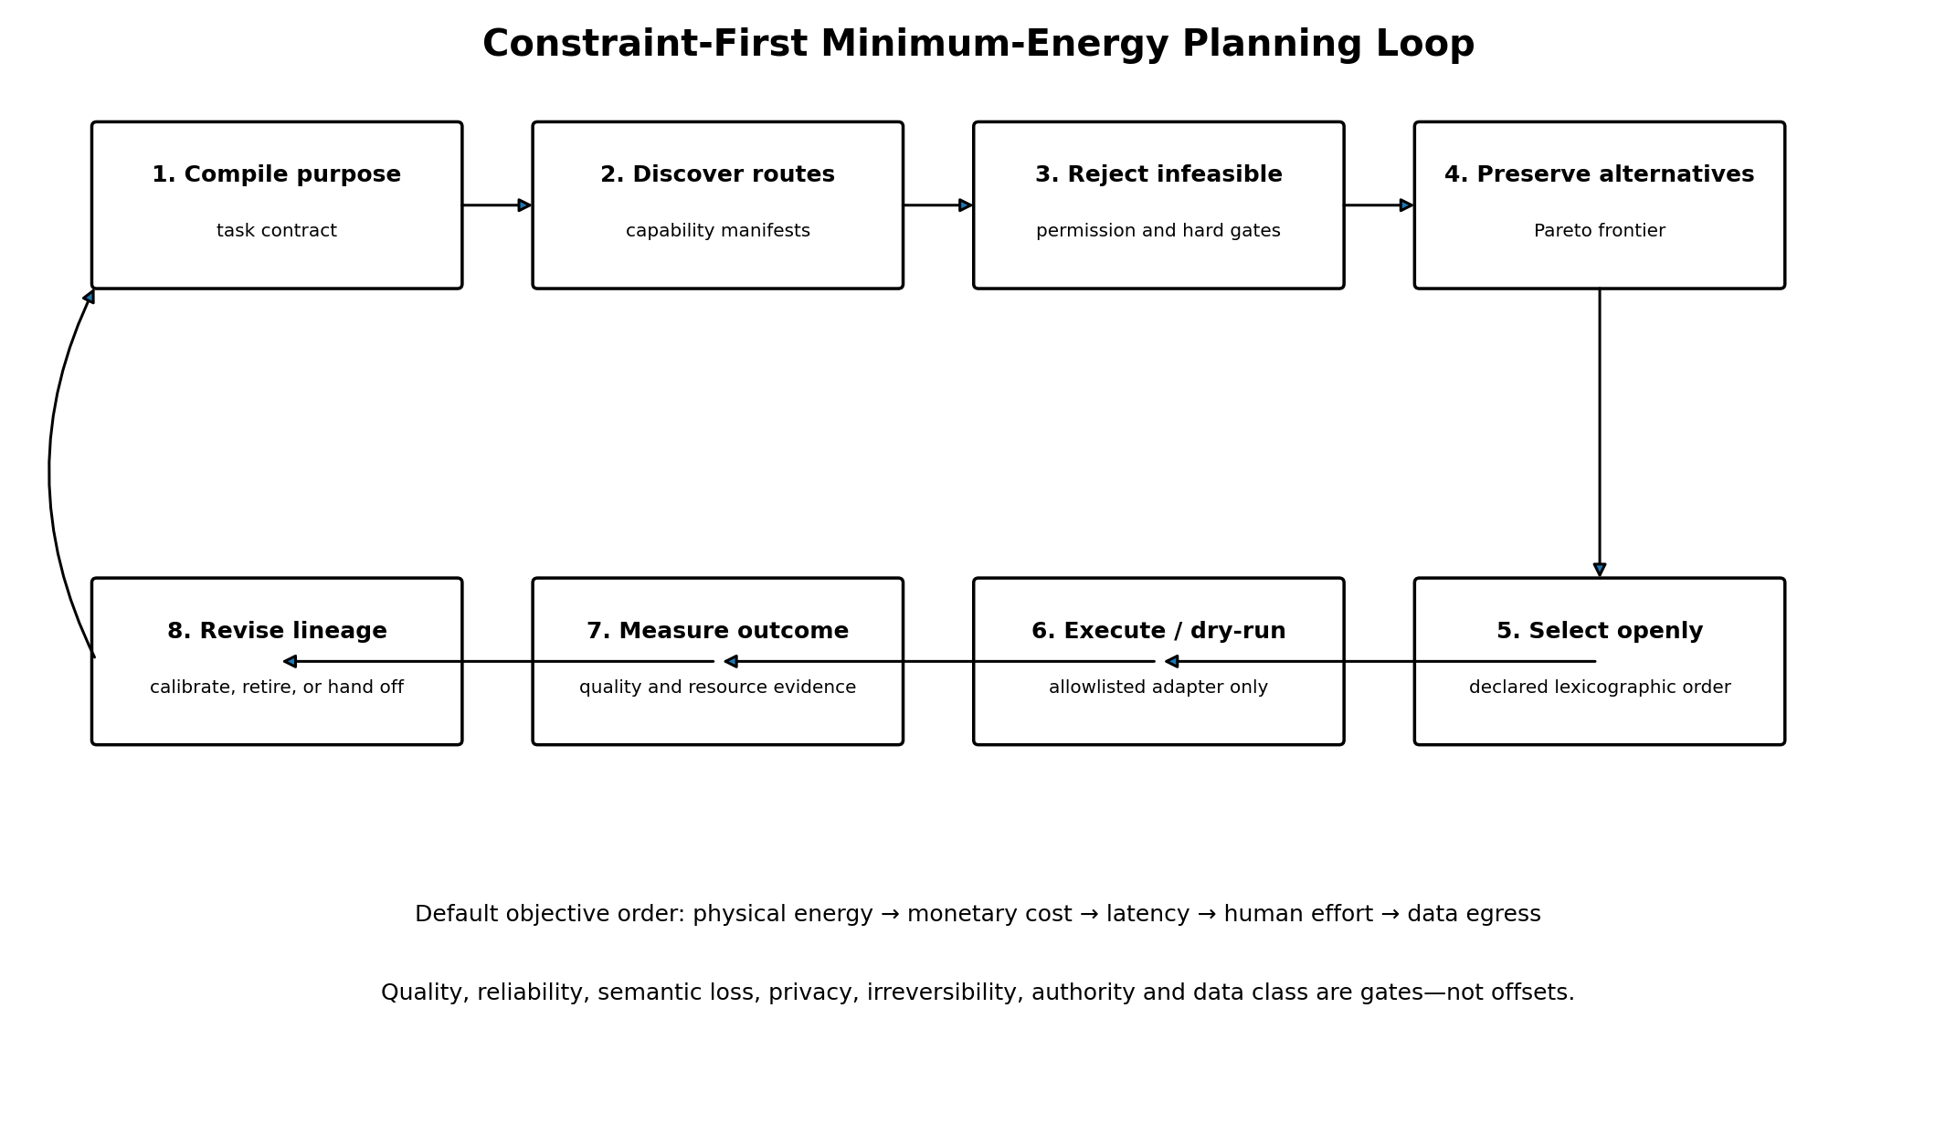
For each feasible capability the planner retains a non-aggregated vector:
v(c,T) = (E_phys, C_money, latency, H_human, B_egress, L_sem, R_priv, R_irrev, -Q, -Reliability)
A route is dominated only if another feasible route is no worse in every declared dimension and strictly better in at least one. Non-dominated routes remain visible. The default selector then uses the declared order physical energy, monetary cost, latency, human minutes and data egress. A project may choose a different order, but the change becomes part of the task contract and cannot silently alter previous certificates.
This design gives the user the energy minimization requested without pretending that every form of effort is a thermodynamic quantity. Money is not energy. Human attention is not energy. Privacy loss is not energy. Semantic distortion is not energy. The system may report all of them and may prioritize them, but does not erase their distinct units and responsibilities.
For a serial plan, energy, cost and latency are summed. For independent parallel steps, energy and cost remain additive while latency is estimated by the critical path. The reference implementation conservatively composes quality and reliability using the minimum step value. More advanced deployments may use dependency-aware reliability models, but must preserve their assumptions in the certificate.

6. Eight execution surfaces
Mode | Use and boundary
MODEL_NATIVE | The model produces the result directly. Best when the task is within measured capability and no application-specific record or rule is required.
GENERATED_CODE | A small local program performs a bounded transformation. Best for deterministic, repeatable functions and private data.
LOCAL_API | A formal interface on the same trusted node. Often highly reliable and auditable.
REMOTE_API | A formal external service. Useful for specialized quality, but adds data, price, network and jurisdictional considerations.
BROWSER | A web interface controlled under a user-authorized session. More fragile and generally more energy intensive than a formal API.
GUI | A desktop application operated through computer use. A legitimate fallback, never a permission bypass.
FEDERATED_NODE | A function hosted by another authorized computer or organization and borrowed under a lease and quote.
HUMAN | A human specialist or operator. Essential when judgment, accountability, empathy, legal authority or physical presence is required.

The planner does not encode a permanent hierarchy such as API > model > GUI. The order is empirical and task-relative. A generated local function can dominate a large application for a deterministic transformation. A specialized API can dominate a model for exact domain rules. A GUI can be the only available carrier. A human can be necessary for authority or accountability. Every route remains conditional on its manifest and observed outcomes.

7. Function internalization
The user’s proposal that a model can “internalize” software or API functions is divided into three technically and legally different cases. First, the model may already possess a general capability and can perform the task directly. Second, it may synthesize a local implementation from an open specification or user-owned requirements. Third, it may imitate a proprietary interface based on observations. The first two can be legitimate under declared conditions; the third may violate intellectual-property, contract, privacy or security boundaries and is prohibited by this release.
The internalizer accepts only a safe declarative expression or allowlisted pipeline. The caller must confirm license permission and supply conformance tests. The result is admitted only within the tested scope:
LicenseOK AND for every test i: distance(f_local(x_i), expected_i) <= epsilon
Passing tests generates an INTERNALIZED_WITHIN_TEST_SCOPE certificate, not a universal claim that the local function is identical to the source service. The successor manifest records the source capability, license statement, expression or pipeline, test count, tolerance, quality estimate and version lineage. A later failure can restrict or retire the local route without erasing the earlier certificate.
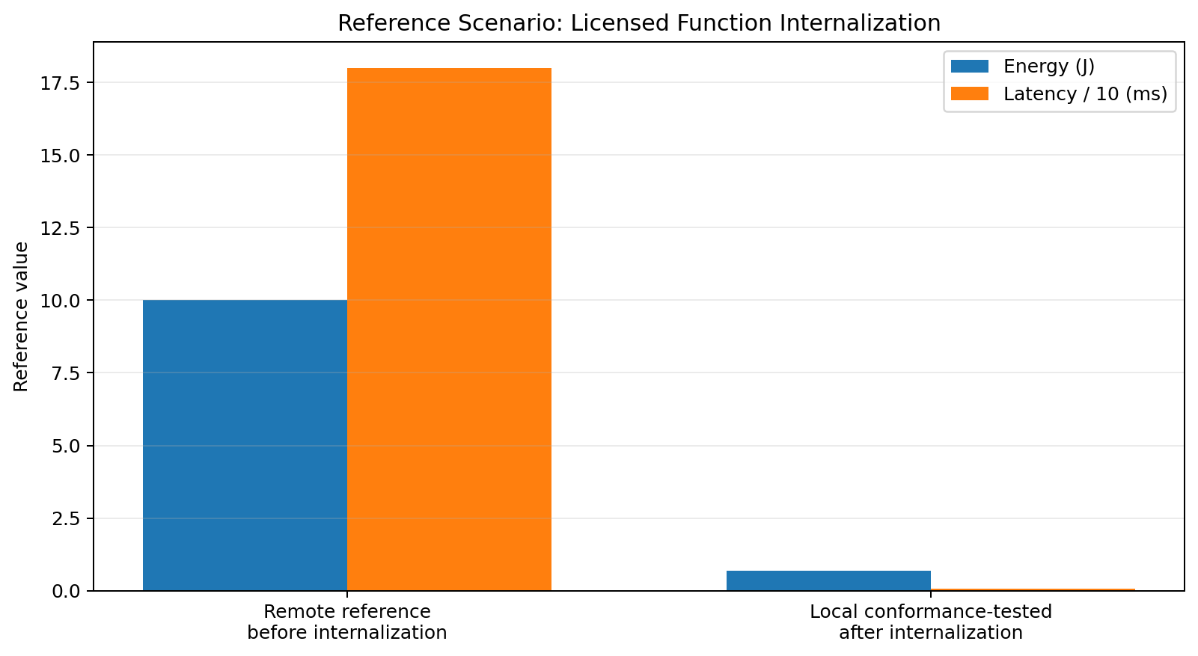
In the synthetic temperature-conversion reference, the remote route is modelled at 10.001128 J and 180.01 ms, while the conformance-tested local route is modelled at 0.7001 J and 0.801 ms. This corresponds to a 92.9998% energy reduction and 99.555% latency reduction in the declared reference model. These figures demonstrate planner behavior, not independent hardware measurement.

8. Federated function borrowing across computers
A capability fabric becomes materially different from a local tool router when several computers can lend functions to one another. In MINEX-FABRIC, a node advertises versioned capability manifests, not unrestricted machine access. The client may discover manifests and request quotes without execution authority. Actual execution requires both a bearer credential and a signed, expiring lease.
Lease field | Meaning
principal | Who is requesting the function
node_ids | Which nodes may be used
capability_ids | Which operations may be borrowed
expires_at_epoch | When the grant ends
max_calls | How many calls are permitted
data class and scopes | What data and authority may enter the node
lease_id | Stable identifier for receipts and revocation

The reference node exposes GET /health, GET /manifest, POST /quote and POST /execute. Execution is disabled unless the operator starts the server with an explicit allow-execution flag, bearer token and lease secret. The executor can invoke only allowlisted built-ins; it cannot run arbitrary shell commands or model-generated programs. A successful call returns an output hash and a receipt hash bound to the node, lease, capability and task.
The release includes an actual localhost federation test: a client obtains a manifest and quote from node-utility, presents a lease limited to cap.hash.federated and two calls, and receives a signed hash receipt. The test demonstrates protocol mechanics on one host. It does not establish internet-grade federation security.

9. Metered capability exchange
The market layer allows a capability provider to declare a base price and a per-unit price, while the requester declares whether paid routes are allowed and a maximum payment. A quote binds provider, node, capability, task, resource vector, currency, expiry and terms hash. If the output is produced and verified, a settlement receipt binds the quote to the output hash.
The reference implementation is deliberately dry-run. It reports DRY_RUN_SETTLED or DRY_RUN_VOID and always records real_funds_moved = false. This separation is essential: software that can optimize a paid route is not thereby authorized to move money, create debt or accept legal terms. A production adapter would require financial custody controls, regulated payment rails, fraud management, tax treatment, sanctions screening, dispute resolution, refunds and human authorization.
The economic model is capability-limited rather than software-annexing. A requester pays for a bounded result under a manifest; the provider retains its software, model, data and infrastructure. Conversely, payment does not eliminate the provider’s responsibility for quality, provenance, data handling or failure disclosure.

10. Permission architecture and the interface/authority split
The most important safety invariant is that interface reach and authority are different variables. A model may be able to see a button, navigate a form or imitate a user action. None of those facts creates a data right, contractual right, operating-system privilege, payment authority or permission to represent a person. MINEX-FABRIC therefore evaluates authorization before energy and before route selection.
The authorization context binds a principal to scopes, allowed nodes, data classes, expiry, call limit, paid-route permission and payment ceiling. The capability manifest separately declares the scopes and data classes it requires. Both sides must agree. The GUI and browser modes are not special exceptions. If desktop control, application access or a data scope is absent, the route is rejected even when it would otherwise be the only path.
Permission-wall demonstration
Reference scenario 04 withholds GUI and desktop-control scopes. The spreadsheet GUI route is rejected, while the local generated-code route remains feasible. Reference scenario 10 requires a high-quality remote translation of sensitive data but provides neither the required scopes nor an acceptable privacy route; the planner returns NO_FEASIBLE_ROUTE rather than weakening the contract.

11. DIKWP and MESH92 operating discipline
The system does not treat D, I, K, W and P as a one-way ladder. D records task inputs, observed manifests, measurements and outcomes. I records differences among routes, conflicts, failures and model uncertainty. K records the bounded feasible plan and tested capability claims. W records authorization, privacy, semantic-loss, externality and future-option constraints. P records an executable input-output relation and a named next handoff.
All twenty-five record-level route kinds are available, but a route exists only when source record, target record and generated content are explicit. In a normal planning run D->I identifies route differences, D->K supports a bounded plan, W->P changes what can be executed, and K->P turns the selected plan into an action contract. New measurements may later create D->K revision or I->P suspension. No cached conclusion is accepted as permanent truth.
The MESH92 cycle is implemented as evidence, plural route/world models, prospective resource predictions, authorized bounded execution, outcome capture, calibration, revision or retirement, memory/manifest reconsolidation and causal handoff. A predicted energy value without a hardware measurement is registered as reality debt. A failed route that is never downgraded is also debt. The next operator receives the remaining obligations rather than a ceremonial “complete” label.

12. Reference implementation
The reference runtime is written for Python 3.10 or later and uses only the standard library. This reduces installation burden and makes the execution path auditable. The codebase contains data classes, capability registry, authorization and lease handling, resource estimation, Pareto planning, allowlisted executors, safe expression compilation, internalization, federation, dry-run market settlement, calibration, semantic ledgers, workflow orchestration and a command-line interface.
Operation | Command
Inspect the contract | python dist/DIKWP_MINEX_FABRIC_OS.pyz inspect
Run all scenarios | python dist/DIKWP_MINEX_FABRIC_OS.pyz suite --root . --output outputs/my-suite
Plan or run one task | python dist/DIKWP_MINEX_FABRIC_OS.pyz run examples/tasks/01_csv_profile_direct_function.json --capabilities examples/capabilities --output outputs/my-run
Internalize an open function | python dist/DIKWP_MINEX_FABRIC_OS.pyz internalize examples/internalization/temperature_recipe.json --output outputs/internalization.json
Verify an evidence ledger | python dist/DIKWP_MINEX_FABRIC_OS.pyz verify outputs/my-run/evidence_ledger.jsonl
Start a controlled node | python dist/DIKWP_MINEX_FABRIC_OS.pyz serve-node --capabilities examples/node_capabilities/utility --node-id node-utility --host 127.0.0.1 --port 8765

The offline dashboard embeds the reference manifests and results. It supports bilingual navigation, route filtering by quality, privacy, data class and execution mode, and visual inspection of the twelve scenarios. It makes no network requests and loads no external scripts.

13. Reference scenarios and results
Scenario | Status | Selected route | Energy J | Cost | Latency ms
01_csv_profile_direct_function | ROUTE_SELECTED | cap.csv.generated-local | 3.62 | 0.0 | 20.4
02_high_quality_paid_translation | ROUTE_SELECTED | cap.translate.remote-expert | 29.64 | 0.18 | 664.0
03_sensitive_local_only | ROUTE_SELECTED | cap.summary.generated-local | 5.0 | 0.0 | 41.0
04_permission_wall_preserved | ROUTE_SELECTED | cap.csv.generated-local | 3.54 | 0.0 | 18.8
05_pre_internalization_remote_only | ROUTE_SELECTED | cap.temperature.remote | 10.001128 | 0.003 | 180.01
06_post_internalization_local | ROUTE_SELECTED | cap.temperature.internalized | 0.7001 | 0.0 | 0.801
07_federated_function_borrowing | ROUTE_SELECTED | cap.hash.federated | 2.516288 | 0.001 | 90.2
08_model_vs_software_summary | ROUTE_SELECTED | cap.summary.model-native | 58.3 | 0.004 | 705.0
09_parallel_composite_workflow | COMPOSITE | parallel plan | 6.8505 | 0.0 | 18.4
10_no_feasible_route_due_to_rights | NO_FEASIBLE_ROUTE | — | — | — | —
11_direct_report_without_app | ROUTE_SELECTED | cap.report.local | 2.56 | 0.0 | 10.6
12_energy_budget_blocks_gui | ROUTE_SELECTED | cap.summary.generated-local | 4.4 | 0.0 | 29.0

The suite produced ten selected routes, one composite parallel plan and one intentional NO_FEASIBLE_ROUTE. All generated evidence ledgers validated. The direct CSV function used 3.62 J in the declared model; the model-native route was selected over a GUI route in scenario 08; the local report composer avoided opening a word processor; the energy budget excluded the GUI path in scenario 12; and the high-quality translation scenario selected an authorized paid federated node because lower-cost local routes did not meet its quality threshold.
These results are protocol tests. They prove that the implementation applies the declared manifests and constraints deterministically. They do not prove that a real frontier model consumes 58.3 J for a task, that a real GUI consumes 190 J, or that a provider achieves its declared quality. Production manifests must be replaced by measured and contractually accountable evidence.

14. Security and failure analysis
Failure | Risk | Control
Capability hallucination | A provider or model claims a function it cannot reliably perform. | Require versioned tests, outcome evidence and calibration; retire persistent failures.
Permission confusion | A screen or endpoint is reachable but the principal lacks authority. | Require scope, node, data-class and lease checks before planning.
Energy gaming | A provider understates energy or shifts work to unmeasured infrastructure. | Record evidence class, meter boundaries, idle allocation and data-transfer energy.
Semantic compression loss | A cheap route changes meaning while preserving surface format. | Set maximum semantic loss and use reverse regeneration or task-specific tests.
Proprietary internalization | A local surrogate copies a hidden or restricted function. | Require license confirmation, open specification and explicit lineage; prohibit secret extraction.
Market mis-settlement | Payment occurs before quality or output verification. | Bind settlement to quote and output hash; keep real payment outside the reference release.
GUI drift | Application layout changes and the route mis-clicks. | Use state verification, reversible steps, checkpoints and fallback; calibrate recovery energy.
Centralized broker capture | One registry controls access and prices. | Support plural registries, portable manifests, local policy and provider comparison.
Over-automation | A low-energy plan executes consequential actions without a person. | Automatic external action authority remains zero; require named human approval.

15. Deployment path
- Phase 0 — Offline evaluation: use the registry, planner, deterministic functions and dashboard with synthetic or non-sensitive tasks.
- Phase 1 — Measured local pilot: connect actual CPU/GPU power counters, token telemetry and wall-clock measurement; replace declared profiles with measured successor manifests.
- Phase 2 — Controlled organizational node: expose a small allowlist of reversible functions on a private network with strong identity, signed leases, rate limits and logs.
- Phase 3 — Multi-provider federation: compare at least two independent nodes, test failure and revocation, and audit jurisdiction and data-transfer constraints.
- Phase 4 — GUI and model adapters: add isolated computer-use and model-provider adapters with task-specific acceptance tests and rollback.
- Phase 5 — Economic pilot: issue non-monetary or test-credit quotes first; enable real payment only after legal, financial, security and dispute-resolution review.
- Phase 6 — Open ecosystem: publish manifests, benchmark packs, measured-energy evidence, incident reports and provider portability rules.
Each phase has a stop condition. If authorization is ambiguous, energy boundaries are unmeasured, quality cannot be independently verified, or a provider cannot support revocation and audit, the project remains at the preceding phase.

16. What this system changes economically
The traditional software market sells seats, licenses and application access. A capability fabric introduces a different unit: a bounded function with a declared outcome, resource vector, permission contract, price and evidence history. The same function may be supplied by a model, local code, an application API, a GUI route, a remote node or a human. Competition can therefore move from “which app owns the workflow?” to “which authorized route produces the outcome with the best measured resource profile?”
This does not make software valueless. Systems of record, domain rules, trusted data, identity, compliance, specialized algorithms and institutional accountability remain scarce. Providers may benefit by exposing high-quality, energy-efficient, governable capabilities. Conversely, opaque interfaces and seat-only pricing become less defensible when an agent can use another route. The market value shifts toward verified function quality, trustworthy records, permission integrity, low-energy execution and reliable outcome responsibility.
The system also makes unused computational capability potentially shareable. A machine with an authorized specialized function can lend it under a lease and receive a metered quote. However, this must not become hidden resource extraction. Node operators choose capabilities, data classes, prices, quotas and revocation. Requesters choose purpose, privacy and payment ceilings. The broker cannot annex either side’s authority.

17. Limitations and open research
- The release contains no real frontier-model adapter; MODEL_NATIVE is a capability mode and reference manifest, not certification of a named model.
- Most energy values are declared or modelled. Hardware-specific measurement, idle allocation and network boundaries remain reality debt.
- The reference HMAC lease is for controlled shared-secret environments, not open internet federation.
- The safe expression internalizer covers a small deterministic class; general program synthesis requires substantially stronger sandboxing and verification.
- GUI execution is represented as a governed dry-run capability. Robust perception, state recovery and action rollback are not certified here.
- The market is a quote and receipt protocol only. It does not move funds or resolve legal, tax, sanctions or consumer-protection obligations.
- Quality and semantic loss are domain-dependent and need task-specific tests; no universal metric is claimed.
- A minimum-energy route can still impose social or ecological externalities outside the current meter boundary; those boundaries must be expanded explicitly.
- Inter-provider collusion, monopoly, strategic misreporting and platform capture require institutional as well as technical controls.

Conclusion
DIKWP-MINEX-FABRIC-OS reframes the next software layer as a purpose-to-capability fabric. It allows a model to complete a function directly when that path is demonstrably adequate, lets APIs remain the preferred route when they are more reliable, keeps GUI interaction as an authorized fallback, permits licensed local internalization, and supports bounded cross-machine borrowing and metered exchange. The unifying criterion is not application loyalty but accountable outcome production with minimal physical energy and minimal effective expenditure.
Its deepest constraint is equally important: the freedom to choose an interface is not the freedom to take authority. Energy minimization begins only after permission, correctness, semantic preservation, privacy and reversibility have been satisfied. Outcomes return to the manifest and model lineage; failures can retire a route; unmeasured claims remain reality debt. This is the difference between an autonomous tool chooser and an accountable capability economy.

Appendix A — Release inventory
Item | Value
Source package | Python 3.10+ standard-library runtime
Capability manifests | 19
Reference scenarios | 12
Automated tests | 66 passed
Execution modes | 8
JSON Schemas | 5
Runtime dependencies | 0 third-party
External scripts in dashboard | 0
Real funds moved | No
Automatic external action authority | 0

Appendix B — Key output files
File | Meaning
plan_decision.json | Candidate routes, rejections, frontier and selected route
execution_result.json | Bounded execution or dry-run result
semantic_graph.json | D/I/K/W/P records and explicit routes
evidence_ledger.jsonl | Append-only SHA-256 event chain
minex_certificate.json | Bounded decision and execution certificate
ledger_verification.json | Independent chain verification result
internalization_result.json | License and conformance-test result
quotes.json | Metered capability quotes
successor_manifest.json | Outcome-calibrated manifest with lineage

