GEOHACKATHON 2026 · GISTDA · PIXEL TO POLICY
GreenSight
Finding the best places for new green space in Don Mueang, Bangkok
THEOS-2 satellite images · NDVI · fitness scoring · Hybrid Genetic Algorithm
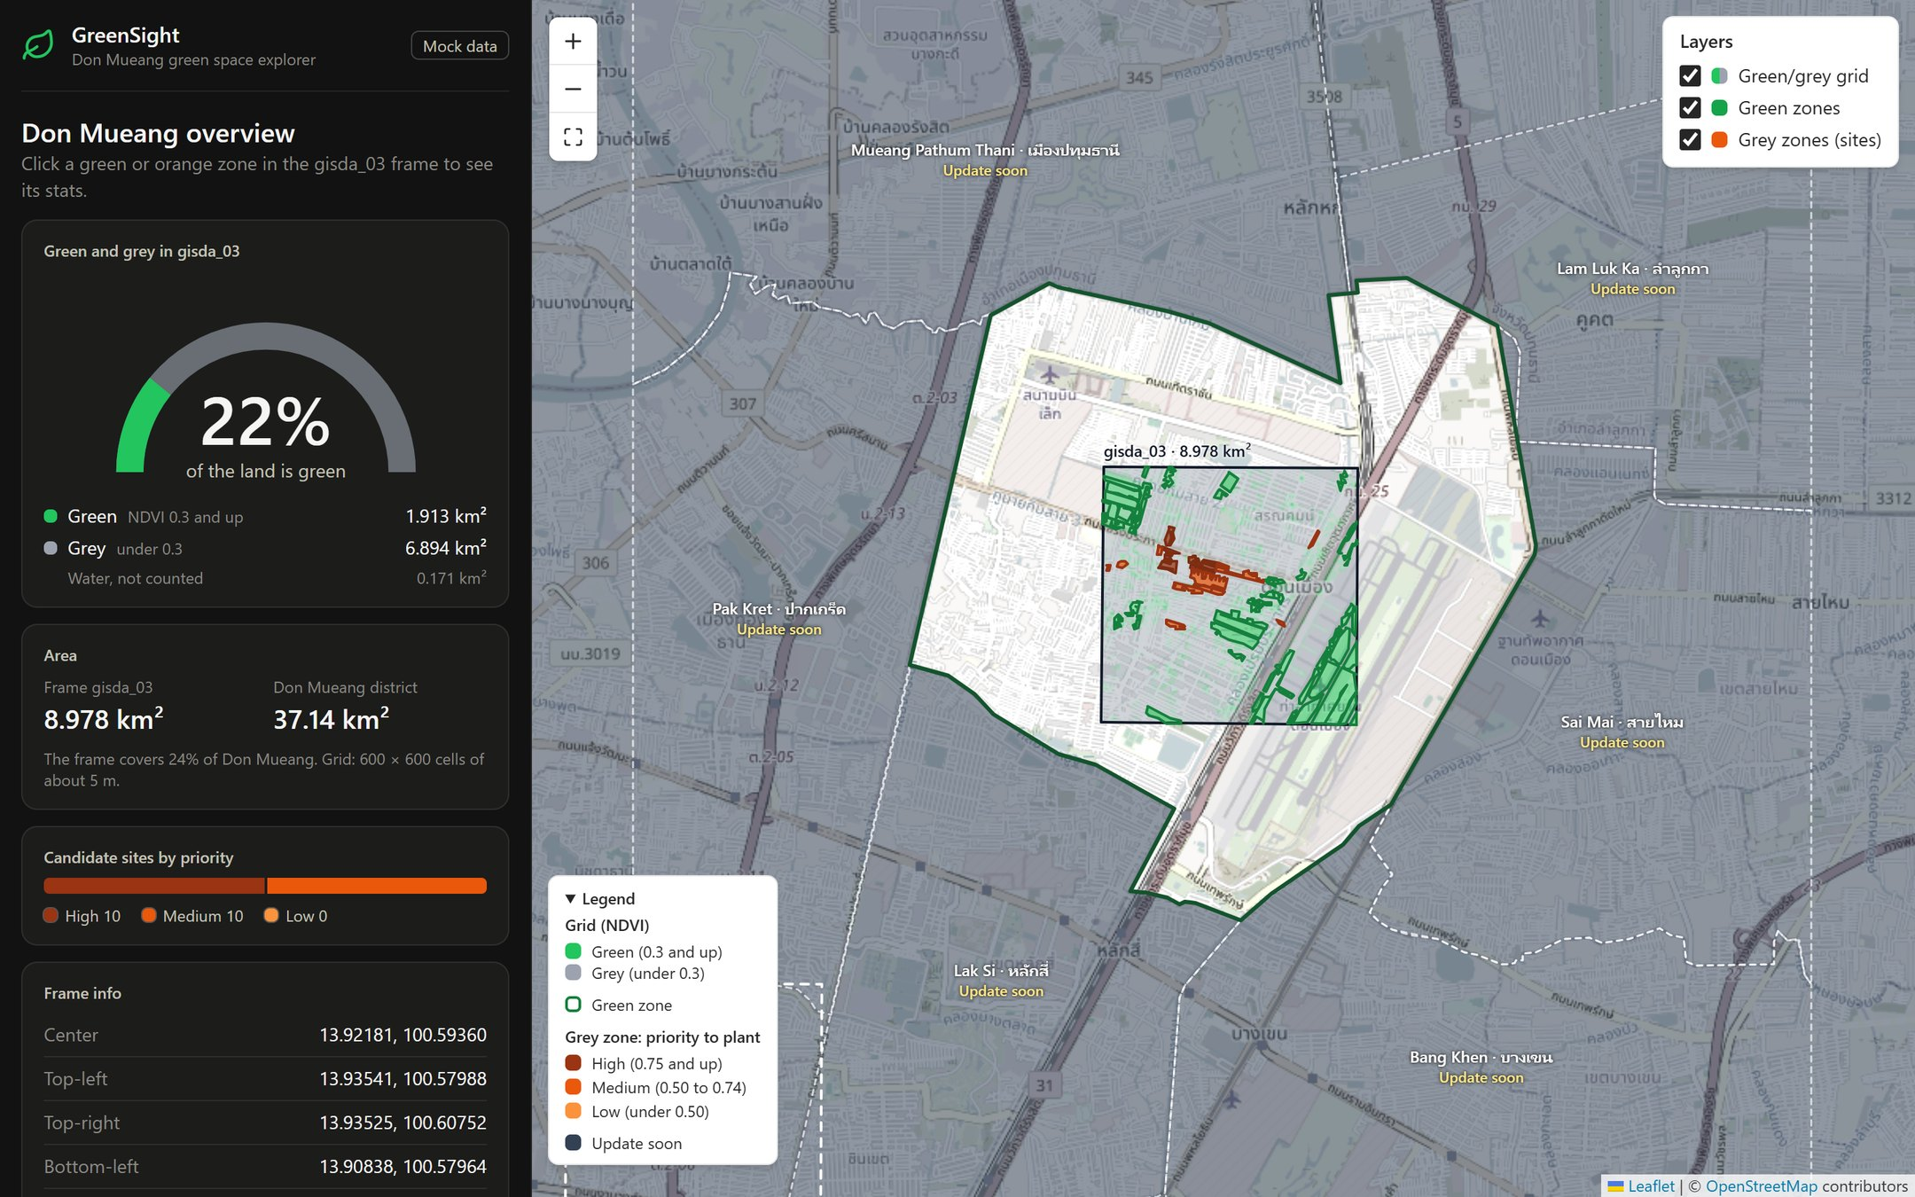
PART 1 · FOR EVERYONE  What GreenSight does, how to read the app and what it found, in plain words. | PART 2 · TECHNICAL  Architecture, grid model, area maths, fitness function, map rendering, data contract and testing.

Presentation document · Frontend prototype v0.1 · 16 October 2026
All NDVI, temperature, population and fitness numbers in this version are mock data, simulated from OpenStreetMap land cover. The backend will replace them with real THEOS-2 and Landsat results.

About this document
GreenSight turns satellite pixels into a ranked list of places where a city could plant new green space. This document explains it in two ways:
- Part 1 – For everyone. No maths. The problem, what the app does, how to read its numbers and what it found in Don Mueang. Use it for a general audience.
- Part 2 – Technical. For engineers, GIS analysts and reviewers. How the system is built, exactly how every number is calculated, and the data contract for the backend.

GreenSight at a glance
Study area | Don Mueang district, Bangkok (37.14 km²)
Satellite frame | gisda_03 from GISTDA's THEOS-2: 8.978 km², fully inside Don Mueang (24% of the district)
Grid | 600 × 600 = 360,000 cells of about 5 m × 5 m
Land cover (mock) | Green 1.913 km² (22% of the land) · grey 6.894 km² · water 0.171 km²
Green zones (mock) | 44 zones of 0.5 ha or more; 6 meet Bangkok's target of 9 m² per person
Candidate sites (mock) | 151 open plots found; the best 20 are ranked (10 high and 10 medium priority)
App | Web app (React + Leaflet) for computers and phones; 74 automated tests pass
Status | Frontend prototype finished; backend with real THEOS-2 data in progress

Mock data. The land cover and district borders are real (OpenStreetMap). The NDVI values, temperatures, population and fitness scores are simulated so the app can be shown before the backend is ready. Every result in this document that depends on them is marked as mock data.

Contents
Part 1 – GreenSight in plain words 4
1.1 The problem: too little green space, in the wrong places 4
1.2 Our idea 4
1.3 How it works, in six steps 4
1.4 The greenness score (NDVI) 5
1.5 Where we start: Don Mueang 5
1.6 A quick tour of the app 6
1.7 How to read the numbers 9
1.8 What we found in Don Mueang (example results) 10
1.9 Who it helps 10
1.10 What's next 10
1.11 Words to know 11
Part 2 – Technical version 12
2.1 Scope and status 12
2.2 System architecture 12
2.3 Study area and frames 13
2.4 Grid model 13
2.5 Classification and areas 14
2.6 Zones 15
2.7 Indicators computed in the frontend 15
2.8 Fitness function and optimisation 16
2.9 Frontend architecture 17
2.10 Drawing 360,000 cells fast 18
2.11 Data contract (API) 20
2.12 How the mock data was made 21
2.13 Quality and verification 21
2.14 Limitations and risks 21
2.15 Roadmap 22
2.16 Running and deploying 22
Appendix A. Project structure 23
Appendix B. References 23

FOR EVERYONE · NO MATHS NEEDED

Part 1 – GreenSight in plain words
This part explains GreenSight without maths: the problem, the idea, how the app works, how to read it, and what it found in Don Mueang.

1.1 The problem: too little green space, in the wrong places
Parks and trees make a city cooler, cleaner and healthier. They give shade, filter the air and soak up rain, so streets flood less. Bangkok's own target is 9 m² of green space for every person. The city is below that target, and its green space is spread unevenly.
7.49 m²  green space per person in Bangkok (official figure) | 9 m²  Bangkok's own target per person | 36 districts  have less than 3 m² per person | 4.5 km  average distance to the nearest green space
Sources: BMA (2022); Chulalongkorn University UDDC (2022); Mongabay (2025). The 9 m² figure is often called a WHO standard, but no WHO document states it, so we treat it as Bangkok's own planning target.
Finding land for new parks is also slow. Officers check maps and visit sites one by one, and there is no standard, fair way to decide which empty plot should become green first.

1.2 Our idea
GreenSight looks at pictures from Thailand's own satellite, finds where green space is missing, and ranks the empty plots that would help the most people if they became green.

It turns satellite pixels into a list of decisions, which is the hackathon's theme, "Pixel to Policy".
- Faster: the computer checks a whole area at once instead of visiting sites one by one.
- Fair and clear: every plot gets a score with three simple reasons, so anyone can see why it was chosen.
- Easy to use: the results are on a map you can zoom and click, on a computer or a phone.

1.3 How it works, in six steps
Steps 1 to 3 find what is green today. Steps 4 to 6 find where new green space would help the most. For step 6 the backend uses a Hybrid Genetic Algorithm. Like evolution, it tries many sets of plots, keeps the best ones, mixes them and repeats until it finds a very good set.
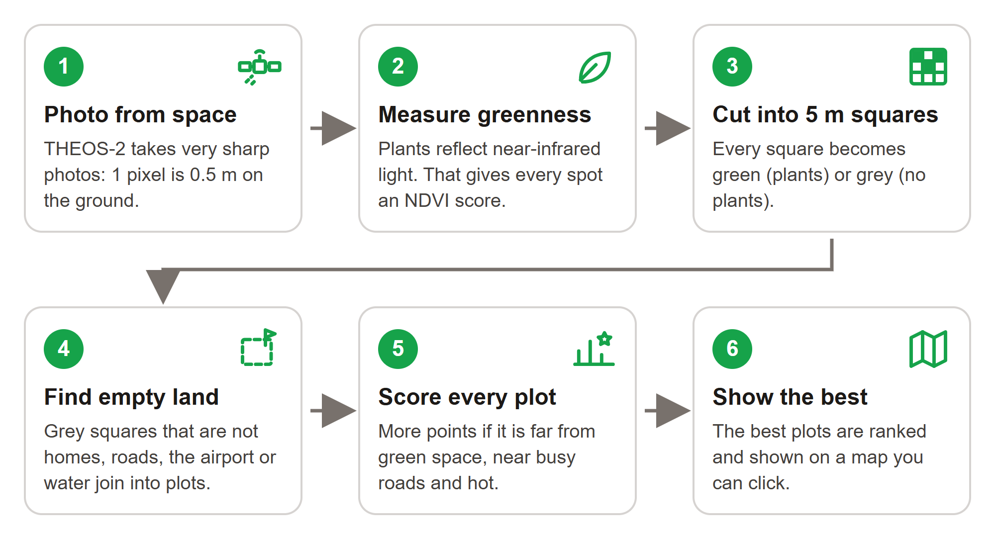
Figure 1. From a satellite photo to a ranked list of places to plant.

1.4 The greenness score (NDVI)
Healthy plants reflect a lot of near-infrared light, which our eyes cannot see, and they absorb red light. The satellite measures both. From them we get NDVI, a greenness score from −1 to +1.
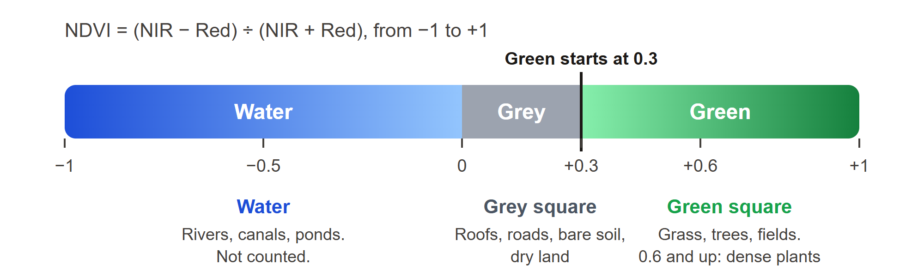
Figure 2. GreenSight's rule: 0.3 and up is green, under 0.3 is grey, under 0 is water.
So every 5 m square in the frame becomes green (plants) or grey (roofs, roads, bare soil, dry land). Water is shown but not counted.

1.5 Where we start: Don Mueang
The first version looks at Don Mueang (ดอนเมือง), a district of 37.14 km² in the north of Bangkok. It has Don Mueang airport, Air Force land, major roads and dense housing. GISTDA gave us three satellite frames. One of them, gisda_03, lies completely inside Don Mueang, so we start there.
Frame size | About 3 km × 3 km = 8.978 km² (about 5,600 rai)
Share of Don Mueang | 24% of the district
Squares | 600 × 600 = 360,000 squares, each about 5 m × 5 m (25 m², the size of two parking spaces)
Coming later | Frames gisda_01 (Pak Kret / Lak Si) and gisda_02 (Chon Buri, Sattahip), and the districts around Don Mueang. The map shows them in grey with "Update soon".

1.6 A quick tour of the app
The screen has two parts: numbers on the left and the map on the right. On a phone, the map is on top and the numbers are below it.
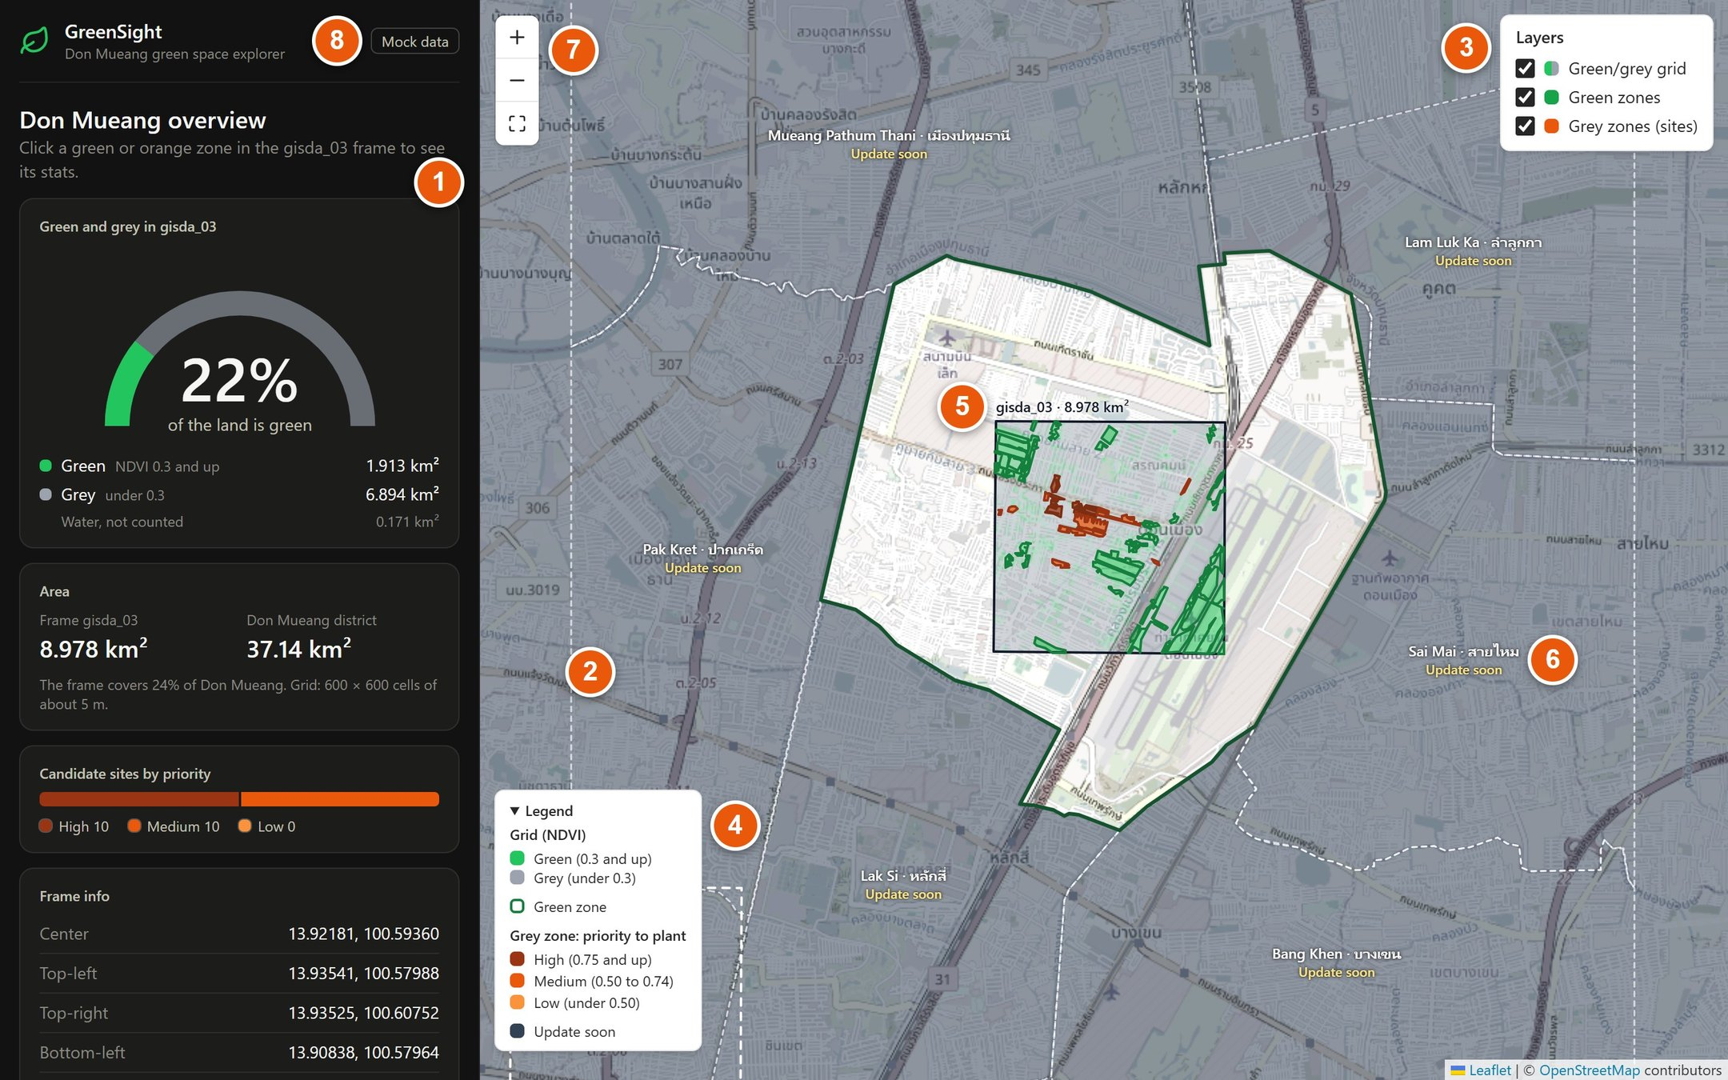
Figure 3. The app when it opens. The numbers match the table below.
No. | Part | What it does
1 | Stats panel | Numbers and charts for the whole frame. Click a zone on the map and the panel shows that zone instead.
2 | Map | Drag to move around. Zoom with the mouse wheel, a pinch or the buttons.
3 | Layers | Show or hide the green/grey squares, the green zones and the grey zones.
4 | Legend | What each colour means.
5 | Frame gisda_03 | The satellite frame we analyse, with its area.
6 | "Update soon" | Areas we will add later. They are covered in grey.
7 | Zoom buttons | Zoom in (+), zoom out (−), or show the whole of Don Mueang again.
8 | "Mock data" | A reminder that the numbers are examples until the real data is connected.

Click a green zone
A green zone is a park, field or group of trees of at least 5,000 m², about two-thirds of a football field. Click one and the left panel shows:
- Green space per person: the zone's area divided by the people who live within 1 km. The mark at the top of the gauge is the 9 m² target.
- Status in words: Meets target, Below target or Far below target, with a symbol, so you never have to rely on colour alone.
- Population and area, with the sum written out: 86,166 m² ÷ 22,000 people = 3.9 m² each.
- Cooling effect: how much cooler the ground is inside the zone than around it (here 2.7 °C).
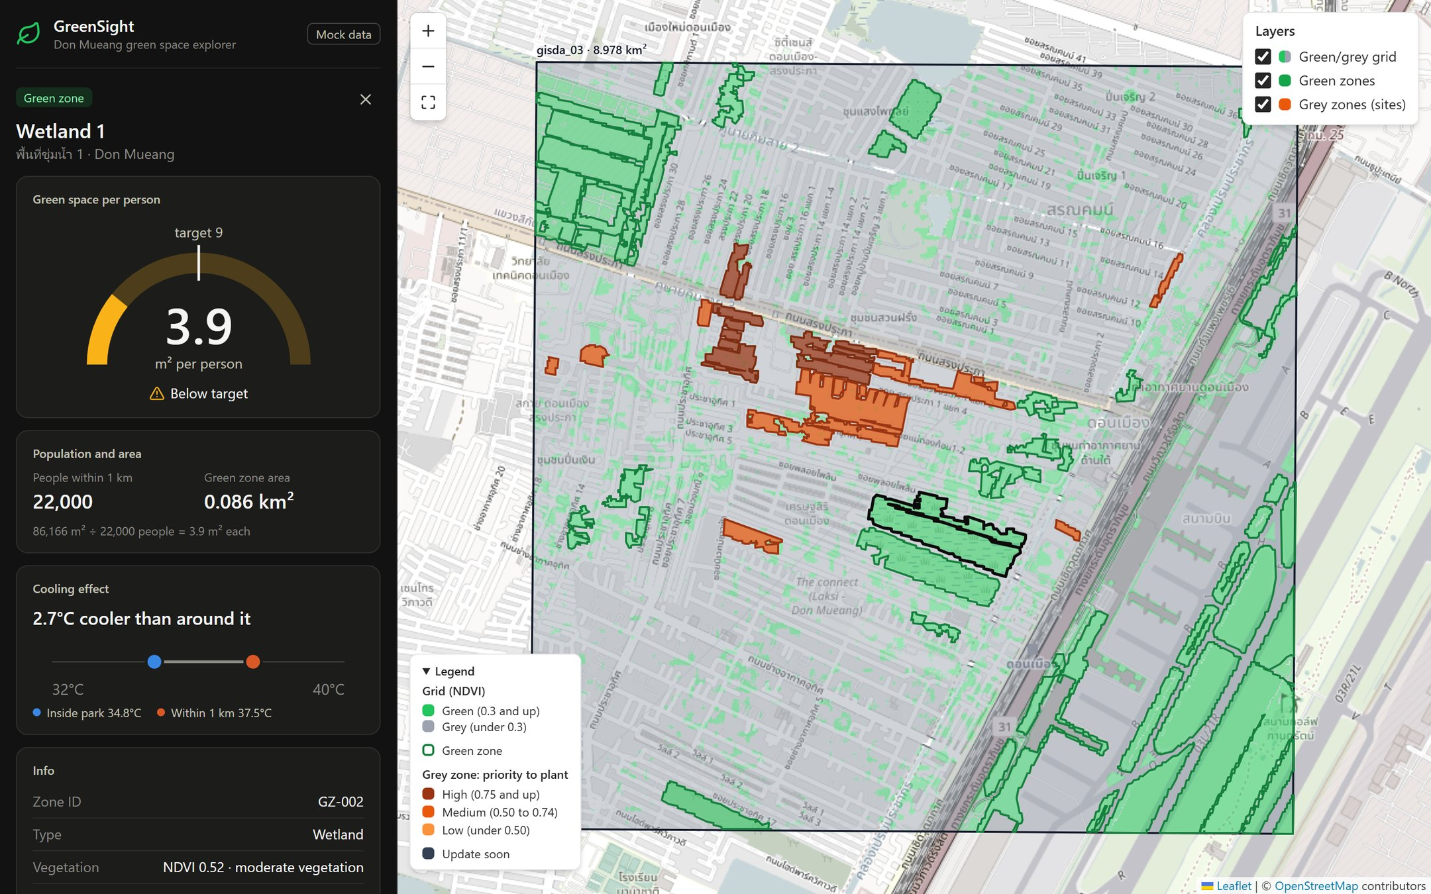
Figure 4. Wetland 1 is selected (black outline). It gives 3.9 m² per nearby person, below the 9 m² target.

Click a grey zone (a candidate site)
Grey zones are empty plots that could become green. Their colour shows the priority: the darker the orange, the higher the priority. Click one to see:
- Fitness score from 0 to 1, the priority (High, Medium or Low) and the rank, for example rank 1 of 20.
- People within 1 km and the plot's area, plus how much green space per person greening the plot would add.
- Why this site? Three reasons, each scored from 1 to 5: far from parks, near busy roads and surface heat.
- Info: how green the land is now, the nearest green zone and the ground temperature.
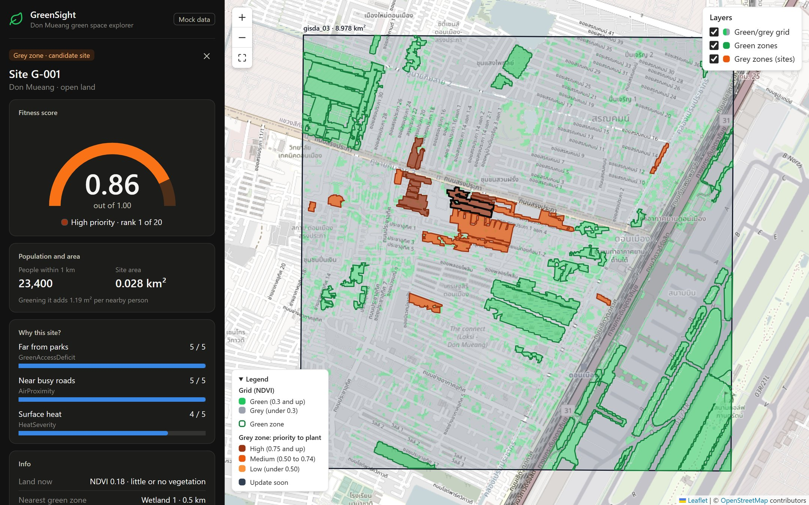
Figure 5. Site G-001: fitness 0.86, high priority, rank 1 of 20, with 23,400 people within 1 km.

Zoom in to see the squares
Zoom in and the 5 m squares appear: green where plants grow, grey where they don't. The outlines of the green zones and sites follow the squares.
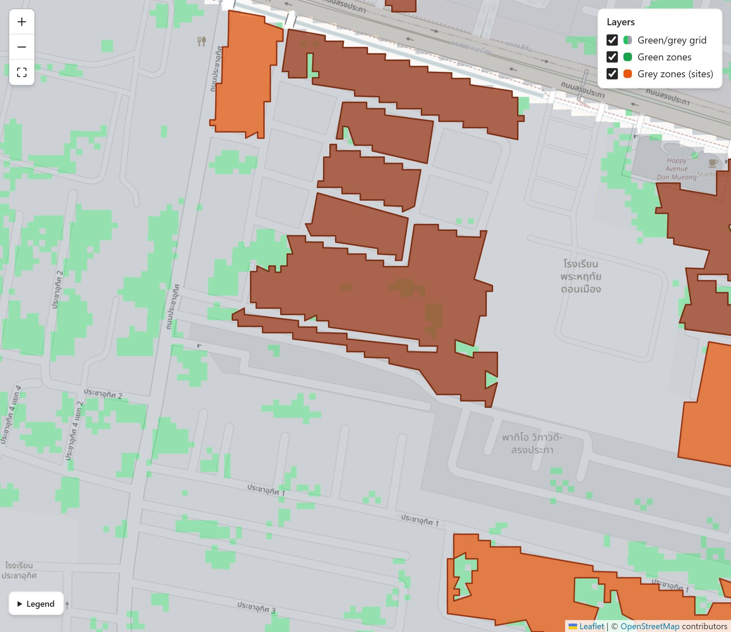
Figure 6. Close-up near the main road. Each small square is about 5 m × 5 m.

1.7 How to read the numbers
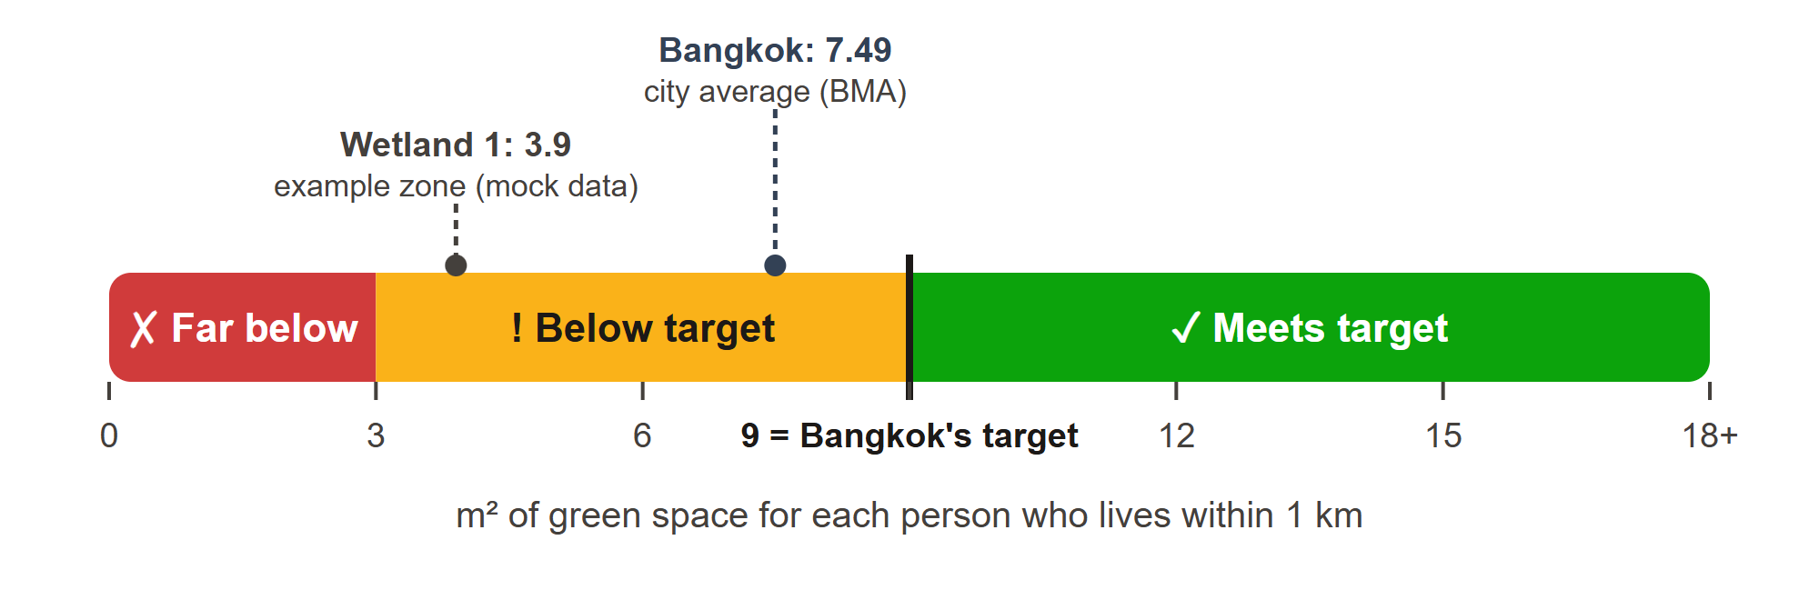
Figure 7. Green space per person compared with Bangkok's 9 m² target.
Number | What it means | How to read it
Green space per person (m²) | A green zone's area divided by the people who live within 1 km | 9 or more: ✓ Meets target  3 to under 9: ! Below target  Under 3: ✗ Far below target
Fitness score (0 to 1) | How good an empty plot is for new green space | 0.75 and up: High priority  0.50 to 0.74: Medium  Under 0.50: Low
Rank | The order of the plots | 1 = do first. "Rank 1 of 20" is the best of 20 plots.
Reasons (1 to 5) | Far from parks, near busy roads, surface heat | 5 = the strongest reason to plant there
Cooling effect (°C) | Ground temperature around the zone minus inside it | Bigger = the zone cools its area more
km² and rai | Units of area: 1 km² = 1,000,000 m² = 625 rai | The frame is 8.978 km² (about 5,600 rai)

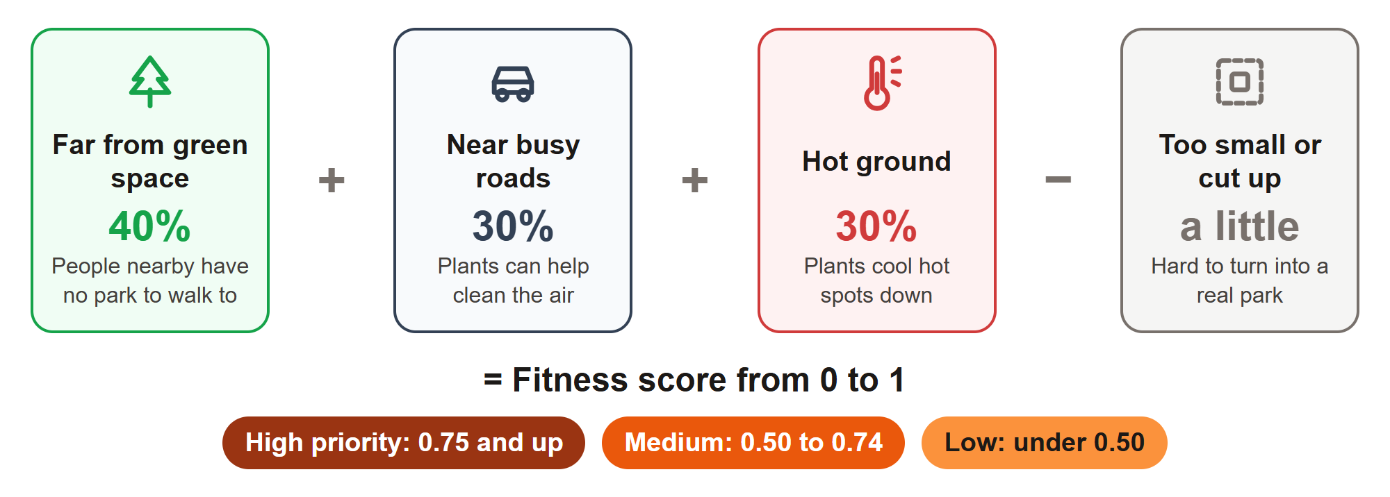
Figure 8. How a plot gets its fitness score.
Colour is never the only signal. Every status also has a word and a symbol, so the app works for colour-blind readers and in black-and-white print.

1.8 What we found in Don Mueang (example results)
These results use mock data. The land cover comes from OpenStreetMap, but the greenness, temperatures, population and scores are simulated. They show how GreenSight works, not real measurements. Real THEOS-2 results will replace them.

22%  of the land in the frame is green (1.913 km²) | 6 of 44  green zones meet the 9 m² target | 151  empty plots found as possible sites | 20  best sites ranked: 10 high and 10 medium priority

Green space. 1.913 km² of the frame is green, 6.894 km² is grey and 0.171 km² is water. There are 44 green zones of at least 0.5 ha. Only 6 give 9 m² or more per nearby person, 7 are below the target and 31 are far below it (under 3 m²). About 30% of the green-zone area is airport grass or Air Force land, which nearby residents usually cannot use.
Best sites. The top site, G-001, is about 27,700 m², roughly four football fields. 23,400 people live within 1 km, the ground reaches 37.7 °C and the nearest green zone is 0.5 km away. It scores 0.86: high priority, rank 1 of 20.
Rank | Site | Area (m²) | People within 1 km | Fitness | Priority
1 | G-001 | 27,746 | 23,400 | 0.86 | High
2 | G-002 | 2,667 | 21,000 | 0.86 | High
3 | G-003 | 2,443 | 16,700 | 0.83 | High
4 | G-004 | 16,053 | 18,400 | 0.82 | High
5 | G-005 | 2,617 | 16,700 | 0.82 | High
Table 1. The five best candidate sites (mock data).
The pattern matches what the project expected: the best sites are empty plots next to dense housing and busy roads, on hot ground and away from existing green zones.

1.9 Who it helps
- City and district planners (BMA, the Don Mueang district office): a ranked list with clear reasons, to plan budgets and pocket parks.
- GISTDA and researchers: a repeatable way to turn THEOS-2 pixels into decisions.
- Communities: see how much green space their area has and where new parks could go.

1.10 What's next
- Connect the real data. The backend will send real THEOS-2 greenness, Landsat temperatures, population and the Hybrid GA ranking. The app is ready: it only needs the backend's address.
- Check accuracy. Compare the green and grey squares with hand-checked samples. The goal is 80% or better.
- Add more areas. Frames gisda_01 (Pak Kret / Lak Si) and gisda_02 (Chon Buri, Sattahip), then more districts.
- Try it with a district office. Compare the ranked sites with real planting plans.

1.11 Words to know
Word | Meaning
THEOS-2 | Thailand's Earth-observation satellite, run by GISTDA and launched on 9 October 2023. Its photos show details down to 0.5 m.
GISTDA | Geo-Informatics and Space Technology Development Agency, Thailand's space agency.
Frame | The area covered by one satellite picture. gisda_03 is about 3 km × 3 km.
NDVI | A greenness score from −1 to +1, calculated from red and near-infrared light.
Green zone | Connected green squares covering at least 0.5 ha (5,000 m²).
Grey zone / candidate site | Connected empty grey land (not homes, roads, the airport or water) that could become green.
Fitness score | A score from 0 to 1 that says how good a site is for new green space.
m² per person | Green space area divided by the number of people living within 1 km.
Hybrid Genetic Algorithm | A computer method inspired by evolution that quickly finds a very good set of sites.
Mock data | Realistic example data used until the real data is ready.
km² and rai | Units of area. 1 km² = 1,000,000 m² = 625 rai.

FOR ENGINEERS, GIS ANALYSTS AND REVIEWERS

Part 2 – Technical version
This part describes the architecture, the data contract, and how the frontend computes and draws every number. File paths refer to the project folder.

2.1 Scope and status
Component | Status | Notes
Frontend web app | Done (v0.1) | React 19, Vite 8, Tailwind CSS 4, Leaflet 1.9. 74 automated tests pass.
Data contract | Done | docs/API.md: three GET endpoints. The files in src/mock/ are valid examples.
Backend: NDVI grid, zones, fitness, Hybrid GA | In progress (teammate) | Must implement the contract in section 2.11.
Mock data | Done | Real OpenStreetMap land cover; simulated NDVI, temperature, population and fitness (section 2.12).
Frames | gisda_03 ready; gisda_01 and gisda_02 "Update soon" | Corner coordinates from GISTDA.

2.2 System architecture
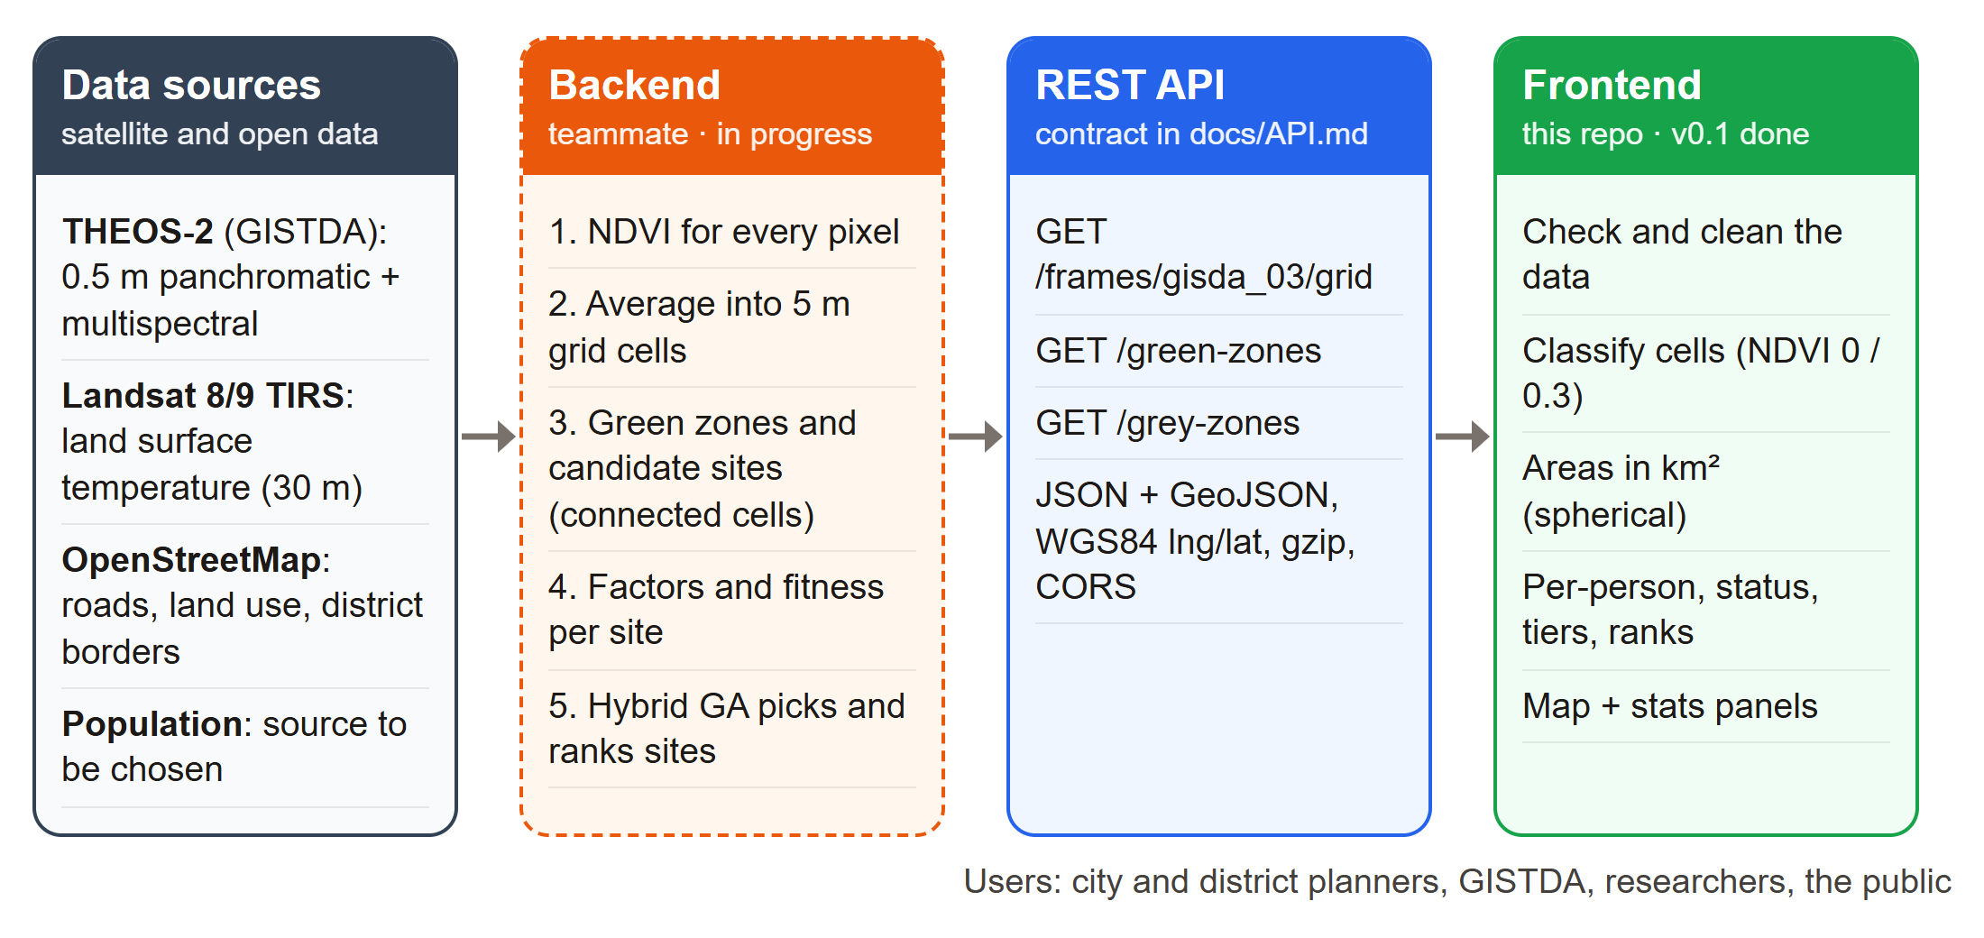
Figure 9. Data flows from satellite and open data through the backend and the API to the frontend.
The backend owns everything that needs imagery or heavy computation. The frontend owns everything that can be derived from the grid and the zone attributes, so the rules (thresholds, units and tiers) live in one place and stay consistent.
Backend computes | Frontend computes
NDVI per 5 m cell | Class per cell: water, grey or green
Zone polygons: green zones and candidate sites | Areas in km²: frame, cells, class totals, district
Population within 1 km; temperatures | Green space per person and its status
Fitness, factor scores 1–5, penalty and rank (Hybrid GA) | Priority tier and "rank N of M"
– | Rendering, interaction and layout

2.3 Study area and frames
The GISTDA frames are quadrilaterals given by four corner coordinates in WGS84 latitude and longitude (src/data/frames.js).
Frame | Place | Status | Area | Edges (top/bottom × left/right)
gisda_03 | Don Mueang | Ready (focus) | 8.978 km² | 2.98–2.99 km × 3.01 km
gisda_01 | Pak Kret / Lak Si | Update soon | 9.024 km² | 2.99–3.00 km × 3.01 km
gisda_02 | Chon Buri (Sattahip) | Update soon | 8.957 km² | 2.98–2.99 km × 3.00–3.01 km
Table 2. Frames. Areas use the spherical formula in section 2.5; edges are great-circle distances.
gisda_03 corner | Latitude | Longitude
Top-left (TL) | 13.9354055 | 100.5798814
Top-right (TR) | 13.9352513 | 100.6075171
Bottom-left (BL) | 13.90838144 | 100.57964238
Bottom-right (BR) | 13.90820126 | 100.60734273
Centre (mean of the corners) | 13.92181 | 100.59360

Don Mueang's boundary is OpenStreetMap relation 1639287 (admin_level 6), with an area of 37.142 km². gisda_03 lies entirely inside it and covers 24.2% of it. The map is limited to the district's bounding box plus 0.03° (about 3 km). Inside that box, the six neighbouring districts (Bang Khen, Sai Mai, Lam Luk Ka, Mueang Pathum Thani, Pak Kret and Lak Si) are clipped, simplified and drawn under a grey mask labelled "Update soon".

2.4 Grid model
The frame is not an axis-aligned rectangle: it is slightly rotated and its edges differ by up to 25 m. The grid is therefore defined by bilinear interpolation between the four corners. The lattice point at fractional position (u, v) is:
$$P(u,v) = (1 - u)(1 - v)·TL + u(1 - v)·TR + (1 - u)v·BL + uv·BR$$
with u = c / cols and v = r / rows, applied to latitude and longitude separately (pointInFrame in src/lib/geo.js). Cell (r, c) is bounded by P(c/cols, r/rows), P((c+1)/cols, r/rows), P((c+1)/cols, (r+1)/rows) and P(c/cols, (r+1)/rows). Row 0 is the northern edge and column 0 the western edge.
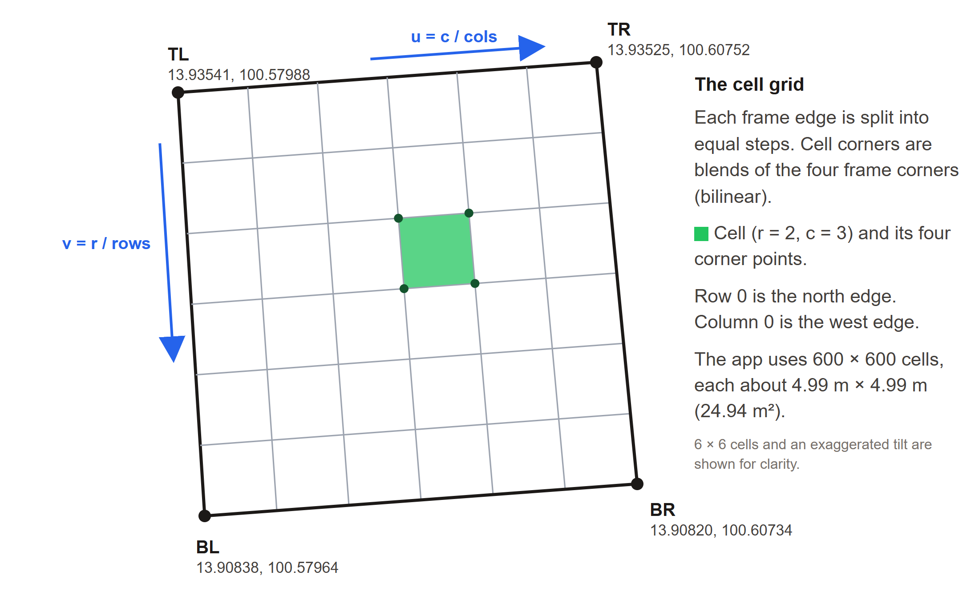
Figure 10. Cells are bilinear blends of the four frame corners (6 × 6 cells and an exaggerated tilt for clarity).
- gisda_03 uses 600 × 600 = 360,000 cells. The mean cell area is 24.94 m² (about 4.99 m × 4.99 m), and cell areas vary by less than 0.2% across the frame (24.90 to 24.98 m²).
- At the 0.5 m resolution used in the project report, one 5 m cell covers 10 × 10 = 100 pixels. The backend should aggregate NDVI per cell (for example the mean of the pixel values) and document the method.
- The backend must use exactly this layout (equal steps between the four corners, row 0 at the top), or cells will be misplaced on the map.

2.5 Classification and areas
The frontend classifies every cell from its NDVI (classifyGrid in src/lib/grid.js):
NDVI | Class | Code and how it is drawn
Under 0 | Water (not counted as green or grey) | 1 · transparent (the basemap shows water)
0 to under 0.3 | Grey | 2 · #9CA3AF at 47% opacity
0.3 and up | Green | 3 · #22C55E at 47% opacity
Missing or not a number | Unknown | 0 · transparent

Classes are stored in a Uint8Array (360 kB for gisda_03). Areas use the spherical polygon formula of turf.js with the mean Earth radius R = 6,371,008.8 m (ringAreaM2 in src/lib/geo.js):
$$A = \frac{R^{2}}{2} · | \sum_{i}{\left(λ_{i+1} - λ_{i}\right)\left(2 + \sin{φ_{i}} + \sin{φ_{i+1}}\right)} |$$
where λ and φ are the longitude and latitude, in radians, of the ring's vertices. Class totals are sums of cell areas, computed once from the (rows + 1) × (cols + 1) = 361,201-point corner lattice (classAreas).
Class | Cells | Area (km²) | Share of frame
Green | 76,712 | 1.913 | 21.3%
Grey | 276,448 | 6.894 | 76.8%
Water | 6,840 | 0.171 | 1.9%
Unknown | 0 | 0.000 | 0%
Total | 360,000 | 8.978 | 100%
Table 3. Classified gisda_03 (mock data). The app's gauge shows the green share of land, water excluded: 1.913 ÷ (1.913 + 6.894) = 21.7%, shown as 22%.
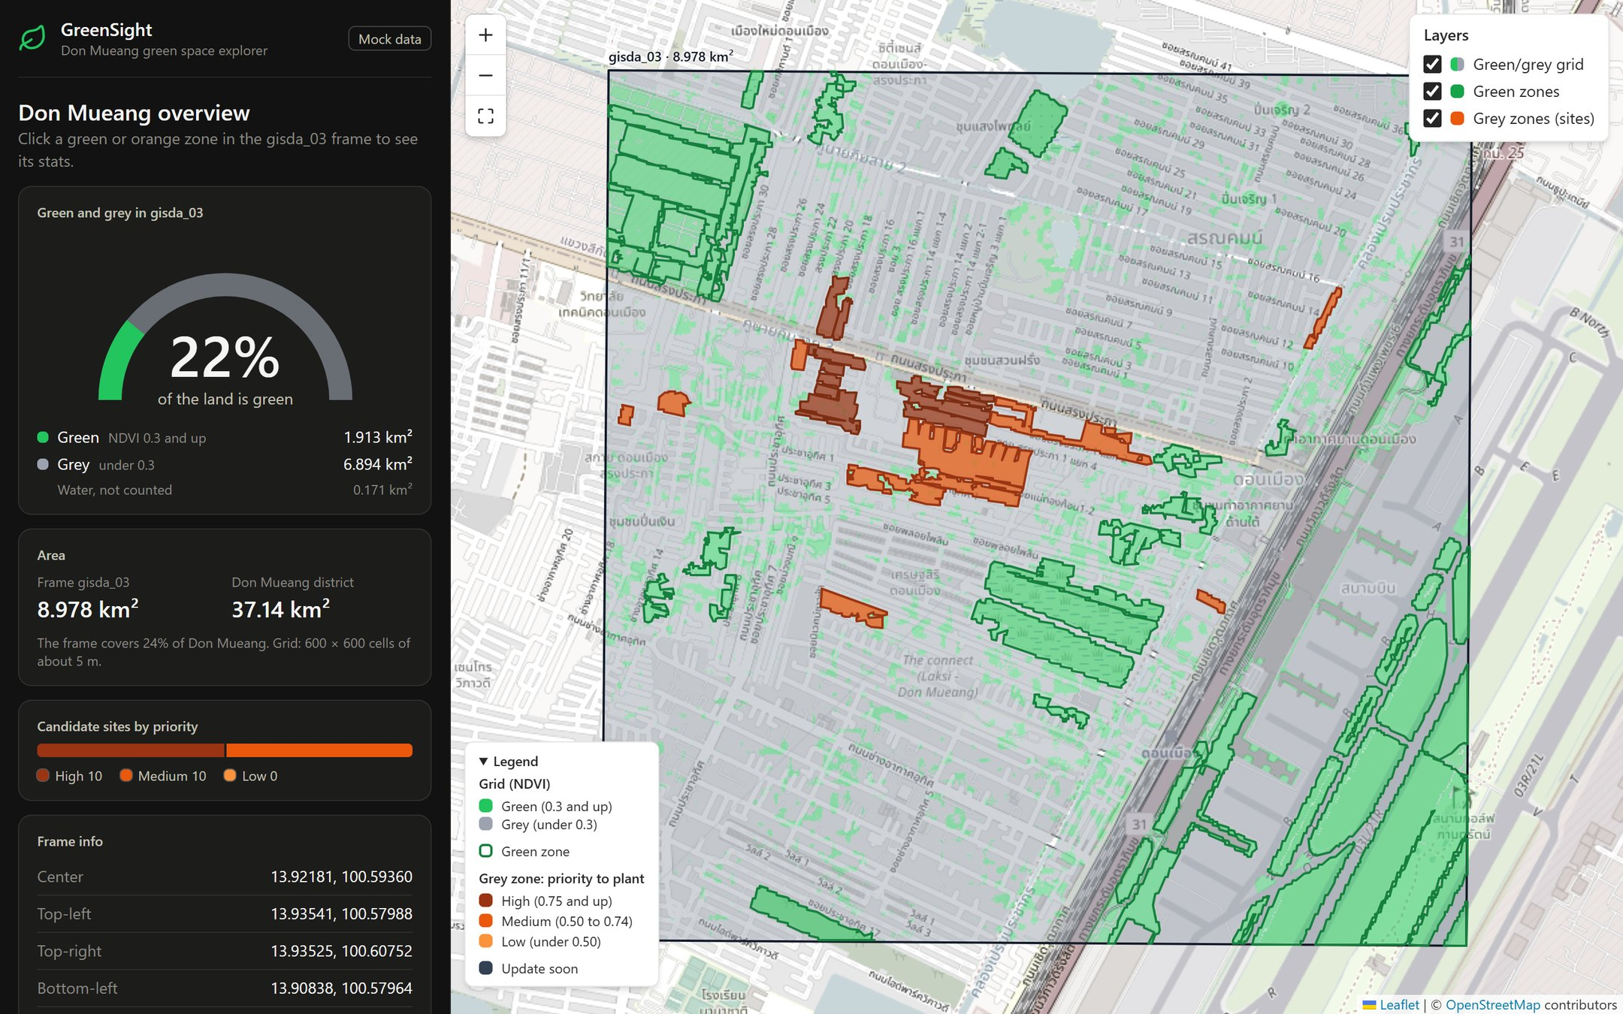
Figure 11. The classified frame with green zones (green outlines) and candidate sites (orange, by priority).

2.6 Zones
The backend builds zones from the same cells and the same NDVI rule. The mock data shows the intended method:
- Green zone: a 4-connected group of green cells with an area of at least 5,000 m² (0.5 ha).
- Candidate site (grey zone): a 4-connected group of grey cells on open land, excluding buildings, roads, runways, aprons and water, with an area of at least 2,000 m².
- Outline: traced along the cell edges, holes under 25 cells dropped, then simplified (Douglas–Peucker, tolerance 0.00003°, about 3 m). Geometry is a Polygon or MultiPolygon in WGS84 [longitude, latitude].
Mock result: 44 green zones covering 1.070 km² (56% of the green cells; the rest are patches under 0.5 ha) and 151 candidate sites. The API returns the best 20 sites, 0.225 km² in total.

2.7 Indicators computed in the frontend
All indicators live in src/lib/metrics.js and src/lib/constants.js:
Indicator | Formula | Display and thresholds
Green space per person | areaM2 ÷ populationNearby (people within 1 km) | ≥ 9 m² Meets target · 3 to < 9 Below target · < 3 Far below target · "—" if the population is missing or 0
Gauge fill | min(1, m² per person ÷ 18) | The 9 m² target sits at the middle of the half-circle
Cooling effect | tempAroundC − tempInsideC | "X °C cooler than around it", on an axis padded by 2 °C
Priority tier | From fitness | ≥ 0.75 High · ≥ 0.50 Medium · otherwise Low
Rank text | rank and the number of sites returned | "rank N of M"
Added green per person (site) | areaM2 ÷ populationNearby | "Greening it adds X m² per nearby person"
Vegetation label | From NDVI | ≥ 0.6 dense · ≥ 0.3 moderate · otherwise little or no vegetation

Mock outcome: 6 green zones meet the target, 7 are below it and 31 are far below it (median 1.4 m² per person). Cooling ranges from 0.6 to 3.9 °C (mean 1.7 °C).

2.8 Fitness function and optimisation
Each candidate site is scored with the fitness function from the project report (Eq. 3.1):
Fitness = w₁ · GreenAccessDeficit + w₂ · AirProximity + w₃ · HeatSeverity − Penalty(Surrounded)
Component | Meaning | Data source
GreenAccessDeficit | Distance to the nearest green zone; farther scores higher | THEOS-2 NDVI green zone map
AirProximity | Nearness to major roads or industry, as a pollution proxy | OpenStreetMap road network
HeatSeverity | Land surface temperature compared with the study-area average | Landsat 8/9 TIRS
Penalty (Surrounded) | Deduction for small, fragmented or isolated plots | Grid contiguity analysis

All components are normalised to 0–1 before weighting. The mock data uses min–max normalisation across the candidate sites:
$$x' = \frac{x - min}{max - min}$$
- Weights w₁ = 0.4, w₂ = 0.3 and w₃ = 0.3.
- AirProximity = 1 − the normalised distance to the nearest motorway, trunk, primary or secondary road.
- A penalty of 0.05 for sites under 5,000 m²; the result is clamped to 0–1 and rounded to two decimals.
- The 1–5 factor scores shown in the app are 1 + round(4x′).
Mock outcome: fitness ranges from 0.66 to 0.86, so 10 sites are high and 10 are medium priority; 10 of the 20 carry the 0.05 penalty.
Optimisation (backend). Choosing the best set of sites is combinatorial: with N candidate cells there are 2^{N} possible plans (about 1.08 × 10²⁰ for the project's encoding), far too many to test one by one. The report therefore uses a Hybrid Genetic Algorithm:
- A population of 90 candidate plans evolves through selection, crossover and mutation.
- A lightweight machine-learning model estimates fitness, so each generation is cheaper to evaluate.
- Guided crossover and mutation favour neighbouring cells with high deficit and heat scores, which speeds up convergence.
- The run stops after a set number of generations or when fitness stops improving.
- Quantum PSO is kept as a faster alternative. The method is to be benchmarked against a standard GA, PSO and simulated annealing, and checked against a greedy top-N baseline for spatial spread and total benefit.

The frontend does not depend on the optimiser. It only needs rank and fitness for each site. The mock data ranks sites greedily by fitness (top 20), which is exactly the baseline the Hybrid GA has to beat.

2.9 Frontend architecture
Part | Choice
UI | React 19.3, JavaScript (ES modules)
Build and dev server | Vite 8.3 with @vitejs/plugin-react 6
Styling | Tailwind CSS 4.3 through @tailwindcss/vite; design tokens in @theme (src/index.css)
Map | Leaflet 1.9.4 with react-leaflet 5.0; OpenStreetMap standard tiles
Icons | lucide-react
Tests | Vitest 5 with jsdom 29 and Testing Library (React 16, DOM 10)
Runtime | Node.js 22.12 or newer (tested with 24.11)
Production bundle | JavaScript 426 kB (131 kB gzip), CSS 34 kB (11 kB gzip); the example data ships as separate files next to it

Map behaviour
- Layer order (Leaflet panes): basemap tiles (200), grey mask and neighbour outlines (350), grid (390), zone shapes and outlines (400), labels (450).
- First view: a ResizeObserver calls invalidateSize and fits Don Mueang (24 px padding) only once the container has a real size. This avoids a bug where Leaflet measured a half-laid-out container and zoomed all the way in.
- Limits: maxBounds is the district box ± 0.03° with viscosity 1; minZoom is the fit zoom − 0.75 (never below 10); maxZoom is 19; zoomSnap is 0.25.
- Selection: clicking a zone selects it (black 3 px outline, brought to the front) and the sidebar switches panel. Zone clicks don't reach the map; clicking empty map, the × button or Esc clears the selection. Hiding a layer clears a selection of that kind.
- Hover: a tooltip that follows the pointer with the zone's name or priority, and a thicker outline.
- Responsive: from 1024 px wide, a 400 px sidebar sits next to the full-height map. Below that, the map (55% of the screen height) sits above the stats and the legend starts folded.
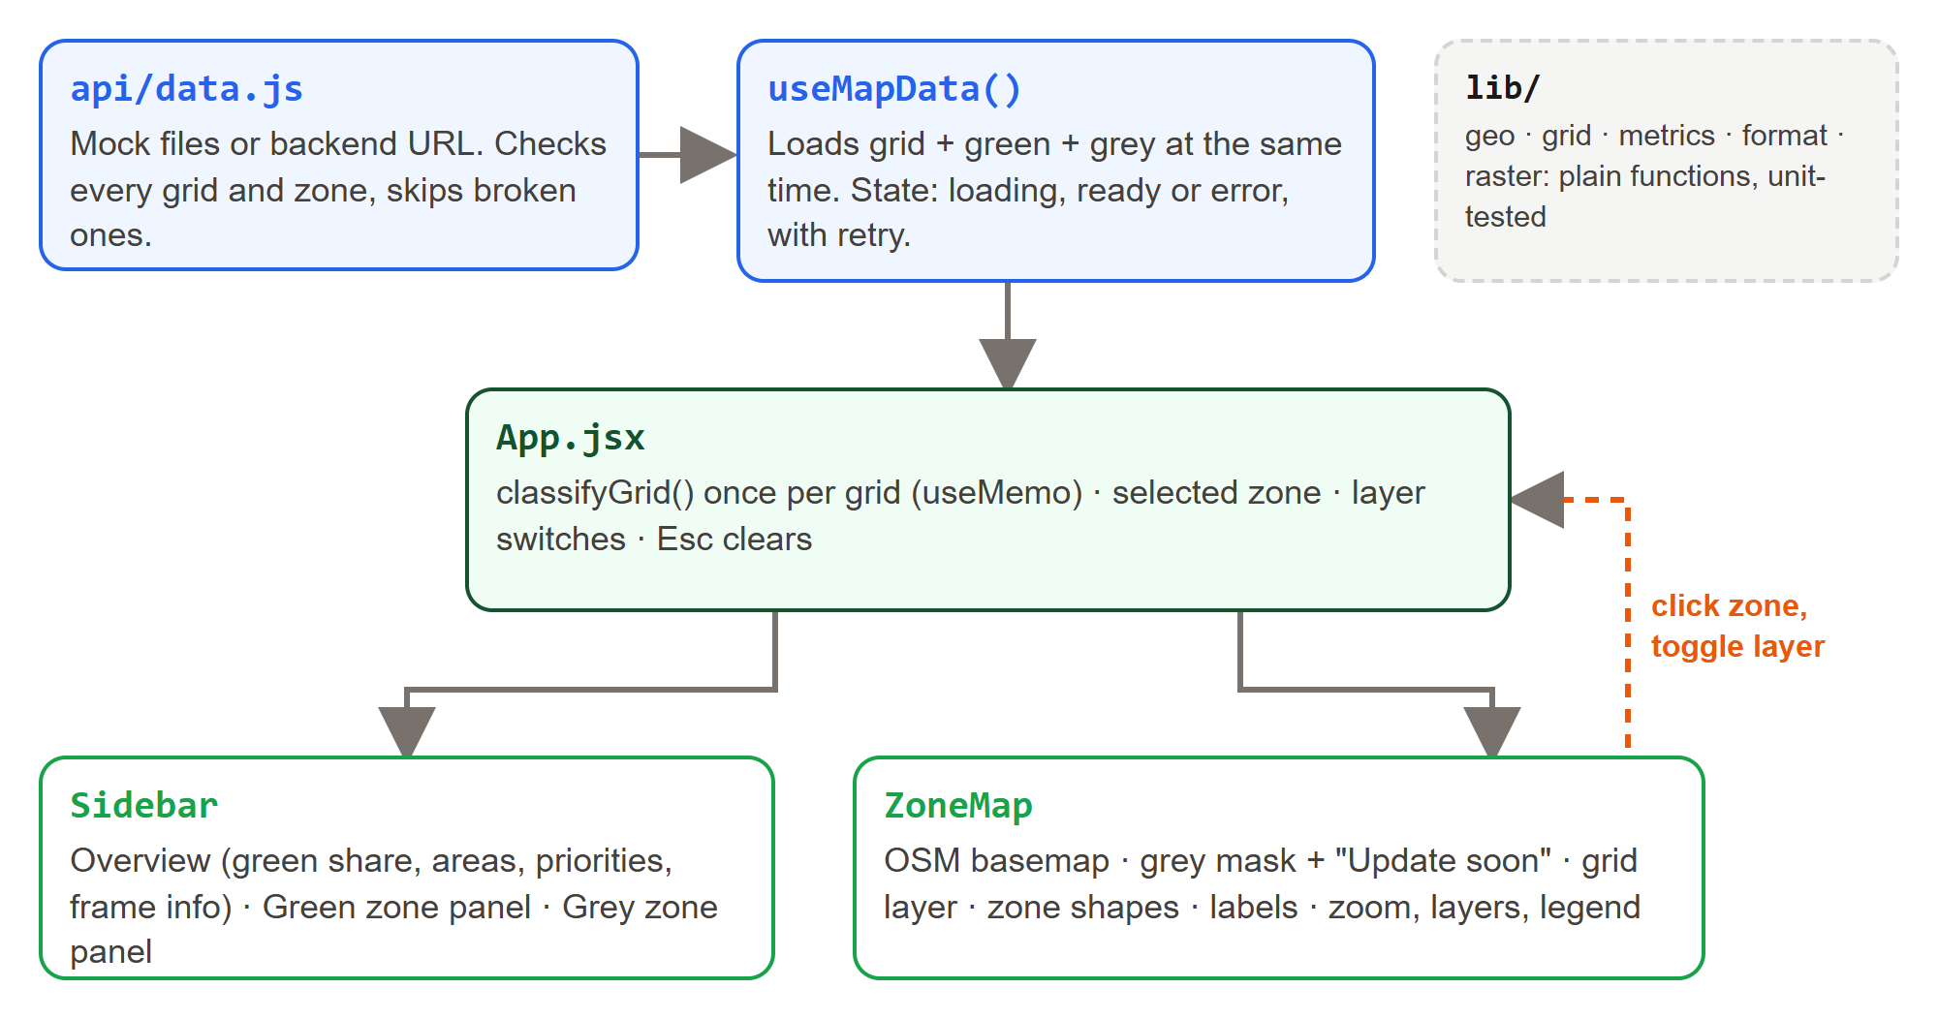
Figure 12. Modules and data flow in the frontend.
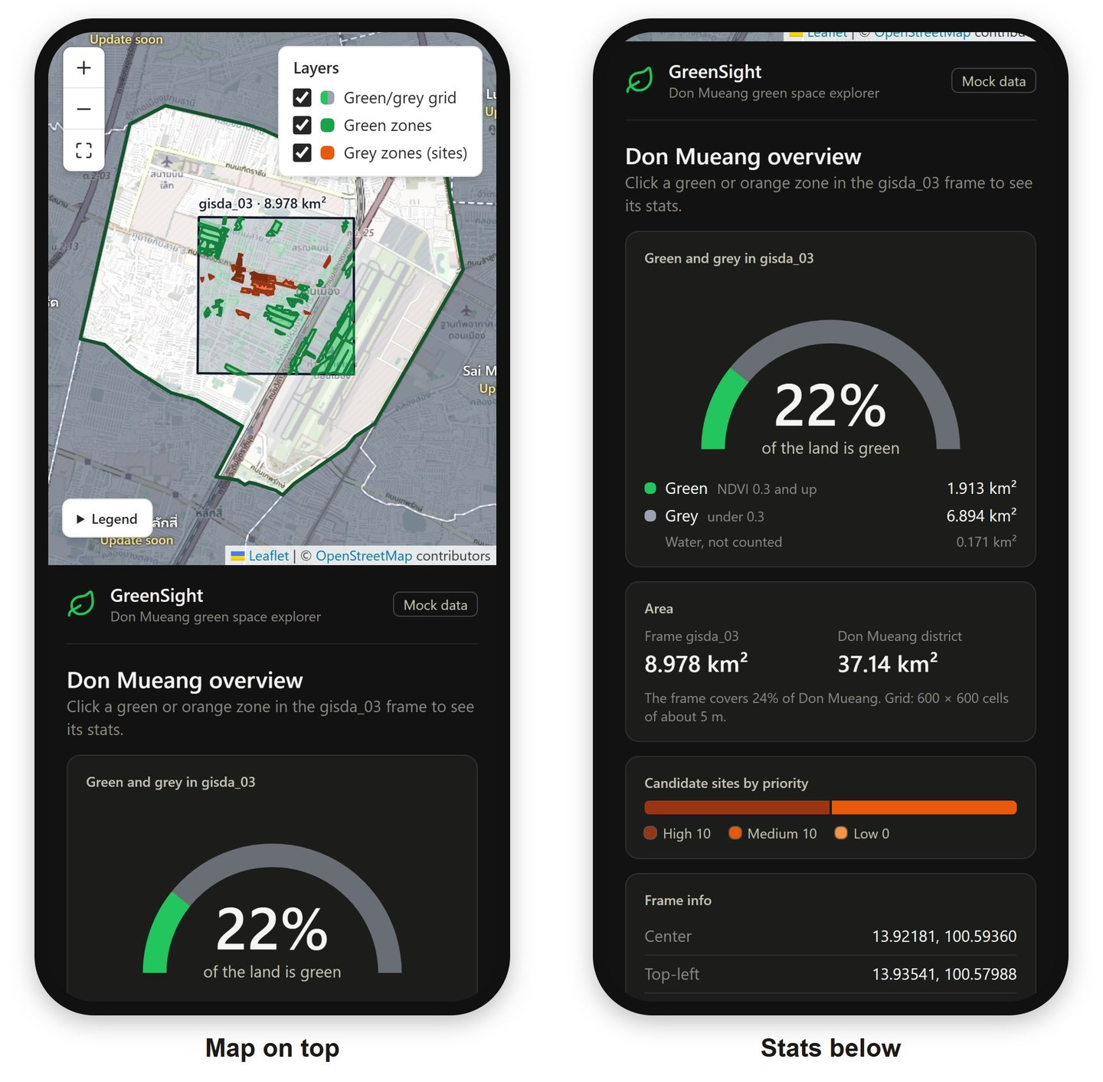
Figure 13. The same app on a phone (390 px wide).

2.10 Drawing 360,000 cells fast
One SVG polygon per cell would put 360,000 shapes in the page, far too slow to pan and zoom. Instead the grid is drawn as an image, one pixel per cell, by a custom Leaflet GridLayer (src/components/map/ClassifiedGridLayer.jsx).
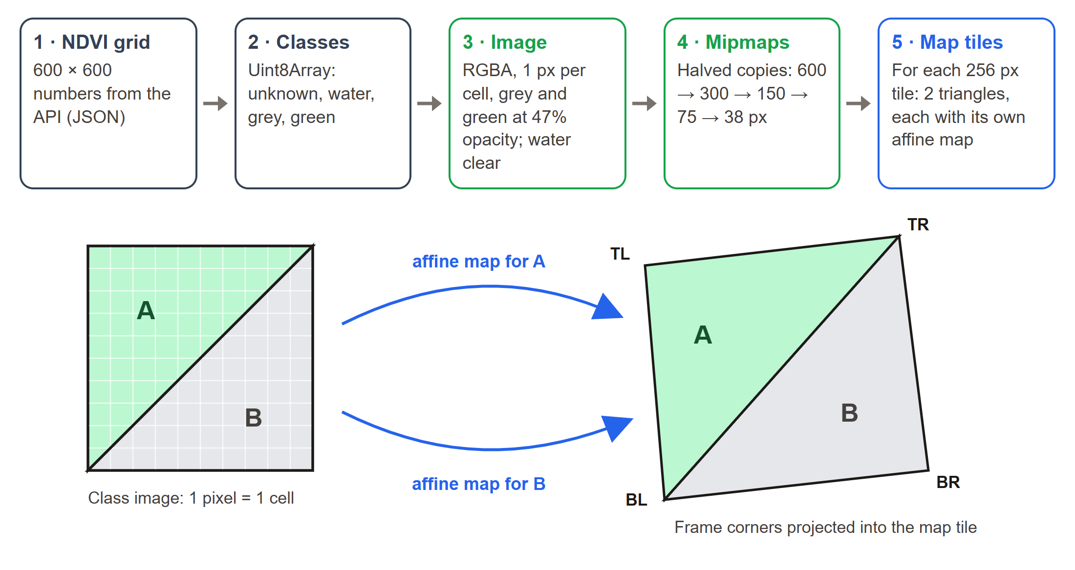
Figure 14. From NDVI values to map tiles. Each tile draws the class image as two affine-mapped triangles.
- Image: classes become a 600 × 600 px RGBA image; grey and green at alpha 120/255 (about 47%); water and unknown are transparent.
- Mipmaps: halved copies down to 32 px or less (600, 300, 150, 75 and 38 px) are built once.
- Per tile: createTile projects the four frame corners into the tile's pixel space at its zoom. The copy used is round(log₂(1 / pixels per cell)), clamped to the available levels.
- Two triangles: the frame is split along the TR–BL diagonal. For each triangle, affineFromPoints solves the affine map from three image points to three tile points; the canvas is clipped to the triangle, grown by 1 px so the halves meet without a seam, and setTransform plus drawImage draw it.
- Sharp or smooth: image smoothing is on only when the image is reduced (a level above 0, or under 1 px per cell), so zoomed-in cells stay crisp squares.
Accuracy. The two-triangle split differs from the true bilinear frame by at most |TL + BR − TR − BL| ÷ 4 = 1.9 m, at the frame centre, which is less than half a cell. The curvature of Web Mercator over 3 km adds only a few centimetres. Figure 15 shows the cells meeting the frame corner exactly at the highest zoom.
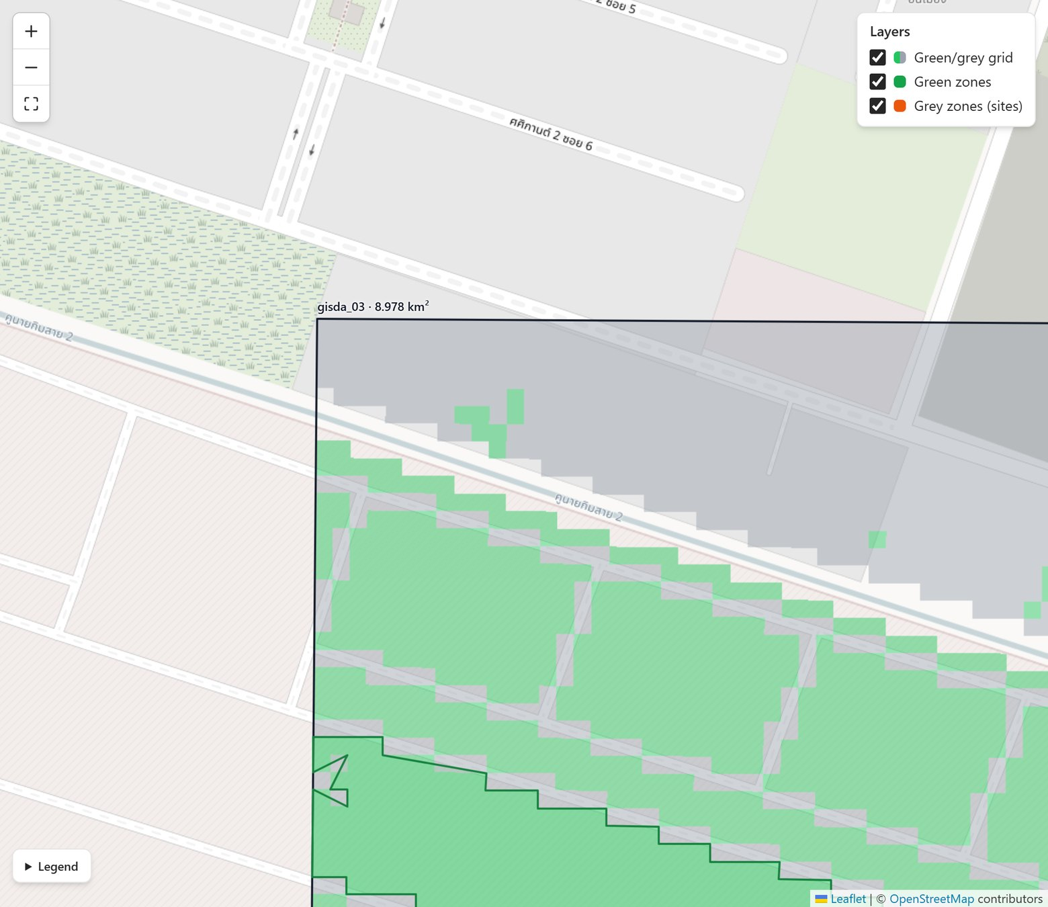
Figure 15. Zoom 19 at the north-west corner of gisda_03: the 5 m cells line up with the frame outline.
Cost. Classification runs once per grid (useMemo). Tiles are drawn on demand and not redrawn during zoom animations (updateWhenZooming: false). The grid JSON is 1.77 MB, or 0.33 MB with gzip.

2.11 Data contract (API)
Full details are in docs/API.md. The frontend needs three endpoints:
Endpoint | Returns | Notes
GET {VITE_API_URL}/frames/gisda_03/grid | NDVI grid (JSON) | rows, cols, cellSizeM, ndvi[rows][cols]
GET {VITE_API_URL}/green-zones | GeoJSON FeatureCollection | Green zones in the frame
GET {VITE_API_URL}/grey-zones | GeoJSON FeatureCollection | Candidate sites, ranked 1…N without gaps

{
"frameId": "gisda_03",
"rows": 600,
"cols": 600,
"cellSizeM": 5,
"ndvi": [[0.41, 0.18, -0.05, ...], ...] // ndvi[row][col], row 0 = north, col 0 = west
}

Required zone fields. Green zone: id, name, district, areaM2, populationNearby. Grey zone: id, rank, district, areaM2, populationNearby, fitness (0–1) and scores.greenAccessDeficit, scores.airProximity, scores.heatSeverity (integers 1–5). Optional: nameTh, type, ndvi, tempInsideC, tempAroundC, surfaceTempC, penalty, nearestGreenZone (id, name, distanceKm), nearbyRadiusKm (default 1) and updatedAt.
- Reply with HTTP 200 and JSON. Any other status shows an error card with a Retry button; the card names the address that failed and why.
- Allow CORS from the frontend origin (http://localhost:5173 during development) and turn on gzip.
- Geometry is a Polygon or MultiPolygon in WGS84 [longitude, latitude] (EPSG:4326).
- Zones without an id or polygon geometry are skipped with a console warning; missing or non-finite numbers show as "—"; extra fields are ignored.
- With VITE_API_URL empty, the app reads the same structures from src/mock/. Vite builds these files into the app, so the example data loads wherever the app is hosted.

2.12 How the mock data was made
The scripts in docs/mock-data/ produce the mock files reproducibly, with seeded random numbers (mulberry32, seed 20261015):
- Download OpenStreetMap data (API v0.6) for Don Mueang, its neighbours and everything around gisda_03.
- Rasterise the land cover onto the 600 × 600 grid. Where shapes overlap, a priority order decides: water, paved, buildings, vegetation, airfield, military, vacant, institutional, residential, open land. Polygons fill the cells whose centres are inside; lines become strips of their real width (runway 45 m, taxiway 23 m, roads 5–24 m, canals 12 m, rivers 30 m).
- Simulate NDVI per cell as a base value for the land cover plus smooth noise at about 200 m and 25 m and a small random jitter (for example trees 0.70, grass 0.58, airfield 0.50, residential 0.19, paved 0.08; water −0.15 to −0.03).
- Simulate land surface temperature as 39.2 − 8.5 × NDVI ± 0.4 °C (water 30.8 °C).
- Estimate people on a 100 m grid that reaches 1 km past the frame (per 100 m cell: residential 120, open 30, institutional 20, military 8, vacant 5, each ±20%).
- Build the zones, outlines, factors and fitness as in sections 2.6 to 2.8, and keep the best 20 sites.

2.13 Quality and verification
- Automated tests: 74 tests in 10 files, all passing (Vitest, jsdom, Testing Library). They cover formatting, metrics and tiers, geometry and areas, grid classification and class areas, the affine solver and palette, API validation, URLs and error messages, the mock-data contract (600 × 600, 360,000 values), the data-loading hook (loading, error, retry), the gauge and the sidebar panels.
- Build: the production build passes (Vite 8).
- Browser checks: grid alignment with the frame at zoom 13, 16 and 19; zone click to stats; layer switches; Esc; phone layout at 375 px.
- Accessibility: each status uses an icon, a word and a colour; the priority colours were checked for contrast on the map and on the dark cards; map buttons have labels; the legend is a native details element.
- Planned (from the report): classification accuracy of at least 80% against hand-labelled cells; the Hybrid GA against a greedy baseline; sensitivity analysis of the weights.

2.14 Limitations and risks
Item | Effect | What to do
Mock data | Results are examples only | Connect the backend; the app shows a "Mock data" badge until then
Frame assumed bilinear between its 4 corners | Cells are misplaced if the imagery is georeferenced differently | Confirm with GISTDA metadata, or send a geotransform or cell polygons
0.5 m imagery averaged to 5 m | Single trees and narrow strips blur | Define the aggregation; test the threshold on samples
One NDVI threshold (0.3) | Season and sensor change NDVI | Calibrate with labelled samples; the value lives in src/lib/constants.js
Thermal data at 30 m | HeatSeverity describes the neighbourhood, not the 5 m cell | State it with results; use finer thermal data when available
AirProximity is a road-distance proxy | Misses informal pollution sources | Add air-quality or industry layers
Weights w₁–w₃ | Rankings depend on them | Run a sensitivity analysis before real use
Population source not yet chosen | Per-person numbers depend on it | Choose and document it (for example a 100 m population grid)
OpenStreetMap standard tiles | The usage policy limits heavy traffic | Use a tile provider or self-host for production
Grid payload: 1.77 MB per frame (0.33 MB gzip) | Fine for one frame, large for a whole city | Binary or PNG encoding, or raster tiles / Cloud-Optimised GeoTIFF

2.15 Roadmap
- Backend integration: serve the three endpoints with real data, and validate them against the mock examples.
- More frames: a frames endpoint and a frame switcher; mark gisda_01 and gisda_02 ready.
- Validation: accuracy assessment, the Hybrid GA against the greedy baseline, and weight sensitivity.
- Scale: tiled grids and caching for city-wide coverage.
- Pilot: test with a district office. Possible additions (proposals, not built): a Thai-language interface and export of the ranked list.

2.16 Running and deploying
- Windows: double-click start.bat. It checks for Node.js, installs the packages the first time, starts the dev server and opens http://localhost:5173.
- Commands: npm run dev (dev server), npm test (tests), npm run build (production build in dist/), npm run preview (serve the build).
- Connect the backend: copy .env.example to .env, set VITE_API_URL (for example http://localhost:8000/api) and restart. The "Mock data" badge disappears.
- Deploy: npm run build produces static files that any web host can serve, at a site's root or in any folder, because the build uses relative paths (base: './' in vite.config.js). VITE_API_URL is read at build time.

Appendix A. Project structure
src/
App.jsx page layout, selected zone, layer switches, Esc key
config.js backend URL, basemap, map zoom limits
data/frames.js GISTDA frames (corner lat/lng) and which one is ready
data/districts.json Don Mueang + neighbouring districts (OpenStreetMap)
api/data.js loads and checks the NDVI grid and the zones
hooks/useMapData.js loading / error / retry state
lib/geo.js areas in km², frame corners -> cell corners, grey mask
lib/grid.js NDVI -> water / grey / green cells, area per class
lib/raster.js affine solver and class image for the grid layer
lib/metrics.js m² per person, status, priority tiers
components/map/ Leaflet map, grid layer, layer switches, legend
components/sidebar/ overview, green zone and grey zone panels
components/charts/ half-pie gauge, cooling chart, factor bars, priority bar
mock/ example grid and zones, built into the app (API examples)
public/ favicon
docs/API.md data contract for the backend
docs/mock-data/ scripts that made the mock data
start.bat one-click start on Windows

Appendix B. References
[1] GreenSight: Optimization of Urban Green Space Development Sites using THEOS-2. GeoHackathon 2026 project report (GISTDA).
[2] Bangkok Metropolitan Administration (BMA). Public green area statistics, reported in "BMA Speeds Up Increasing Bangkok's Green Areas", Lifestyle and Travel, 2022. https://www.lifestyleandtravel.com/bma-speeds-up-increasing-bangkoks-green-areas/
[3] Chulalongkorn University / UDDC. "Solving the City's Lack of Green Space", Bangkok Post, 2022. https://www.bangkokpost.com/thailand/general/2303294/solving-the-citys-lack-of-green-space
[4] JLL Research and Consulting Thailand. "The Green Way Forward: Expanding Bangkok's Pocket Parks", 2025. https://www.jll.co.th/en/trends-and-insights/research/the-green-way-forward-expanding-bangkoks-pocket-parks
[5] Cowan, C. "As Tree Planting Gathers Pace in Bangkok, Urban Green Spaces Still Under Threat", Mongabay, 2025. https://news.mongabay.com/2025/06/as-tree-planting-gathers-pace-in-bangkok-urban-green-spaces-still-under-threat/
[6] Teo, V. Discussion on the "WHO 9 m² per capita" green space standard. ResearchGate, 2017.
[7] GISTDA. THEOS-2 (Thailand Earth Observation System-2) mission overview. https://www.eoportal.org/satellite-missions/theos-2
[8] USGS. Landsat 8-9 OLI/TIRS data products. https://earthexplorer.usgs.gov
[9] OpenStreetMap contributors. Map data and tiles, Open Database License (ODbL). https://www.openstreetmap.org/copyright

