**GAP ANALISYS – Processo de matrícula BandTec**

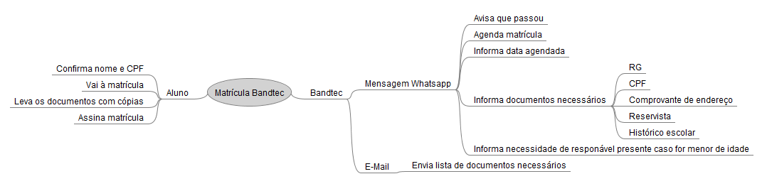**1 - Mapa mental (AS IS)**

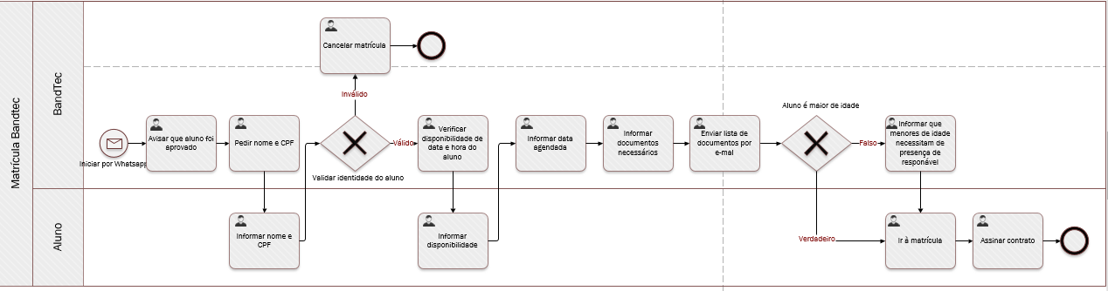**2 - BPMN (AS IS)**

**3 – BPMN NOVO (TO BE)**