装配指南

PDB
https://www.getfpv.com/learn/new-to-fpv/all-about-multirotor-fpv-drone-power-distribution-board/
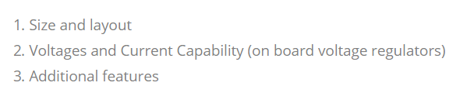
Matek PDB-XT60
Input
9-18V (3-4s LiPo)
PDB/FC combom

Output
ESC x4
12V/0.5A X1 Receiver, FC, 5V LED
5V/2A x1 VTX, FPV camera
https://item.taobao.com/item.htm?spm=a230r.1.14.52.50155c0fHkYeOm&id=545406853226&ns=1&abbucket=15#detail

Motor
2204/2300KV
QAV 210 250
https://item.taobao.com/item.htm?spm=a230r.1.14.1.2054776dCh52qd&id=583343025341&ns=1&abbucket=15#detail
http://bbs.5imx.com/forum.php?mod=viewthread&tid=1429326
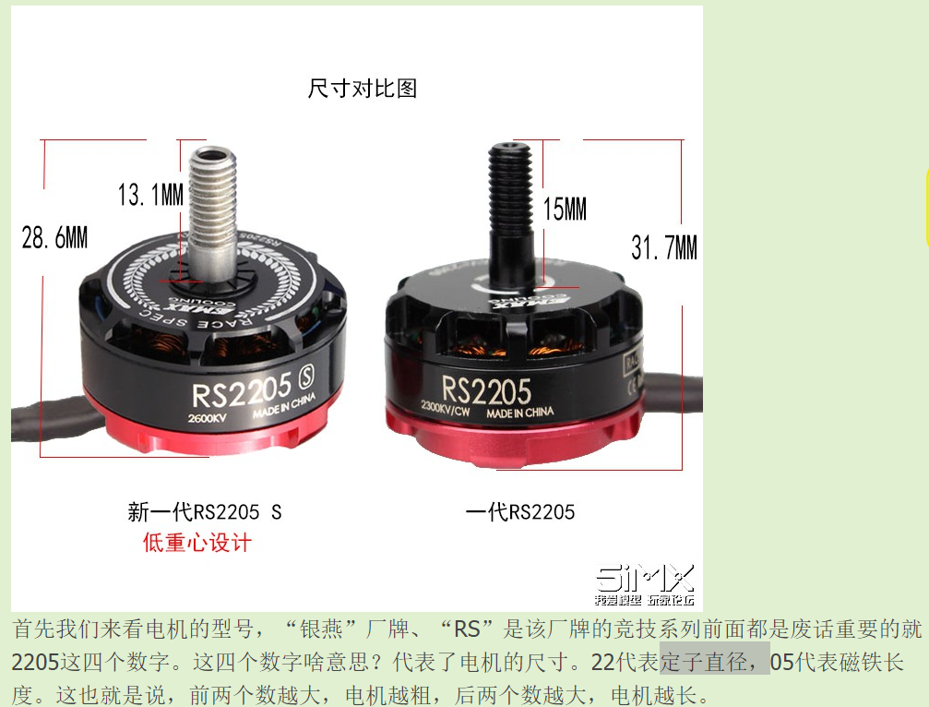
钻子直径
磁铁长度

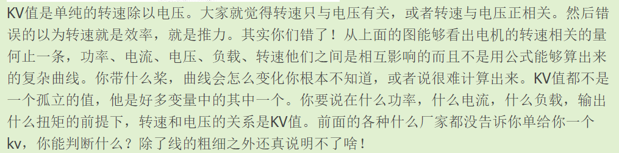
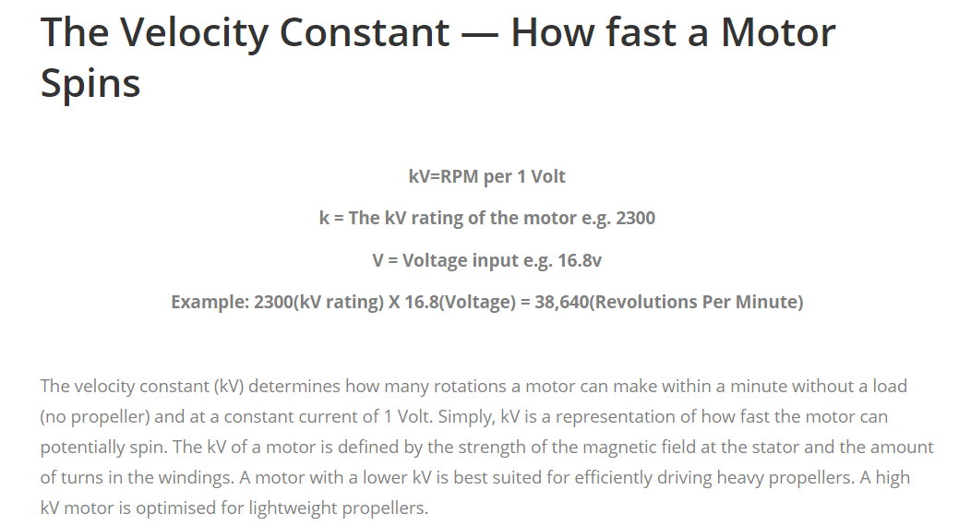
https://www.getfpv.com/learn/new-to-fpv/all-about-multirotor-drone-fpv-motor/

Esc
Esc 选择与电子最大电流匹配
https://item.taobao.com/item.htm?spm=a230r.1.14.23.2f9f2b4dT9ovEv&id=566280389915&ns=1&abbucket=15#detail
比如以上电机
测试数据，最大电压下最大电流38A，电调就要选择40A

Amperage
30 amps sustain 40amp burst
Battery
4-Cellbatteral(4s) 16.8 V
Motor(power) = ESC(Amperage) * Battery(Voltage)
P = UI = 30* 16.8 = 480W

ESC chips type
- BLHeli: This is found on older 8-bit ESC’s. It is capable of running oneshot protocols. The 8-bit microprocessor of later models, called the F390, is capable of the faster analog signal Multishot.
- BLHeli_S: This is also found on 8-bit ESC’s, but the hardware is more modern, running quieter and able to run all protocols (Oneshot, Multishot) up to D-Shot 600.
- BLHeli_32: This is a relatively new firmware which will run on the new 32-bit ESCs. It is capable of the faster iterations of D-Shot, like D-Shot 1200, and has things like telemetry.
- KISS: This is a proprietary ESC firmware that will only run on KISS ESCs. It is capable of Oneshot and D-Shot, and has telemetry and other features.

Propeller
5Inch for FPV most common

Camera
https://item.taobao.com/item.htm?spm=a230r.1.14.1.620030a7bKN7dv&id=545432414574&ns=1&abbucket=15#detail

Video transmitter
Poweroutput
250mm quadcopter
25Mw ~ 800Mw
Frequency
5.8Ghz transmitter/receiver (< 1 KM)
2.4GHz/1.2GHz (> 1KM)
Band&Channel
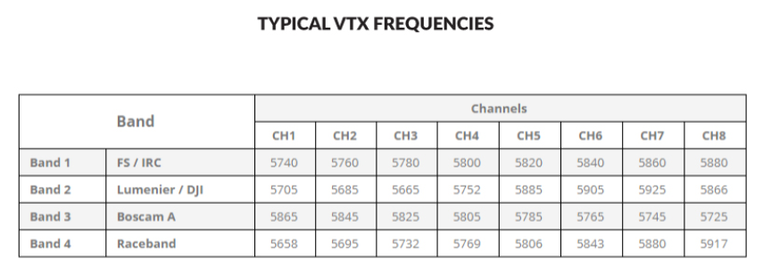
https://item.taobao.com/item.htm?spm=a230r.1.14.32.d23129cc1zUpOP&id=43521697577&ns=1&abbucket=15#detail

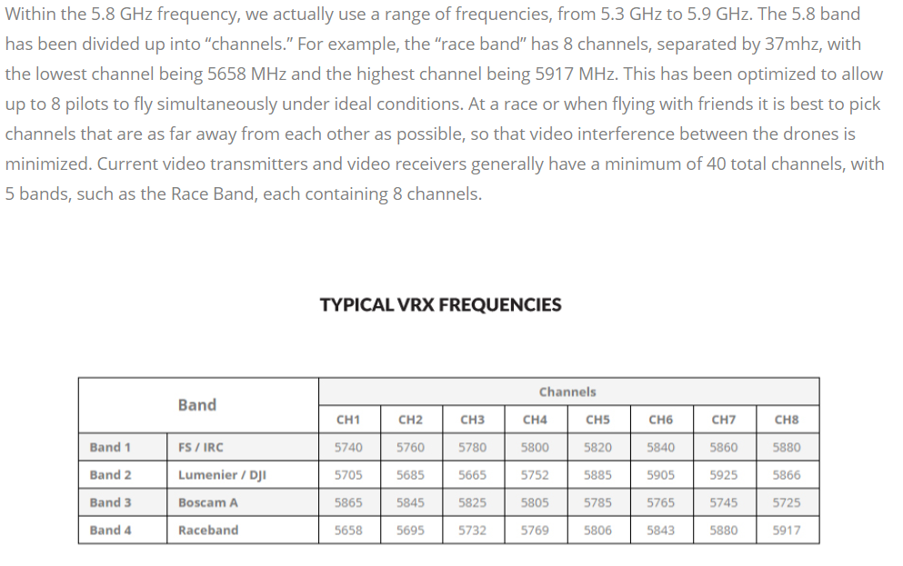
遥控器
首先选购遥控器时，首先要保证具有绝对的安全性和可靠性，其次才是设备本身的功能多少和档次的高低，这是楼主你必须考虑的。
国产的富斯I6（6通道约250元左右，黑白液晶屏幕，初学推荐）、乐迪9系列（9通道约500到600元，中文彩屏，模式较多，个人推荐，这个控性价比好，彩屏和中文显示也比较装B,够你用到你进阶）、华科尔DEVO 7（7个通道约440元左右）和天地飞7（7个通道470元上下，这个有点不高不低，米多的话上天地飞9，这个是个神器，用的人很多，），至于进口控，自己也没用过，身边的朋友也没有，不敢乱说。
现在你应该有个基本概念了，至于一开始上500左右的还是用上千的控，这就仁者见仁，智者见智了，好了，就说那么多，祝爽飞。

https://blog.csdn.net/iracer/article/details/52895316

总体清单
飞控
PDB
Frame
Motor
ESC
遥控器/接收器
电池
充电器
其他（扎带，魔术贴，热缩管3mm/5mm）

摄像头
图传/接收器
监视器
天线

