Pre-departure orientation
- documents
  - Passport with the visa
  - COPR
  - Accompany goods list BSF186 CBSA website
  - Goods to follow BFS186(A)
  - Customs declaration card?
- Cash more than 10,000. E677 form needed
- BSF186 & BSF186A
- Housing 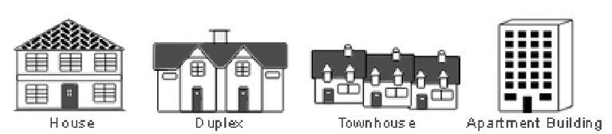
- Landlord and tenant board
- SIN – social insurance number
  - Service Canada website/office (passport/copr)
- Health care card
  - See a doctor
  - Use public health care services
  - Provincial health care system/plan
  - Waiting period
    - Buy private health insurance
  - Different coverage
    - What is (not) covered
- Driving license
  - International driving permit 1-3 month
  - Car insurance
- Banking
- Tax 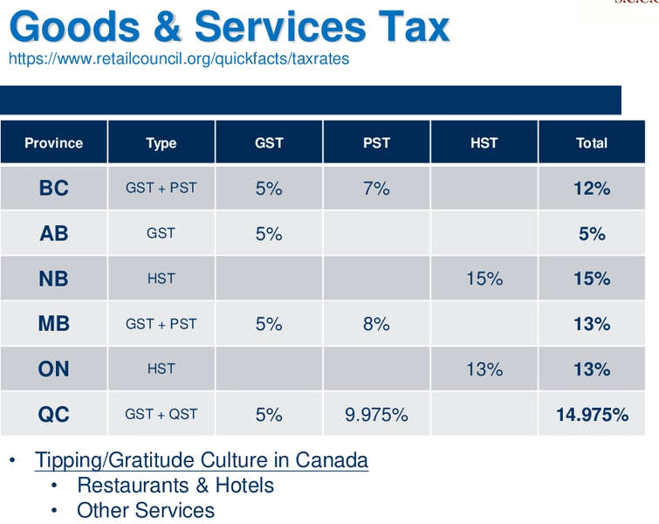
- Community connection
- Government funded training program
  - Job finding clubs
  - Career exploraration programs
  - Industry specific career programs
  - Mentoring programs
  - Contact local employment consoler
- PR card application
  - 4-8 weeks
  - What I do not apply for PR card at the customs
    - Provide new address > Canada.ca to update the address
  - Renewal
    - Record traveling outside Canada including to USA
- Find a job
  - Job bank
  - Indeed
  - Glass door
  - Monster
- Resources for new comer
  - Living in Canada
  - Welcome to Canada
  - Before you arrive

