Davinci Resolve 15 Study
Basic functions
Subtitle
Effects library > Toolbox > Titles > subtitles
Keyboard mapping
 | Ctl T | Add transition
 | Alt T | Add video only transition
 | Shift T | Add audio only transition
 | Ctl \ | slit clip
 | Alt \ | join clip
 | Alt [1-8] | Video track destination
 | Alt shift [1-8] | Audio track destination
 | Ctl shift Up | Video track destination moving up
 | Ctl shift Down | video track destination moving down
 | Ctl Alt Up Audito | Audio track destination moving up
 | Ctl Alt Down | Audio track destination moving down
 | Alt shift [1-8] | Lock video track
 | Alt shift [F1-F8] | Lock audio track
 | Ctl shift [1-8] | Enable/disable video track
 | Ctl Shit +/- | Increase/decrease 1 DB for audio
 | i | Mark in
 | o | Mark out
 | Alt i | Clean in
 | Alt o | Clean out
 | Ctrl m | Add/select current marker
 | Alt m | Delete current marker
 | Shift m | Modify current marker
 | j | Play reverse
 | k | Stop
 | l | Play forward
 | Whitespace | Play/pause
 | Alt l | Play again
 | / | Play current selection
 | Alt/shift whitesiiiipace | Play around in/out
preview | Shift / | Play current clip
Preview | Left/right | Play reverse/forward
Preview | Shift left/right | Play reverse/forward x 2

Media Pool
Bin – a bin is like a folder, different media can be put in different bins, for different projects. That media would not be physically moved to another place, but organized in those bins.
Master – the main bin for media imported.

In/out mark
In preview, in/out marks can be added to a clip so that only the part between in/out will be added into a video track while adding this clip to that track.
Add only video/audio
In preview,

Low resource-demanding preview

Transition
Blur dissolve
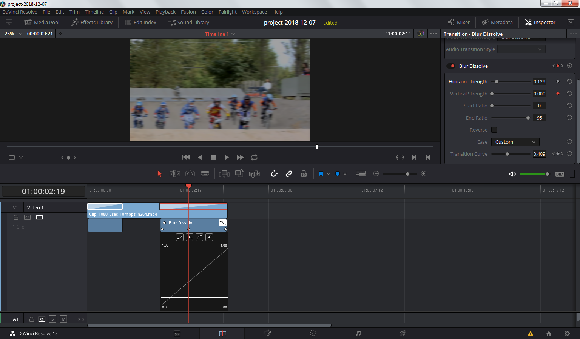
Inspector
Blur dissolve

