**UTSW location:**

UT Southwestern Medical Center

5323 Harry Hines Blvd, Dallas, TX 75390

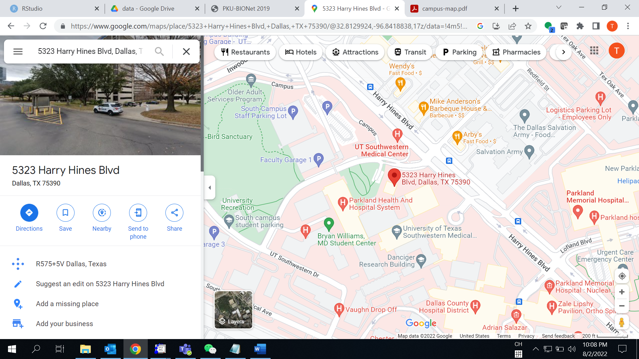

**Main event venue:**

D1.600, South Campus (red, see map below)

**Parking options:**

Student/Staff Parking Lot4B and Student Garage 3 (yellow); or

Lot 7 Visitor Parking (orange)

