Objective of the

**[Student Research Project]**

**from**

**Yue Yao**

Matriculation Nr.: 4995937

Title:

**Database Establishment for EIS of All-solid-state Battery System**

**Introduction:**

Lithium (Li)-ion batteries (LiBs) are widely applied in automotive field. In order to meet the growing energy and performance demand, battery systems with higher gravimetric energy and improved safety are desired [1]. All-solid-state battery (ASB) system is considered to be one kind of great advancement. With a solid-state electrolyte (SE) an ASB system promises a higher energy density and improved safety.

The investigation of ASB systems is still in its nascent stage and needs a great deal of research. As an advanced measurement method electrochemical impedance spectroscopy (EIS) is widely used to detect the process occurred in a battery system. With the laboratory data we can acquire Nyquist plots and Bode plots, which contain a wealth of information about the battery system. Through applying EIS in the charge/discharge processes of the battery system, the performance of battery under different conditions such as state-of-charge, degradation and temperature dependence can be compared.

An ASB system can be simulated and described with the equivalent circuit model (ECM). By fitting the Nyquist curves in corresponding ECMs, the internal structure of a battery is quantificationally modelled as a circuit consisting of electrical elements, such as resistors, capacitors and inductors. Combined with machine learning method, the experimental data are regard as features and used to predict some parameters of battery like degradation, aging. [1].

**Contents:**

In this project a database will be established about the experimental data of EIS measurement and charge/discharge processes in MySQL. The data amount will be huge. Therefore, the structure of the database must be cautiously considered. In addition, the raw data from the test are messy, which include device setting, loop data and experimental data. They should be separated into different table in regular formation. The desired structure of the database is shown in Figure 1.

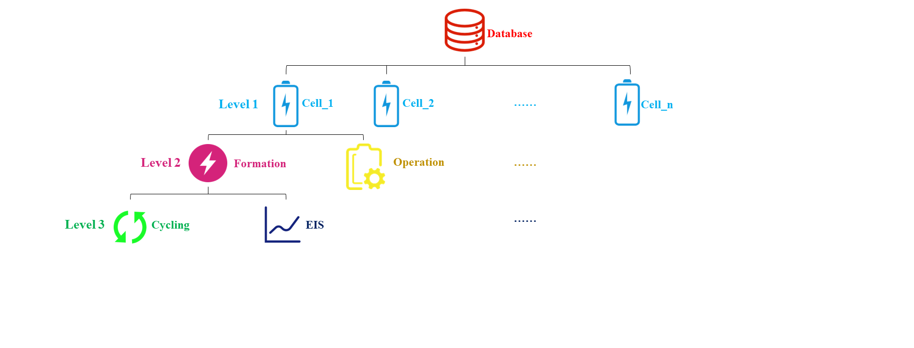

Figure 1 structure of database

Specifically, the following tasks are to be performed:

1. Establish the database:
2. Write a function in Python to separate and clean the data
3. Use python code connecting the processed data to the created database in MySQL
4. Load the data into MySQL automatically
5. Improve the structure of database:
6. Find the relationship among the different data
7. Use some methods to express the relationship
8. Define features with existing information for further research of machine learning(optional)

**Reference:**

[1] Vadhva, Pooja ; Hu, Ji ; Johnson, Michael J. ; Stocker, Richard ; Braglia, Michele ; Brett, Dan J. L. ; Rettie, Alexander J. E.: *Electrochemical Impedance Spectroscopy for All‐Solid‐State Batteries: Theory, Methods and Future Outlook*. In: *ChemElectroChem* 8 (2021), Nr. 11, S. 1930–1947. URL https://chemistry-europe.onlinelibrary.wiley.com/doi/10.1002/celc.202100108

**Attention:**

The work must be carried out individually. The details of the thesis such as required data, drawings, etc. are to be discussed with the supervisors. The processing time of this work is settled by the currently valid examination regulations.

One copy of the thesis must be submitted to the institute, additionally a digital version of the thesis and the presentation must be handed in. The thesis must contain the original signed task sheet, a statutory declaration and, if required by the examination regulations, a print out of the submission confirmation from WISA Online. The thesis may be disclosed to others only with consent of the institute.

Even with positive grading of this project, neither Prof. Dr.-Ing. Daniel Schröder, nor the Institute of Energy and Process Systems Engineering, nor the author, nor any employee will take any liability for the application of the results.]

Braunschweig, 05.05.2022

.

Prof. Dr.-Ing. Daniel Schröder (First examiner)

Supervisor at InES: Binbin Zhu

Starting date: 01.06.2022 .

Submission date: 30.08.2022 .