PHYS1110D – Engineering Physics: Mechanics and Thermodynamics

Week 13: Oscillation and Waves

**Problem 1 – Simple Harmonic Oscillator**

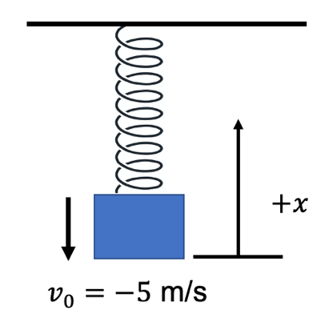A mass , hanged vertically with a spring of stiffness , is set to undergo a simple harmonic motion. Let be the center-of-mass position of the mass. We choose such a coordinate system that when the spring is at its natural length, ; and means that the spring is compressed. Initially (), the mass is at , and the speed of the mass is (pointing downward). :

1. Derive the function (*do not plug in numerical values for this question*);
2. Find the amplitude and the phase angle (up to a difference of ) of the simple harmonic motion;
3. Find the maximum compression and the maximum stretch of the spring.

**Solution:**

1. You should have noticed that we have chosen a rather inconvenient coordinate system. As usual, it is more convenient to work with instead of :

The equation of motion (EOM) of the mass is

This equation is not the standard form: we got another constant term ; however, if we make the following change of variable:

Then we arrive at

This change of variable is equivalent to setting the origin at the equilibrium position :

Then we write down the general solution

To determine the constants , we use the initial conditions

It is convenient to make use of . Therefore

We finally obtain

1. We shall solve this problem with instead of . It amounts to the following conversion

Expanding the RHS, we have

Comparing with the LHS:

Thus

1. With result from last question, we have

We can easily read off the maximum compression and stretch :

Another way to get the answer is using conservation of energy. Let correspond to zero gravitational potential energy. Then

The solutions are

**Problem 2 – Oscillation of a Floating Block**

A rectangular block of height and cross-section area is floating in water. The densities of the block and of the water are respectively.

1. When the block is in equilibrium, find the vertical distance between the water level and the bottom of the block;
2. Now suppose that we press the block to make it sink a little bit more, and then release it from rest. The block will then oscillate. Assume that the pool of water is so big that the oscillation does not change the height of the water. Find the angular frequency of this oscillation.

**Solution:**

1. There are two forces on the block: the gravity

And the buoyancy

Here is the volume of the block immersed in water. In equilibrium

1. For definiteness, let us take the downward direction as the positive direction. Suppose that the block moves downward by a further distance . Then the volume immersed in water will be . We also notice that the acceleration of the block is just . Therefore

But by definition of , we have . So we are left with

This should remind you of the equation of motion of a body connected to a spring. Therefore

**Problem 3 – Mathematical Expression of Sinusoidal Waves**

The wavefunction of a travelling wave on a string is

where and are in meters and is in seconds. Find the speed, direction of travel, wavelength and frequency of the wave.

**Solution:**

Compare with the standard expression

We obtain

Then

**Problem 4 – Superposition of Waves: Beats**

*Note: You can read Chapter 48 of The Feynman Lectures on Physics, Volume 1 to learn more about the following problem. (*[*https://www.feynmanlectures.caltech.edu*](https://www.feynmanlectures.caltech.edu)*)*

Consider the superposition of the following two right-travelling waves at the origin (we forget the units in this problem):

What is the frequency that the displacement is zero at the origin?

**Solution:**

It convenient to use *complex numbers* to deal with wave superposition. For convenience, let us set . We know that

Therefore

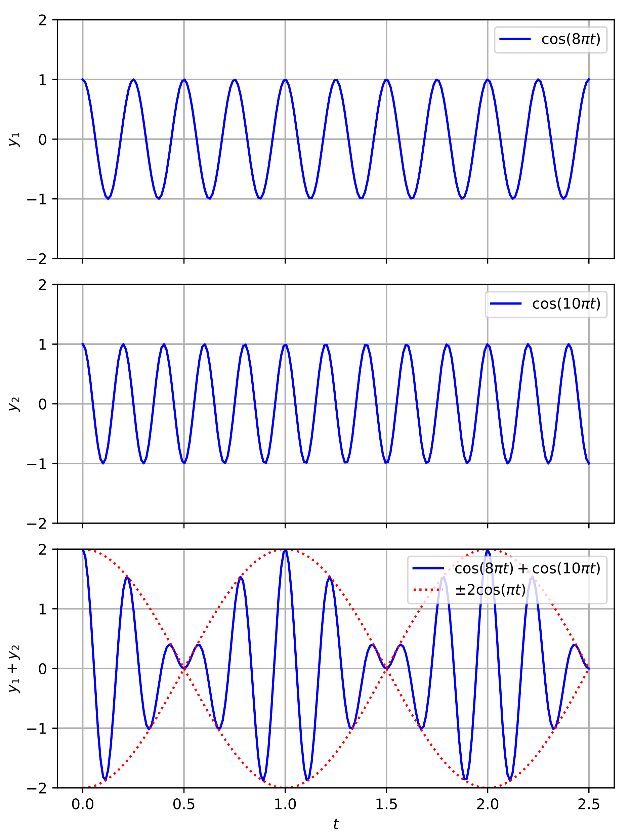Let us plot and to see things more clearly (figure on the right). We discover that:

* The low frequency part controls the amplitude;
* The high frequency part actually gives the frequency that the displacement at is zero.

Therefore, the required frequency is

*Remark*: In general, we can show that

When and are close, we will again discover that the wave behaves like having the frequency , but with time-varying amplitude . This phenomenon is called **beats**.

**Problem 5 – Superposition of Waves**

Two sinusoidal waves with the same amplitude and the same wavelength travel in the same direction along a string that is stretched along an *x*-axis. One of the waves is described by

Here is the wave number and is the angular frequency. If the superposition has the same amplitude , find the phase difference between two waves.

**Solution:**

The two waves must have the same velocity, because they are on the same string. Then we also know that their wavelengths are the same, so they have the same frequency. We can then express as

Meanwhile

Then their superposition is

The new amplitude is

Therefore

**Problem 6 – Standing Wave**

A nylon guitar string has a linear density of and is under a tension . The fixed supports are distance apart. The system can support standing wave of certain frequency. It is known that the wave velocity on the string is given by .

1. Find the lowest frequency can be supported on the string.
2. Find the lowest frequency that can be supported on the string and makes the point A (see the figure) a node.
3. If the tension is reduced to , what are the answers to (a) and (b)?

**Solution:**

1. As two ends of string are fixed, the wavelength of the standing wave is limited to by

The wave velocity is calculated to be

The frequency of the wave is given by

So the lowest frequency is

1. A picture containing computer

   Description automatically generatedIf we require the point A be a node, the longest wavelength should be , i.e. . Thus, the corresponding frequency is
2. If the tension is reduced to half, then the wave speed is changed to and the frequency is changed to . Therefore, the new frequencies are (a) and (b) .