PHYS1110D – Engineering Physics: Mechanics and Thermodynamics

Tutorial Problems for Week 3: Differentiation and Integration

**Formulae You Should Memorize:**

**Problem 1 – Linear Motion with Changing Acceleration**

1. A body is moving on the axis. At time , it is at the origin and is moving at velocity 10 m/s2 towards the direction. Find the position for if its acceleration is given by:

a) ; b) (and in m/s2 and seconds respectively.)

1. A body is moving on the axis. Find the position and acceleration for if the velocity of the body is given by

a) ; b) (and in m/s and seconds respectively)

**Solution:**

Solving this problem is in principle simple:

However, we remind you an important detail: whenever you are going to integrate, don’t forget the *initial condition*! They correspond to the *integration constants* when calculating indefinite integrals.

* 1. (*Again, don’t forget !*)

*Remark*: You can try applying the rule for differentiating the product of two functions

when finding the acceleration. Check if the results agree with each other.

**Problem 2 – Average Value**

In the lecture, you learned that the average velocity with respect to time over is given by

If an object moves with velocity on the axis ( are positive constants with appropriate units):

1. Is this object moving with constant acceleration?
2. Find the average velocity in the time interval (. Is it equal to or ?

**Solution:**

1. Obviously not, since
2. By definition

Meanwhile

They are of course not equal to .

*Remark: Do Dimensional Analysis for Your Answer*

The last question is designed to emphasize the importance of *units* of physical quantities. When doing Assignment 1, some really confused students thought that the average velocity is given by

But we can *immediately* say that it must be wrong, since it is *not even a velocity*. To see this, we check the unit of this expression

It corresponds to the unit of the *acceleration*. However, if you thought

We cannot easily tell whether it is true or not, since this wrong expression is indeed some kind of velocity. Nevertheless, such checking of the unit (called **dimensional analysis**) can quickly help you eliminate obviously unreasonable results.

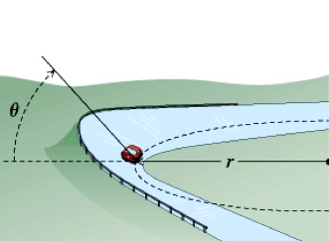**Problem 3 – Circular Motion on Banked Road**

Engineers often make use of the centripetal acceleration when designing road turnings. Suppose a turning is an arc of radius (see the figure). Cars are expected to pass this turning with speed . In order to reduce the friction along the radial direction between the car tires and the road to zero, at what angle should the road be banked?

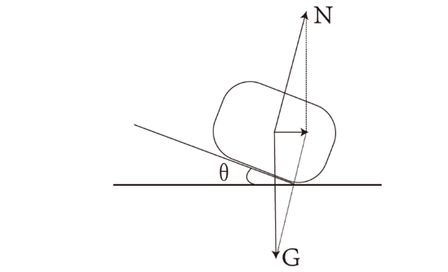**Solution:**

The free-body diagram of the car when passing the turning is shown on the left. The centripetal force is entirely provided by the radial (horizontal) component of the normal force exerted by the road on the car. Meanwhile, the normal force must balance the gravity in the vertical direction, since the car is not moving vertically. Now we can write down