PHYS1110D – Engineering Physics: Mechanics and Thermodynamics

Tutorial Problems for Week 5: Parametric Curve and Kinetic Energy

**Problem 1 – Parametric Curve**

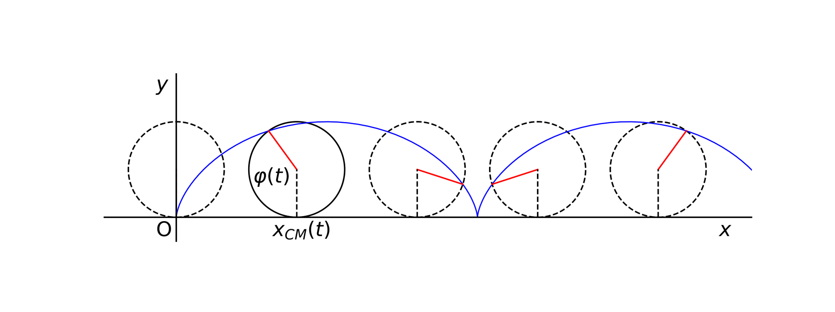

A wheel of radius $R$ is rolling on the ground. Its center is moving with constant velocity $v_{0}$ (towards $+x$). We focus on a point A on the wheel, which is at the origin when $t=0$. As the wheel rolls, the its position is given by

$$r\left(t\right)=\left(v_{0}t-R\sin{ωt}\right)e_{x}+\left(R-R\cos{ωt}\right)e_{y}$$

Here we introduced $ω={v_{0}}/R$. Such a curve is called a **cycloid**.

1. Calculate the velocity $v\left(t\right)$ and acceleration $a\left(t\right)$ of A.
2. Calculate the unit vector parallel to the tangent line at the point $r\left(t\right)$ (difference by an overall minus sign is OK).
3. When will $a\left(t\right)$ be pointing upwards?

**Solution:**

1. Simply calculate the time derivatives:
$$\begin{aligned}v_{x}\left(t\right)&=\frac{d}{dt}x\left(t\right)=\frac{d}{dt}\left(v_{0}t-R\sin{ωt}\right)=v_{0}\left(1-\cos{ωt}\right) \\ v_{y}\left(t\right)&=\frac{d}{dt}y\left(t\right)=\frac{d}{dt}\left(R-R\cos{ωt}\right)=v_{0}\sin{ωt} \\ a_{x}\left(t\right)&=\frac{d}{dt}v_{x}\left(t\right)=v_{0}\frac{d}{dt}\left(1-\cos{ωt}\right)=\frac{v_{0}^{2}}{R}\sin{ωt} \\ a_{y}\left(t\right)&=\frac{d}{dt}v_{y}\left(t\right)=v_{0}\frac{d}{dt}\left(1+\sin{ωt}\right)=\frac{v_{0}^{2}}{R}\cos{ωt}\end{aligned}$$

2. The tangent unit vector is no other things but
$$\begin{aligned}\hat{v}\left(t\right)&=\frac{v\left(t\right)}{\left|v\left(t\right)\right|}=\frac{v_{0}\left(1-\cos{ωt}\right)e_{x}+v_{0}\sin{ωt}e_{y}}{\sqrt{{\left[v_{0}\left(1-\cos{ωt}\right)\right]}^{2}+{\left[v_{0}\sin{ωt}\right]}^{2}}} \\ &=\frac{\left(1-\cos{ωt}\right)e_{x}+\sin{ωt}e_{y}}{\sqrt{2-2\cos{ωt}}}\end{aligned}$$

3. “Pointing upwards” means $a_{x}=0$ and $a_{y}>0$. Then

$$\left.\begin{aligned}\sin{ωt}=0 \\ \cos{ωt}>0\end{aligned}\right\}⇒ωt=2Nπ⇒t=\frac{2πR}{v_{0}}N \left(N∈N\right)$$

**Problem 2 – Work**

A block with mass $m$ is suspended vertically on a non-stretching rope (i.e. its length will not change) of length $L$. Now, we apply a varying *horizontal* force on the block, and move it to a final position *very slowly*, in which the rope forms an angle of 30 $°$ to the vertical direction (see the figure). Neglecting the mass of the string, please:

1. Find the magnitude of the force required to maintain the block at the final position;
2. Calculate the work done on the block: (*Be careful about these two questions*)
   1. by the tension in the rope.
   2. by the horizontal force ;

**Solution:**

1. From force diagram, we have
$$\left.\begin{aligned}F&=T\sin{30°} \\ T\cos{30°}&=mg\end{aligned}\right\}⟹F=mg\tan{30°}=\frac{mg}{\sqrt{3}}$$

2. The work done by a force is given by
 $$W=\lim_{Δl_{n}→0}{\sum_{\text{path}}{Δl_{n}∙F_{n}}}=\int_{\text{path}}{dl∙F}$$

  1. During the whole process, $T$ is perpendicular to $dl$ all the time, so the tension does *zero work.*
   2. Method 1: The work done by $F$ is converted to the increase in the potential energy of the block. This method in fact does not require that the block is moved very slowly. Therefore

$$W=Δ\left(\text{P.E.}\right)=mgL\left(1-\cos{30°}\right)=mgL\left(1-\frac{\sqrt{3}}{2}\right)$$

Method 2: Using the definition

$$W_{F}=\int_{0}^{\frac{π}{6}}{mg\tan{θ}∙L\cos{θ}dθ}=-mgL\left(\frac{\sqrt{3}}{2}-1\right)$$

*Question: Can you see why the component of $dl$ in the direction of $F$ is $L dθ\cos{θ}$?*

**Problem 3 – Work**

1. The restoring force of a spring is given by $F\left(x\right)=-k_{1}x-k_{2}x^{3}$ where $x$ and $F$ are in meters and Newtons respectively. Find the work done required to compress the spring by 1 m. Express your answer in terms of $k_{1}$ and $k_{2}$.
2. A block is attached to a spring with restoring force of $F\left(x\right)=-160x-4x^{3}$ where $x$ and $F$ are in meters and Newtons respectively. An external force of 164 N acts on the block to compress the spring. Calculate the maximum amount of compression of the spring.

**Solution:**

1. Work done required is the minus of the work done by the spring
$$\begin{aligned}W&=-W_{sp}=-\int_{x_{i}}^{x_{f}}{F\left(x\right) dx} \\ &=\int_{0}^{1}{k_{1}x+k_{2}x^{3} dx} \\ &={\left[\frac{k_{1}}{2}x^{2}+\frac{k_{2}}{4}x^{4}\right]}_{0}^{1}=\frac{k_{1}}{2}+\frac{k_{2}}{4} \left(\text{J}\right)\end{aligned}$$

2. This problem is tricky because the block will have gained certain velocity when the force of the spring is equal to the external force, which means that the spring will be compressed further.

Therefore, the following is wrong:

$$F_{ext}+F\left(x\right)=0⇒164-160x-4x^{3}=0⇒x=1 \left(\text{wrong}\right)$$

The initial state and the final state of the block are both at rest, so the work done by the external force should cancel the work done by the spring. Suppose that the maximum compression length is $l$, then

$$W_{ext}+W_{sp}=F_{ext}l-\int_{0}^{l}{F_{sp}\left(x\right) dx}=0$$

$$164l-\int_{0}^{l}{\left(160x+4x^{3}\right)dx}=164l-80l^{2}-l^{4}=0$$

Solving it numerically, we obtain

$$l=1.96 \left(\text{m}\right)$$