PHYS1110D – Engineering Physics: Mechanics and Thermodynamics

Tutorial Problems for Week 7: Linear Momentum

**Problem 1 – A Not Fixed Wedge**

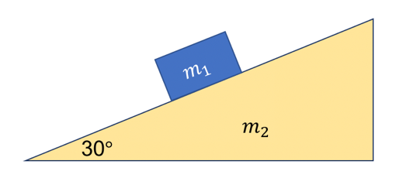A block of mass $m_{1}=1 \text{kg}$ is placed on a frictionless wedge of mass $m_{2}=2 \text{kg}$. The wedge is placed on a frictionless plane and can move freely. The inclining angle of the wedge is $θ=30°$. Find the magnitude and direction of the acceleration of $m_{1}$.

**Solution**:

Since the wedge can move freely, it is no longer guaranteed that the acceleration of $m_{1}$ will be along the direction of the slope. This makes the problem more complicated.