座位

状态集合={Available, Locked, Reserved}

事件集合={Make order, Complete payment, Cancel}

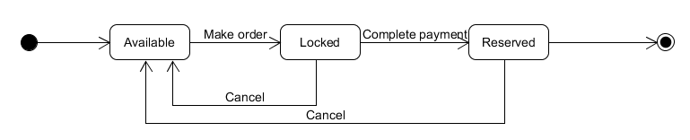

订单

状态集合={Unpaid, Confirmed, Canceled}

事件集合={Create order, Complete payment, Cancel, Payment timeout}

