**CS5542 Big Data Analytics and Applications**

**In Class Programming – 1**

**24th Jan 2019**

1.GitHub desktop

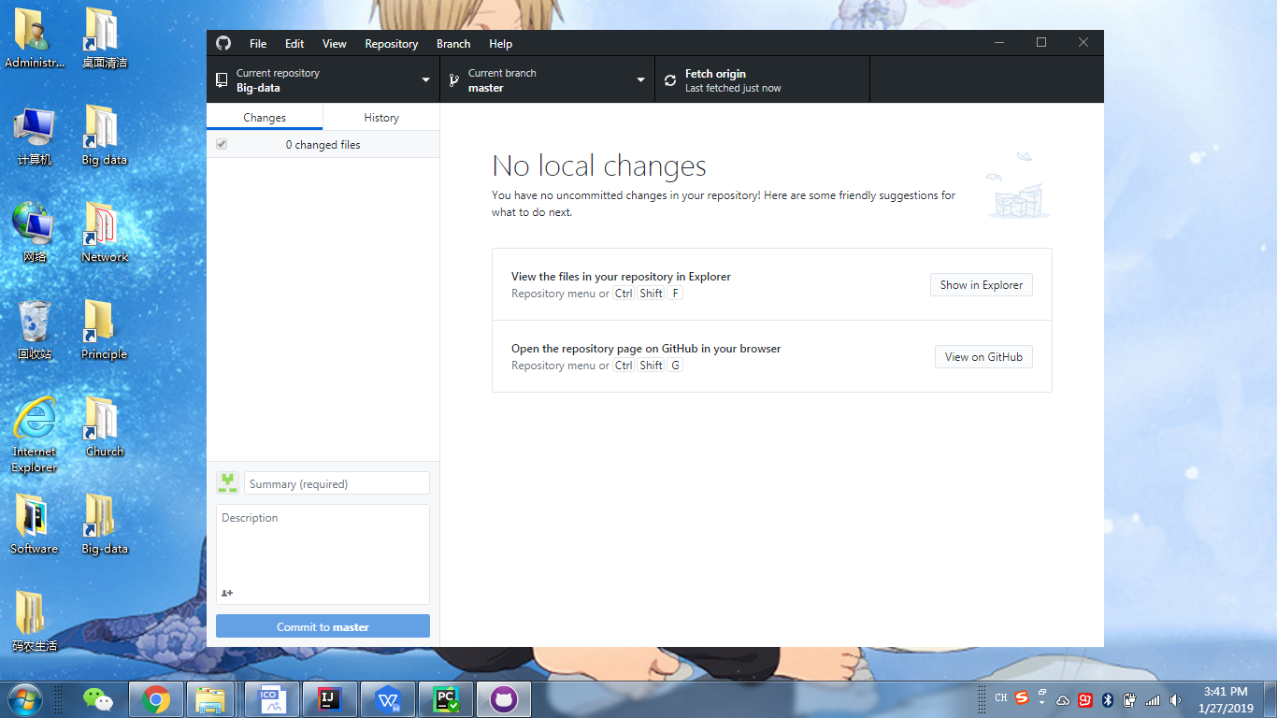

2. Zenhub

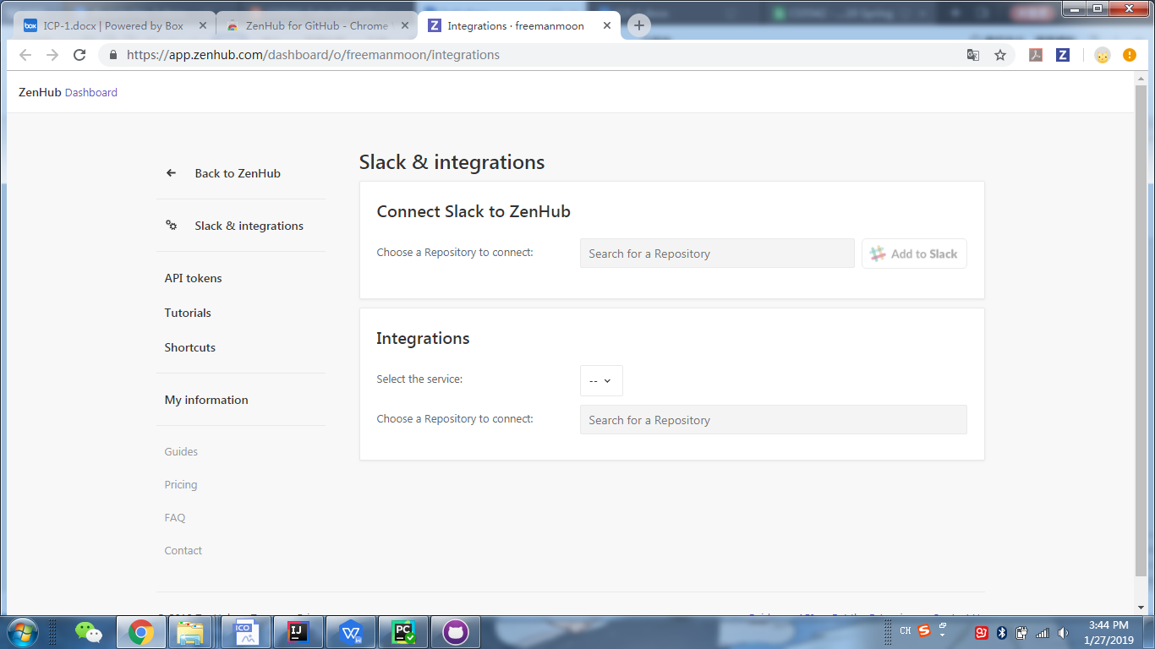

3.installed IDEs

intelliJ

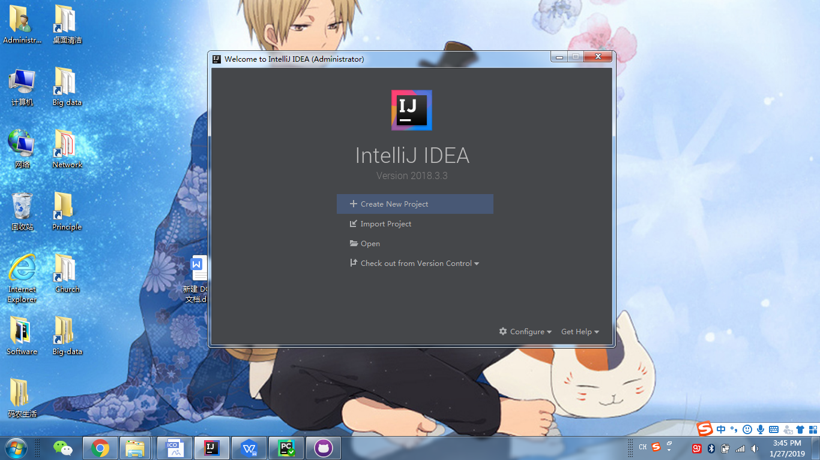

Pycharm

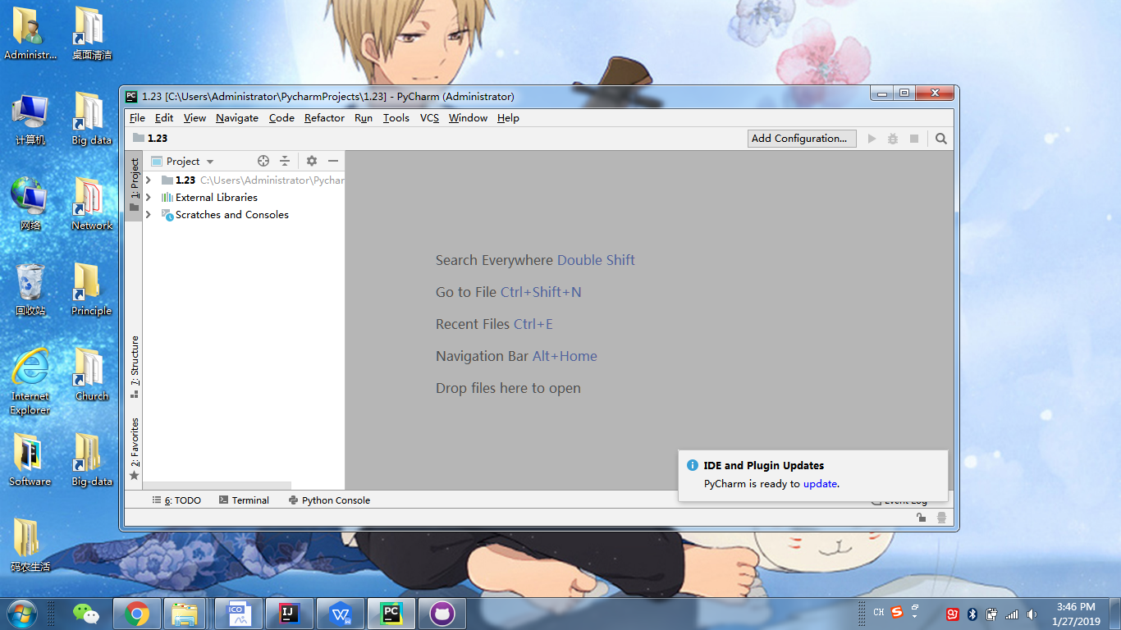

4.python -V

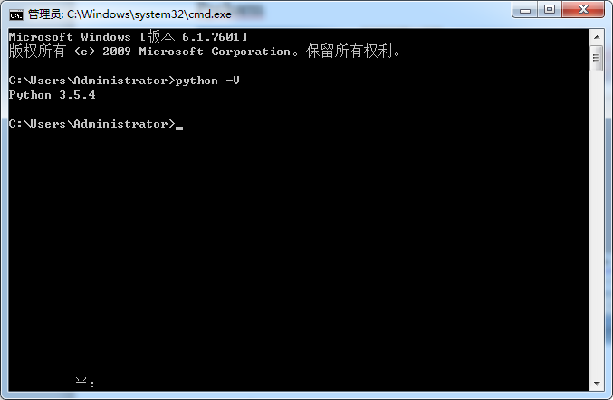

1. tensorflow installation

