《嵌入式系统新技术及应用》实验报告
姓名 | 徐志鹏 | 实验日期 | 2026.4.13 | 实验成绩
班级 | 电A2361 | 学号 | 12
实验名称 | 实验一 按键控制LED和蜂鸣器实验 |  |  | 教师签字
一、实验目的
1、掌握MDK软件的安装。
2、掌握GPIO的编程应用。
二、实验原理
STM32单片机的GPIO有8种工作模式，其中数字输入有GPIO_Mode_IN_FLOADING、GPIO_Mode_IPU、GPIO_Mode_IPD三种，数字输出有GPIO_Mode_OUT_OD、GPIO_Mode_OUT_PP、GPIO_Mode_AF_OD、GPIO_Mode_AF_PP四种，利用GPIO可检测数字输入信号，还可以作数字控制，或模拟I2C、SPI等通信接口。
三、实验内容
根据下面的电路用STM32F103C8T6实现功能：
1.按键1~4分别控制LED1~4的亮暗。按键按下时LED灯亮，松下即暗。
2.按下按键时，蜂鸣器给出0.5秒的提示音。
四、实验结果记录
1.引脚功能分配
F103C8T6引脚 | 控制板引脚 | 功能 | 初始值 | 备注
PA0 | KEY1 | Input | N/A
PA2 | KEY2 | Input | N/A
PA4 | KEY3 | Input | N/A
PA6 | KEY4 | Input | N/A
PB12 | BUZ | Out Push Pull | H
PB5 | LED1 | Out Push Pull | H
PB6 | LED2 | Out Push Pull | H
PB7 | LED3 | Out Push Pull | H
PB8 | LED4 | Out Push Pull | H
2.控制方法描述：
按键控制（PA0/PA2/PA4/PA6）
配置：设为GPIO输入，启用内部上拉(Out Push Pull)
读取：轮询或中断读取电平，低电平为按下
消抖：检测到变化后延时10-20ms再确认
LED控制（PB5/PB6/PB7/PB8）
重映射：开启GPIOB时钟
配置：设为推挽输出，初始输出高电平（熄灭）
控制：低电平点亮，高电平熄灭
蜂鸣器控制（PB12）
配置：设为推挽输出，初始输出高电平（关闭）
控制：低电平鸣叫

3.实验结果描述（文字和图片）：
按键按下时对应的LED灯亮，松下即暗；按下时，蜂鸣器给出0.5秒的提示音。
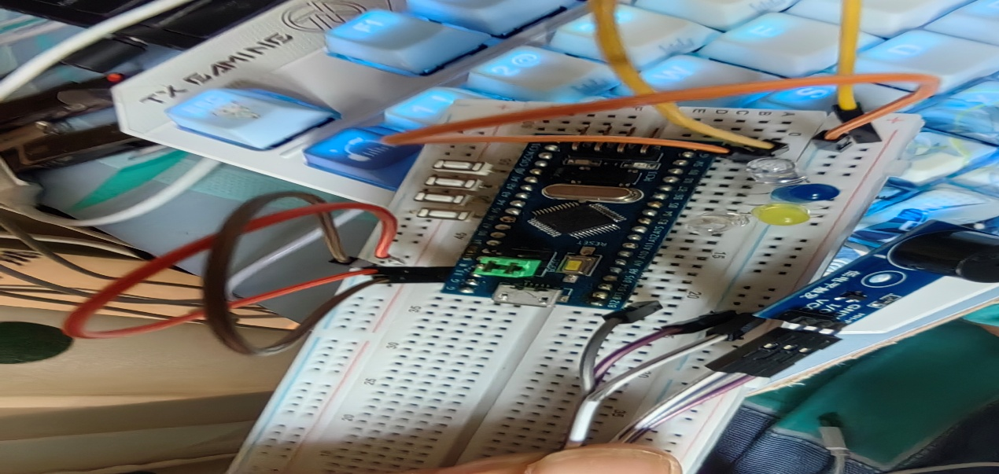

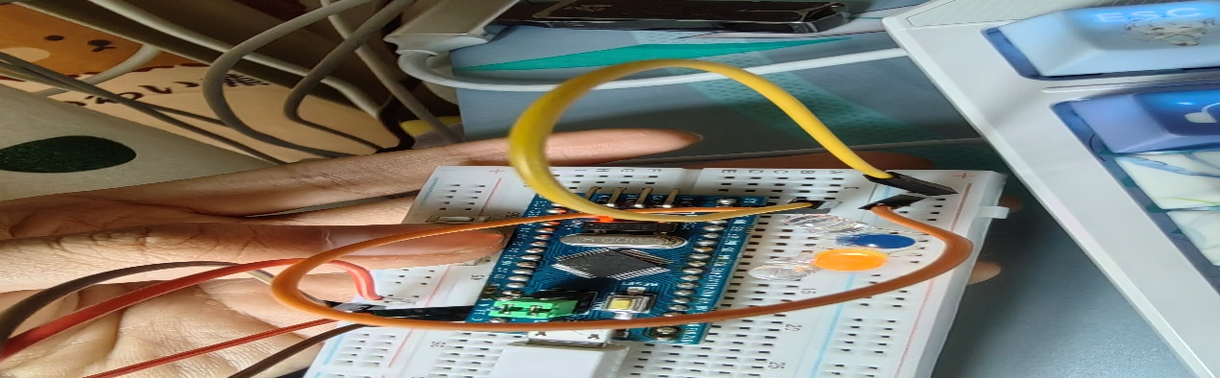

五、心得体会
通过本次STM32按键控制实验，我主要有以下几点收获：
- 掌握GPIO配置：深刻理解了输入与输出模式的区别。按键需配置为上拉输入以避免电平悬空，而LED和蜂鸣器则需配置为推挽输出以提供足够的驱动能力。
- 理解软件消抖：认识到机械按键存在抖动现象，通过软件延时（如20ms）进行二次确认，是保证按键检测准确性的关键。
- 硬件驱动逻辑：明白了单片机IO口驱动能力有限，同时区分了有源蜂鸣器（给电平即响）与无源蜂鸣器的使用差异。
- 编程思维提升：通过模块化编程（将按键、LED、蜂鸣器分开封装），让主程序逻辑更加清晰，体会到了良好代码结构对开发效率的提升。

六、自己编写的程序
1. main()函数
/* USER CODE BEGIN Header */
/**
******************************************************************************
* @file : main.c
* @brief : Main program body
******************************************************************************
* @attention
*
* Copyright (c) 2026 STMicroelectronics.
* All rights reserved.
*
* This software is licensed under terms that can be found in the LICENSE file
* in the root directory of this software component.
* If no LICENSE file comes with this software, it is provided AS-IS.
*
******************************************************************************
*/
/* USER CODE END Header */
/* Includes ------------------------------------------------------------------*/
#include "main.h"
#include "gpio.h"

/* Private includes ----------------------------------------------------------*/
/* USER CODE BEGIN Includes */
#include "stdbool.h"
/* USER CODE END Includes */

/* Private typedef -----------------------------------------------------------*/
/* USER CODE BEGIN PTD */
typedef struct {
GPIO_TypeDef* KEY_PORT;
uint16_t KEY_PIN;
GPIO_TypeDef* LED_PORT;
uint16_t LED_PIN;
} KeyLedMap_t;
/* USER CODE END PTD */

/* Private define ------------------------------------------------------------*/
/* USER CODE BEGIN PD */
// 按键消抖延时（ms）
#define KEY_DELAY_MS 20
// 蜂鸣器鸣响时长（ms）
#define BUZZER_BEEP_MS 100
/* USER CODE END PD */

/* Private macro -------------------------------------------------------------*/
/* USER CODE BEGIN PM */
#define READ_KEY(PORT, PIN) (HAL_GPIO_ReadPin(PORT, PIN) == GPIO_PIN_RESET)

/* USER CODE END PM */

/* Private variables ---------------------------------------------------------*/

/* USER CODE BEGIN PV */
// 按键-LED映射表
const KeyLedMap_t KeyLedMap[] = {
{GPIOA, KEY_1_Pin, GPIOB, LED_1_Pin},
{GPIOA, KEY_2_Pin, GPIOB, LED_2_Pin},
{GPIOA, KEY_3_Pin, GPIOB, LED_3_Pin},
{GPIOA, KEY_4_Pin, GPIOB, LED_4_Pin}
};
// 按键数量
#define KEY_LED_NUM (sizeof(KeyLedMap)/sizeof(KeyLedMap_t))
// 蜂鸣器状态标记
bool buzzer_beep_flag = false;
uint32_t buzzer_beep_start_time = 0;
/* USER CODE END PV */

/* Private function prototypes -----------------------------------------------*/
void SystemClock_Config(void);
/* USER CODE BEGIN PFP */
void Key_Scan_Handler(void);
void Buzzer_Control(void);
/* USER CODE END PFP */

/* Private user code ---------------------------------------------------------*/
/* USER CODE BEGIN 0 */
/**
* @brief 按键扫描处理函数（消抖+LED控制）
* @param None
* @retval None
*/
void Key_Scan_Handler(void)
{
static uint8_t key_press_flag = 0;

// 遍历所有按键
for(uint8_t i=0; i<KEY_LED_NUM; i++)
{
// 按键消抖：连续读取两次状态一致则判定为有效
if(READ_KEY(KeyLedMap[i].KEY_PORT, KeyLedMap[i].KEY_PIN))
{
HAL_Delay(KEY_DELAY_MS);
if(READ_KEY(KeyLedMap[i].KEY_PORT, KeyLedMap[i].KEY_PIN))
{
// 按键按下：点亮对应LED，触发蜂鸣器
HAL_GPIO_WritePin(KeyLedMap[i].LED_PORT, KeyLedMap[i].LED_PIN, GPIO_PIN_RESET);
key_press_flag = 1;
}
}
else
{
// 按键松开：熄灭对应LED
HAL_GPIO_WritePin(KeyLedMap[i].LED_PORT, KeyLedMap[i].LED_PIN, GPIO_PIN_SET);
}
}

// 有按键按下时触发蜂鸣器
if(key_press_flag)
{
buzzer_beep_flag = true;
buzzer_beep_start_time = HAL_GetTick();
key_press_flag = 0;
}
}

/**
* @brief 蜂鸣器控制函数
* @param None
* @retval None
*/
void Buzzer_Control(void)
{
if(buzzer_beep_flag)
{
// 打开蜂鸣器
HAL_GPIO_WritePin(GPIOB, Buzzing_Pin, GPIO_PIN_RESET);

// 达到鸣响时长后关闭蜂鸣器
if(HAL_GetTick() - buzzer_beep_start_time >= BUZZER_BEEP_MS)
{
HAL_GPIO_WritePin(GPIOB, Buzzing_Pin, GPIO_PIN_SET);
buzzer_beep_flag = false;
}
}
else
{
// 默认关闭蜂鸣器
HAL_GPIO_WritePin(GPIOB, Buzzing_Pin, GPIO_PIN_SET);
}
}
/* USER CODE END 0 */

/**
* @brief The application entry point.
* @retval int
*/
int main(void)
{
/* USER CODE BEGIN 1 */

/* USER CODE END 1 */

/* MCU Configuration--------------------------------------------------------*/

/* Reset of all peripherals, Initializes the Flash interface and the Systick. */
HAL_Init();

/* USER CODE BEGIN Init */

/* USER CODE END Init */

/* Configure the system clock */
SystemClock_Config();

/* USER CODE BEGIN SysInit */

/* USER CODE END SysInit */

/* Initialize all configured peripherals */
MX_GPIO_Init();
/* USER CODE BEGIN 2 */
HAL_GPIO_WritePin(GPIOB, LED_1_Pin|LED_2_Pin|LED_3_Pin|LED_4_Pin, GPIO_PIN_SET);
HAL_GPIO_WritePin(GPIOB, Buzzing_Pin, GPIO_PIN_SET);
/* USER CODE END 2 */

/* Infinite loop */
/* USER CODE BEGIN WHILE */
while (1)
{
/* USER CODE END WHILE */

/* USER CODE BEGIN 3 */
// 按键扫描
Key_Scan_Handler();
// 蜂鸣器控制
Buzzer_Control();
}
/* USER CODE END 3 */
}

/**
* @brief System Clock Configuration
* @retval None
*/
void SystemClock_Config(void)
{
RCC_OscInitTypeDef RCC_OscInitStruct = {0};
RCC_ClkInitTypeDef RCC_ClkInitStruct = {0};

/** Initializes the RCC Oscillators according to the specified parameters
* in the RCC_OscInitTypeDef structure.
*/
RCC_OscInitStruct.OscillatorType = RCC_OSCILLATORTYPE_HSE;
RCC_OscInitStruct.HSEState = RCC_HSE_ON;
RCC_OscInitStruct.HSEPredivValue = RCC_HSE_PREDIV_DIV1;
RCC_OscInitStruct.HSIState = RCC_HSI_ON;
RCC_OscInitStruct.PLL.PLLState = RCC_PLL_ON;
RCC_OscInitStruct.PLL.PLLSource = RCC_PLLSOURCE_HSE;
RCC_OscInitStruct.PLL.PLLMUL = RCC_PLL_MUL9;
if (HAL_RCC_OscConfig(&RCC_OscInitStruct) != HAL_OK)
{
Error_Handler();
}

/** Initializes the CPU, AHB and APB buses clocks
*/
RCC_ClkInitStruct.ClockType = RCC_CLOCKTYPE_HCLK|RCC_CLOCKTYPE_SYSCLK
|RCC_CLOCKTYPE_PCLK1|RCC_CLOCKTYPE_PCLK2;
RCC_ClkInitStruct.SYSCLKSource = RCC_SYSCLKSOURCE_PLLCLK;
RCC_ClkInitStruct.AHBCLKDivider = RCC_SYSCLK_DIV1;
RCC_ClkInitStruct.APB1CLKDivider = RCC_HCLK_DIV2;
RCC_ClkInitStruct.APB2CLKDivider = RCC_HCLK_DIV1;

if (HAL_RCC_ClockConfig(&RCC_ClkInitStruct, FLASH_LATENCY_2) != HAL_OK)
{
Error_Handler();
}
}

/* USER CODE BEGIN 4 */

/* USER CODE END 4 */

/**
* @brief This function is executed in case of error occurrence.
* @retval None
*/
void Error_Handler(void)
{
/* USER CODE BEGIN Error_Handler_Debug */
/* User can add his own implementation to report the HAL error return state */
__disable_irq();
while (1)
{
}
/* USER CODE END Error_Handler_Debug */
}

#ifdef USE_FULL_ASSERT
/**
* @brief Reports the name of the source file and the source line number
* where the assert_param error has occurred.
* @param file: pointer to the source file name
* @param line: assert_param error line source number
* @retval None
*/
void assert_failed(uint8_t *file, uint32_t line)
{
/* USER CODE BEGIN 6 */
/* User can add his own implementation to report the file name and line number,
ex: printf("Wrong parameters value: file %s on line %d\r\n", file, line) */
/* USER CODE END 6 */
}
#endif /* USE_FULL_ASSERT */

2.Gpio.c
/* USER CODE BEGIN Header */
/**
******************************************************************************
* @file gpio.c
* @brief This file provides code for the configuration
* of all used GPIO pins.
******************************************************************************
* @attention
*
* Copyright (c) 2026 STMicroelectronics.
* All rights reserved.
*
* This software is licensed under terms that can be found in the LICENSE file
* in the root directory of this software component.
* If no LICENSE file comes with this software, it is provided AS-IS.
*
******************************************************************************
*/
/* USER CODE END Header */

/* Includes ------------------------------------------------------------------*/
#include "gpio.h"

/* USER CODE BEGIN 0 */

/* USER CODE END 0 */

/*----------------------------------------------------------------------------*/
/* Configure GPIO */
/*----------------------------------------------------------------------------*/
/* USER CODE BEGIN 1 */

/* USER CODE END 1 */

/** Configure pins as
* Analog
* Input
* Output
* EVENT_OUT
* EXTI
*/
void MX_GPIO_Init(void)
{

GPIO_InitTypeDef GPIO_InitStruct = {0};

/* GPIO Ports Clock Enable */
__HAL_RCC_GPIOD_CLK_ENABLE();
__HAL_RCC_GPIOA_CLK_ENABLE();
__HAL_RCC_GPIOB_CLK_ENABLE();

/*Configure GPIO pin Output Level */
HAL_GPIO_WritePin(GPIOB, Buzzing_Pin|LED_1_Pin|LED_2_Pin|LED_3_Pin
|LED_4_Pin, GPIO_PIN_SET);

/*Configure GPIO pins : PAPin PAPin PAPin PAPin */
GPIO_InitStruct.Pin = KEY_1_Pin|KEY_2_Pin|KEY_3_Pin|KEY_4_Pin;
GPIO_InitStruct.Mode = GPIO_MODE_INPUT;
GPIO_InitStruct.Pull = GPIO_PULLUP;
HAL_GPIO_Init(GPIOA, &GPIO_InitStruct);

/*Configure GPIO pins : PBPin PBPin PBPin PBPin
PBPin */
GPIO_InitStruct.Pin = Buzzing_Pin|LED_1_Pin|LED_2_Pin|LED_3_Pin
|LED_4_Pin;
GPIO_InitStruct.Mode = GPIO_MODE_OUTPUT_PP;
GPIO_InitStruct.Pull = GPIO_NOPULL;
GPIO_InitStruct.Speed = GPIO_SPEED_FREQ_HIGH;
HAL_GPIO_Init(GPIOB, &GPIO_InitStruct);

}

/* USER CODE BEGIN 2 */

/* USER CODE END 2 */

