**Yue-Hong Li**

0963325918 | harry123458538@gmail.com

**Permanent Address Home Address**

Room 615A, Guo Qing Graduate 3rd Dorm, No. 69, Ln. 250, Xiapi Rd., West Dist., No. 30, Sec. 3, Xinhai Rd., Da’an Dist., Taipei City 106032 Chiayi City 600079

**OBJECTIVE**

To obtain the position of full-time data scientist

**EDUCATION**

**National Taiwan University**  Taipei, Taiwan

**Master of Science in Industrial Engineering** Expected July 2023

* Overall GPA: 3.86/4.3
* Relevant Courses: Manufacturing Data Science, Data Analytics, Optimization, Soft Computing Methods and Applications

**National Taiwan Ocean University**  Keelung, Taiwan

**Bachelor of Science in Transportation Science** June 2021

* Overall GPA: 3.64/4.3
* Relevant Courses: Statistics, Operations Research, Database Management
* Recipient, Dean’s List Award (2019)

**EXPERIENCE**

**Taiwan Semiconductor Manufacturing Company Limited** Tainan, Taiwan

**Summer Manufacturing Engineering Intern** July – August 2022

* Analyzed the performance of manufacturing machine in order to improve production efficiency
* Boosted the efficiency of the bottleneck tool group by 3 %
* Demonstrated the operation of a new software for monitoring the production status

**Marugame Seimen, Toridoll Taiwan Company Limited** Keelung, Taiwan

**Part-time Worker** May 2019 – June 2020

* Collaborated with supervisors and co-workers to make meals efficiently for customers
* Organized and cleaned work station regularly to ensure sanitary, efficient work environment
* Floated between stations whenever necessary

**SKILLS**

**Language**: Fluent in Mandarin and Taiwanese; Intermediate in English (TOEIC: 890)

**Computer**: Microsoft Office Suite (Excel, Powerpoint, Word); Python; SQL; C#

**LEADERSHIP**

National Taiwan Ocean University Dragon Boat Team September 2018 – June 2020

* Provided leadership as the team vice captain for the 2019 – 2020 season
* Organized and participated in dragon boat training

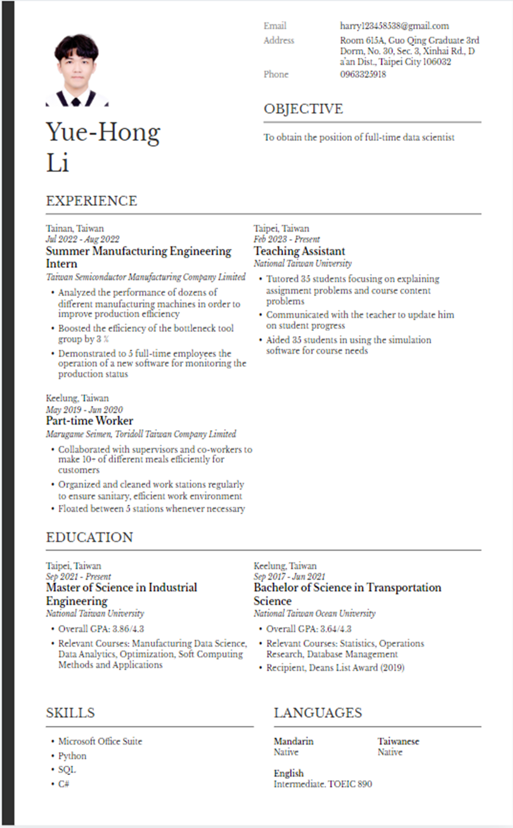

|  |  |  |  |  |
| --- | --- | --- | --- | --- |
| Yue-Hong, Li |  | Email | harry123458538@gmail.com | |
| Address | Room 615A, Guo Qing Graduate 3rd Dorm, No. 30, Sec. 3, Xinhai Rd., Da’an Dist., Taipei City 106032 | |
| Phone | 0963325918 | |
| **OBJECTIVE** | | |
| To obtain the position of full-time data scientist | | |
| **EDUCATION** | | | | |
| Taipei, Taiwan  *Expected July 2023*  **Master of Science in Industrial Engineering**  *National Taiwan University*   * Overall GPA: 3.86/4.3 * Relevant Courses: Manufacturing Data Science, Data Analytics, Optimization, Soft Computing Methods and Applications | | Keelung, Taiwan  *June 2021*  **Bachelor of Science in Transportation Science**  *National Taiwan Ocean University*   * Overall GPA: 3.64/4.3 * Relevant Courses: Statistics, Operations Research, Database Management * Recipient, Dean’s List Award (2019) | | |
| **EXPERIENCE** | | | |
| Tainan, Taiwan  *July 2022 – August 2022*  **Summer Manufacturing Engineering Intern**  *Taiwan Semiconductor Manufacturing Company Limited*   * Analyzed the performance of dozens of different manufacturing machines in order to improve production efficiency * Boosted the efficiency of the bottleneck tool group by 3 % * Demonstrated to 5 full-time employees the operation of a new software for monitoring the production status | | Taipei, Taiwan  *February 2023 – Present*  **Teaching Assistant**  *National Taiwan University aaaaaaaaaaaaaaaaaaaaaaaaa*   * Tutor 35 students focusing on explaining assignment problems and course content problems * Communicate with the teacher to update him on student progress * Aid 35 students in using the simulation software for course needs | |
| Keelung, Taiwan  *May 2019 – June 2020*  **Part-time Worker**  *Marugame Seimen, Toridoll Taiwan Company Limited*   * Collaborated with supervisors and co-workers to make 10+ of different meals efficiently for customers * Organized and cleaned work stations regularly to ensure sanitary, efficient work environment * Floated between 5 stations whenever necessary | |  | |
| **SKILLS** | | **LANGUAGES** | |
| * Microsoft Office Suite * Python * SQL * C# | | **Mandarin**  Native | **Taiwanese**  Native |
| **English**  Intermediate (TOEIC 890) | |