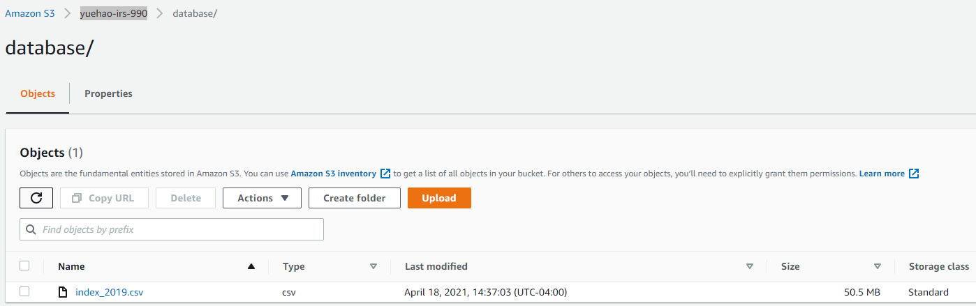

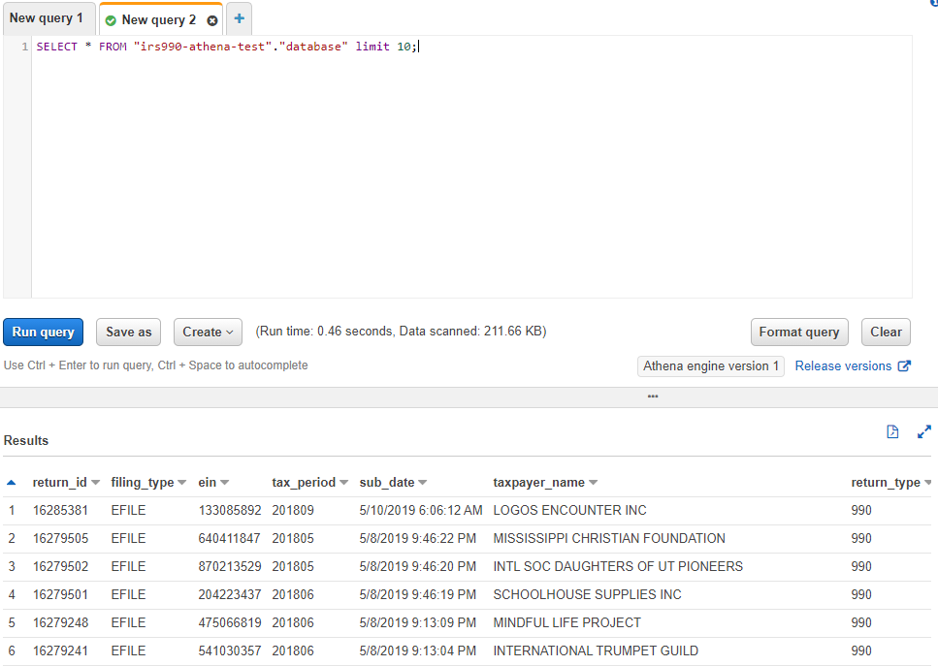

Q1:

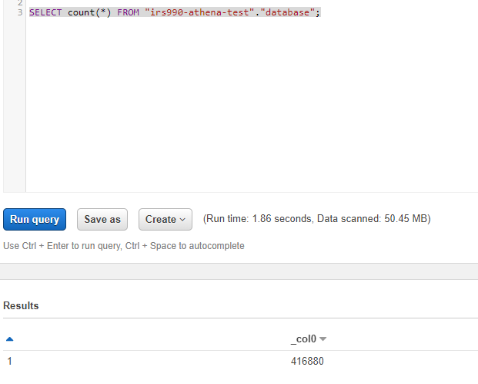

Q2:

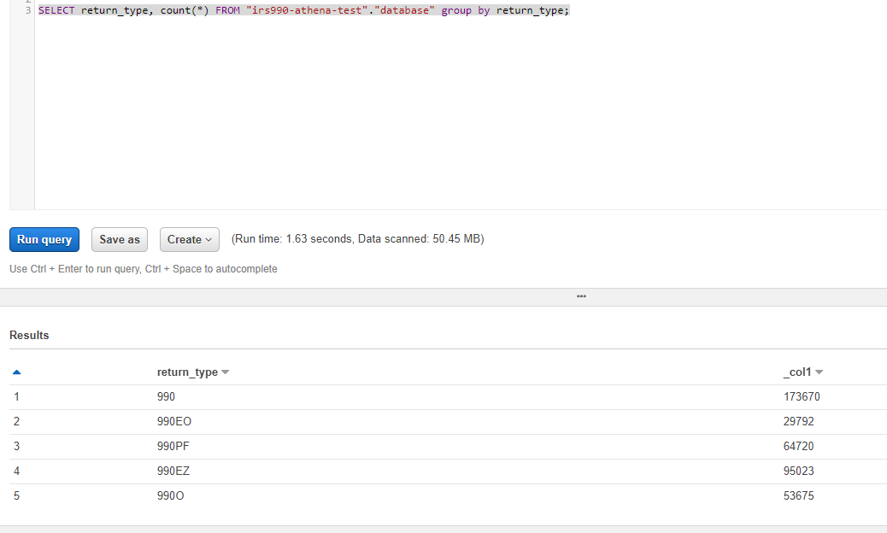

Q3

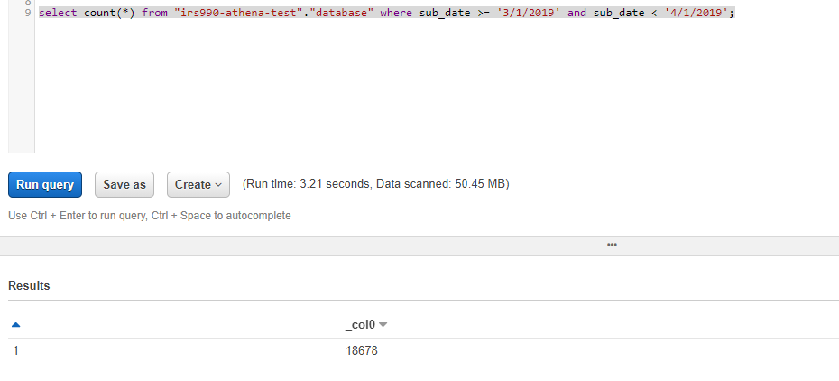

Partition

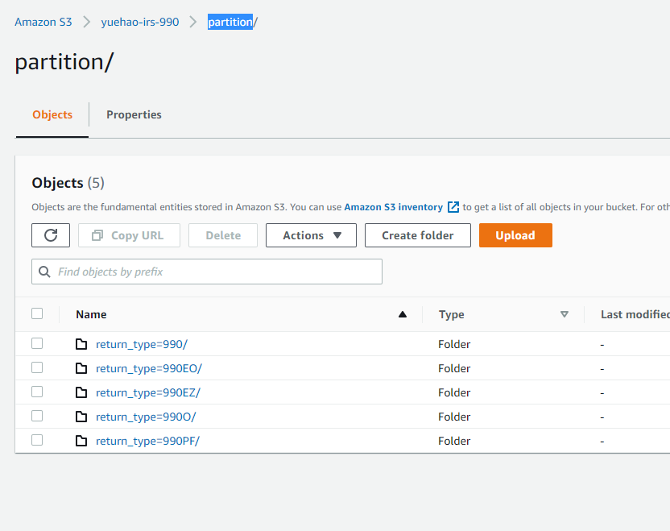

CREATE EXTERNAL TABLE IF NOT EXISTS manudatabase.manutable990 (

`return_id` bigint,

`filing_type` string,

`ein` bigint,

`tax_period` bigint,

`sub_date` string,

`taxpayer_name` string,

`dln` bigint,

`object_id` bigint

) PARTITIONED BY (

return_type string

)

ROW FORMAT SERDE 'org.apache.hadoop.hive.serde2.lazy.LazySimpleSerDe'

WITH SERDEPROPERTIES (

'serialization.format' = ',',

'field.delim' = ','

) LOCATION 's3://yuehao-irs-990/partition'

TBLPROPERTIES ('has_encrypted_data'='false',

'skip.header.line.count'='1');

MSCK REPAIR TABLE manutable990;

