# Line chart:

For: happiness score – alcohol total – pisa mean (with all countries to get a first impression)

Maybe: Point out countries with especially high/low values of the three categories (maybe separate bar chart for each of the three categories)

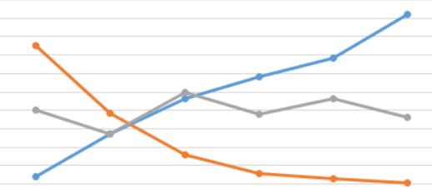

# Correlations:

- happiness – alcohol

- happiness – pisa mean

- happiness – different pisa scales

- pisa – alcohol

# Boxplot:

-- Line Chart

```{r eval=TRUE, echo=TRUE}

plot(happiness_clean[, 3],type = "o",col = "red", xlab = "country", ylab = "Happiness_Score")

boxplot(happiness_clean[, 3], type , notch, varwidth, names, main)

```