Will students who have high GPA in high school get high GPA in the first year college?

## Interpretation and Implementation

#primary objective  
#set up  
install.packages("ggplot2")  
library(ggplot2)  
  
#load the data  
student_info<-read.csv("FirstYearGPA.csv",header=T)  
  
#set up variables  
#set of high school GPA of students  
x<-student_info$HSGPA  
#set of first year college GPA of students  
y<-student_info$GPA  
  
#student whose GPA scores above or equal 3.7 in high school  
HSGPA_greater_than_critical_value<-student_info[student_info$HSGPA>=3.7,]  
  
  
#student whose GPA scores below 3.7 in high school  
HSGPA_less_than_critical_value<-student_info[student_info$HSGPA<3.7,]  
  
  
#college GPA>=3.7 and high school GPA >=3.7  
group_A<-student_info[(student_info$HSGPA>=3.7&student_info$GPA>=3.7),]  
  
#college GPA>3.7 and high school GPA <3.7  
group_B<-student_info[student_info$HSGPA<3.7&student_info$GPA>=3.7,]  
  
#college GPA<3.7 and high school GPA >=3.7  
group_C<-student_info[student_info$HSGPA>=3.7&student_info$GPA<3.7,]  
  
#college GPA<3.7 and high school GPA <3.7  
group_D<-student_info[student_info$HSGPA<3.7&student_info$GPA<3.7,]  
  
  
#Graph plotting  
#scatter plot  
graph_GPA<-ggplot(student_info,aes(x=HSGPA,y=GPA))+geom_point(size=0.35,color="forestgreen")+geom_smooth(size=0.4,method="lm",color="red",se=F)+labs(x="High school GPA",y="First year college GPA",title="First year college GPA versus High school GPA")+theme(axis.text=element_text(size=11),plot.title=element_text(size=11,hjust = 0.5))  
  
graph_GPA

## `geom_smooth()` using formula 'y ~ x'

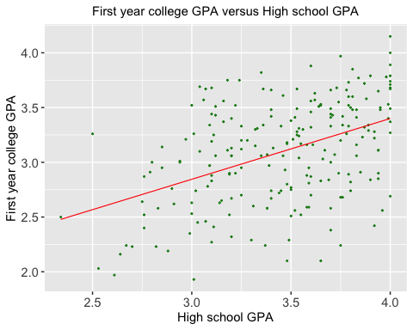

#barchart   
#set up  
group_name<-c("GPA>=3.7&HSGPA>=3.7","GPA>=3.7&HSGPA<3.7","GPA<3.3&HSGPA>=3.7","GPA<3.3&HSGPA <3.7")  
group_size<-c(length(group_A$GPA),length(group_B$GPA),length(group_C$GPA),length(group_D$GPA))  
group_data<-data.frame(group_name,group_size)  
  
   
  
ggplot(data=group_data,aes(x=group_name,y=group_size,fill=group_name))+geom_bar(stat="identity",width=0.5,color="black",size=1)+theme_minimal()+labs(x="Group of students",y="Number of student",title=" GPA comparsion between high school and college")+theme(axis.text=element_text(size=4),plot.title=element_text(size=9,hjust = 0.5))

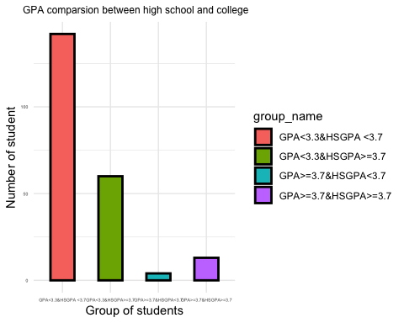

#Pearson’s Correlation Coefficient  
  
size_of_sample<-length(x)  
  
#mean of sample X  
mean_x<-mean(x)  
  
#mean of sample Y  
mean_y<-mean(y)  
  
#calculation for Pearson’s Correlation Coefficient according to the formula shown in the appendix of the report  
numerator<-sum((x-mean_x)*(y-mean_y))  
denominator_1<-(sqrt(sum(((x-mean_x)^2))))  
denominator_2<-(sqrt(sum(((y-mean_y)^2))))  
  
   
r<-numerator/(denominator_1*denominator_2)  
  
r

## [1] 0.4468873

#secondary objective  
#set up  
#load the data  
data<- read.csv("FirstYearGPA.csv",header=T)  
#set up variables  
satvnc_1<- data$SATV  
satvnc_2<- data$SATM  
#sumsat=sum of SAT score  
sumsat<- satvnc_1 + satvnc_2  
#highgpa=high school GPA  
highgpa<- data$HSGPA  
#unigpa=first year college GPA  
unigpa<- data$GPA  
#familyedu=family education level  
familyedu<- data$FirstGen  
  
#boxplot:family education level and sumsat  
boxplot(sumsat~familyedu, xlab="1= student is the first in her or his family to attend college,  
0=otherwise")

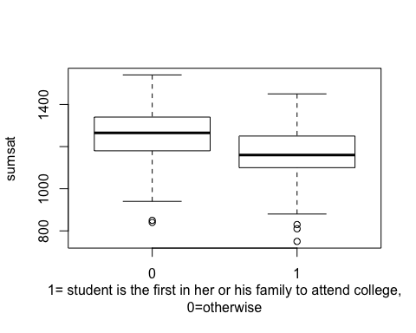

#boxplot:family education level and high school GPA  
boxplot(highgpa~familyedu,xlab="1= student is the first in her or his family to attend college,  
0=otherwise")

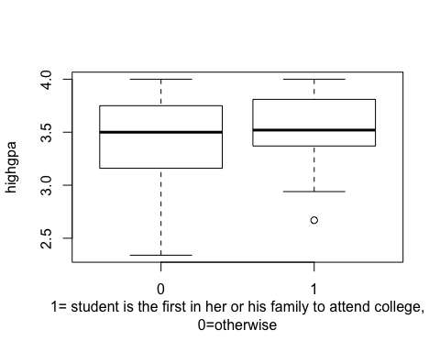

#boxplot:family education level and first year college GPA  
boxplot(unigpa~familyedu,xlab="1= student is the first in her or his family to attend college,  
0=otherwise")

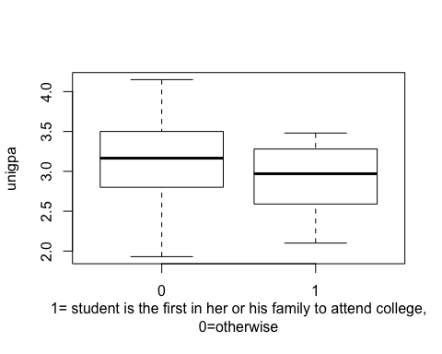

#correlation coefficient:family education level and sumsat  
cor(familyedu,sumsat)

## [1] -0.250557

#correlation coefficient:family education level and high school GPA  
cor(familyedu,highgpa)

## [1] 0.06418575

#correlation coefficient:family education level and first year college GPA  
cor(familyedu,unigpa)

## [1] -0.1565773

#Tertiary objective  
#read data set  
data <- read.csv("FirstYearGPA.csv")  
  
#extract the Male, HU, SS from the data set  
d <- data.frame(data$Male, data$HU, data$SS)  
  
#seperate set  
m <- d$data.Male == 1  
male <- d[m,]  
female <- d[!m,]  
  
#add gender  
nrow(male)

## [1] 102

nrow(female)

## [1] 117

gender <- c(rep("Male",102), rep("Female",117))  
HU <- c(male$data.HU, female$data.HU)  
SS <- c(male$data.SS, female$data.SS)  
df <- data.frame(gender, HU, SS)  
genderm <- c(rep("Male",102))  
HUm <- c(male$data.HU)  
SSm <- c(male$data.SS)  
dfm <- data.frame(genderm, HUm, SSm)  
genderf <- c(rep("Female",117))  
HUf <- c(female$data.HU)  
SSf <- c(female$data.SS)  
dff <- data.frame(genderf, HUf, SSf)  
  
#graph of gender and cradit on humanity course  
p1 <- hist(male$data.HU, breaks = 40)

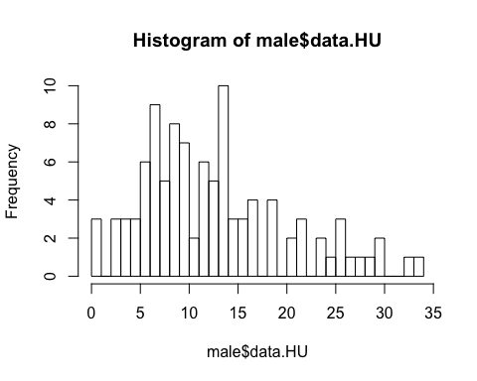

p2 <- hist(female$data.HU, breaks = 40)

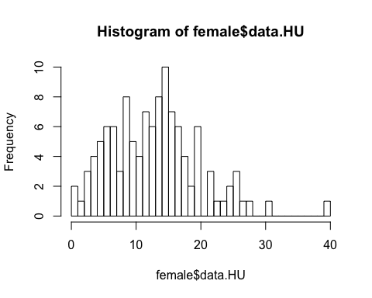

plot(p2, col = rgb(0, 0, 1, 1/2), main="Credit Hours on Humanity of Males and Females", xlab="credit hours", ylim = c(0,10))  
plot(p1, col = rgb(1, 0, 0, 1/2), add = T)  
abline(v = mean(male$data.HU), col="blue")  
abline(v = mean(female$data.HU), col="red")  
legend("topright", c("Male", "female"), fill = c(rgb(0, 0, 1, 1/2), rgb(1, 0, 0, 1/2)))

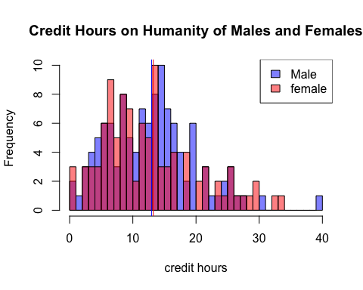

#graph of Credit Hours on Social Science course  
p1 <- hist(male$data.SS, breaks = 25)

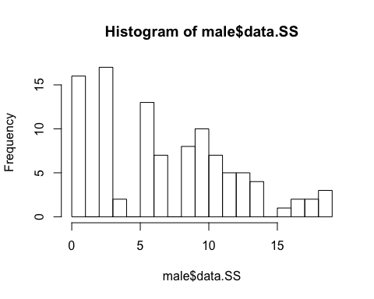

p2 <- hist(female$data.SS, breaks = 25)

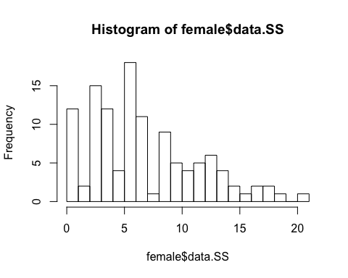

plot(p2, col = rgb(0, 0, 1, 1/2), main="Credit Hours on Social Science of Males and Females", xlab="credit hours", ylim = c(0,18))  
plot(p1, col = rgb(1, 0, 0, 1/2), add = T)  
abline(v = mean(male$data.SS), col="blue")  
abline(v = mean(female$data.SS), col="red")  
legend("topright", c("Male", "female"), fill = c(rgb(0, 0, 1, 1/2), rgb(1, 0, 0, 1/2)))

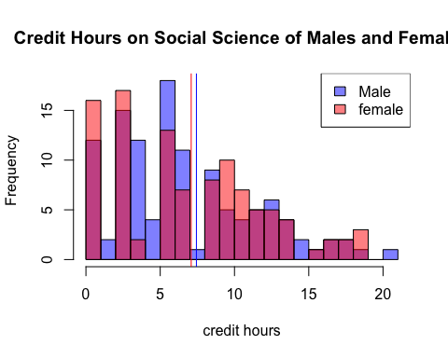

#graph of Credit Hours on Social Science and Humanity of males  
p1 <- hist(male$data.HU, breaks = 40)



p2 <- hist(male$data.SS, breaks = 20)



plot(p2, col = rgb(0, 0, 1, 1/2), main="Credit Hours on Social Science and Humanity of Males", xlab="credit hours", xlim = c(0,40), ylim = c(0,17))  
plot(p1, col = rgb(1, 0, 0, 1/2), add = T)  
abline(v = mean(male$data.SS), col="blue")  
abline(v = mean(male$data.HU), col="red")  
legend("topright", c("Social Science", "Humanity"), fill = c(rgb(0, 0, 1, 1/2), rgb(1, 0, 0, 1/2)))

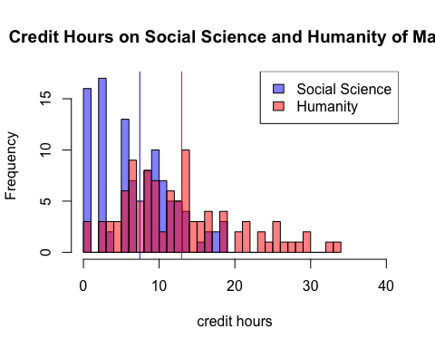

#graph of Credit Hours on Social Science and Humanity of males  
p1 <- hist(female$data.HU, breaks = 40)



p2 <- hist(female$data.SS, breaks = 25)



plot(p2, col = rgb(0, 0, 1, 1/2), main="Credit Hours on Social Science and Humanity of Females", xlab="credit hours", xlim = c(0,40), ylim = c(0,18))  
plot(p1, col = rgb(1, 0, 0, 1/2), add = T)  
abline(v = mean(female$data.SS), col="blue")  
abline(v = mean(female$data.HU), col="red")  
legend("topright", c("Social Science", "Humanity"), fill = c(rgb(0, 0, 1, 1/2), rgb(1, 0, 0, 1/2)))

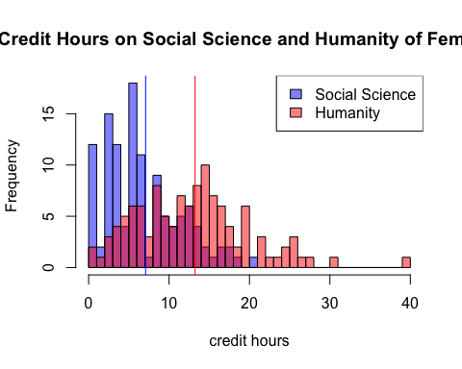

#mean  
mean(male$data.SS)

## [1] 7.436275

mean(male$data.HU)

## [1] 12.96275

mean(female$data.SS)

## [1] 7.08547

mean(female$data.HU)

## [1] 13.23504

#normality test  
shapiro.test(male$data.SS)

##   
## Shapiro-Wilk normality test  
##   
## data: male$data.SS  
## W = 0.94794, p-value = 0.0005277

shapiro.test(male$data.HU)

##   
## Shapiro-Wilk normality test  
##   
## data: male$data.HU  
## W = 0.94264, p-value = 0.000241

shapiro.test(female$data.SS)

##   
## Shapiro-Wilk normality test  
##   
## data: female$data.SS  
## W = 0.95042, p-value = 0.0002822

shapiro.test(female$data.HU)

##   
## Shapiro-Wilk normality test  
##   
## data: female$data.HU  
## W = 0.96966, p-value = 0.009397

#variance test  
bartlett.test(HU ~ gender, df)

##   
## Bartlett test of homogeneity of variances  
##   
## data: HU by gender  
## Bartlett's K-squared = 0.90554, df = 1, p-value = 0.3413

bartlett.test(SS ~ gender, df)

##   
## Bartlett test of homogeneity of variances  
##   
## data: SS by gender  
## Bartlett's K-squared = 0.71881, df = 1, p-value = 0.3965

document: male: subset that contains the sample data of male students. female: subset that contains the sample data of female students. maledata.HU: Credit hours on humanity of female subset maledata.SS: Credit hours on social science of female subset