

{Your Proposal Title}

by
{Author’s Name}
under the supervision of
{Supervisors Name}

How to Use this Template
Title Page
- Replace text enclosed in curly brackets { } with your own content.
- The title should be formatted in sentence case (i.e. only the first word and proper nouns should be capitalised).
- Present your name as it appears in your official UQ MySI-net record.
- The UQ logo provided on the Title Page has been approved by UQ for use in theses. Please do not change the size of the logo.
- Please do not add any other content or change the formatting of the Title Page.
Preliminary Pages
- Do not modify the wording or format of any headings on the preliminary pages.
- Retain all headings in the order provided in this template.
- Replace text enclosed in curly brackets { } with your own content.
- Delete or replace any instructional text (displayed in purple) before submitting.
Proposal Content Pages
- The remainder of the template starting with ‘Table of Contents’ is offered as guidance only and is not intended to be prescriptive. You may adapt it to suit the specific requirements and conventions of your discipline and your project. The layout in this example is Introduction, Background and Literature Review, Project Plan but this may not suit your project! You can change these sections to whatever you need.
- The content pages that follow the preliminary pages are formatted using Microsoft Styles with embedded auto-numbering for chapters and headings. Page numbers have been incorporated to enable the automatic generation of the Table of Contents, as well as lists of tables and figures.
- If you include blank pages in your work, please mark the page with: “This page was intentionally left blank.”

Use of AI Statement
Read and acknowledge the Use of AI Statement, describe the specific ways that you used AI in the assessment and fill in the AI table below (remove the purple example text from the table first). Keep a record of this information over the year as you will need to update it for your proposal and final thesis report.
I acknowledge the use of generative AI tools in completing this assignment. Details of which tools were used and how they were used are provided in the table below, along with appropriate in-text and full references. I take responsibility for critically evaluating and integrating the AI-generated content, and ensuring it adheres to academic integrity standards.

Have you used AI to:
- To explore your topic? Yes/no Explain how (or explain why not)
- To define your research question? Explain how (or explain why not)
- To assist with your literature review? Explain how (or explain why not)
- To assist with formatting the answers presented here? (e.g. grammar, spelling, language) Explain how (or explain why not)
- For other aspects of your work? Explain how you used it.

AI Model  and date | Artificial Intelligence (AI) tool usage (tick all that apply)
 | Language translation | Grammar/style/spelling | Topic exploration | Research question | Literature review | Content creation visual (formatting) | Content creation (e.g. code, text) | feedback | other (provide details)
ChatGTP 4o
11/09/24
Midjourney
11/09/24

Abstract
The notes and instructional text in this document are displayed in purple and are meant to be informative but not necessarily illustrative; for example, this paragraph is not really an abstract, because it contains information not found elsewhere in the document. The template is also available as a skel.tex file for students who wish to typeset their theses in LATEX. You can download the source, edit out the unwanted material, insert your own frontmatter and bibliographic entries, and in-line or \include{} your own chapter files. Of course, the type of project and content of a particular proposal will largely influence the form. Hence this document should not be seen as an attempt to force every project proposal into the same mold. If in doubt about the structure of your project proposal, seek advice from your supervisor.

Contents
Use of AI Statement iii
Abstract iv
List of Figures (optional) v
List of Tables (optional) v
1. Introduction 1
1.1 Sub-heading as required 1
1.2 Sub-heading as required 1
2. Background and Literature Review 2
2.1 Sub-heading as required 2
2.2 Sub-heading as required 2
3. Project Plan 4
3.1 Sub-heading as required 4
3.2 Sub-heading as required 4
3.3 Sub-headings as required 4
References 6
Appendix A 7
Appendix B 7

List of Figures (optional)

List of Tables (optional)

- Introduction
The introductory chapter describes the importance of the field and the scope and significance of your project. It sometimes ends with an overview of the remainder of the proposal.
Notice that Arabic page numbering begins with Chapter 1. Preceding pages (known as “frontmatter”) have Roman numbering. The book document class in LATEX follows this numbering convention by default (see Lamport [1], p. 80).

Sub-heading as required
You may want to use sub-headings here… you may not!

Sub-heading as required

- Background and Literature Review
You will need to review previous work in the field, which may include books and papers (“literature”), patents and commercial products (“prior art”), and earlier work in your Department. This information is usually (but not always) collected in a single chapter, whose title should preferably be more specific and interesting than the one above.

Sub-heading as required
You many want to use sub-headings here… you may not!
Some sub-sections you might consider are:
- Background and theory lay out the well-known theory and concepts (not cutting-edge research, could be found in a textbook) that must be understood to understand the literature review and your project proposal. If there is some nice background/theory that is complementary but not essential, consider pointing the reader to further sources (e.g. a textbook or paper) if they want a refresher
- Literature Review outline the state of research, what has been done, where are the limitations
- Literature/Knowledge Gaps concisely summarize knowledge gaps. How you do this will depend on your project, you might wish to outline a broad gap, then narrow down toward the gap you are addressing in the project; you may wish to highlight several different gaps that need to be addressed and then narrow in on the one you will be addressing in your project.

Sub-heading as required
Theory sections often contain equations like the equation for the Fourier series of the function $f\left(x\right)$
 | $$f\left(x\right)=a_{0}+\sum_{n=1}^{∞}{\left(a_{n}\cos{\frac{nπx}{L}}+b_{n}\sin{\frac{nπx}{L}}\right)}$$ | ( 1)
where $a_{0}$ is the average value of the function, $a_{n}$ and $b_{n}$ are the coefficients for the $n$th harmonic …… etc

Equations in Word can be tricky, this one is set up in a 1×3 Table, and Word’s automatic Cross referencing feature is used to set up Equation numbering. It takes a minute to setup, but you can then refer to Equation ( 1) in text and Word will update the equation number automatically if you need to change it later.
Setting up automatic equation numbers in Word:
- Insert a 1×3 table (Insert → Table → 1×3).
- Left cell: leave empty (spacing)
- Middle cell: equation (centered)
- Right cell: equation number (right-aligned)
- In the middle cell, press Alt + = (Windows) or Control + = (Mac) to insert an equation.
- In the right cell, go to References → Insert Caption.
- Click “New Label…” and type ( (just the open parenthesis).
- Click “Numbering…” and choose the format (1, 2, 3…).
- After inserting, type ) manually after the number.
Format:
- Middle cell: center align.
- Right cell: right align.
- Remove table borders: Right-click → Table Properties → Borders and Shading → None.
- Adjust cell widths to keep equations centered.
Cross-referencing an equation number:
- Place your cursor where you want the reference in your text.
- Go to References → Cross-reference.
- In the “Reference type” dropdown, choose your custom label "(" (it will appear in the list).
- In “Insert reference to”, choose Only label and number so you get (3) instead of extra text.
- Select the equation you want from the list, then click Insert.
- If numbering changes, all cross-references will update when you press Ctrl + A → F9.

- Project Plan

Sub-heading as required
You may want to use sub-headings here… you may not!
Some sub-sections you might consider are:
- Project Aims based on the literature gaps from the previous sections, what do you aim to do?
- Methodology What methods are going to be used and why. Are they faster, more efficient, all you have access to?
- Milestones and Timelines outline what will be done when to ultimately meet your aims. Are there any high-risk milestones you should identify which may require you to pivot your project in another direction?
- Health and Safety and Risk Assessments
- Ethics statement if you have human/animal data

Sub-heading as required
You will almost certainly need diagrams in your project proposal to clarify your meaning.
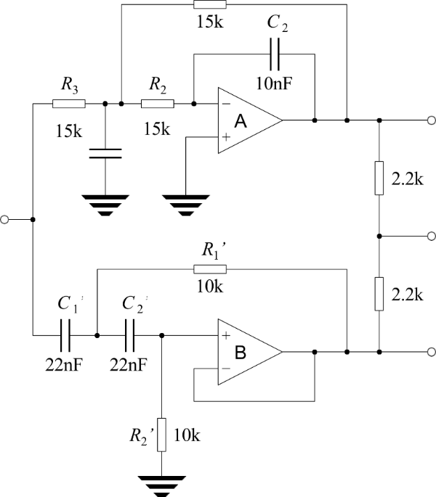
The caption for the Figure 1 below is setup using Words cross referencing feature. If you mouse over the “1” in “Figure 1” in previous sentence, it will allow you to follow a link to the Figure. The cross-referencing feature allows you to refer to the figure in-text (like your referencing manager) and Word will update figure numbers as required.
Figure 1. Experimental two-way active crossover (op-amp version)

Sub-headings as required
The caption for the Table 1 below is setup using Words cross referencing feature. If you mouse over the “1” in “Table 1” in the previous sentence it will allow you to follow a link to the Table. The cross-referencing feature allows you to refer to the figure in-text (like your referencing manager) and Word will update figure numbers as required.

Table 1 Fraction of air volume involved in heat exchange for second mode (right column) vs. filling factor (left column). The plain-text headings represent f, m, µ2 and f2.
f(%) | m | µ2 | f2 (%)
0.016 | 80.00 | 0.05400 | 4.874
0.031 | 56.57 | 0.07732 | 5.438
0.062 | 40.00 | 0.11103 | 6.125
0.125 | 28.28 | 0.16001 | 6.970
0.250 | 20.00 | 0.23175 | 8.020
0.500 | 14.14 | 0.33799 | 9.329
1.000 | 10.00 | 0.49789 | 10.967
2.000 | 7.07 | 0.74444 | 13.008
4.000 | 5.00 | 1.13919 | 15.525
8.000 | 3.54 | 1.81095 | 18.568
19.237 | 2.28 | 3.61958 | 23.174
37.180 | 1.64 | 7.28635 | 27.094
57.392 | 1.32 | 14.63631 | 29.813
74.316 | 1.16 | 29.35160 | 31.453
85.734 | 1.08 | 58.79364 | 32.360

References
Use your reference manager to insert references in the text and then generate this list automatically. Check all the references as they are printed below to ensure they are complete and correct.
- L. Lamport, LATEX: A Document Preparation System, 2nd ed. (Addison-Wesley, 1994).
- REFERENCE 2
- Etc.

Appendix A
Appendices are useful for supplying necessary details or explanations which do not seem to fit into the main text, perhaps because they are too long and would distract the reader from the central argument. Appendices are also used for program listings. Notice that appendices are “numbered” with capital letters, not numerals. When the \appendix command in LATEX [1, p. 175] is used with the book document class, it causes subsequent chapters to be treated as appendices.

Appendix B

