Date and time: 02/03/2026 9:30-9:39am
Attendance: Priya, Shan, Alex, Yunting, Lewis
Apologies: Yueran
Conclusion so far: client claims that UK has using cleaning energy so far but the mean temperature still goes up, they are asking if they should go back to use the old style energy, and they are asking if we have any solutions for that, they want the strongest possible way to support our conclusion, can use other dataset to support.
- Answer: Implications
- Global vs UK emission (cumulative emission level still increasing)
  - Total emissions = energy demand × carbon intensity of energy
    - Electricity in China is still heavily powered by coal.
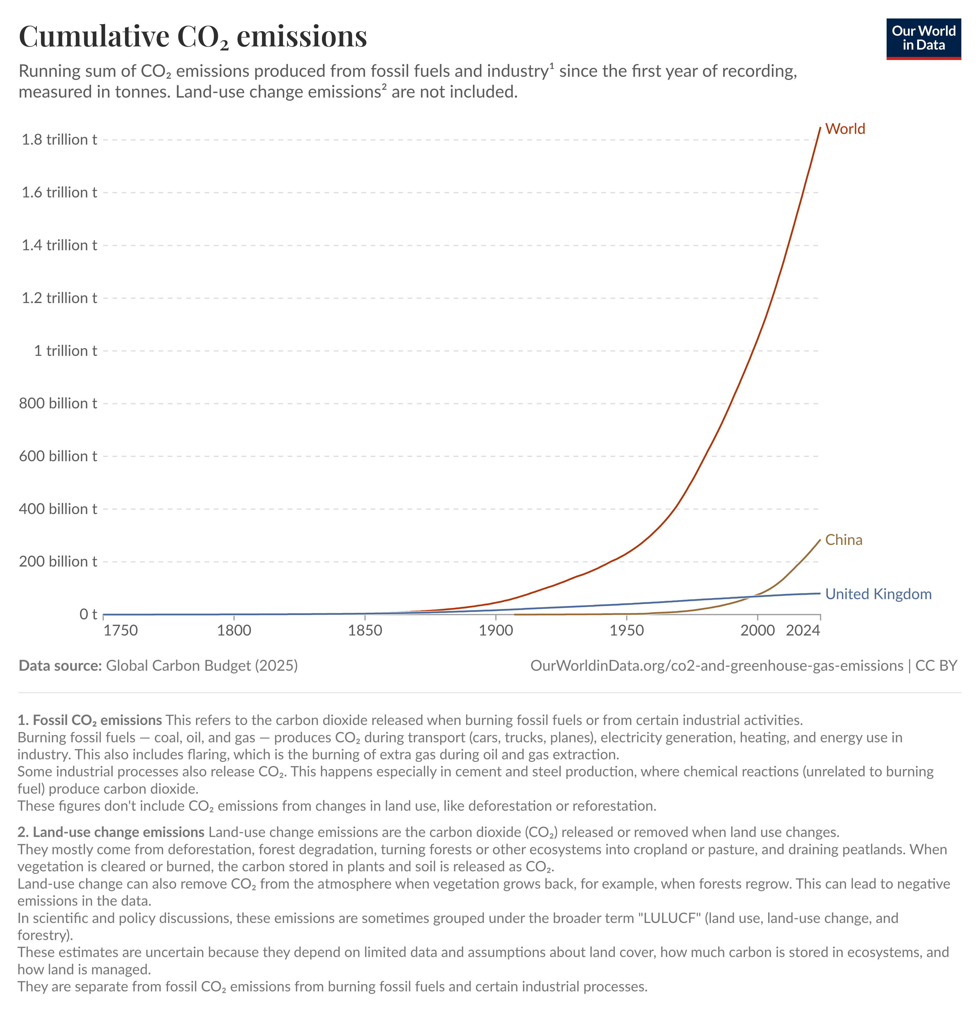
- Climate inertia:
  - Even if emissions stabilise, CO₂ does not disappear quickly from the atmosphere. A substantial fraction remains for hundreds of years.
    - -> Greenhouse effect -> higher temperature
  - Over 90% of excess heat from global warming goes into the oceans -> lag
Uncertainty: uncertainty associated with conclusion, need to know how the uncertainty could change the conclusion slightly, how could the conclusion support the decision
Robustness: client asks what GLM is
Question: can use other dataset and other sources to support the conclusion and suggestion

