Bug Fix in Toker

C:\su\cse687\code\project1HelpS06

Symptom:

Following a C style comment, e.g., /* comment */, Toker returned a space as the next token – definitely not the design intent.

These notes describe the fix and the fixing process.

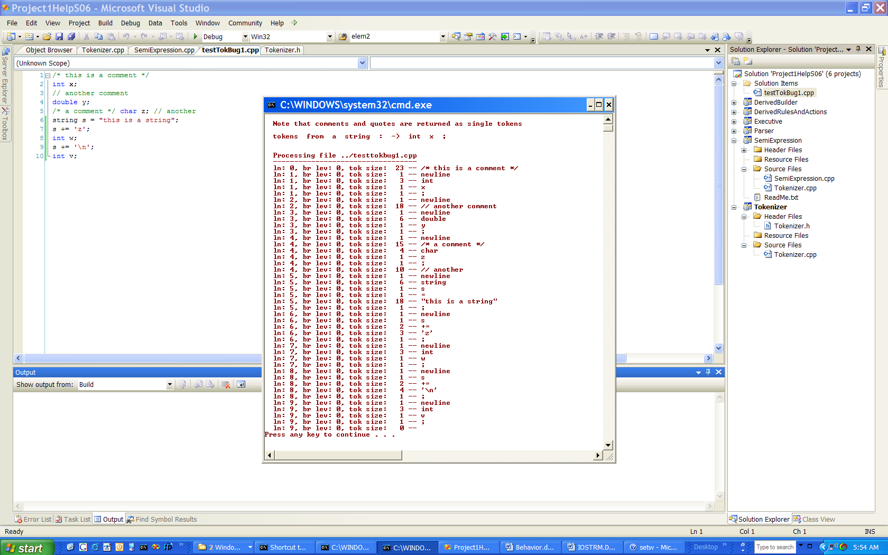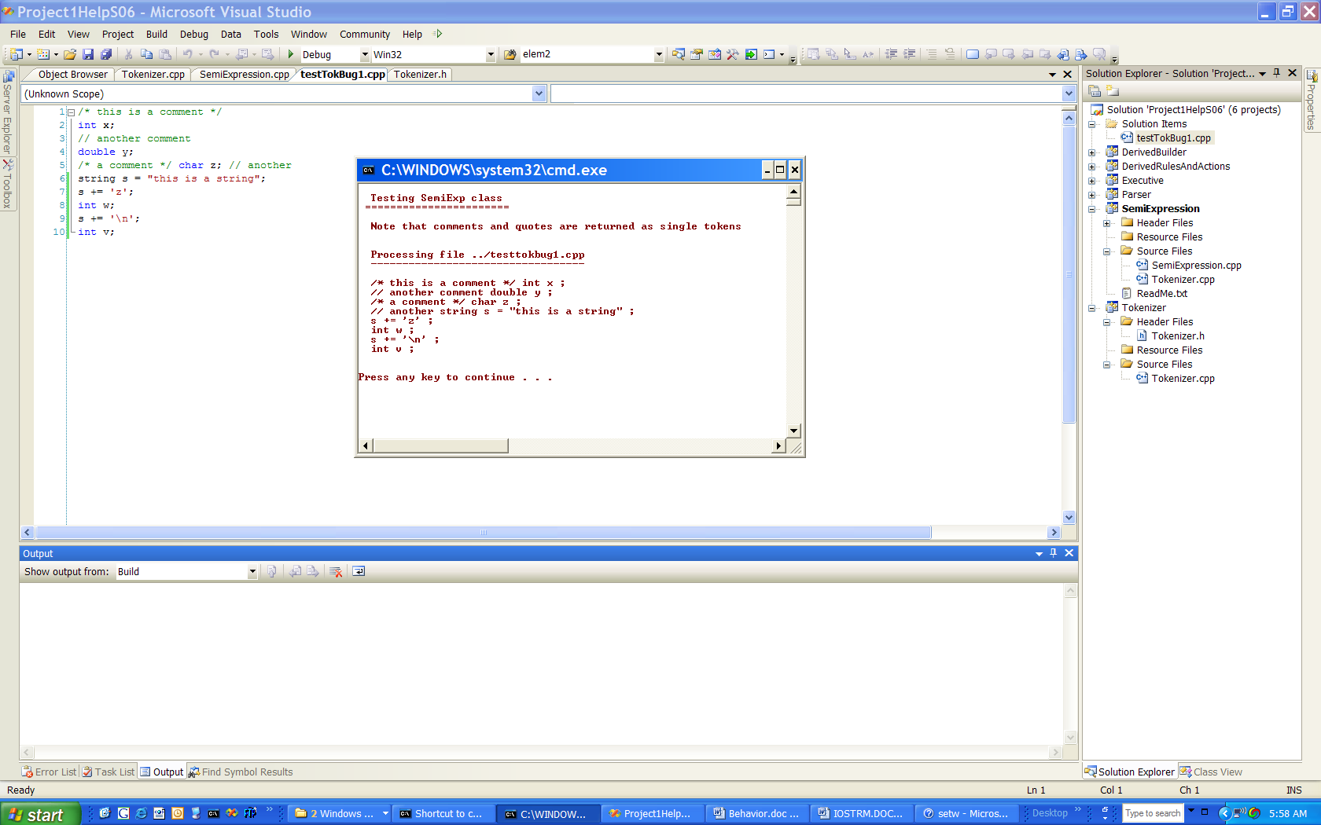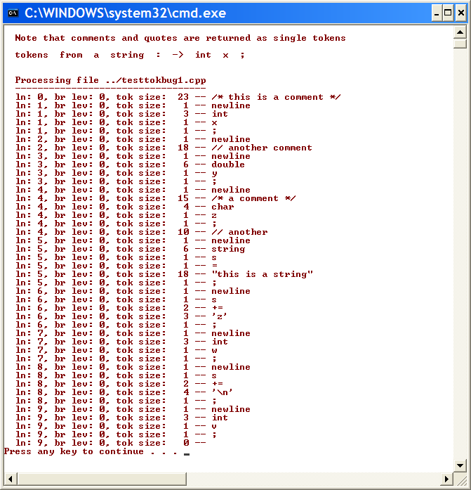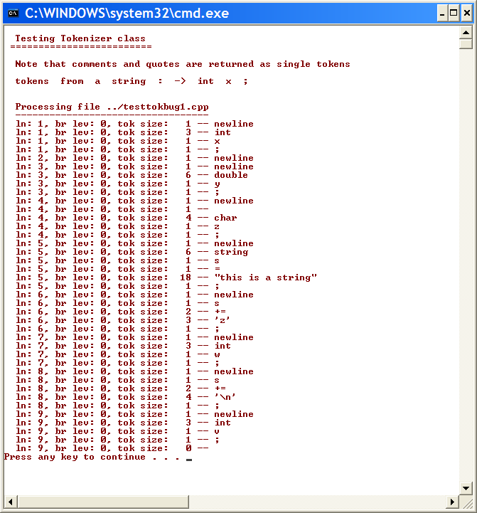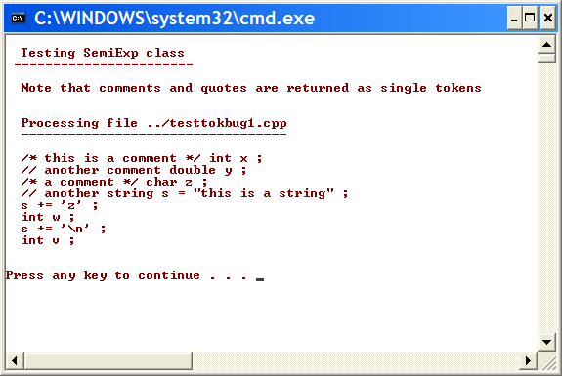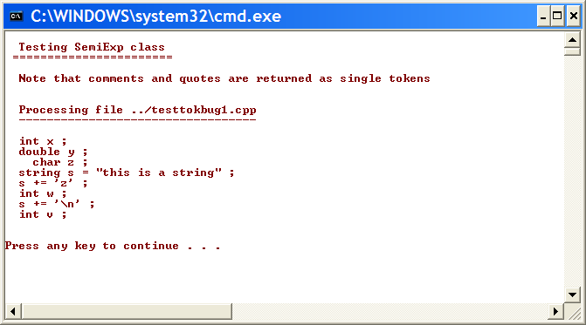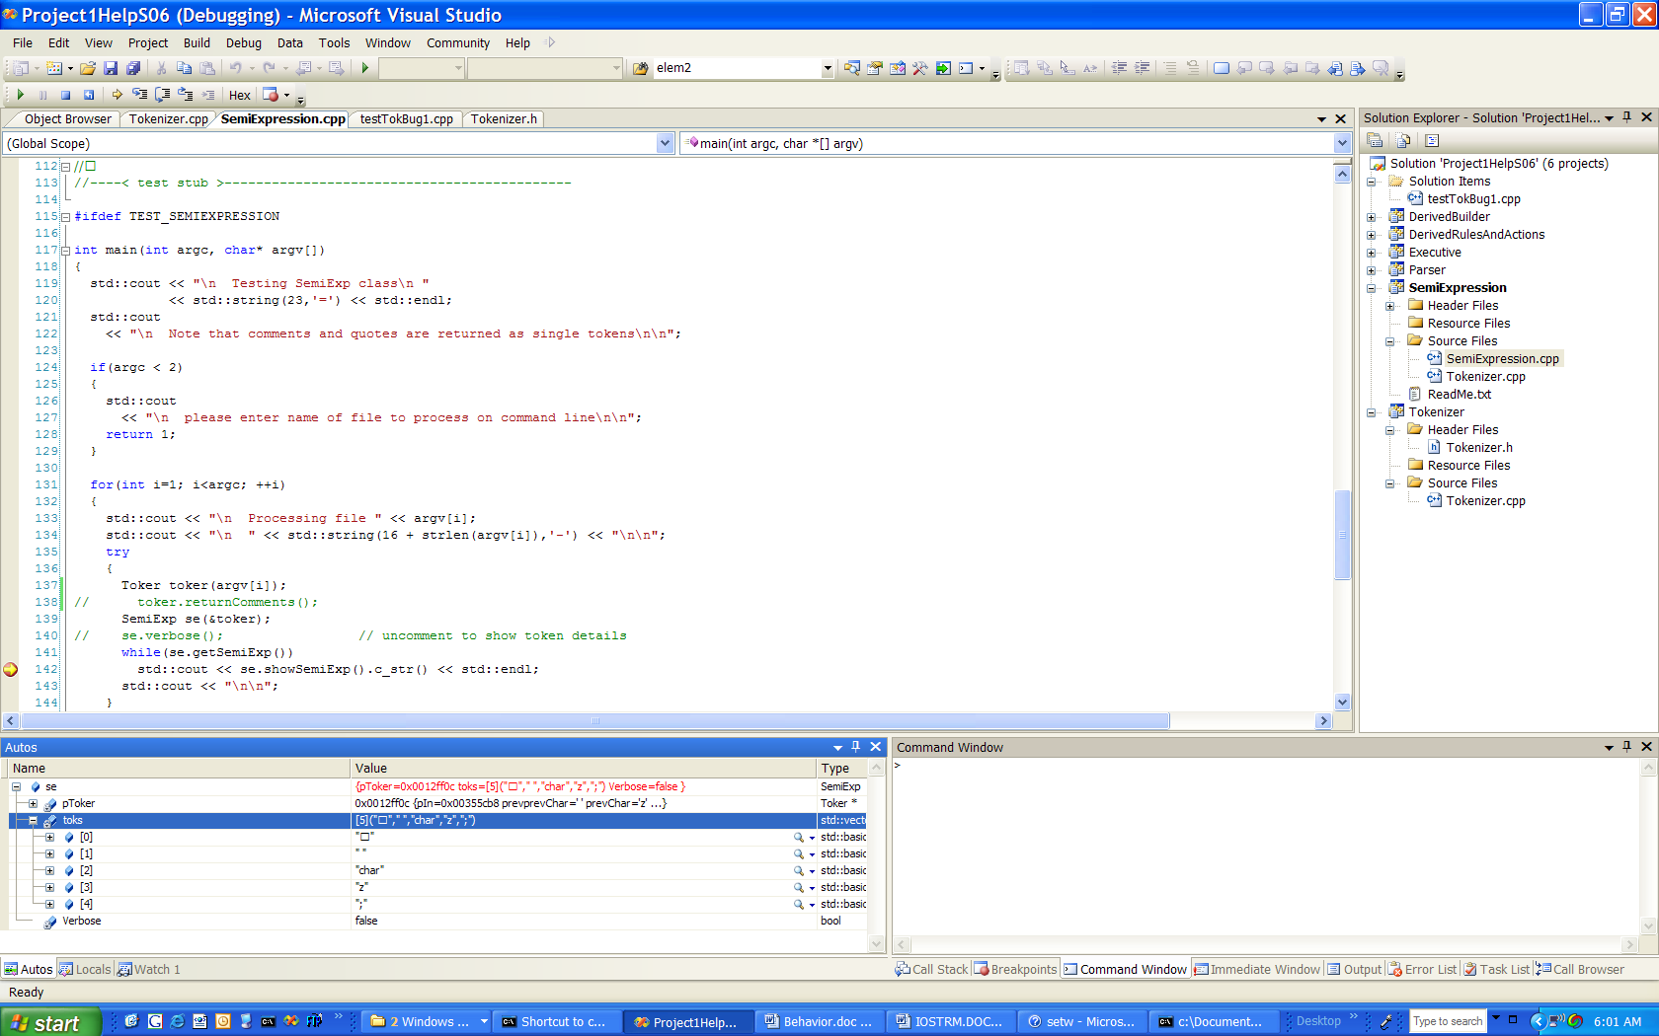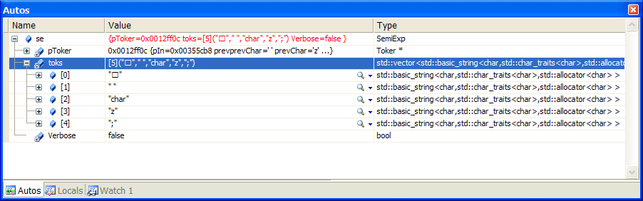
First, create a test case that reproduces the problem.
Intended behavior, per design
Oh-oh! Problem shows up when you run toker, throwing away all comments.

This is a token composed of a single space. That is definitely a bug.
Here is another manifestation of the same bug.
Here is a close look at the symptoms of the bug, seen in a debugger “Autos” window.

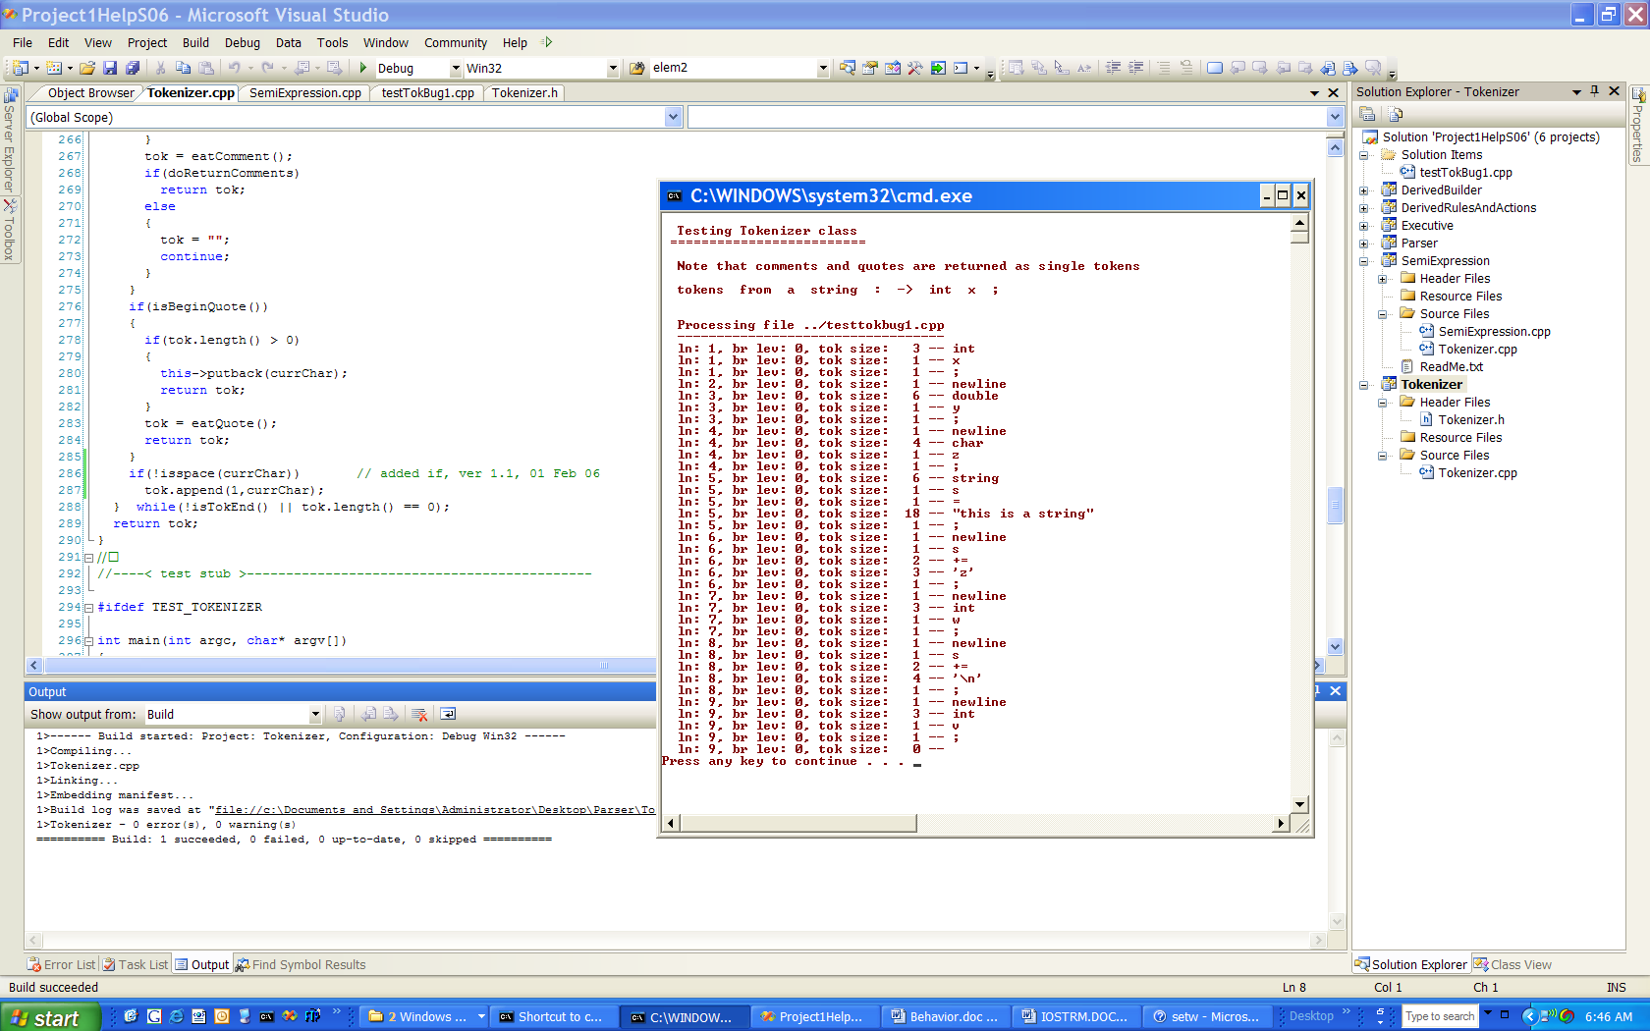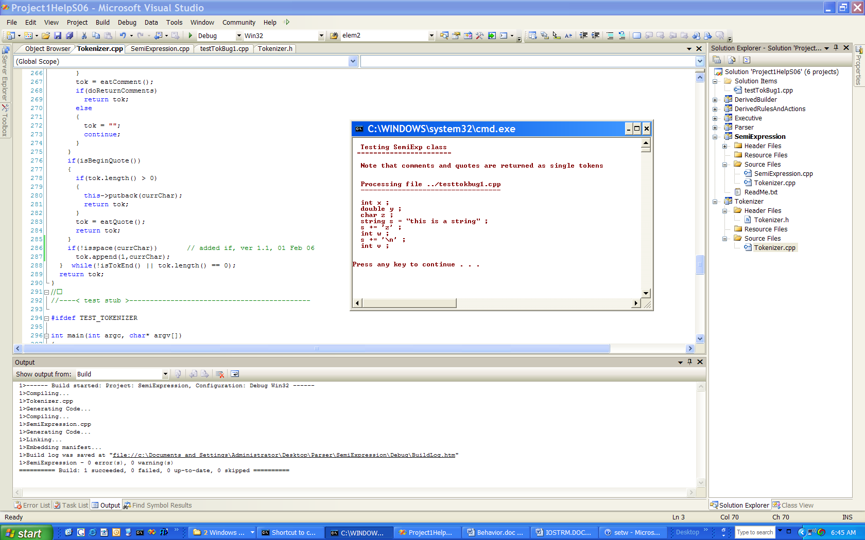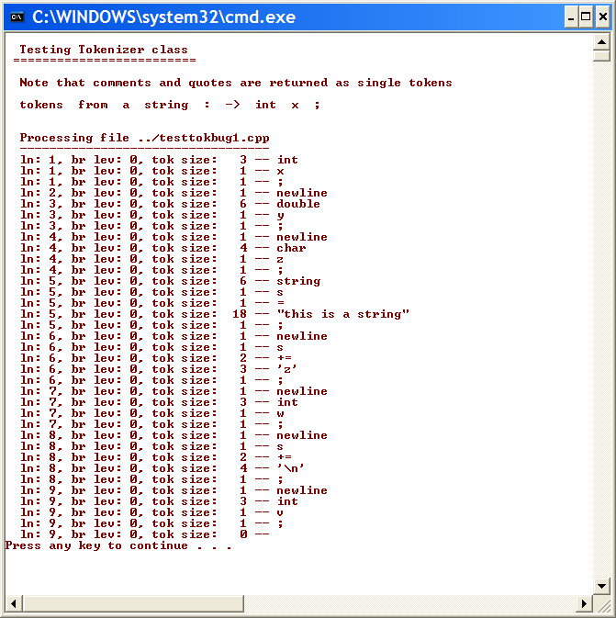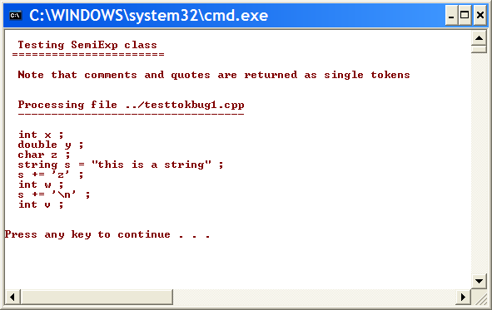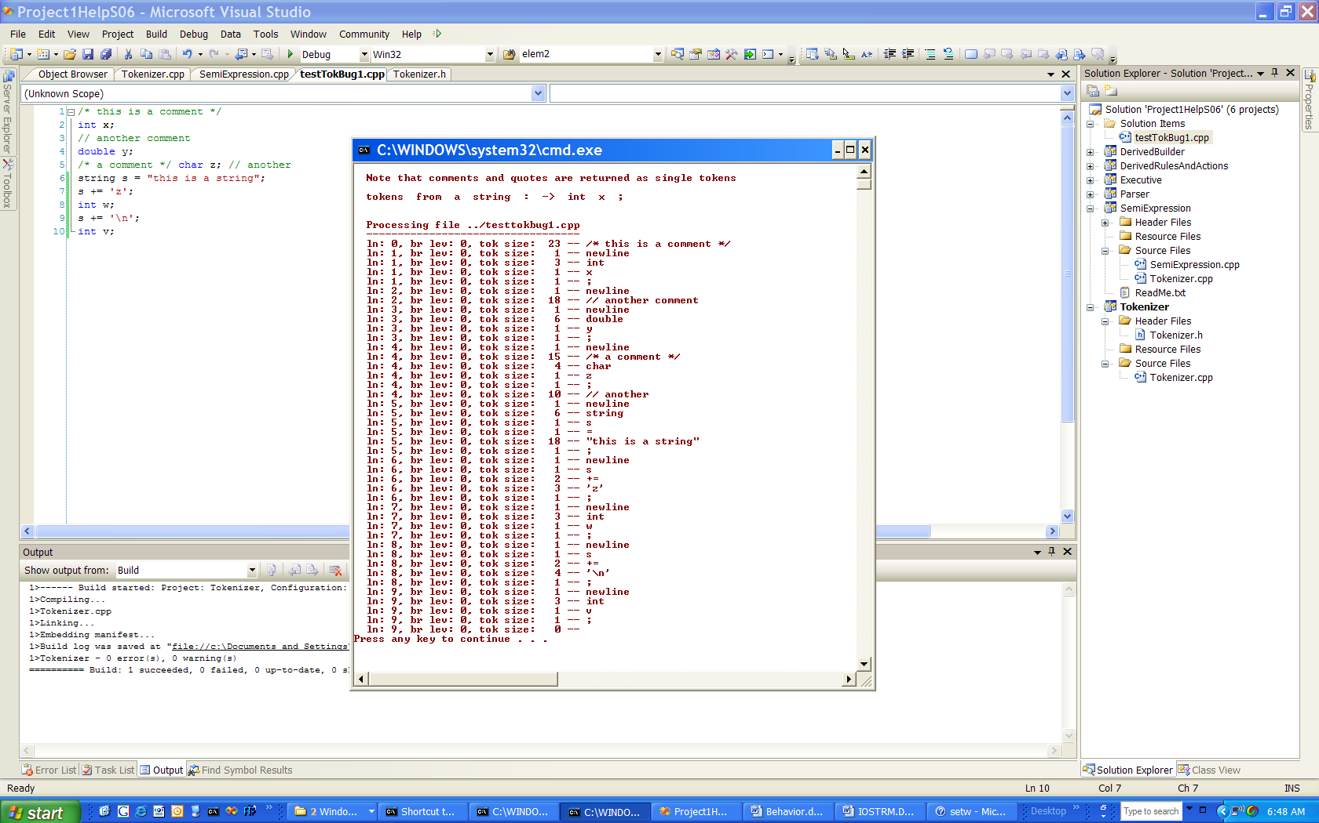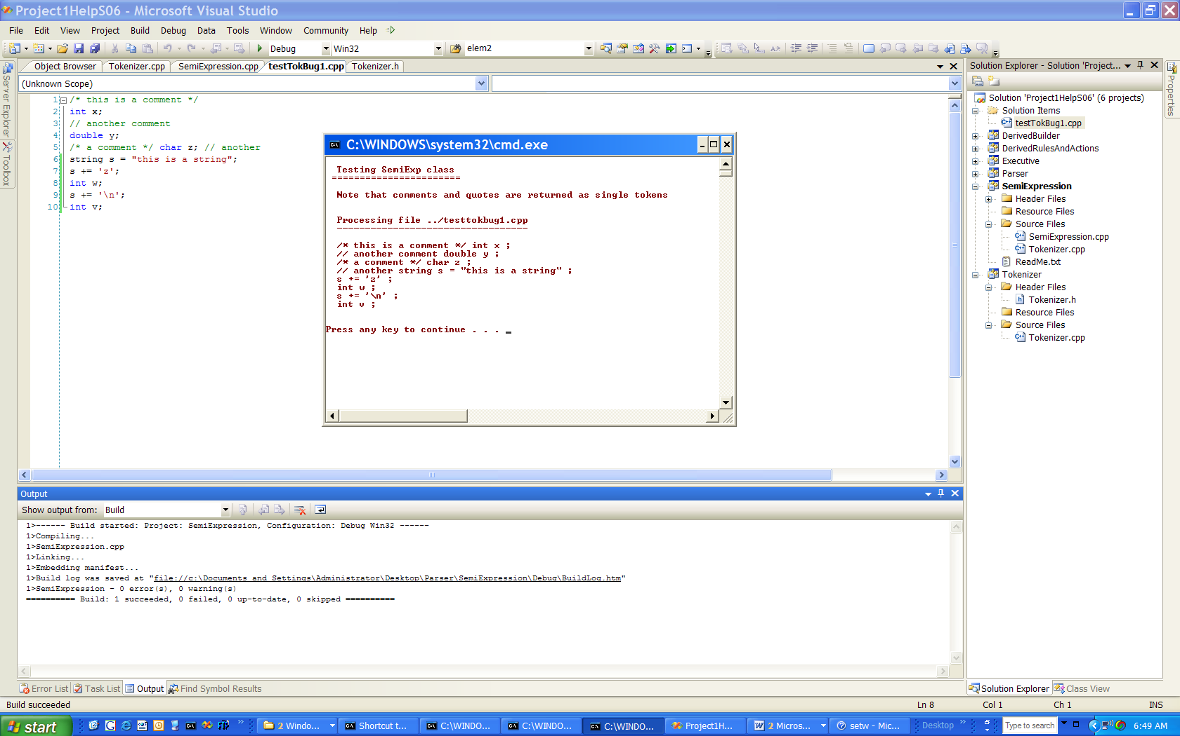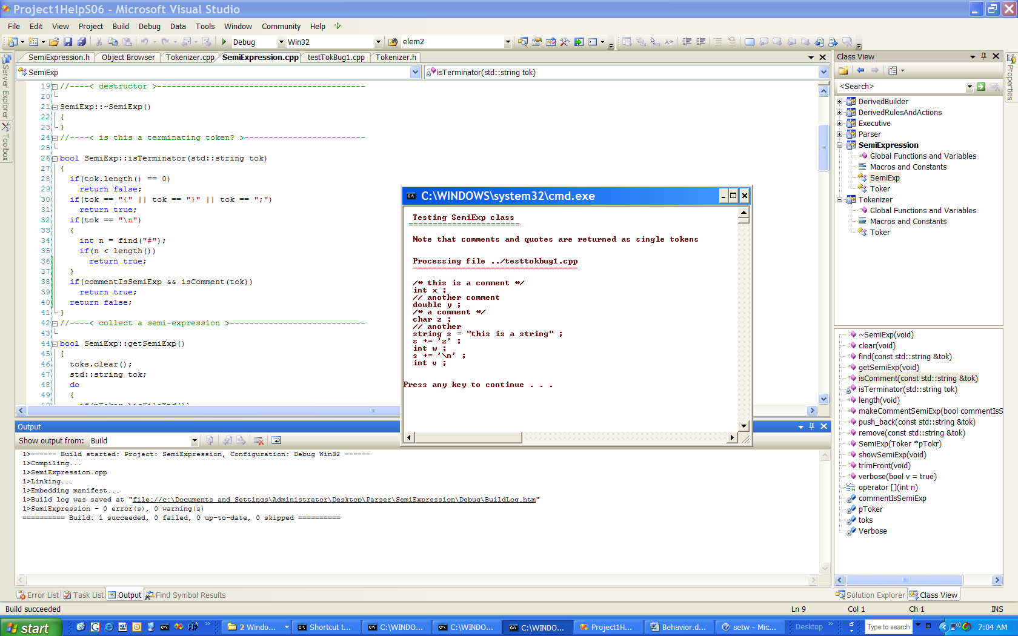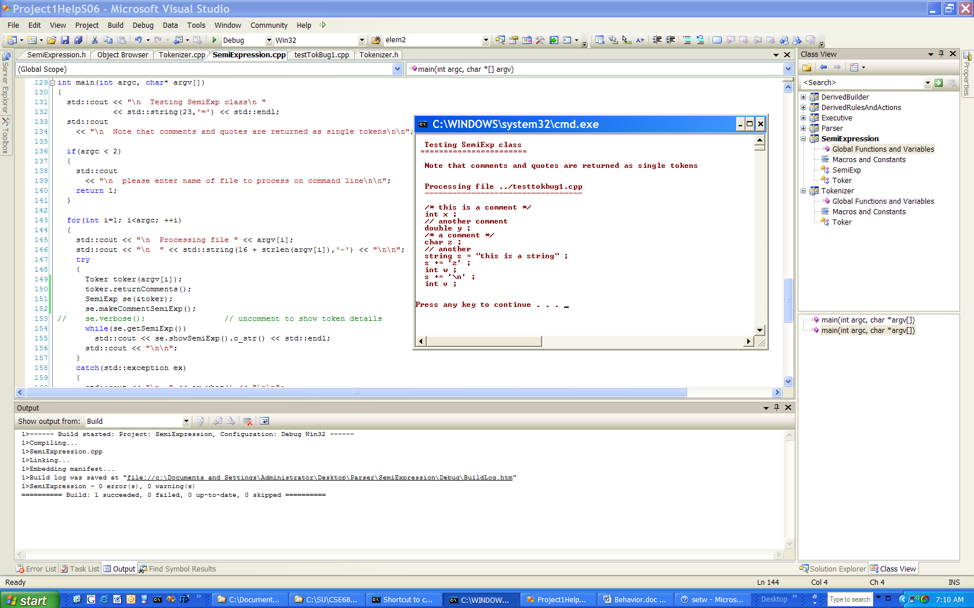
Now fixed.
Added if() test shown here.
Added comment termination condition if client specifically asks for that.
Comments are, by default, just tokens in a semi-expression. If we call makecommentSemiExp(), then each comment is treated like a separate semi-expression.

