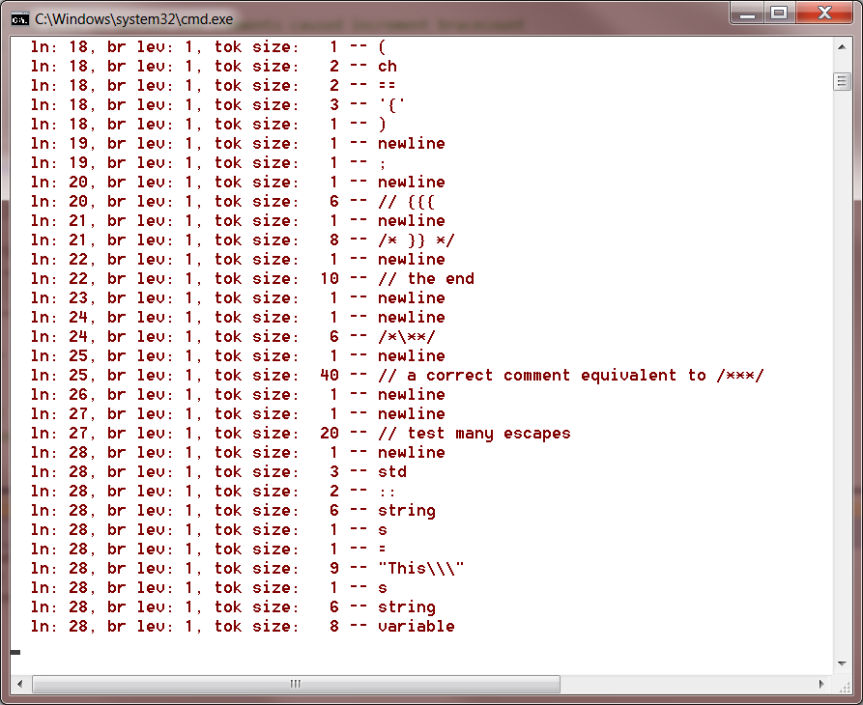

// testBraceBug.cpp

/* ver 1.3 - braces in quotes and comments caused increment bracecount

* ver 1.4 - eliminated by adding:

* enum state { default_state, comment_state, quote_state }

* and incrementing only if in default_state

*/

#include <string>

using namespace std;

void test()

{

std::string tok;

char ch = 'a';

if(tok == "{")

;

if(ch == '{')

;

// {{{

/* }} */

// the end

/*\**/

// a correct comment equivalent to /***/

// test many escapes

std::string s = "This\\\"s string variable";

int x; // more tokens

}