**Basic Block Testing for Account Creation Transactions**

Made by Chinese-broccoli

Author: Mason Chang, Yueyang Liu, Ruikang Luo.

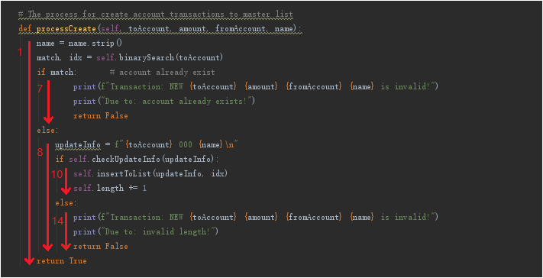

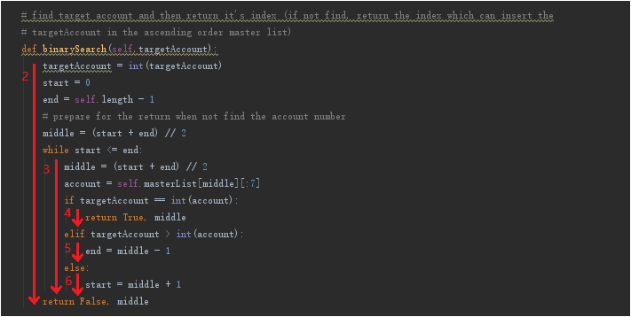

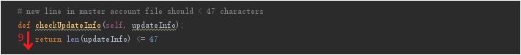

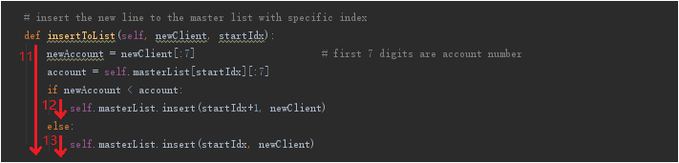

Test Table for Basic Block Testing:

|  |  |  |  |  |  |
| --- | --- | --- | --- | --- | --- |
| Test No. | Block include | Test Input (Transaction) | Important Variable Values | Description | Terminal Output |
| T1.0 | 1, 2, 3, 4, 7 | NEW 1000500 000 0000000 Account02 | Block 1: match -> True  Block 1: idx -> 1 | Unsuccessfully account creation, due to account already exists | Transaction: NEW 1000500 000 0000000 Account02 is invalid!  Due to: account already exists!  program terminated! |
| T1.1 | 1, 2, 3, 5, 6, 8, 9, 10, 11, 12 | NEW 1000550 000 0000000 Account04 | Block 1: match -> False  Block 1: idx -> 0  Block 8: checkUpdateInfo(updateInfo) -> True  Block 11: (newAccount < account) -> True | Successfully account creation, the created account is in the second line of the new master file | None |
| T1.2 | 1, 2, 3, 5, 8, 9, 10, 11, 13 | NEW 1000650 000 0000000 Account04 | Block 1: match -> False  Block 1: idx -> 0  Block 8: checkUpdateInfo(updateInfo) -> True  Block 11: (newAccount < account) -> False | Successfully account creation, the created account is in the first line of the new master file | None |
| T1.3 | 1, 2, 3, 5, 6, 8, 9, 14 | NEW 1000550 000 0000000 Account04aaaaa-aaaaaaaaaaaaaa-aaaaaaaaaaaaaa-aaaaaaaa | Block 1: match -> False  Block 1: idx -> 0  Block 8: checkUpdateInfo(updateInfo) -> False | Unsuccessfully account creation, due to invalid length | Transaction: NEW 1000550 000 0000000 Account04aaaaaaaaaaaaaaaaaa-  aaaaaaaaaaaaaaaaaaaaaaa is invalid!  Due to: invalid length!  program terminated! |
| All blocks (1 to 14) are covered in the tests | | | | | |