Decision coverage of withdraw

Made by Chinese-broccoli

Author: Mason Chang, Yueyang Liu, Ruikang Luo.

    def processWithdraw(self, toAccount, amount, fromAccount):

        match, idx = self.binarySearch(fromAccount)

       if match:

            decreaseAccount = self.masterList[idx].split(' ')

            name = decreaseAccount[2].strip()

            oldAmount = decreaseAccount[1]

            newAmount = int(oldAmount) - int(amount)

         if newAmount < 0 :

                print(f"Transaction: WDR {toAccount} {amount} {fromAccount} *** I

s invalid!")

                print("Due to: insufficient balance.")

                return False

         else:

                updateInfo = f"{fromAccount} {newAmount} {name}\n"

             if self.checkUpdateInfo(updateInfo):

                    self.masterList[idx] = updateInfo

             else:

                    print(f"Transaction: WDR {toAccount} {amount} {fromAccount} *

** is invalid!")

                    print("Due to: Invalid length.")

                    return  False

      else:

            print(f"Transaction: WDR {toAccount} {amount} {fromAccount} *** is in

valid!")

            print("Due to: no matching account found!")

            return False

        return True

    def binarySearch(self,targetAccount):

        targetAccount = int(targetAccount)

        start = 0

        end = self.length - 1

        # prepare for the return when not find the account number

        middle = (start + end) // 2

     while start <= end:

            middle = (start + end) // 2

            account = self.masterList[middle][:7]

         if targetAccount == int(account):

                return True, middle

         elif targetAccount > int(account):

                end = middle - 1

         else:

                start = middle + 1

        return False, middle

|  |  |  |  |  |
| --- | --- | --- | --- | --- |
| Test No. | Input transaction | Decision | Terminal output | Description |
| T1.0 | WDR 0000000 100000 1000327 *** | True False  False True  True False  True True  False True | None | Successfully withdraw, account is in the bottom of the master file |
| T1.1 | WDR 0000000 100000 1000329 *** | True False  False True  True False  True True  False True | None | Successfully withdraw, account is in the top of the master file |
| T1.2 | WDR 0000000 10000 1000330 *** | False True  False False | Transaction: WDR 0000000 10000 1000330 *** is invalid!  Due to: no matching account found! | Unsuccessfully withdraw, due to no matching account found |
| Notes: up to now, both side of direction (,), whether within given range (), and matching or not () have tested. For simplicity, they will not be stated in the below table. | | | | |
| T1.3 | WDR 0000000 100000 1000328 *** | True False  True False | Transaction: WDR 0000000 100000 1000328 *** is invalid!  Due to: insufficient balance! | Unsuccessfully withdraw, due to insufficient balances |
| T1.4 | WDR 0000000 10000 1000328 *** | True False  False True  False True | Transaction: WDR 0000000 10000 1000328 *** is invalid!  Due to: Invalid length! | Unsuccessfully withdraw, due to the account information is longer than 46 characters. |
| Sum up: both sides of is tested at T1.0 and T1.2; is tested at T1.0 and T1.3;  is tested at T1.0 and T1.3; is tested at T1.0 and T1.4;  is tested at T1.0 and T1.4; is tested at T1.0 and T1.2; | | | | |

Failure spotted at T1.0 and T1.2

T1.0, found that the account list should be stored in descending order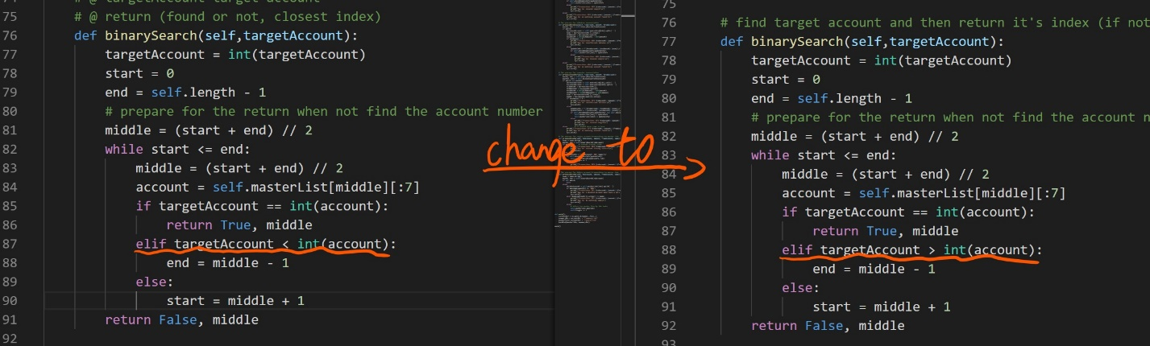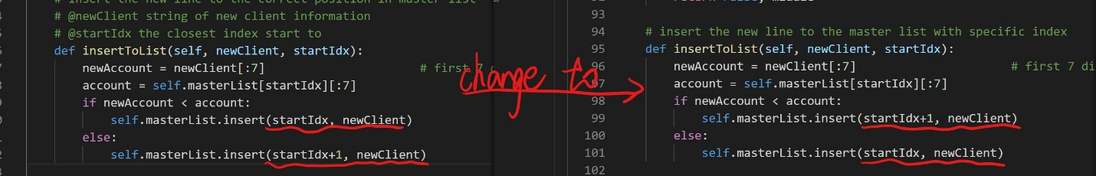

T1.2, found that sys.exit() can’t be used in pytest. Changing sys.exit() to return False (For simplicity, will not post more similar example.)

