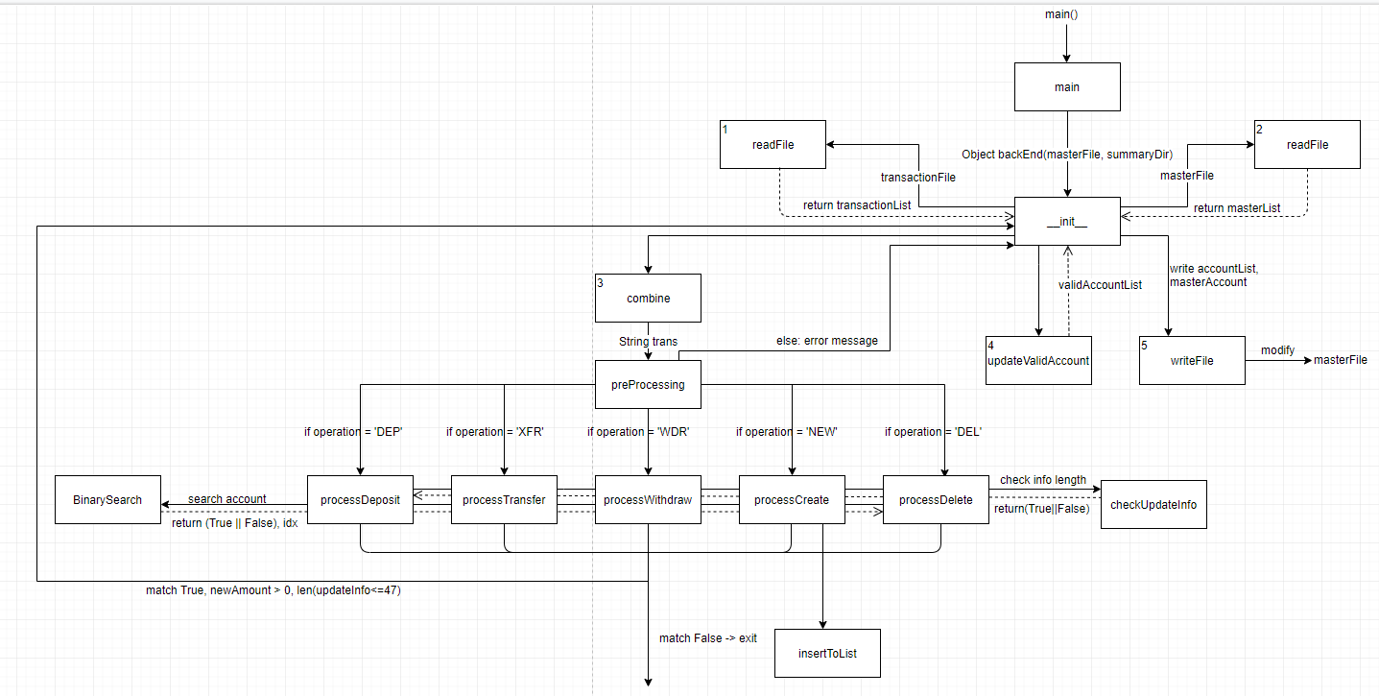

readFile(self, target): Read the targeted file

writeFile(self, directory, name, content): write file with given content, directory, and name

combine(self): combine transaction summary file with old master account file

updateValidAccList(self): Update the valid account list

preProcessing(self, transact): classify different transaction, and send them to corresponding function

binarySearch(self,targetAccount): search for target account by binary search, return (found or not, closest index)

insertToList(self, newClient, startIdx): insert the new line to the correct position in master list

checkUpdateInfo(self, updateInfo): line of information in master account file should < 47 characters

processDeposit(self, toAccount, amount, fromAccount): The process for deposit transcription

processWithdraw(self, toAccount, amount, fromAccount): The process for withdraw transcription

processTransfer(self, toAccount, amount, fromAccount): The process for transfer transcription

processCreate(self, toAccount, amount, fromAccount, name): The process for create account transcription

processDelete(self, toAccount, amount, fromAccount, name): The process for delete account transcription

main: main function