United Kingdom

1. 'PINK REGENCY TEACUP AND SAUCER', 'ROSES REGENCY TEACUP AND SAUCER'=>'GREEN REGENCY TEACUP AND SAUCER'

Confidence=0.90293, lift=18.047 ,確認非偽相關，單一貢獻皆大於0.05

2. JUMBO BAG PINK POLKADOT', 'JUMBO STORAGE BAG SUKI' => 'JUMBO BAG RED RETROSPOT'

Confidence=0.80198, lift=7.72516,確認非偽相關，單一貢獻皆大於0.05

3.'GARDENERS KNEELING PAD CUP OF TEA' => 'GARDENERS KNEELING PAD KEEP CALM'=>

Confidence=0.721333, lift=14.9954,確認非偽相關，單一貢獻皆大於0.05

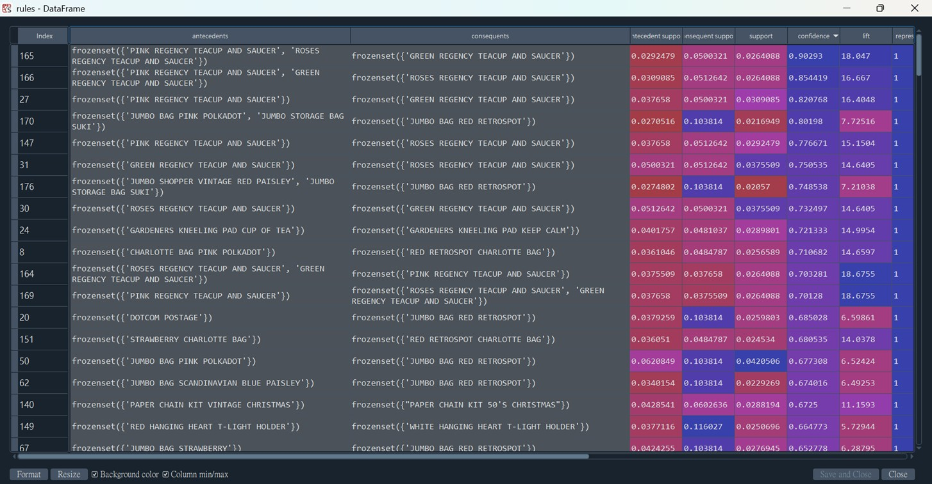

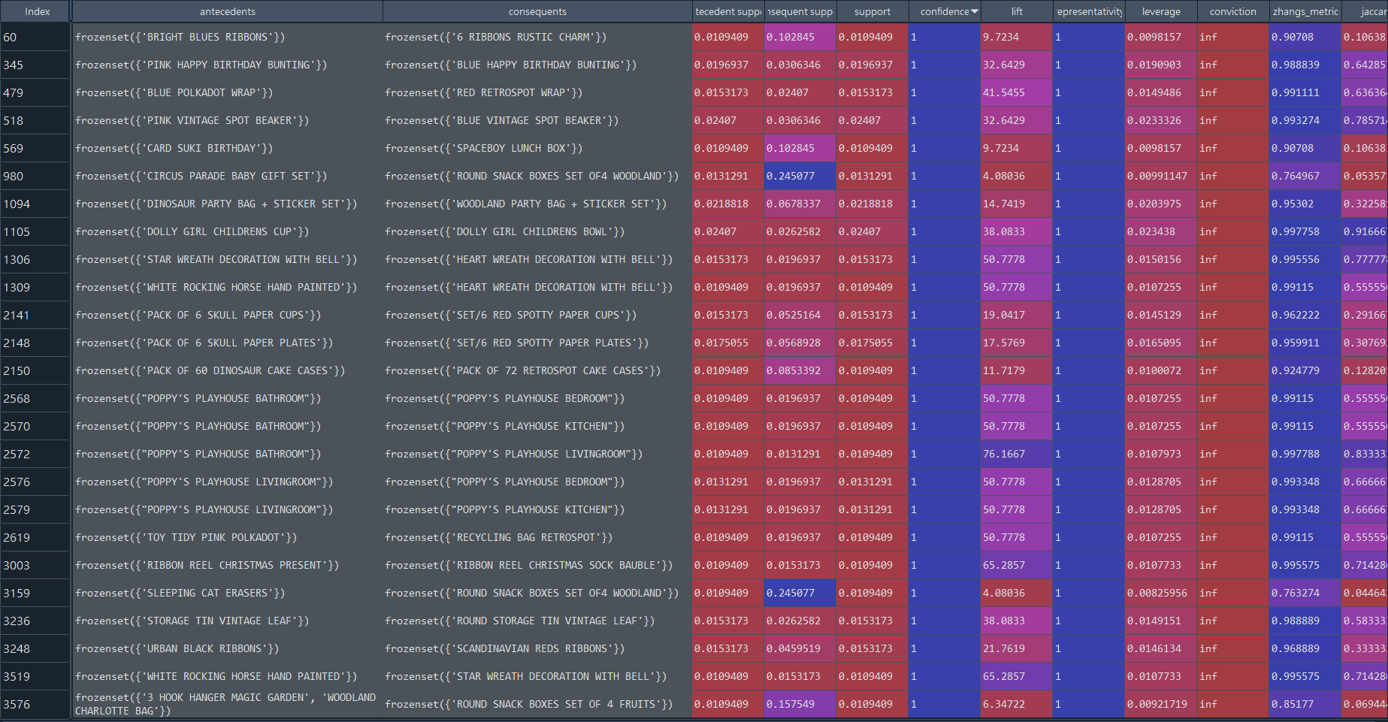Germany

Germany 2

