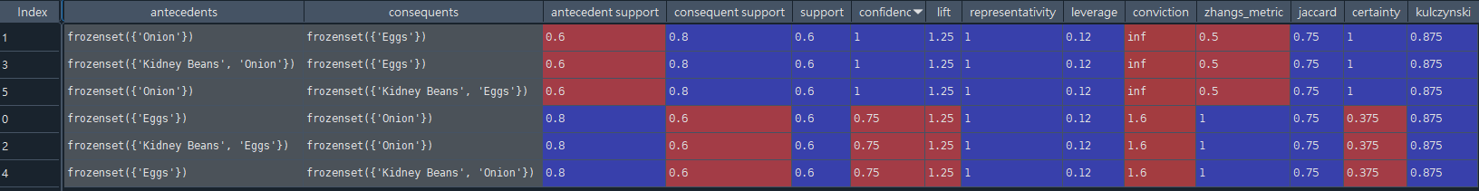

最強的法則為 {“Onion”} => {“Kidney Beans”, “Eggs”}

Support = 0.6, Confidence = 1, Lift = 1.25 確認非偽相關

