**Q12:**

For this task, we trained a regression model to predict the rating of three movies. When constructing the model, we **randomly picked 5 actors** who get involved into corresponding movies. When rating a movie people usually tend to evaluate the actors’ performance in the movie, so we use it as our features. The reason why we randomly choose the 5 actors is that we want our model to be robust and try to ignore the outlier problems.

For the model itself, we utilized SVR algorithm to fit our model. The training set is derived from the whole movie (90% training, 10% testing) with rating (if the movie given has no rating in the rating file, we discard it).

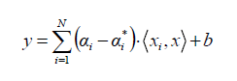

We used the root mean square error (RMSE) to evaluate the results.

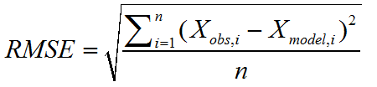

According to the result, the RMSE given by our model is **0.77(testing); 1.13(validation)**. The predictions for those three movies (Batman v Superman: Dawn of Justice (2016), Mission: Impossible - Rogue Nation (2015), Minions (2015)) are shown in the following table:

|  |  |
| --- | --- |
| Movie | Rating |
| Batman v Superman: Dawn of Justice (2016) | 6.12 |
| Mission: Impossible - Rogue Nation (2015) | 6.18 |
| Minions (2015) | 6.15 |

We also tried using top 5 pagerank actors instead of randomly picking to build the same model and we got a better results: **0.69(testing); 1.08(validation)**.

**Q13:**

For this task, we used bipartite graph to predict the rating of each movie. The metric we utilized in this model is mean. To be specific, we investigated one actor’s all relative movies with ratings and calculated the mean of those ratings to get the rating of the corresponding actor. Intuitively, this kind of definition makes sense due to how people tend to rate a movie. People usually tend to rate a movie with high a score if there are some high-quality actors in it.

The bipartite graph shown as follows:

All: (actors are on the left while movies are on the right)

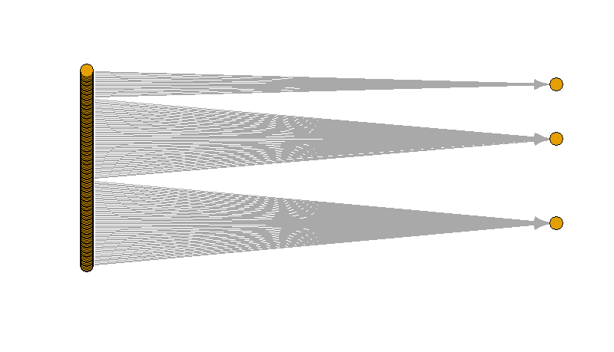

Batman v Superman: Dawn of Justice (2016):

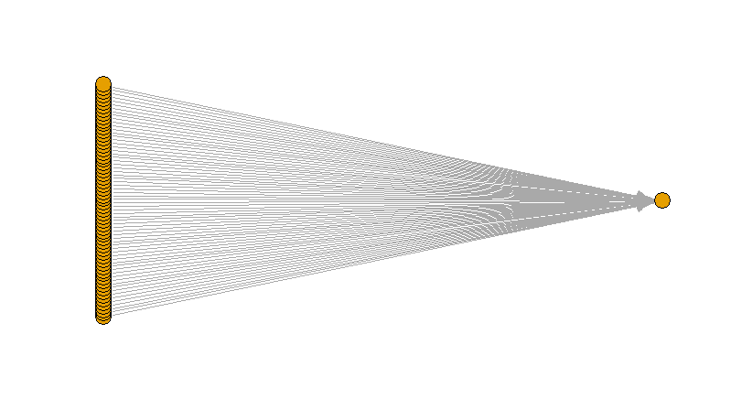

Mission: Impossible - Rogue Nation (2015):

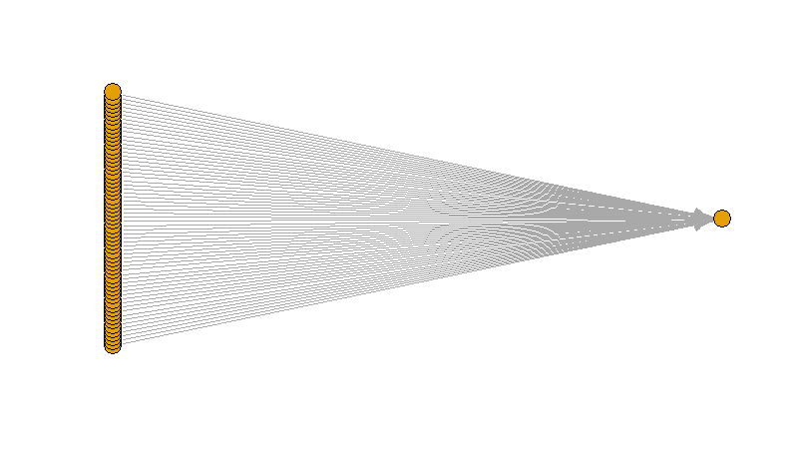

Minions (2015):

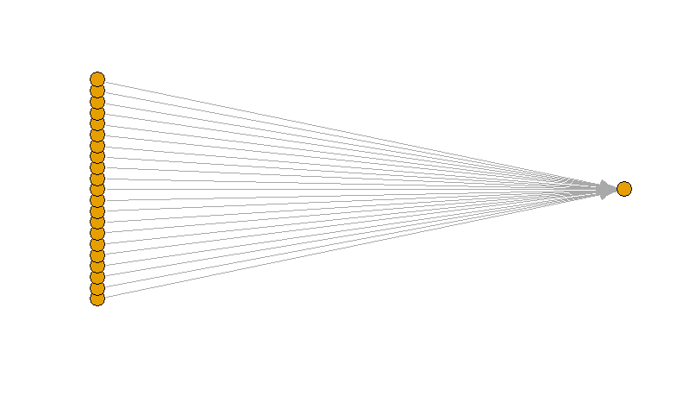

The RMSE given by our model using bipartite graph is **0.58**. The predictions are:

|  |  |
| --- | --- |
| Movie | Rating |
| Batman v Superman: Dawn of Justice (2016) | 6.43 |
| Mission: Impossible - Rogue Nation (2015) | 6.54 |
| Minions (2015) | 6.90 |

Clearly we can see, the bipartite model performs better than the model in problem 12. The reason of that is because we consider more actors in this model for a single movie while the other model only takes 5 actors into consideration when assigning ratings. (This is not always the truth and we need to analyze the parameters to get the results for each situation)