**CMPUT 414: Winter 2016**

**Lab2, due date Jan 23, 2016, 23:59 PM**

1. **3D Transformations**

a) What is the homogenous transformation matrix for:

i) Translation of (2, -3, 2)

$$M_{1}=\left[\begin{matrix}\begin{matrix}1 & 0 \\ 0 & 1\end{matrix} & \begin{matrix}0 & 2 \\ 0 & -3\end{matrix} \\ \begin{matrix}0 & 0 \\ 0 & 0\end{matrix} & \begin{matrix}1 & 2 \\ 0 & 1\end{matrix}\end{matrix}\right]$$

ii) Followed by Scaling with (2, 2, 2)

$$M_{2}=\left[\begin{matrix}\begin{matrix}2\sqrt{2} & 0 \\ 0 & 2\sqrt{2}\end{matrix} & \begin{matrix}0 & 0 \\ 0 & 0\end{matrix} \\ \begin{matrix}0 & 0 \\ 0 & 0\end{matrix} & \begin{matrix}2 & 0 \\ 0 & 1\end{matrix}\end{matrix}\right]\left[\begin{matrix}\begin{matrix}1 & 0 \\ 0 & 1\end{matrix} & \begin{matrix}0 & 2 \\ 0 & -3\end{matrix} \\ \begin{matrix}0 & 0 \\ 0 & 0\end{matrix} & \begin{matrix}1 & 2 \\ 0 & 1\end{matrix}\end{matrix}\right]=\left[\begin{matrix}\begin{matrix}2\sqrt{2} & 0 \\ 0 & 2\sqrt{2}\end{matrix} & \begin{matrix}0 & 4\sqrt{2} \\ 0 & -6\sqrt{2}\end{matrix} \\ \begin{matrix}0 & 0 \\ 0 & 0\end{matrix} & \begin{matrix}2 & 4 \\ 0 & 1\end{matrix}\end{matrix}\right]$$

iii) Followed by Rotation of 45 degrees around Z-axis

$$M_{3}=\left[\begin{matrix}\begin{matrix}cos(\frac{π}{4}) & sin(\frac{π}{4}) \\ -sin(\frac{π}{4}) & cos(\frac{π}{4})\end{matrix} & \begin{matrix}0 & 0 \\ 0 & 0\end{matrix} \\ \begin{matrix}0 & 0 \\ 0 & 0\end{matrix} & \begin{matrix}1 & 0 \\ 0 & 1\end{matrix}\end{matrix}\right]\left[\begin{matrix}\begin{matrix}2\sqrt{2} & 0 \\ 0 & 2\sqrt{2}\end{matrix} & \begin{matrix}0 & 4\sqrt{2} \\ 0 & -6\sqrt{2}\end{matrix} \\ \begin{matrix}0 & 0 \\ 0 & 0\end{matrix} & \begin{matrix}2 & 4 \\ 0 & 1\end{matrix}\end{matrix}\right]=\left[\begin{matrix}\begin{matrix}2 & 2 \\ -2 & 2\end{matrix} & \begin{matrix}0 & -2 \\ 0 & -10\end{matrix} \\ \begin{matrix}0 & 0 \\ 0 & 0\end{matrix} & \begin{matrix}2 & 4 \\ 0 & 1\end{matrix}\end{matrix}\right]$$

b) Apply the above final transformation matrix to a 3D point at (5, 3, 4).

$$M_{Final}=\left[\begin{matrix}\begin{matrix}2 & 2 \\ -2 & 2\end{matrix} & \begin{matrix}0 & -2 \\ 0 & -10\end{matrix} \\ \begin{matrix}0 & 0 \\ 0 & 0\end{matrix} & \begin{matrix}2 & 4 \\ 0 & 1\end{matrix}\end{matrix}\right]\left[\begin{aligned}\begin{matrix}5 \\ 3 \\ 4\end{matrix} \\ 1\end{aligned}\right]=\left[\begin{aligned}\begin{matrix}14 \\ -14 \\ 12\end{matrix} \\ 1\end{aligned}\right]$$

c) Illustrate the transformations applied in (b). You can either draw them manually, or build them by using a geometry software package (e.g. Geogebra http://app.geogebra.org/3d/), and copying its output. Make sure to illustrate rotation angles.

I did translation first, and then scaling, then rotation.

The answers are as follows (starting from (5, 3, 4)):

$$\left[\begin{matrix}5 \\ 3 \\ 4\end{matrix}\right]→\left[\begin{matrix}7 \\ 0 \\ 6\end{matrix}\right]→\left[\begin{matrix}14\sqrt{2} \\ 0 \\ 12\end{matrix}\right]→\left[\begin{matrix}14 \\ -14 \\ 12\end{matrix}\right]$$

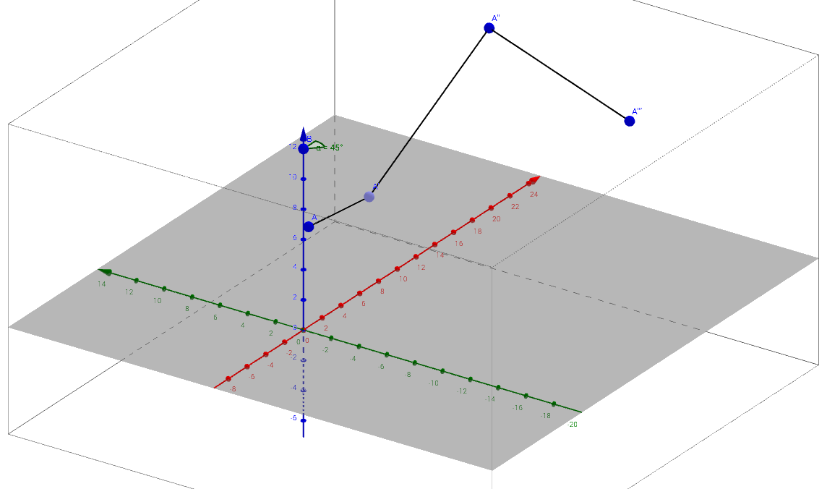

d) If after the same transformations as in (a), we get the resulting 3D point (6, 1, 4), what is the original 3D point?

$$\left[\begin{aligned}\begin{matrix}X \\ Y \\ Z\end{matrix} \\ 1\end{aligned}\right] = {\left[\begin{matrix}\begin{matrix}2 & 2 \\ -2 & 2\end{matrix} & \begin{matrix}0 & -2 \\ 0 & -10\end{matrix} \\ \begin{matrix}0 & 0 \\ 0 & 0\end{matrix} & \begin{matrix}2 & 4 \\ 0 & 1\end{matrix}\end{matrix}\right]}^{-1}*\left[\begin{aligned}\begin{matrix}6 \\ 1 \\ 4\end{matrix} \\ 1\end{aligned}\right]={\left[\begin{matrix}\begin{matrix}\frac{1}{4} & \frac{-1}{4} \\ \frac{1}{4} & \frac{1}{4}\end{matrix} & \begin{matrix}0 & -2 \\ 0 & 3\end{matrix} \\ \begin{matrix}0 & 0 \\ 0 & 0\end{matrix} & \begin{matrix}\frac{1}{2} & -2 \\ 0 & 1\end{matrix}\end{matrix}\right]}^{-1}*\left[\begin{aligned}\begin{matrix}6 \\ 1 \\ 4\end{matrix} \\ 1\end{aligned}\right]=\left[\begin{aligned}\begin{matrix}\frac{-3}{4} \\ \frac{19}{4} \\ 0\end{matrix} \\ 1\end{aligned}\right]$$

So, the initial 3D point is ($\frac{-3}{4}$, $\frac{19}{4}$, 0)

e) Rotate the vector from the origin to  by an angle 60 around direction (-1, 1, 1).

Normalized direction: $[-1, 1, 1]→[\frac{-1}{\sqrt{3}}, \frac{1}{\sqrt{3}}, \frac{1}{\sqrt{3}}]$

$$Arbitray Rotation= \left[\begin{matrix}\begin{matrix}\frac{2}{3} & \frac{-2}{3} \\ \frac{1}{3} & \frac{2}{3}\end{matrix} & \begin{matrix}\frac{1}{3} & 0 \\ \frac{2}{3} & 0\end{matrix} \\ \begin{matrix}\frac{-2}{3} & \frac{-1}{3} \\ 0 & 0\end{matrix} & \begin{matrix}\frac{2}{3} & 0 \\ 0 & 1\end{matrix}\end{matrix}\right]$$

$$A_{Final}=\left[\begin{matrix}\begin{matrix}\frac{2}{3} & \frac{-2}{3} \\ \frac{1}{3} & \frac{2}{3}\end{matrix} & \begin{matrix}\frac{1}{3} & 0 \\ \frac{2}{3} & 0\end{matrix} \\ \begin{matrix}\frac{-2}{3} & \frac{-1}{3} \\ 0 & 0\end{matrix} & \begin{matrix}\frac{2}{3} & 0 \\ 0 & 1\end{matrix}\end{matrix}\right]\left[\begin{aligned}\begin{matrix}-\sqrt{2} \\ \frac{1}{\sqrt{2}} \\ 2\end{matrix} \\ 1\end{aligned}\right]=\left[\begin{aligned}\begin{matrix}\frac{2-3\sqrt{2}}{3} \\ \frac{4}{3} \\ \frac{8+3\sqrt{2}}{6}\end{matrix} \\ 1\end{aligned}\right]$$

Therefore, the final vector is ($\frac{2-3\sqrt{2}}{3}, \frac{4}{3}, \frac{8+3\sqrt{2}}{6}$)