Design and Validation of a Wearable Ankle Rehabilitation Robot with an Anatomically Aligned 3-RRR Spherical Parallel Mechanism
AMR Research Course · Closing Presentation · May 2026
Yufei Zhang · Department of Mechanical Engineering, Columbia University in the City of New York
Advisor: Prof. Sunil K. Agrawal · yz4917@columbia.edu
Code (MIT, open source): https://github.com/YufeiZhang0601/wearable-3rrr-ankle-rehab
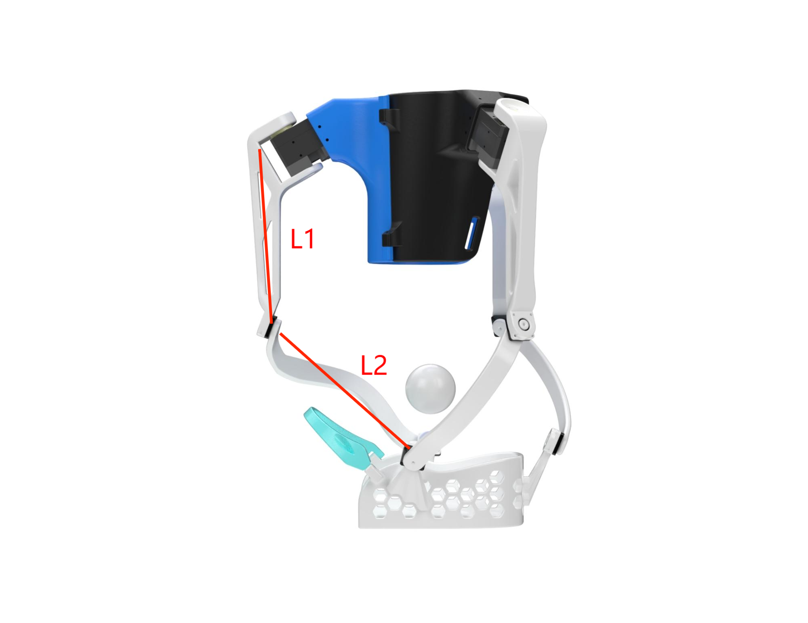

How to use this document
This is a single scrolling speaker-notes document. Each section corresponds to one slide of the closing presentation. The visual at the top of each section is what the audience sees; the indented “Speaker notes” block below is what you say. The full talk is paced for ~15 minutes.

Slide 1 · Title slide

🎤 Speaker notes · 20 s
Good morning, everyone. Thank you for being here. My name is Yufei Zhang, and I am a graduate student in the Department of Mechanical Engineering, working with Professor Sunil K. Agrawal. Today I will walk you through my AMR research-course project: the design and validation of a wearable ankle rehabilitation robot with an anatomically aligned 3-RRR spherical parallel mechanism. The whole project — code, URDF, and this report — is open-source on GitHub at the link on the slide.

Slide 2 · Outline
- 1. Motivation: clinical need & gap in the state of the art
- 2. Mechanism: anatomically aligned 3-RRR SPM + shoe-tray foot plate
- 3. Kinematics: closed-form & numerical inverse kinematics
- 4. Dynamics & baseline PID; proposed Assist-As-Needed control
- 5. Embedded system & hardware integration
- 6. Open-source ROS 2 / Gazebo simulation pipeline
- 7. Closed-loop tracking demo (recorded video)
- 8. Planned ablation experiments & quantitative metrics
- 9. Honest project status & invitation to extend
🎤 Speaker notes · 25 s
Here is what I will cover in the next fifteen minutes. I will start with the clinical motivation and the gap in the state of the art, then introduce the mechanism — including the shoe-tray foot plate, which is one of our two structural innovations. After that, the kinematics, the baseline control, the proposed Assist-As-Needed law, and the embedded hardware. Then I will spend a few minutes on the open-source ROS 2 / Gazebo simulation pipeline and the closed-loop tracking demo, before closing with the planned experiments, an honest project status, and an invitation for future students.

Slide 3 · Motivation: Clinical Need
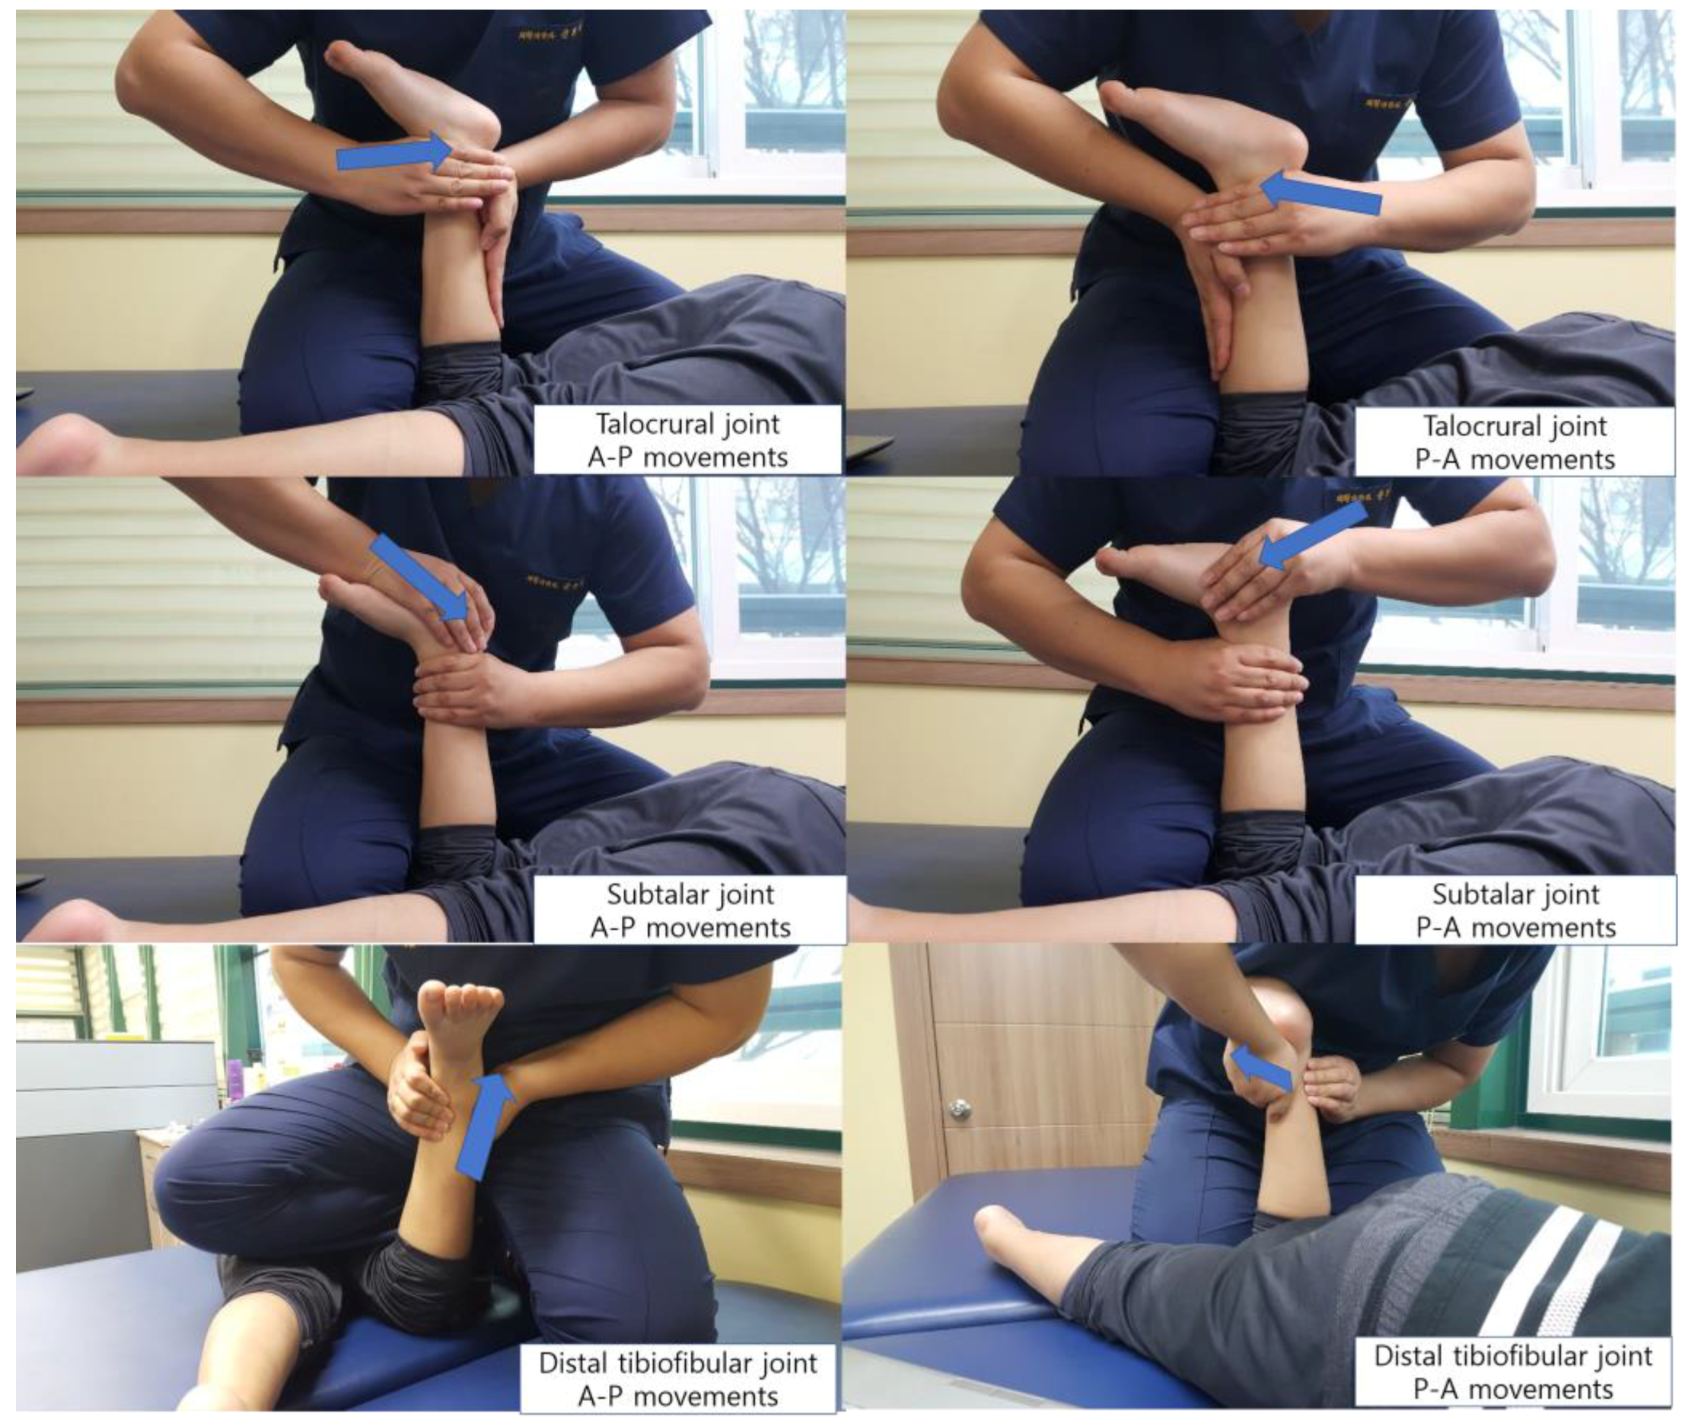
🎤 Speaker notes · 45 s
Let me start with the clinical picture. Ankle injuries — sprains, fractures, post-operative cases — and neurological deficits like stroke and foot-drop are extremely common. The standard of care today is therapist-driven manual mobilization of the talocrural, subtalar, and tibiofibular joints. You can see a representative example on the slide. The problem is that manual therapy is highly dependent on clinician experience, the dosing is qualitative, and the trajectory is not measurable. A robotic device can give you repeatability, dose control, and objective outcome metrics — and that is exactly what motivates this work.

Slide 4 · State of the Art and the Gap
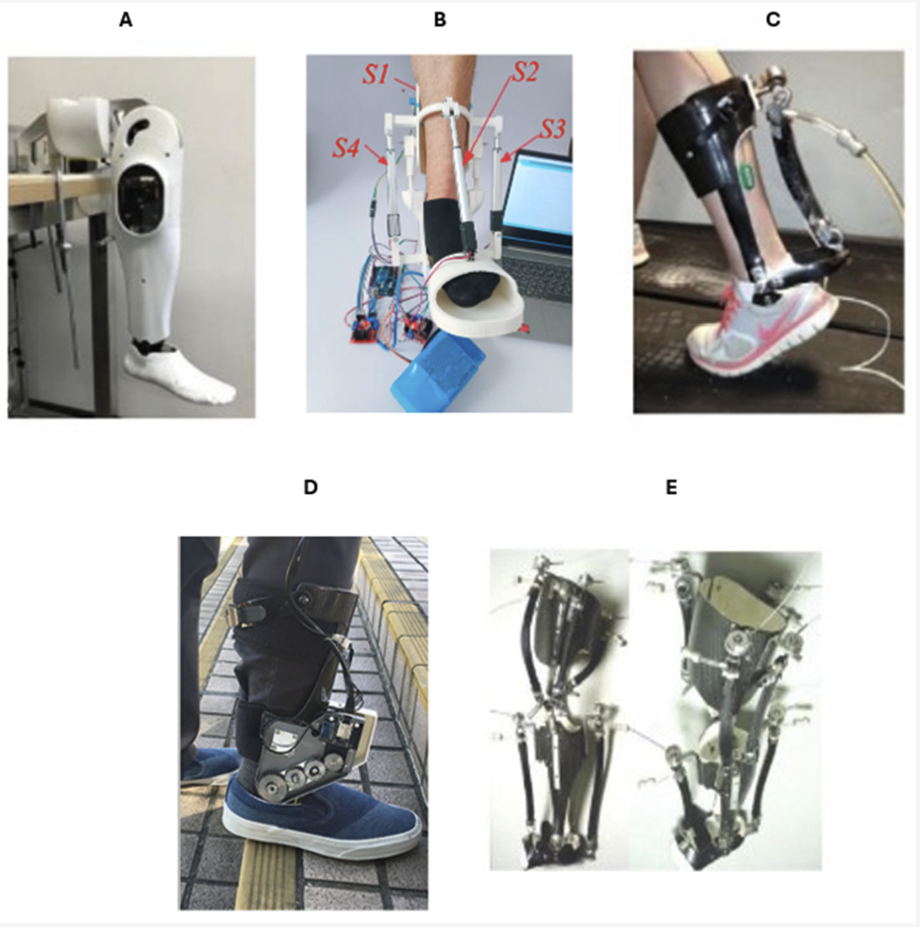
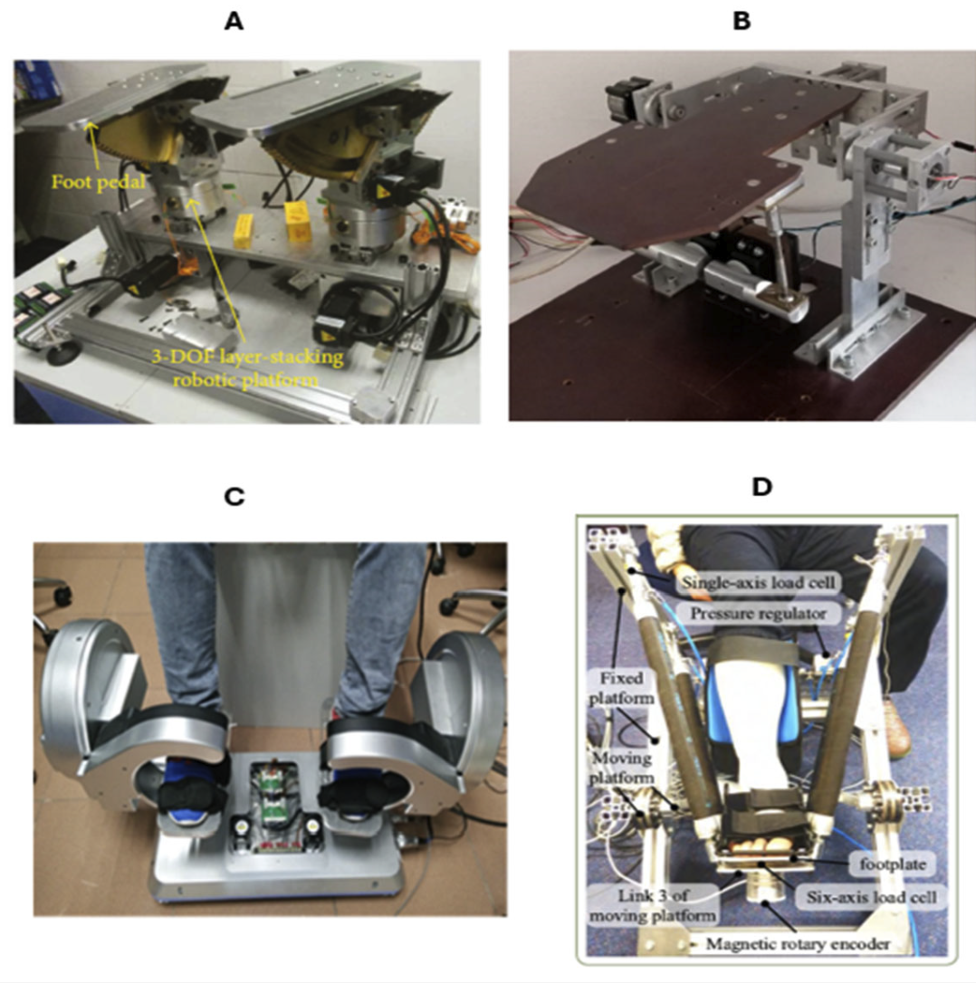
🎤 Speaker notes · 60 s
If we look at the existing literature, ankle rehab devices fall into two big families. On the top, you have wearable exoskeletons — powered, passive, or quasi-passive. They are portable and easy to deploy, but they typically constrain the joint to one or at most two degrees of freedom. They mostly cover dorsiflexion and plantarflexion, and they ignore inversion and yaw — which are exactly the motions you need for proprioceptive ankle rehab.
On the bottom, you have platform-style robots. They give you the full three to six degrees of freedom, but they are stationary, and their geometric center of rotation does not coincide with the patient's talocrural joint. That mismatch produces parasitic shear across the ankle, which is a safety concern.
Our target is the gap between these two families: a wearable mechanism whose remote center of rotation is anatomically aligned with the human ankle.

Slide 5 · Biomechanical Motivation → 3-RRR SPM
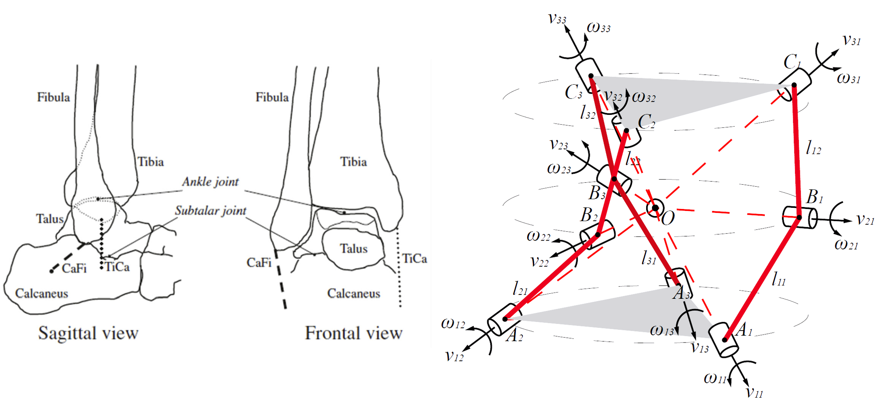
🎤 Speaker notes · 50 s
The biomechanical reason this is even possible is shown on the left. The talocrural and subtalar complex has three rotation axes that converge near a single anatomical point. So if we use a mechanism whose joint axes also intersect at one common point — and place that point at the ankle — we get the same kinematic structure as the ankle itself. That is exactly what a 3-RRR spherical parallel mechanism does. On the right, you can see the canonical 3-RRR diagram: nine revolute joints arranged so all axes converge at the spherical center O, producing exactly three rotational degrees of freedom — pitch, roll, and yaw.

Slide 6 · Mechanism Design
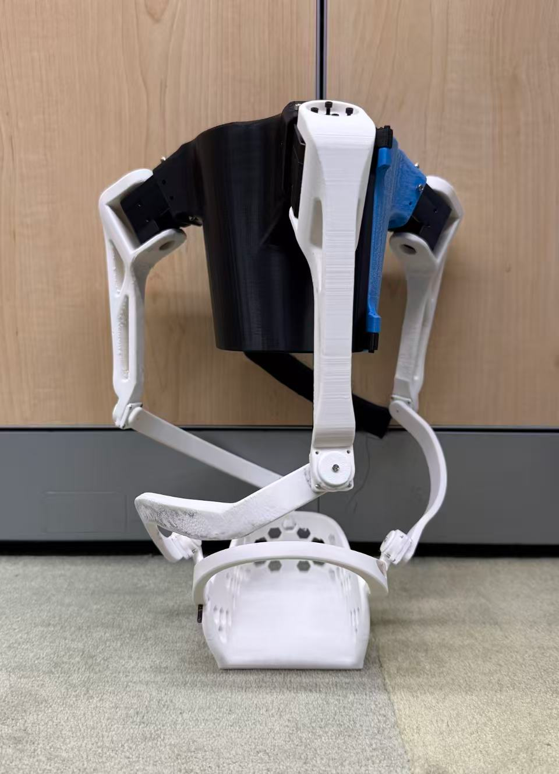
CAD with L₁ / L₂ annotation 3D-printed prototype
🎤 Speaker notes · 60 s
Here is the wearable embodiment we have built. It is a strap-mounted device with a contoured shank cuff at the top, three identical RRR limbs spaced at 120 degrees, and a foot plate at the bottom. Two things are worth highlighting on this slide. First, the link lengths L₁ on the proximal side and L₂ on the distal side are deliberately annotated, because — as you will see in two slides — their ratio directly governs the singularity placement and the rotational isotropy of the device. Second, on the right you can see the assembled 3D-printed prototype, which is what we use today to verify fit, clearance, and bench-level integration.

Slide 7 · Foot-Plate Innovation: Shoe-Tray Design

🎤 Speaker notes · 75 s
Now I want to spend a slide on what I think is the more clinically interesting innovation, which is the foot-plate design. The classic options in the literature are either a rigid foot plate, which only fits one foot size, or a soft sandal, which loses stiffness. Neither generalizes well across patients.
Our choice — informed by a survey of comparable rehab devices — is a shoe-tray foot plate. The subject keeps their own shoes and just steps into the tray. Velcro and straps fix the foot in place across the dorsum and around the heel, and the wearable strap-mounted device drives the tray as a rigid body.
This buys us three concrete things. First, comfort: there is no direct skin contact, and the patient walks on their own shoe sole, so longer training sessions become tolerable. Second, generalization: a single device fits a wide range of foot sizes, roughly EU 36 through 46, without re-manufacturing. Third, clinical workflow: don and doff is a one-step “step-in” motion, which matters in a real clinic.

Slide 8 · CAD Multi-View
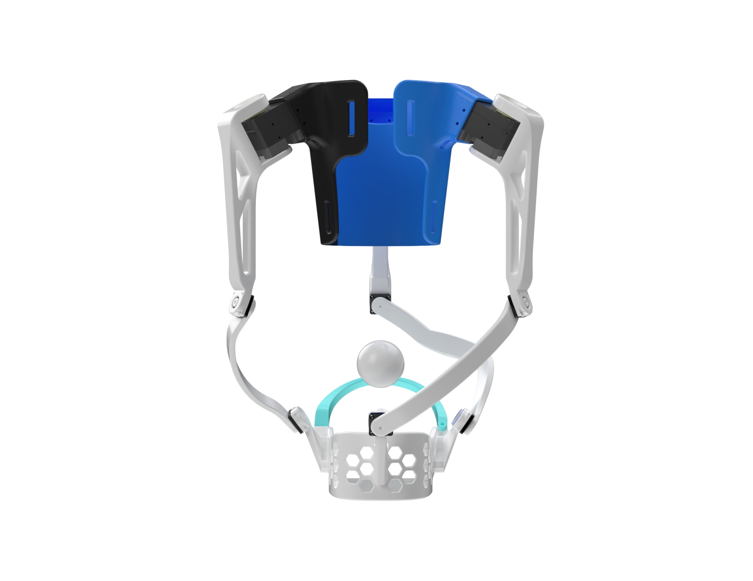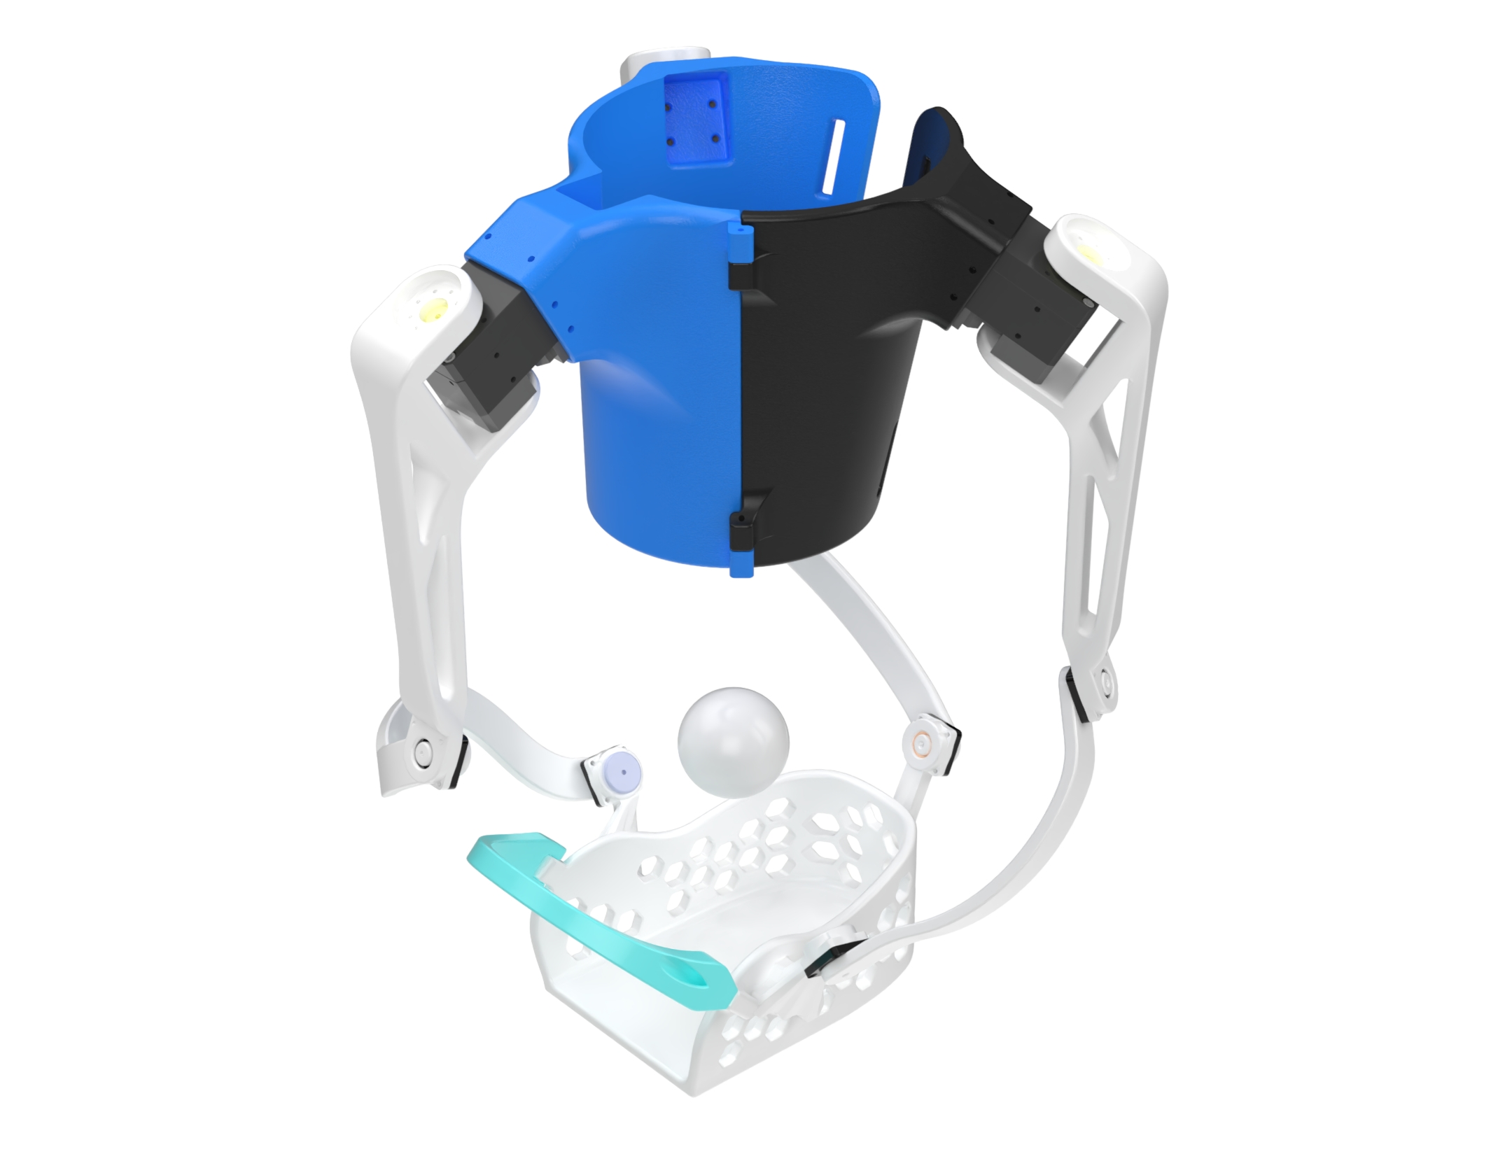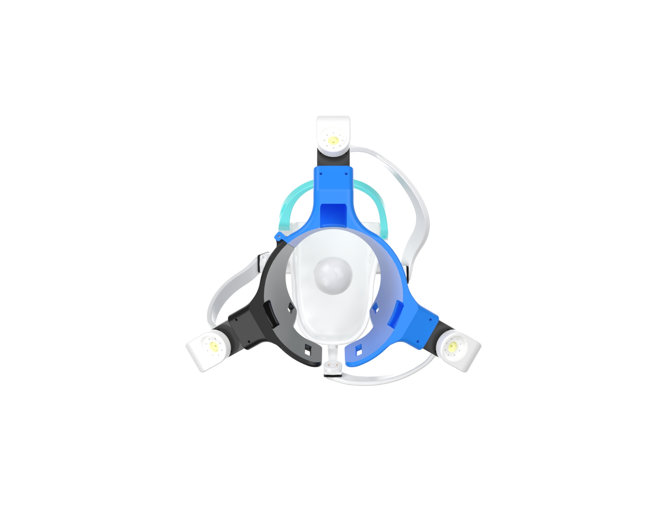
(a) Front (b) Perspective (c) Top
🎤 Speaker notes · 35 s
Three views of the same CAD: front, perspective, and top. The two things I want you to notice are the symmetric three-limb topology around the shank cuff and the open-back base ring, which is what makes the device tolerant to different calf circumferences.

Slide 9 · Singularity-Aware Geometry
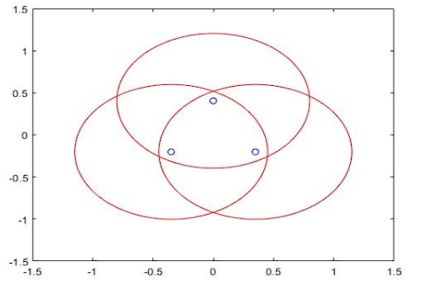
🎤 Speaker notes · 60 s
Now let me say a word about parallel singularities, because they are a real safety concern. At a parallel singularity the platform can pick up an extra, uncontrollable degree of freedom even when all the actuators are locked — meaning the device loses stiffness and can no longer resist external loads. In a rehab context that is dangerous.
Following the analytical guidance of Saheb 2021 and Wu and Bai 2019 for the 3-RRR architecture, we picked the link ratio ρ = L₂ / L₁ approximately equal to 1.15. The plot on the slide shows the per-leg reachable circles, and their intersection is the parallel-singularity-free common workspace. The result is roughly a 20 % improvement in the global isotropy index of the rotational Jacobian, with the singular curves pushed outward toward the workspace boundary.

Slide 10 · Inverse Kinematics (Algorithm 1)
Algorithm 1 per-cycle parallel IK
input : (roll, pitch, yaw), prior q⁻
output : motor angles q = (q1, q2, q3)

R_BF ← Rz(yaw) Ry(pitch) Rx(roll)
for each leg i in {1, 2, 3}:
P_i ← R_BF · P_i_F
f_i(q) ← |P_i − A_i(q)| − L_i
bracket ← grid containing q⁻_i
q_i ← bisect(f_i, bracket)
return q
🎤 Speaker notes · 60 s
The kinematics layer is what feeds the controller. We derived a closed-form inverse-kinematic expression per leg, which is great for offline workspace evaluation, and a numerical formulation for real-time control. The numerical version, summarized as Algorithm 1, takes the desired roll, pitch, and yaw, computes each platform-side point, and then for each leg it scans a coarse motor-angle grid for a sign change in the leg residual, runs bisection inside the bracket, and picks the root closest to the previous control cycle to enforce branch continuity. The whole thing runs in the Python standard library, with no external dependencies, which is what allows the same code to run inside a ROS 2 node, inside a standalone CLI, and — eventually — inside the embedded loop on the Teensy.

Slide 11 · Dynamics & Baseline PID
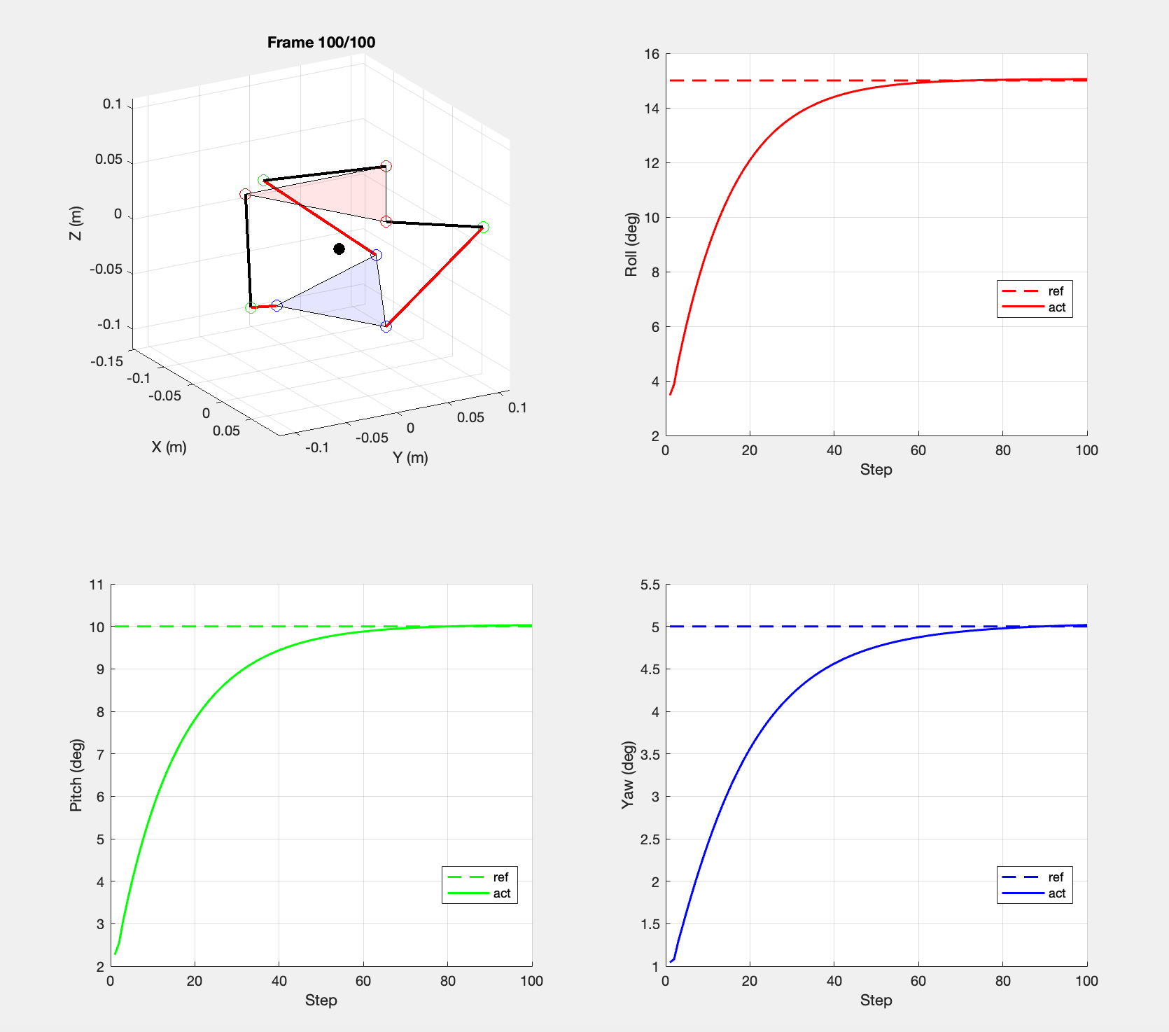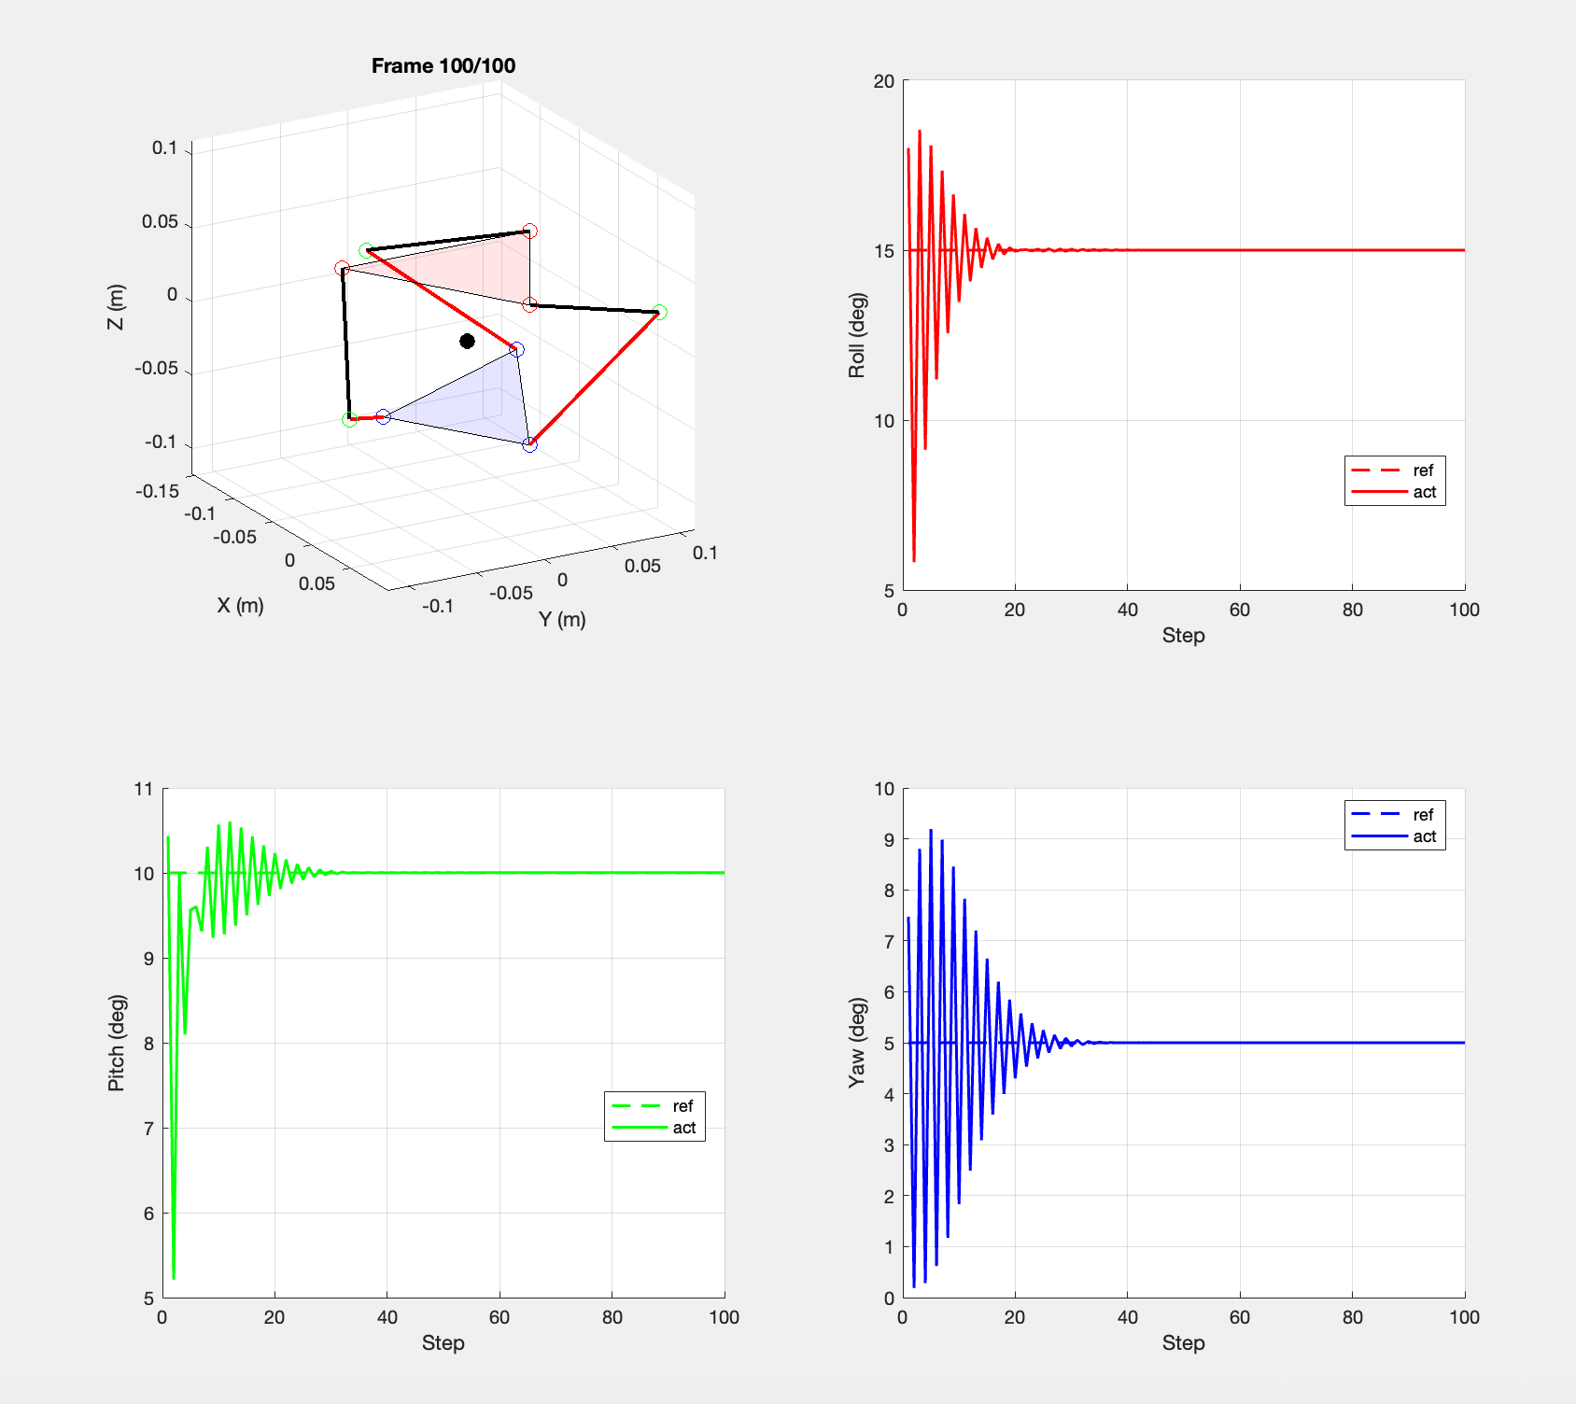
Underdamped: Kp = 20, Kd = 0.5, Ki = 1 Critically damped: Kp = 50, Kd = 2, Ki = 5
🎤 Speaker notes · 40 s
For the baseline controller we use three independent PID loops on the actuator angles. The two plots show the platform orientation response to a step reference under two tunings. On the left, an underdamped tuning gives oscillatory settling — basically a soft, compliant interaction. On the right, a critically damped tuning gives fast, monotonic convergence. The point is that even on a rigid SPM, the feedback gains alone modulate effective compliance, and these two regimes bracket the spectrum that the AAN controller we are about to introduce will interpolate online.

Slide 12 · Assist-As-Needed Control (proposed)
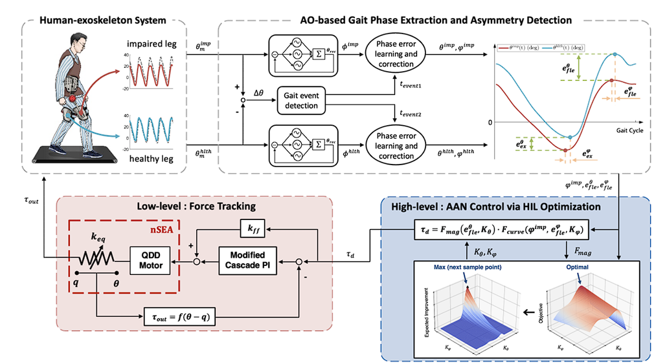
🎤 Speaker notes · 60 s
The AAN strategy comes from David Reinkensmeyer’s group, and the idea is simple but powerful: the robot only assists when the patient actually needs help. If the patient can follow the trajectory on their own, the robot stays out of the way; if the patient starts drifting, the robot ramps up the assistance gradually. To estimate the patient torque without a distal force sensor, we subtract the model-predicted dynamic torque from the Dynamixel current measurement times the torque constant. The block on the slide shows the architecture: a high-level supervisor computes gait phase and asymmetry, schedules the assistance torque, and a low-level loop tracks it on the actuator. To be transparent: AAN is proposed and formulated, not yet deployed on real hardware.

Slide 13 · Embedded System & Hardware
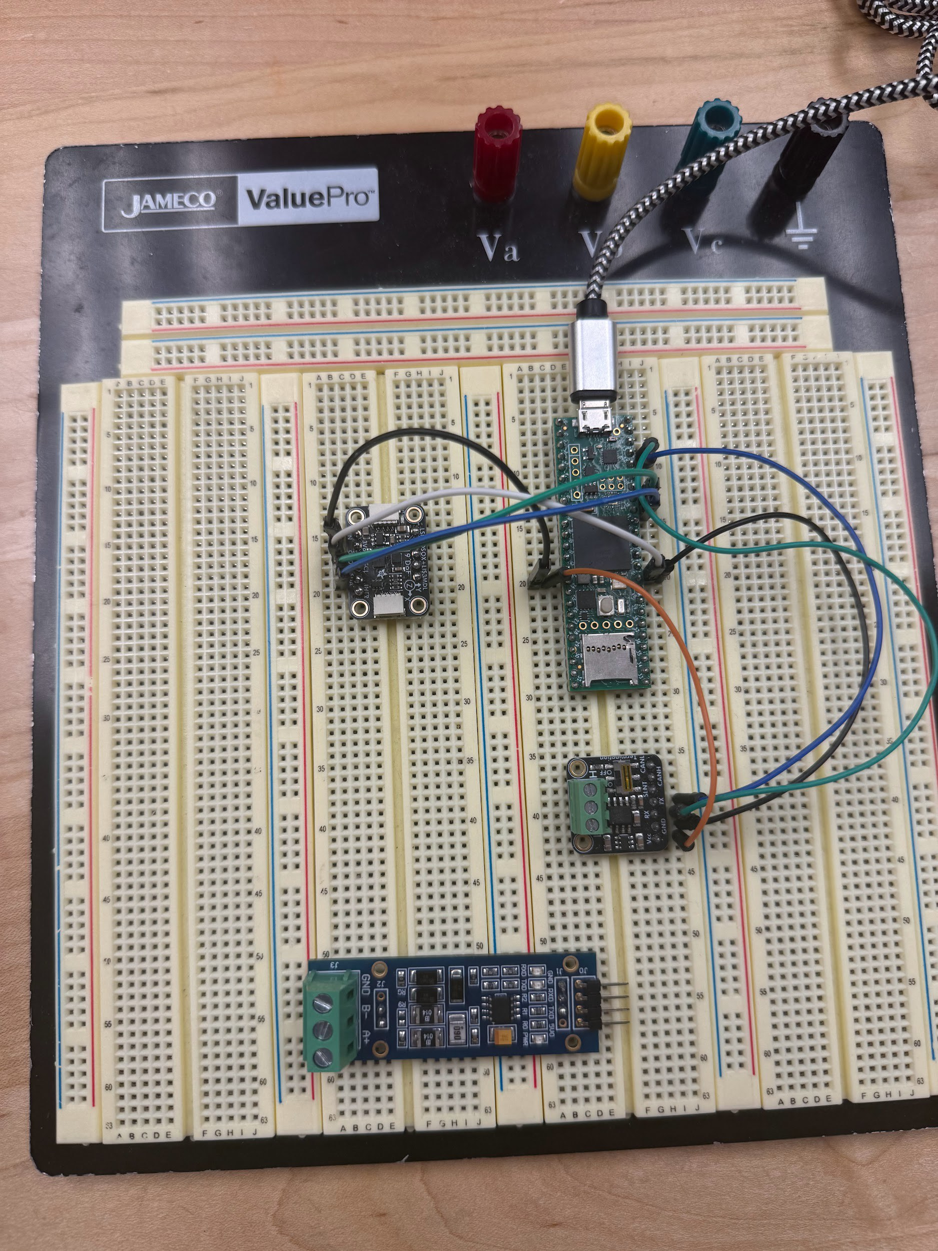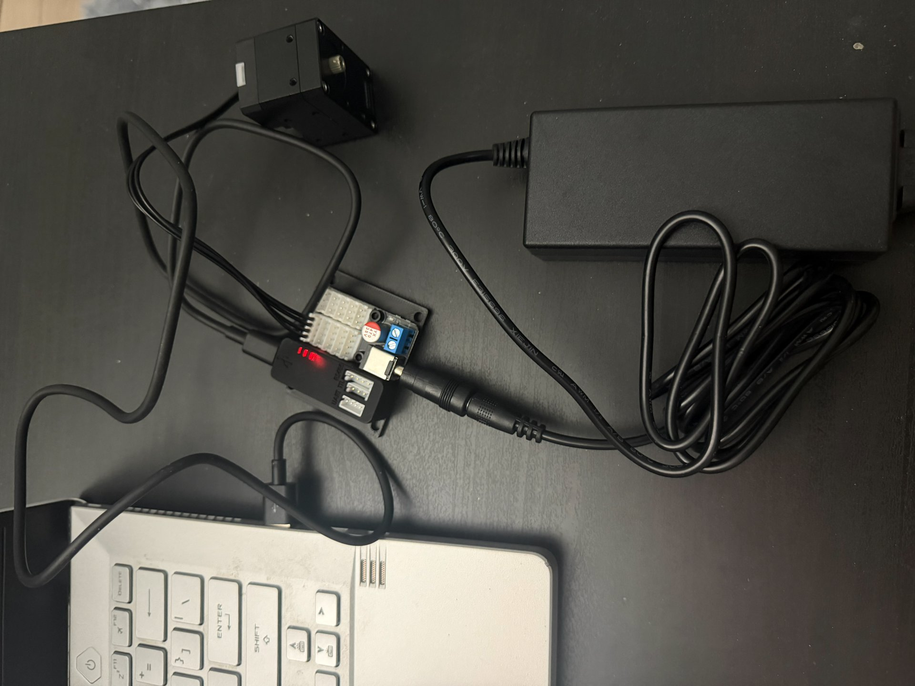
Prototype electronics stack Servo control wiring (Dynamixel + U2D2 + PSU + host)
🎤 Speaker notes · 55 s
Two photos on this slide. On the left, the prototype electronics stack: a Teensy 4.1 master in the center, an IMU breakout on the left for shank and foot orientation, and a TTL-to-RS-485 transceiver at the bottom that bridges the master to the daisy-chained Dynamixel actuator bus. On the right, the actual servo-control wiring used on the bench: the XM430 motor at the top, the ROBOTIS U2D2 communication board in the middle, the dedicated power supply on the right, and the host laptop at the bottom. Closed-loop control runs at 1 kHz on the Teensy, with the encoder giving us roughly 0.088° per tick — more than enough resolution for the angular precision required in ankle rehab.

Slide 14 · Open-Source ROS 2 / Gazebo Pipeline
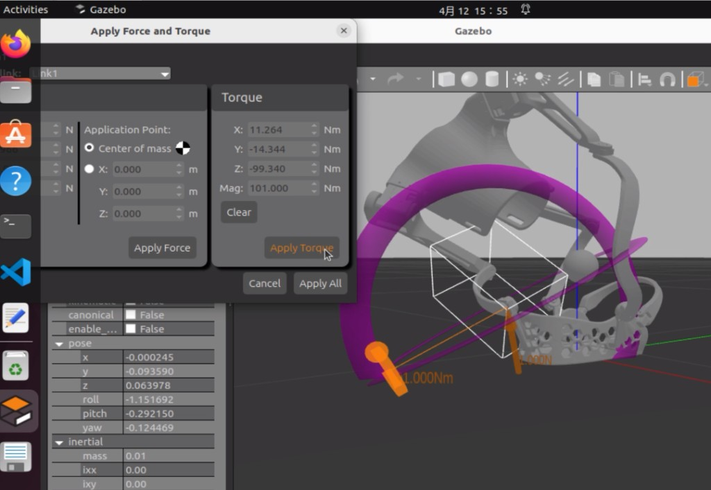
Repository (MIT licensed):
https://github.com/YufeiZhang0601/wearable-3rrr-ankle-rehab
🎤 Speaker notes · 60 s
One of the deliverables I am most proud of is the open-source simulation pipeline. The whole thing is shipped as a single ROS 2 ament-python package, MIT licensed, at the URL above. It bundles the URDF and Xacro, twenty-two STL meshes, four launch files for visualization and Gazebo, and the parallel-IK solver as a shared kinematic core. The screenshot shows the workflow we use to gate URDF changes: we load the model into Gazebo, use the Apply Force and Torque dialog to inject a 100-newton-meter torque, and verify that the joint axes and inertials behave physically — no NaN inertias, no mesh interpenetration. This is what gives us confidence that any change to the robot description still simulates correctly before we touch hardware.

Slide 15 · Closed-Loop Tracking Demo (Algorithm 2)
Algorithm 2 closed-loop ankle-rehab tracking demo
parse URDF; pick (j1, j4, j6) as the three Dynamixel actuators
q ← 0; t ← 0
while running:
sigma(t) ← min(t / Tsoft, 1) # soft start
pitch ← sigma(t) * A_p * sin(2*pi*f*t)
roll ← sigma(t) * A_r * sin(2*pi*f*t)
q_ref ← ParallelIK(roll, pitch, 0) # Algo 1
dq ← clamp(q_ref - q, qdot_max * dt)
tau ← clamp(controller(dq), tau_max)
q ← q + dq # virtual actuator
log(t, q_ref, q, tau, ToTicks(q)) # CSV row
t ← t + dt
🎤 Speaker notes · 45 s
Algorithm 2 shows the closed-loop tracking demo. It is dependency-free Python: it parses the URDF, treats joints 1, 4, and 6 as the three Dynamixel actuators, generates a slow sinusoidal reference at ±12° of dorsi/plantarflexion and ±6° of inversion, runs Algorithm 1 to get the motor angles, applies a 1.2 Nm torque cap and a 0.8 rad/s velocity cap from the safety supervisor, and logs everything to CSV. A screen capture of the demo running against the URDF model is shipped in the repository as media/closed_loop_demo.mp4, about 25 MB.

Slide 16 · Planned Experiments
Quantitative metrics
- Limb Symmetry Index (LSI) – north-star clinical metric
- Jerk = d³x/dt³ from foot-plate IMU (smoothness)
- Interaction torque τ_int (sensorless estimator)
- Center of pressure (CoP) trajectory from gait mat
- Human-contribution ratio η_h = τ_ext / (τ_ext + τ_assist)
Four sub-experiments
- E1 Simulated-impairment recovery (controlled foot-drop)
- E2 Transparency evaluation (R² ≥ 0.95 vs. barefoot)
- E3 Active participation under AAN (η_h trend across sessions)
- E4 Passive transfer effect after a CPM bout
🎤 Speaker notes · 75 s
Now to the experimental design — which is fully designed but not yet executed.
The metrics are drawn from the rehab-robotics literature: the Limb Symmetry Index as the north-star clinical metric, jerk as a smoothness indicator, the interaction torque from our sensorless estimator, the gait-mat center of pressure, and the human-contribution ratio.
On the right, four sub-experiments. E1, simulated-impairment recovery, where we induce a controlled foot-drop with a small toe weight or a downward bias torque, and check whether AAN training brings the LSI from around 80 % back toward 95 %. E2, transparency — the device should not perturb natural gait under near-zero impedance, R squared above 0.95 between barefoot and device-on kinematics. E3, active participation, where the human-contribution ratio should rise across training sessions. And E4, the passive transfer effect of a CPM bout on overground gait. Statistics are within-subject paired tests with Bonferroni-Holm correction and bootstrap 95 % confidence intervals.

Slide 17 · Implementation Status — Honest Snapshot
Item | Status | Outcome / Notes
Wearable 3-RRR mechanism (ρ≈ 1.15) | Done | + ~20 % isotropy index
Shoe-tray foot-plate design (size-generalizing, comfortable) | Done | Subject keeps own shoes
Closed-form & numerical inverse kinematics | Done | Algorithm 1, in repo
Open-source simulation controller (ROS 2 + Gazebo) | Done | MIT-licensed release
Closed-loop tracking demo against the URDF | Done | Algorithm 2 + recorded video
Embedded electronics stack (Teensy + RS-485 + IMU) | Done | Bench-tested
Ablation experiments + quantitative metrics designed | Done | LSI / jerk / τ_int / CoP / η_h
AAN control law formulated | Proposed | Eq. (16) - (18); pending HW deploy
Standalone untethered operation (battery, free walking) | Not yet | Next milestone
Human-subject experiments (E1–E4) | Not yet | Platform built; subjects pending
🎤 Speaker notes · 75 s
I want to be very transparent with this slide, because honest framing matters. Here is what is done today, in dark navy. The wearable 3-RRR mechanism, the shoe-tray foot plate, the closed-form and numerical IK, the open-source simulation controller, the closed-loop tracking demo against the URDF, the bench-tested embedded electronics, and the full ablation-experiment design with quantitative metrics — these are all delivered, all in the repo, and all reproducible.
Here is what is proposed but not yet hardware-deployed, in grey: the AAN control law itself. It is fully formulated, but it needs to ride on top of a real Dynamixel current loop before we can claim it works.
And here is what is not yet done, in orange: first, standalone untethered operation — by which I mean battery-driven, free wearable walking on the gait mat. Second, the human-subject experiments themselves. The platform is built and runnable; the subject trials are simply the next milestone.

Slide 18 · Conclusion & Open Invitation
Delivered (turn-key)
- Wearable, anatomically-aligned 3-RRR SPM with the shoe-tray foot plate that fits a wide range of foot sizes
- Closed-form + numerical IK that maps (roll, pitch, yaw) to motor angles in real time
- MIT-licensed ROS 2 / Gazebo simulation controller, verified end-to-end against the URDF
- Ablation-experiment design and a full set of quantitative rehab metrics (LSI, jerk, τ_int, CoP, η_h)
Open for the next phase
- Standalone untethered operation: battery, free wearable walking on the gait mat
- Subject experiments E1–E4: healthy-subject simulated foot-drop → IRB-approved patient cohort
→ An open invitation to future students
The simulation codebase, the wearable hardware design, and the experimental protocol together form a turn-key starting point. Pull the repo, plug in your own subject trials, and the project picks up exactly where this report leaves off.
🎤 Speaker notes · 60 s
So to summarize. The three concrete deliverables are: a wearable, anatomically aligned 3-RRR mechanism with a shoe-tray foot plate that fits a wide range of foot sizes; a closed-form plus numerical inverse-kinematic stack that runs in real time; and an MIT-licensed ROS 2 / Gazebo simulation controller that has been verified end-to-end against the URDF.
Two open items remain: standalone untethered operation, and the subject experiments E1 through E4.
And here is the honest invitation. The simulation codebase, the wearable hardware design, and the experimental protocol together form a turn-key starting point. If a future student in our group is interested in this direction, they can pull the repository, plug in their own subject trials, and the project picks up exactly where this report leaves off. I would be very happy to support that.

Slide 19 · Thank You
Thank you. Questions and discussion?
Yufei Zhang · yz4917@columbia.edu
Advisor: Prof. Sunil K. Agrawal
github.com/YufeiZhang0601/wearable-3rrr-ankle-rehab
🎤 Speaker notes · 15 s
Thank you for your attention. I am happy to take questions.

